December 10, 2014

Dear Sir or Madam,

This study constitutes the first study directly comparing brain extraction in CT images to a gold standard manual segmentation.

We would like to thank the Editor, Associate Editor and reviewers for their comments and recommendations on previous manuscript submission NIMG-14-2266. In particular, we would like to thank the editor for correctly noting that, indeed, this is the first validation paper for CT skull stripping. Indeed, while Smith (2002) have done validation of BET skull stripping for MRI images, there is currently no validation for CT skull stripping. Our paper addresses this important gap in the literature. In addition to addressing the comments of the previous reviewers we have further strengthened the paper by:

1) Increasing the number of validation CT images from 20 to 36, removing multiple scans per patient. This is closer to the 45 validation images used by Smith (2002) for MRI. All estimated performance measures remain high.

2) Deploying the skull stripping procedure on a longitudinal study of CT brain images and studying the scan-rescan reliability for intracranial volume estimation. We used 1095 scans on 129 people for a mean (SD) of 8.5 (2.8) longitudinal repetitions per subject.

3) We have estimated the failure rates for each processing pipeline in this large collection of scans.

Thank you for your consideration.

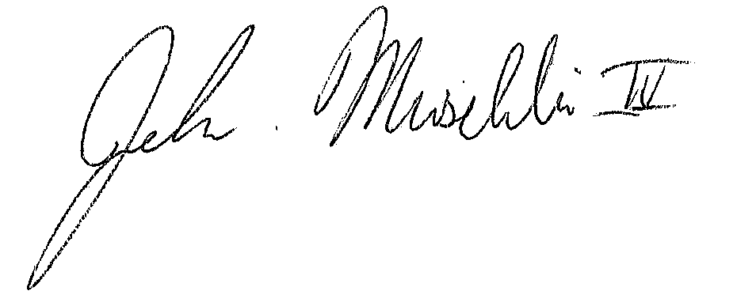

John Muschelli, ScM

PhD Student

Department of Biostatistics

Johns Hopkins Bloomberg School of Public Health