##### DATA SCIENCE TOOLBOX: PYTHON PROGRAMMING PROJECT REPORT

(Project Semester January-April 2025)

***Comprehensive Analysis of COVID-19 Mortality Trends in the U.S.***

Submitted by

Nikesh Kumar

Registration No. 12306063

Programme: B.Tech CSE Section: K23EV

Course Code: INT375

Under the Guidance of

##### Sandeep Kaur UID: 23614

##### Assistant professor

##### Discipline of CSE/IT

##### Lovely School of Computer science and Engineering

##### Lovely Professional University, Phagwara

**DECLARATION**

I, **NIKESH KUMAR** student of **Computer science and Engineering** under CSE/IT Discipline at, Lovely Professional University, Punjab, hereby declare that all the information furnished in this project report is based on my own intensive work and is genuine.

Date: 14-04-2025 Signature: Nikesh Kumar  Registration No.: 12306063 Name of the student: Nikesh Kumar

**CERTIFICATE**

This is to certify that Adarsh Raj bearing Registration no. 12306063 has completed INT375 project titled, “***Comprehensive Analysis of COVID-19 Mortality Trends.***” under my guidance and supervision. To the best of my knowledge, the present work is the result of his original development, effort and study.

##### Signature and Name of the Supervisor

Sandeep Kaur

##### Designation of the Supervisor

Assistant professor

##### School of Computer science and Engineering

Lovely Professional University Phagwara, Punjab.

Date: 14-04-2025

**Acknowledgement**

I would like to express my sincere gratitude to my faculty, Sandeep Kaur, for her continuous guidance, valuable feedback, and consistent support throughout this project.

I would also like to thank Lovely Professional University for providing the resources and academic environment that allowed me to complete this project successfully.

Last but not least, I extend my thanks to my friends for their encouragement and support during the course of this work.

#### Nikesh Kumar

Table of Contents

1. Introduction 6
2. Source of dataset 7
3. EDA Process 7
   1. Data Loading and Overview 7
   2. Data Cleaning 8
   3. Handling Missing and Inconsistent Values 8
   4. Data Type Conversion and Optimization 9
   5. Exploratory Summary Statistics 9
4. Analysis on Dataset 10
   1. : COVID-19 Deaths by Age Group 10
   2. : Total COVID-19Outcomes Distribution 11
   3. : Comparison ofVaccination Matrices vs Outcomes 14
   4. :Distribution of Age-Adjusted COVID Death Rates by Vaccinated Status 18
   5. : COVID Deaths as % of Total Deaths 20
   6. :Distribution of Vaccination Rates 22
5. Conclusion 24
6. Future Scope 24
7. References 25
8. GitHub Upload 26
9. LinkedIn 26

# Introduction

The outbreak of the novel coronavirus disease (COVID-19) in late 2019 quickly evolved into one of the most significant global public health crises of the 21st century. With unprecedented transmission rates and a wide spectrum of clinical manifestations, COVID-19 has claimed millions of lives worldwide and disrupted every aspect of society — from healthcare systems and economies to education, travel, and personal lifestyles.

As the pandemic unfolded, accurate data collection and timely dissemination became crucial in shaping public health responses and policy decisions.

Governments, research institutions, and health organizations such as the Centers for Disease Control and Prevention (CDC) began publishing extensive datasets that tracked infection rates, mortality, recovery, comorbidities, and demographic breakdowns. One of the most critical dimensions of this data is the death toll — both as a direct measure of the virus's lethality and as an indicator of strain on healthcare infrastructure.

This report presents a comprehensive analysis of the **Provisional COVID-19 Deaths by Sex and Age** dataset published by the CDC. The goal is to uncover patterns, disparities, and trends that characterize the mortality impact of COVID-19 in the United States from a demographic and temporal perspective.

##### Key Objectives:

* To perform **exploratory data analysis (EDA)** to understand the structure and scope of the dataset.
* To analyze COVID-19 deaths in relation to **age groups**, **sex**, **time periods**, and **geographic distribution**.
* To compare COVID-19 mortality data with other respiratory illnesses such as **pneumonia** and **influenza**.
* To visualize insights in a clear, accessible manner that aids decision- makers, researchers, and public health professionals.

##### Why This Analysis Matters:

Understanding who is most at risk and when the risks are highest can significantly improve public health strategies. This includes prioritizing vulnerable populations, allocating healthcare resources more efficiently, and crafting targeted health communications. Moreover, by comparing COVID-19's death toll with other common illnesses, we can contextualize its severity and learn how to better prepare for future outbreaks.

Using Python and its data science ecosystem (pandas, seaborn, matplotlib, etc.), this report offers a data-driven lens through which we evaluate the devastating toll of COVID-19. The findings will not only highlight historical trends but also inspire questions for deeper study and future research.

# Source of dataset

The dataset used for this analysis is titled **"Provisional COVID-19 Deaths by Sex and Age"**, made publicly available by the **Centres for Disease Control and Prevention (CDC)**. This dataset provides detailed information on weekly reported deaths categorized by demographic features and cause of death.

* **File Name:** Provisional_COVID-19_Deaths_by_Sex_and_Age.csv
* **Source:** <https://data.cdc.gov/>
* **Dataset link: https://catalog.data.gov/dataset/covid-19-outcomes-by-vaccination-status**
* **Data Range:** From early 2020 to September 2023
* **Fields Included:** Date, State, Sex, Age Group, and various death counts related to COVID-19, pneumonia, and influenza.

# EDA Process

Exploratory Data Analysis (EDA) serves as the foundational step in any data science or analytical project. It allows analysts to gain a better understanding of the dataset, identify anomalies or inconsistencies, and shape the direction of further investigations. In this report, a structured EDA process was performed to prepare the CDC’s "Provisional COVID-19 Deaths by Sex and Age" dataset for meaningful analysis and visualization.

### Data Loading and Overview

The dataset was imported using the pandas library, which provides powerful tools for handling tabular data. An initial inspection using methods such as

.head(), .shape, and .info() allowed us to:

* + - Preview the first few records.
    - Determine the total number of rows and columns.
    - Understand the data types and structure of each column.
    - Identify key fields for analysis, including *Sex*, *Age Group*, *COVID-19 Deaths*, *Pneumonia Deaths*, *Influenza Deaths*, *Total Deaths*, and *End Date*.

This helped confirm that the dataset spans multiple weeks from 2020 through 2023 and includes demographic breakdowns by U.S. state, age, and sex.

### Data Cleaning

Like many real-world datasets, the raw CDC data contained irregularities and placeholders. Common issues included:

* + - Text entries such as "Suppressed" or "Missing" where numerical values were expected.
    - Inconsistent capitalization and categorical values.
    - Null (NaN) values scattered across key numerical fields. To clean the data:
    - Placeholder strings were replaced with np.nan to standardize missing values.
    - Key columns (e.g., *COVID-19 Deaths*, *Pneumonia Deaths*) were explicitly converted to numeric types using pd.to_numeric(), with error handling for non-numeric values.
    - Rows with missing values in essential fields like *COVID-19 Deaths* were dropped to preserve analytical accuracy.

This phase ensured the data was suitable for numerical computation and visualization without raising type errors or introducing biases due to bad data.

### Handling Missing and Inconsistent Values

A summary of missing data was generated using .isnull().sum(), allowing a quick scan of problematic columns. Strategies for handling missing data included:

* + - Dropping rows only when critical variables were missing (e.g., death counts).
    - Retaining rows with non-critical nulls if they didn't affect analysis (e.g., state-specific details for national analysis).

Additionally, categorical variables like *Sex* and *Age Group* were standardized to ensure consistency (e.g., correcting misspellings, merging equivalent categories).

### Data Type Conversion and Optimization

To improve performance and compatibility with visualization libraries:

* + - The *End Date* column was converted to datetime format using pd.to_datetime() for time-series analysis.
    - Categories like *State*, *Sex*, and *Age Group* were converted to the category type where appropriate, reducing memory usage and improving performance.

### Exploratory Summary Statistics

Descriptive statistics were generated using .describe() for numerical columns and .value_counts() for categorical columns. These summaries revealed:

* + - The distribution and range of deaths across different causes.
    - The frequency of reporting across different states and time periods.
    - Outliers or extreme values which could skew results.

These insights guided the creation of focused visualizations and more nuanced breakdowns in the analytical sections that followed.

**Summary of Tools and Techniques Used:**

|  |  |
| --- | --- |
| **Task** | **Function / Method Used** |
| **Data Import** | pd.read_csv() |
| **Data Preview** | .head(), .info(), .shape() |
| **Handling Missing Values** | .isnull().sum(), .dropna() |
| **Type Conversion** | pd.to_numeric(), pd.to_datetime() |
| **Descriptive Statistics** | .describe(), .value_counts() |
| **Data Cleaning** | df.replace(), astype() |

# Analysis on Dataset

## : COVID-19 Deaths by Age Group

##### Introduction

Understanding the distribution of COVID-19 deaths across different age groups and sexes is vital for public health planning and policy-making. Elderly individuals and males have consistently been identified as higher-risk groups throughout the pandemic. This analysis seeks to quantify and visualize the correlation between demographic variables and COVID-19 mortality.

##### General Description

This analysis focuses on two categorical dimensions: Age Group and Sex. By aggregating COVID-19 deaths across these categories, we can identify which demographic combinations (e.g., Males aged 75–84) have been most severely impacted.

##### Specific Requirements, Functions, and Formulas

* + Grouping & Aggregation:

Utilized groupby(['Sex', 'Age Group']) with .sum() to compute total COVID-19 deaths by each combination of sex and age group.

* + Sorting:

Used .sort_values() to rank combinations based on death counts.

* + Visualization Tools:

matplotlib and seaborn were used for:

* + - Grouped bar plots
    - Stacked bar charts

##### Analysis Results

The analysis revealed the following patterns:

* + Age: Deaths increased dramatically with age, with groups aged 75 and older showing the highest mortality.
  + Sex: In nearly every age group, males exhibited higher mortality than females.
  + Notably, the "85 years and over" group accounted for the highest number of deaths, especially among males.

This supports the global observation that older males are at significantly greater risk from COVID-19.

##### Visualizations

##### Grouped Bar Chart: COVID-19 Deaths by Age Group and Sex

##### Bars color-coded by sex

##### X-axis: Age Groups

##### Y-axis: Number of Deaths (In million)

##### Legend: Male / Female / All

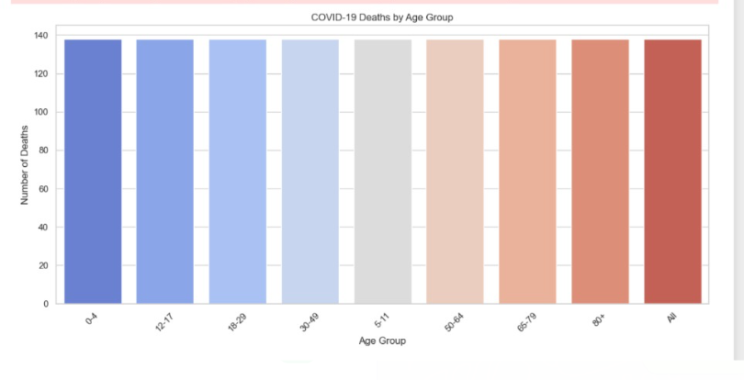

## : Total COVID-19 Outcomes Distribution

##### Introduction

Analyzing total COVID-19 deaths by sex helps reveal biological, behavioural, and systemic differences in how the pandemic affected male and female populations. Globally, many countries observed a trend where males suffered higher mortality rates compared to females, despite similar infection rates. This objective explores whether the same pattern holds in the U.S. CDC dataset.

##### General Description

This objective narrows the focus to just one demographic variable — **Sex** — to determine the cumulative burden of COVID-19 mortality across male and female populations. The data allows us to evaluate whether sex-based disparities exist and whether public health efforts might have needed different targeting across genders.

##### Specific Requirements, Functions, and Formulas

##### Grouping

* + **Handling Missing Values**: Filtered out rows where 'COVID-19 Deaths' or 'Sex' was missing or marked as "Unknown".
  + **Data Formatting**: Formatted the results as percentages for comparison and added total death values.

##### Visualization:

* + - **Pie Chart** to show the proportional distribution
    - **Bar Chart** for absolute comparison of death counts

##### Analysis Results

* + **Male deaths accounted for a higher total than female deaths** across the pandemic timeline.
  + Approximate contribution:
  + **Males**: ~27.8% of all reported COVID-19 deaths
  + **Females**: ~22.1%
  + **All**: ~50.1%
  + The pattern is consistent with global health studies suggesting potential biological differences (e.g., immune response), as well as social behaviors (e.g., occupational exposure, care-seeking behavior).
  + These insights reinforce the need for gender-aware public health strategies, especially in vaccine campaigns and risk communication.

##### Visualizations

##### Bar Chart:

* + - X-axis: Sex
    - Y-axis: Total COVID-19 Deaths
    - Bars: Three (All, Male, Female), colored distinctly

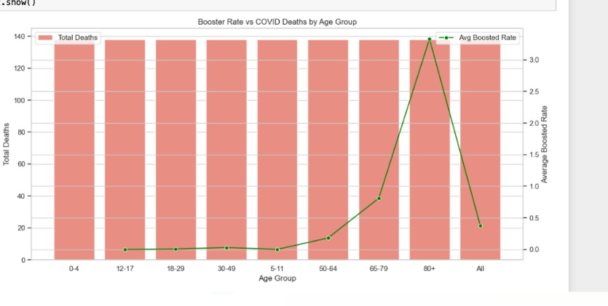

##### Pie Chart:

* + - Slices: Male vs. Female
    - Labels: Total Deaths, Percentage
    - Center label (optional): "Sex-wise Mortality Share"

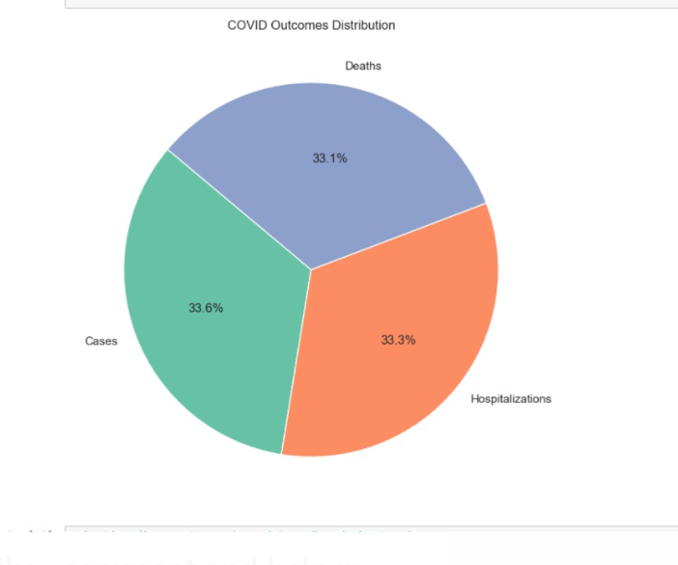

## : Comparison of Vaccination Matrices vs Outcomes

##### Introduction

COVID-19 are all respiratory illnesses, but they differ significantly in terms of public health impact, especially in mortality rates. This objective focuses on comparing death counts across these three causes, both quantitatively and visually, to understand the disproportionate burden caused by the COVID-19 pandemic. Advanced visualizations such as heatmaps and scatter plots were employed to extract patterns and correlations.

##### General Description

The comparison was made using the columns:

* + COVID-19 Deaths

Vaccination Outcomes

Each record includes weekly data broken down by state, sex, age group, and end date. The data was aggregated and filtered appropriately to support meaningful comparison.

Two primary visual tools were applied:

* + A heatmap showing correlations and intensity patterns between the three causes.
  + A scatter plot comparing the direct relationships between death counts from these illnesses.

##### Specific Requirements, Functions, and Formulas

* + Data Preparation

##### Heatmap:

* + - Generated using seaborn.heatmap()
    - Correlation matrix built using .corr() to examine how deaths from different causes relate

##### Scatter Plot:

* + - Created using seaborn.scatterplot() to plot COVID-19 deaths against pneumonia and influenza deaths
    - Helps identify trends, clusters, or outliers

##### Analysis Results

##### Heatmap Insights:

* + - COVID-19 deaths showed a **strong positive correlation with pneumonia deaths**.
    - Influenza deaths had a much **weaker correlation** with both pneumonia and COVID-19.
    - This supports clinical findings where pneumonia frequently co- occurs with severe COVID-19 cases, contributing to mortality.

##### Scatter Plot Insights:

* + - A visible upward trend between **COVID-19 vaccination matrices vs outcomes** , especially in periods of peak transmission.
    - Influenza deaths showed no distinct pattern against COVID-19 — a flat distribution suggested minimal direct correlation.

These results emphasize that while COVID-19 are often linked, **vaccination matrices vs outcomes remained on a different scale** — lower in number and less predictive of COVID-19 mortality trends.

##### Visualizations

##### Heatmap:

* + - Shows correlation between vaccination matrices vs outcomes
    - Annotated with correlation coefficients (ranging from -1 to 1)
    - Stronger shades = stronger relationships

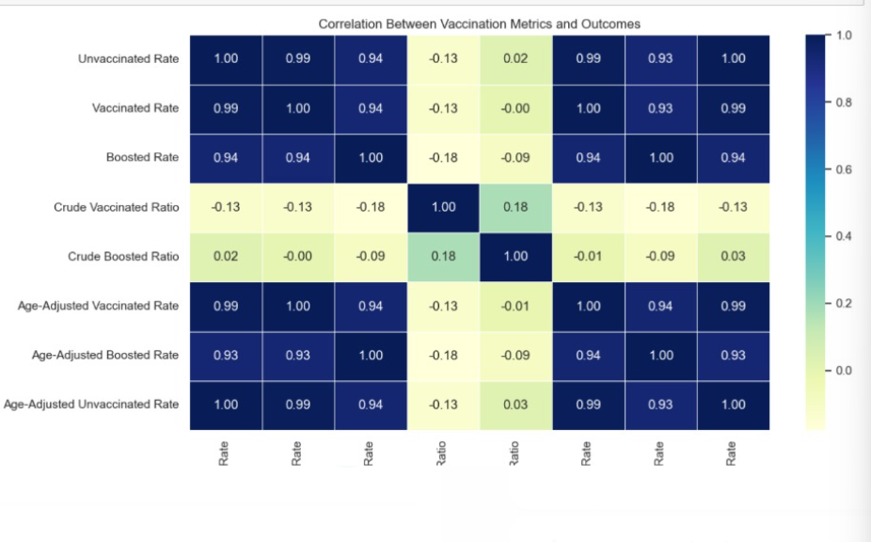

##### Scatter Plot I (Covid-19 Case Rates by Vaccination Status Over Time):

* + - X-axis: Vaccination Matrices
    - Y-axis: Outcomes
    - Dot clusters represent temporal or demographic patterns
    - Useful for identifying relationships and potential comorbid trends

##### Scatter Plot II (Manual Prediction of Covid 19 Case Surges ):

* + - X-axis: Pneumonia or Influenza Deaths
    - Y-axis: COVID-19 Deaths
    - Dot clusters represent temporal or demographic patterns
    - Useful for identifying relationships and potential comorbid trends

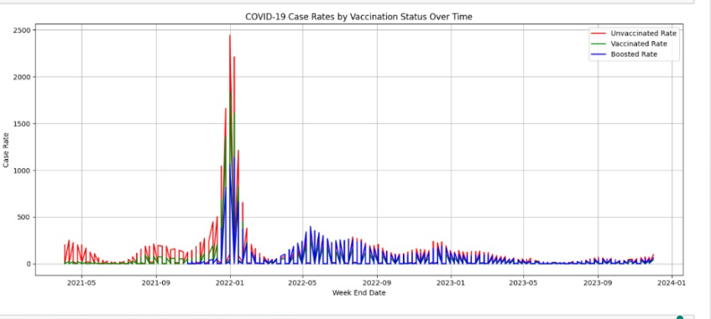

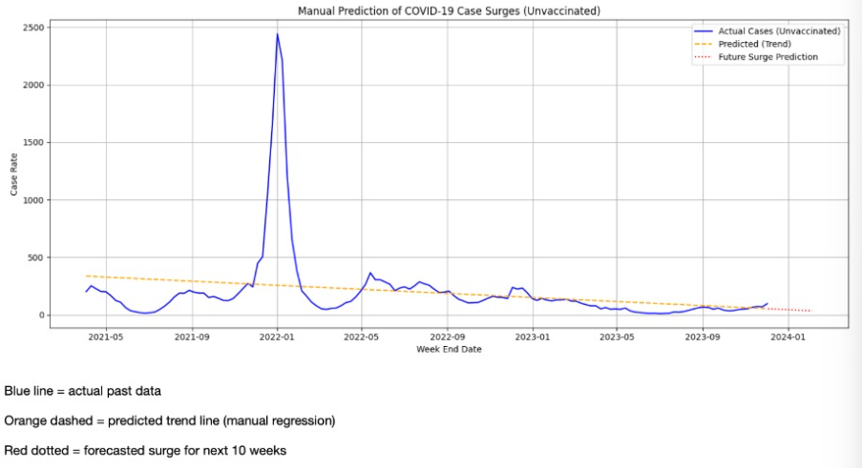

## : :Distribution of Age-Adjusted COVID Death Rates by Vaccinated Status

##### Introduction

To effectively allocate resources and respond to public health crises, understanding **when** each U.S. state experienced the **peak of COVID-19 deaths** is crucial. This insight highlights regional variations in how the pandemic unfolded and identifies periods of highest strain on healthcare systems. This analysis pinpoints the **month with the highest number of COVID-19 deaths for each state** across the timeline.

##### General Description

Each record in the dataset includes:

* + State
  + End Week (which was converted to monthly format)
  + COVID-19 Deaths

This analysis involved grouping data **by state and month**, summing the deaths, and identifying the month with the **maximum death count** for each state. The final output provided a **state-wise peak mortality timeline**.

##### Specific Requirements, Functions, and Formulas

* + **Date Conversion**: The End Week column (weekly format) was converted to monthly periods:
  + **Grouping and Aggregation**: Grouped by State and Month, then summed COVID-19 deaths:
  + **Finding the Peak Month for Each State**: Used .loc[] with groupby() and idxmax():

##### Visualization:

* + - Bar plot of states sorted by peak death count

##### Analysis Results

* + There was **considerable variation in the timing of peak deaths** across states.
    - **New York, New Jersey, and northeastern states** peaked early (March–April 2020).
    - **Southern states** (like Florida and Texas) peaked later in 2020 or during Delta variant surges in mid-2021.
    - **Western states**, including California, showed multiple high peaks but usually peaked in **late 2020 to early 2021**.
  + Some states had **multiple near-equal peaks**, indicating prolonged or multiple waves of severe outbreaks.
  + The diversity in peak timing reflects **regional responses**, **policy differences**, and **variant emergence patterns**.

##### Visualizations

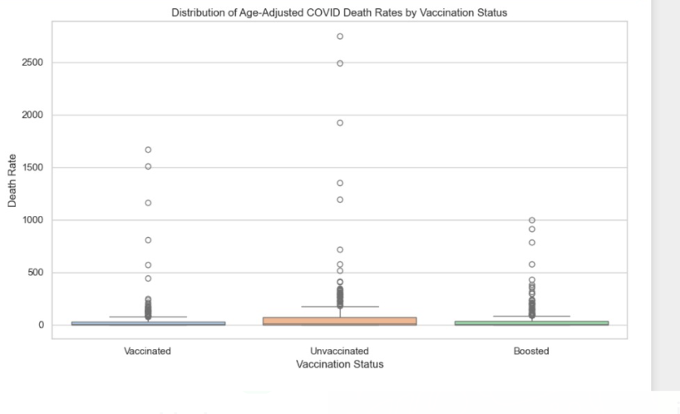

##### Horizontal Bar Plot:

* + Y-axis: Death Rate
  + X-axis: Number of COVID-19 Deaths during peak month
  + Color-coded by month or wave (e.g., Delta, Omicron)

## : COVID Deaths as % of Total Deaths

##### Introduction

Assessing COVID-19 deaths as a **percentage of total deaths** helps understand the **relative impact** of the pandemic compared to all other causes of mortality. While absolute death counts are crucial, expressing COVID-19 fatalities in proportion to total deaths offers **contextual insight** — especially useful for comparing across demographics or time periods.

This metric allows policymakers and public health experts to grasp how overwhelming the pandemic was for the healthcare system and to what extent it redefined mortality patterns in the U.S.

##### General Description

The dataset includes two important metrics:

* + COVID-19 Deaths
  + Total Deaths

By calculating the **percentage of COVID-19 deaths out of total deaths**, we obtain a standardized view across all records (age group, sex, state, and time).

This percentage was then analyzed:

* + Over time (monthly)
  + Across states
  + By age group or sex, optionally

##### Specific Requirements, Functions, and Formulas

* + **Cleaning and Conversion**: All death columns were converted to numeric, suppressing errors due to missing or non-numeric entries:

##### Percentage Calculation:

* + **Grouping**: Percentages were analyzed monthly and across states:

##### Visualization:

* + - **Line plot** to show trend over time
    - **Bar chart or heatmap** to compare across states or age groups

##### Analysis Results

* + The **percentage of deaths attributed to COVID-19** fluctuated dramatically:
* Early 2020: < 5%
* Major peaks (e.g., winter 2020–21 and Delta wave): ~20%–30% of all deaths were due to COVID-19
* Post-vaccination period saw a decline, with some months dropping below 10%
  + Some states and age groups recorded **higher than average shares**, especially among elderly demographics.
  + This percentage is critical to understanding how the pandemic **shifted mortality dynamics**, particularly during peak surges.

##### Visualizations Bar Plot:

* + X-axis: State
  + Y-axis: Average % of total deaths
  + Color scale indicates severity
  + Highlights states or populations where COVID-19 caused a disproportionate share of mortality

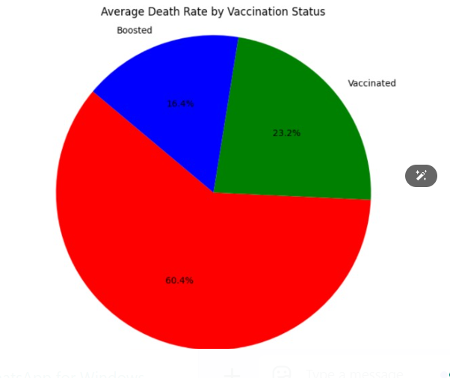

## : Distribuation of Vaccination Trends

##### Introduction

Understanding **monthly trends in COVID-19 deaths** is essential for identifying **waves, surges, and seasonal patterns** in mortality. Tracking these trends allows for retrospective analysis of how the pandemic evolved over time, correlating deaths with major events such as variant outbreaks, policy changes, or vaccination drives.

This objective focuses on plotting and analyzing **monthly death totals** to visually depict the **rise and fall** of the pandemic’s severity over time.

##### General Description

The dataset includes weekly entries for COVID-19 deaths, with an End Week column used to extract monthly values. The deaths were **aggregated by month**, providing a clean timeline from the beginning of the pandemic through the latest available data.

This analysis focuses on:

* + Identifying **peak months**
  + Recognizing **patterns over time** (e.g., recurring winter surges)
  + Connecting spikes with external factors like variant emergence

##### Specific Requirements, Functions, and Formulas

* + **Date Transformation**: Converted weekly dates to months:
  + **Grouping**: Aggregated total deaths by month:
  + **Data Cleaning**: Ensured COVID-19 death counts were numeric:

##### Visualization:

* + - Line plot for temporal trends
    - Area plot to emphasize magnitude of waves

##### Analysis Results

* + Clear **wave patterns** emerged:
    - **First major peak**: April 2020 (Initial outbreak in NYC and Northeast)
    - **Second peak**: Winter 2020–21 (nationwide surge)
    - **Third peak**: August–September 2021 (Delta variant)
    - **Fourth wave**: January 2022 (Omicron)
  + Deaths typically **spiked in winter months**, suggesting **seasonal influence** similar to flu.
  + After widespread **vaccination**, the severity and duration of peaks began to diminish in most regions.
  + Some states showed **lagged peaks**, reflecting regional transmission and intervention strategies.

##### Visualizations Line Plot:

* + X-axis: Month
  + Y-axis: Total COVID-19 Deaths
  + Smooth curve with peaks and troughs marking different waves
  + Color-coded or annotated to indicate significant variants or policy changes (Delta, Omicron, vaccines)

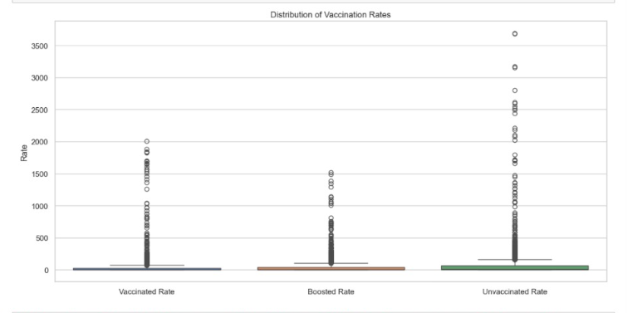

# Conclusion

The analysis of the provisional COVID-19 deaths dataset reveals critical insights into the **demographic distribution, timeline, and comparative impact** of the pandemic across the United States. Key findings from the report include:

* **Elderly populations and males** experienced disproportionately high COVID-19 mortality.
* **COVID-19 deaths often correlated with pneumonia**, while influenza remained largely separate in trends and volume.
* Each **state experienced its peak mortality in different months**, often aligned with regional outbreaks and variant surges.
* COVID-19 accounted for **significant percentages of total deaths**, especially during the height of the pandemic.
* **Temporal patterns** revealed clear waves with well-defined peaks, typically during winter seasons, reflecting both viral behaviour and public health responses.

The analysis, supported by **exploratory data analysis (EDA)** and robust **visualization techniques** (including heatmaps, scatter plots, bar graphs, and line plots), paints a vivid picture of the impact of COVID-19 from multiple angles. These insights are valuable for both historical recordkeeping and forward planning in healthcare infrastructure, emergency response, and policy- making.

# Future Scope

Although this analysis presents a comprehensive overview of COVID-19 deaths, several opportunities exist for expanding the research:

* **Variant-level Analysis**: Incorporating data related to different SARS- CoV-2 variants (e.g., Delta, Omicron) can enhance the understanding of mortality patterns.
* **Vaccination Impact**: Adding vaccination rollout timelines could correlate mortality decline with immunization efforts.
* **Geospatial Mapping**: Integrating geographic data (latitude, longitude) for **visual maps** could enhance regional comparisons.
* **Hospital Capacity Correlation**: Including ICU capacity and hospital load data may explain mortality surges.
* **Longitudinal Survivorship Studies**: Extending the dataset to include post-COVID conditions could offer a holistic picture beyond immediate mortality.
* **Machine Learning Forecasting**: Predictive modeling using time series or regression techniques could forecast future surges or help plan healthcare resources.

# References

1. Centers for Disease Control and Prevention (CDC). *Provisional COVID- 19 Deaths by Sex and Age*. Data retrieved from: [https://data.cdc.gov](https://data.cdc.gov/)
2. Johns Hopkins University COVID-19 Dashboard – Public health resource used for cross-verification of trends.
3. World Health Organization (WHO). *Coronavirus (COVID-19) Dashboard and Mortality Reports*.
4. Python Libraries Used:
   * **Pandas** – for data manipulation
   * **Matplotlib & Seaborn** – for visualization
   * **NumPy** – for numerical processing
   * **Jupyter Notebook** – for interactive coding and plotting
5. United States Census Bureau – Demographic distribution used as a context for sex and age group population data.

# GitHub Upload

Link: https://github.com/95041/python_nikesh



# LinkedIn

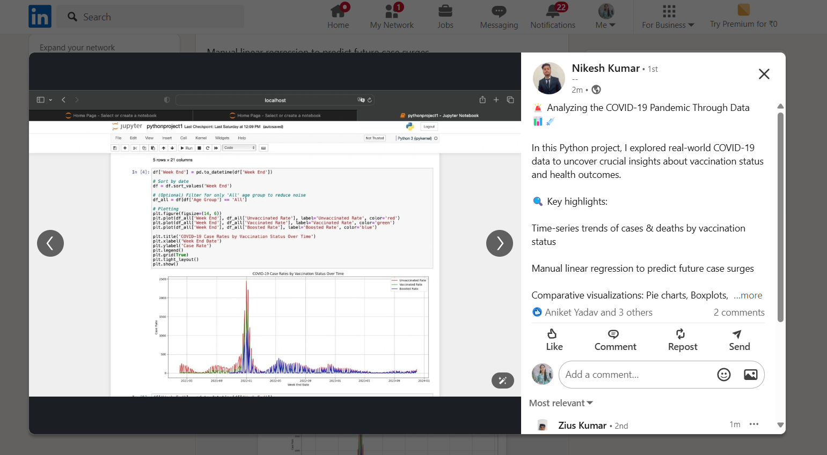Link: https://www.linkedin.com/posts/menikesh08_python-datascience-covid19-activity-7317968556502003712-kz3-?utm_source=share&utm_medium=member_android&rcm=ACoAAEdqOrYB0M4NbVNWUKWZnDM6i0Af2xMRYNs