-0.666756926920233 -2.66958392359893 -0.536580411420973 -0.605359376481941 -23.2068387775298 -8.06456018789760 -8.06903361571505 -1.75984921149724 -20.3537206094212 -0.542486937305666
-0.666756926920229 -2.66958392359892 0.536580411420974 0.605359376481943 -8.06903361571505 -1.75984921149724 -23.2068387775298 -8.06456018789759 -20.3537206094213 -0.542486937305668
0.470893620274872 1.91764862272194 -0.921046061995381 -1.07005602344185 35.4509325299552 12.0791016812271 -12.5130789503965 -3.79820070055546 -93.2285647401494 -2.02189003324512
0.470893620274865 1.91764862272192 0.921046061995377 1.07005602344185 -12.5130789503965 -3.79820070055548 35.4509325299551 12.0791016812271 -93.2285647401491 -2.02189003324512
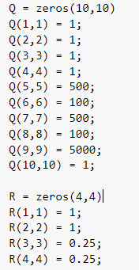
平步参数 25.58° 第51个参数
- Yaw有问题 旋转会发散
- 轮电机力矩很抖

-0.667772506103798 -3.39315030834621 -0.536580411420972 -0.605359376481941 -23.9215353576366 -8.12819072244725 -8.78373019582215 -1.82347974604689 -18.5837086126832 -0.533547435425051
-0.667772506103798 -3.39315030834622 0.536580411420971 0.605359376481941 -8.78373019582216 -1.82347974604689 -23.9215353576366 -8.12819072244725 -18.5837086126832 -0.533547435425053
0.465101623698945 2.39966555766642 -0.921046061995382 -1.07005602344185 36.1131657659871 12.1960333256291 -11.8508457143637 -3.68126905615344 -83.2631784669468 -1.95026748188818
0.465101623698953 2.39966555766646 0.921046061995382 1.07005602344186 -11.8508457143635 -3.68126905615338 36.1131657659871 12.1960333256292 -83.2631784669470 -1.95026748188818
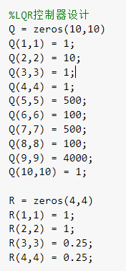 Q(9,9) pitch 惩罚给小 Q(2,2) 速度给大

-0.667289288284732 -2.67371965728097 -0.536580411420975 -0.605359376481942 -23.2812706261812 -8.09623212048822 -8.14346546436656 -1.79152114408788 -24.6409721958192 -0.574780243292859
-0.667289288284732 -2.67371965728097 0.536580411420973 0.605359376481943 -8.14346546436654 -1.79152114408787 -23.2812706261812 -8.09623212048823 -24.6409721958193 -0.574780243292860
0.467867527150456 1.90005123867558 -0.921046061995380 -1.07005602344186 35.0983275493432 11.9284120510013 -12.8656839310085 -3.94889033078134 -118.356812365256 -2.18436120421457
0.467867527150461 1.90005123867560 0.921046061995374 1.07005602344185 -12.8656839310084 -3.94889033078131 35.0983275493432 11.9284120510013 -118.356812365256 -2.18436120421456
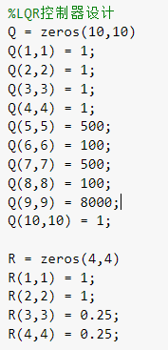 Q(9,9) pitch 惩罚给大

-0.667865844914558 -3.39659108545469 -1.72174815096550 -0.746797899505841 -23.8739355455603 -8.15230421586357 -9.04342859002098 -1.89039287537225 -24.6687883016700 -0.579939002223882
-0.667865844914564 -3.39659108545472 1.72174815096550 0.746797899505842 -9.04342859002102 -1.89039287537227 -23.8739355455604 -8.15230421586356 -24.6687883016700 -0.579939002223881
0.464565229850656 2.38826989497829 -2.85347739058635 -1.30423225304171 35.8781678591309 12.0172066915781 -12.6041624454644 -3.93104024338665 -118.337509430737 -2.18087111731740
0.464565229850668 2.38826989497834 2.85347739058634 1.30423225304171 -12.6041624454644 -3.93104024338662 35.8781678591309 12.0172066915781 -118.337509430737 -2.18087111731740
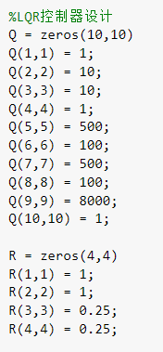 Pitch给大的情况下 速度和yaw给大

-0.669920873866524 -3.56703542553252 -1.71806810349271 -0.747148942167799 -27.8897263590145 -8.15265104219524 -9.33693082879887 -1.87437278704018 -20.4185857104402 -0.549552424224915
-0.669920873866526 -3.56703542553253 1.71806810349271 0.747148942167796 -9.33693082879896 -1.87437278704018 -27.8897263590145 -8.15265104219524 -20.4185857104402 -0.549552424224914
0.452574956257756 2.44187965852457 -2.86233610308851 -1.30343373427028 42.5325415510506 12.1963918280435 -14.6996989190552 -3.79032921533435 -93.1792488278421 -2.01746260125633
0.452574956257754 2.44187965852455 2.86233610308851 1.30343373427028 -14.6996989190552 -3.79032921533436 42.5325415510506 12.1963918280435 -93.1792488278419 -2.01746260125632
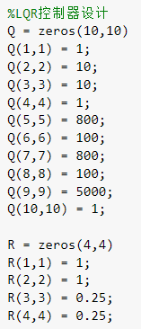Q（5，5）（7，7） 增大为800

