**总结**

**1.本目录下面包括所有大数据组件：**

**/opt/cloudera/parcels/CDH/lib/**

**Hdfs、Yarn、Zookeeper、Kafka、Hive、Flume、Spark、Sqoop、Oozie、Hue等**

**HDFS:**

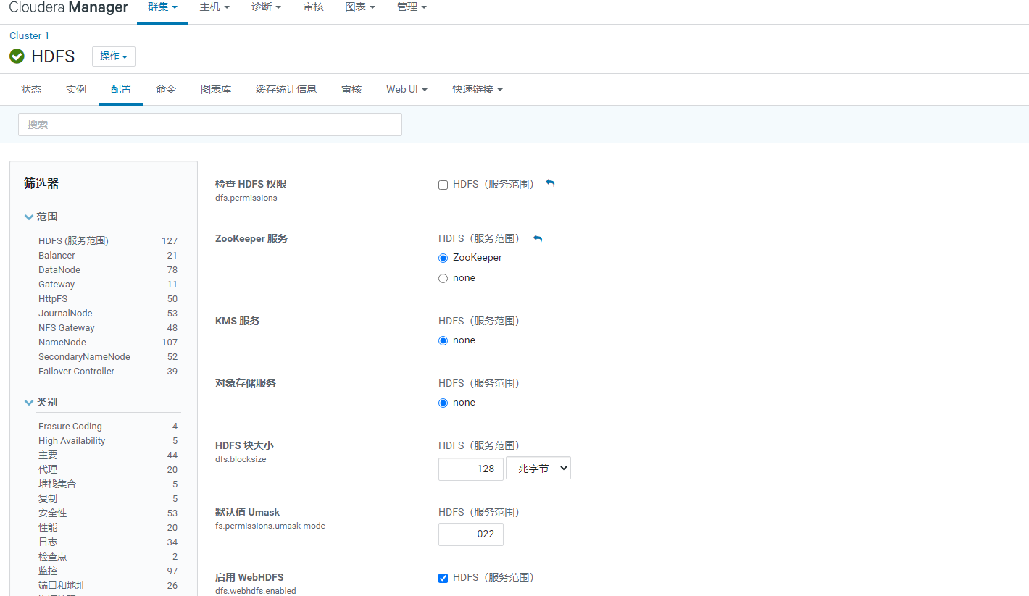

**每个组件的数据存储目录都可以在配置里面修改**

**dfs.datanode.data.dir 目录 /dfs/dn**

**dfs.journalnode.edits.dir 目录 /dfs/jn**

**dfs.nfs3.dump.dir 目录 /tmp/.hdfs-nfs**

**dfs.namenode.name.dir 目录 /dfs/nn**

**dfs.namenode.checkpoint.dir 目录 /dfs/snn**

**Kafka:**

**kafka的数据存储目录 /var/local/kafka/data**

1. **/var/log目录信息下面查看各个组件的报错日志**
2. **开发需要大数据平台的几个配置文件:**

**从/opt/cloudera/parcels/CDH/lib/hive/conf目录拷贝**

**core-site.xml、hdfs-site.xml、hive-site.xml**

1. **微服务部署方面:**

**每次服务器重启后需要重启:**

**/home/software/redis-3.2.1/src/redis-server &**

**/usr/local/nginx/sbin/nginx &**

**/home/software/start.sh 启动这个脚本即可**

1. **hadoop1:**

**flume启动命令**

**/home/flume-start.sh**

**Hadoop2:**

**flume启动命令**

**/home/flume-start.sh**

**6.断电后重启CDH：**

**Hadoop1：启动server**

**systemctl start cloudera-scm-server**

**查看状态:**

**systemctl status cloudera-scm-server**

**进入目录:**

**cd /var/log/cloudera-scm-server/**

**查看日志记录:**

**tail -F cloudera-scm-server.log**

**vi cloudera-scm-server.log**

**进入日志里面**

**Shift+G到最后一行**

**Hadoop1,Hadoop2,Hadoop3：启动agent**

**systemctl start cloudera-scm-agent**

**systemctl status cloudera-scm-agent**

**cd /var/log/cloudera-scm-agent/**

1. **flume的拦截器配置文件讲解:**

**a./opt/cloudera/parcels/CDH/lib/flume-ng/conf/mos-sink-flume.conf**

**flume采集mosquito的数据进入hadoop1的4141端口**

**b./opt/cloudera/parcels/CDH/lib/flume-ng/conf/flume-flume-kafka.conf**

**flume采集hadoop1的4141端口的数据进入hadoop1的kafka中**

**c./opt/cloudera/parcels/CDH/lib/flume-ng/conf/kafka-flume-kafka.properties**

**flume采集BI端的kafka数据进入hadoop2的kafka中,用到拦截器进行租户认证**

**d./opt/cloudera/parcels/CDH/lib/flume-ng/conf/kafka-sink-hdfs.conf**

**flume采集hadoop2的kafka中的数据进入hdfs,用到拦截器进行数据过滤,根据json数据的table名字作为hdfs的目录**

**{"table":"hive_meta_D7","factoryCode":"dhlk2","after":{"device_num":7,"temperature":0,"pressure":9,"ts":1.5913489430377672E9,"createtime":"2020-06-05 09:22:23","deviceId":"D7","create_time":"2020-06-05 9:22:23"}}**

1. **mosquito重启:**

**每次断电后,需要重启服务器,/home/mosquitto-1.5.1/src/ mosquitto &**