**UI Wireframe Review for University Ranking Analytics Startup**

Our startup would cater to prospective students and educational institutions. These consumers would use the application to make informed decisions based on their priorities. The web application would enable this functionality by letting the users personalize their respective pages through a series of selections and arrive at a “Decision Board” which would help them give a holistic picture as per their need. The different pages of our application and their functionalities are highlighted below.

1. **Landing Page**

The landing page for our application would require the user to select whether they are a Student or an Educational Institution through a selection panel. Using this input, we would direct them to the next appropriate page.



**FOR STUDENTS**

1. **Choice of location and Level of Education**

If the user is a Student, the application will direct the user to a page where they will need to select their preferred locations where they wish to pursue their education along with the degree they wish to pursue (Bachelors, Masters, PhD)

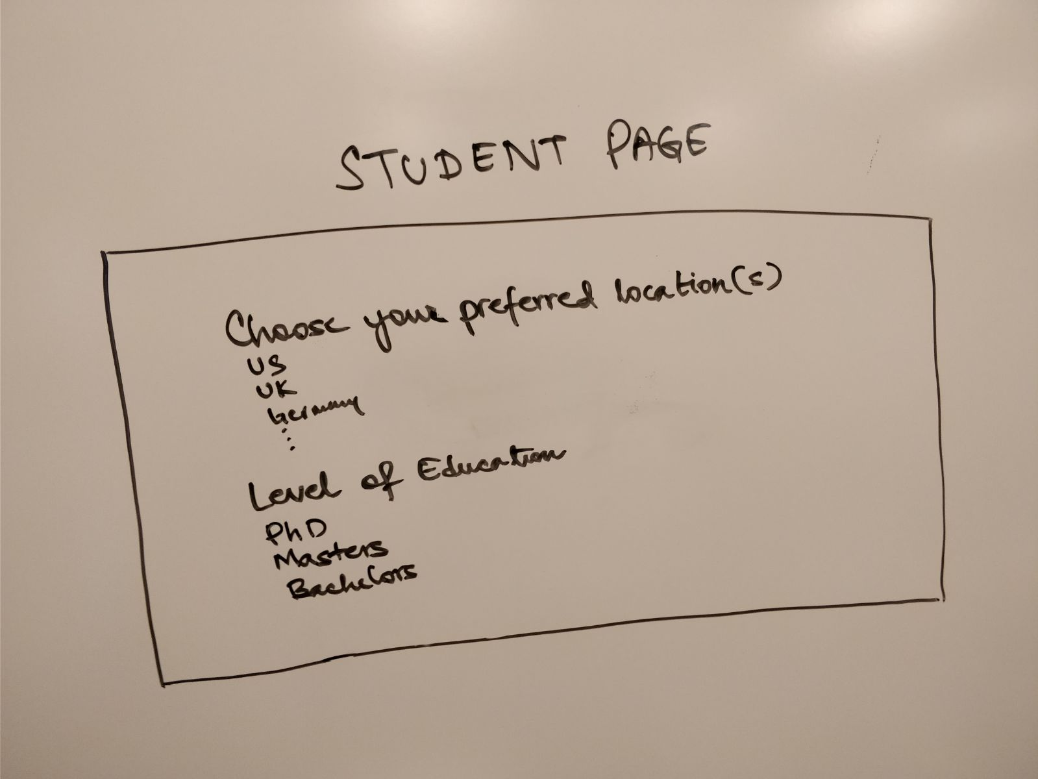

1. **Select the priority to give for different metrics**

Considering that different students have different priorities, our application will allow users to select the level of priority they would give to an attribute for college rankings. This selection will be on a scale of 1-5 which would be used later for creating a customized ranking for each user.

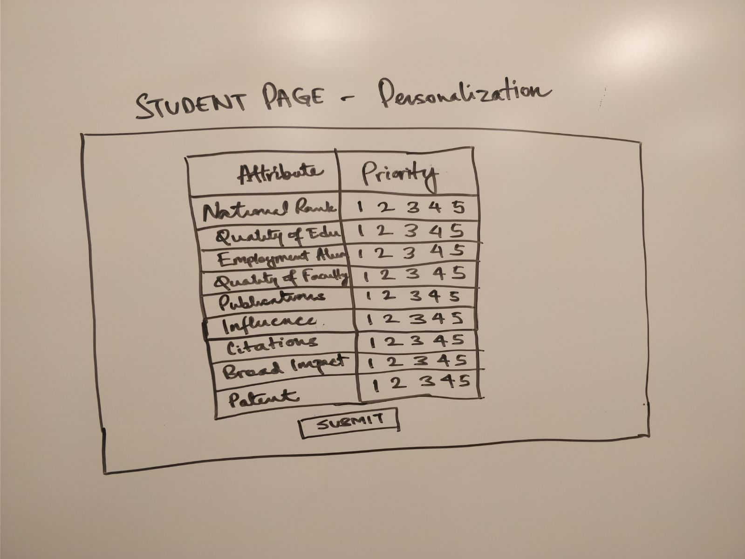

1. **Show College Rankings as per user specifications**

After the student selects the weightage he/she wants to give to different metrics, our application uses an algorithm to provide personalized results to the user. These results would be made available to the user in the form of a bar chart as well as a tabular representation. The user can switch between the two views through links provided at the bottom of each page.

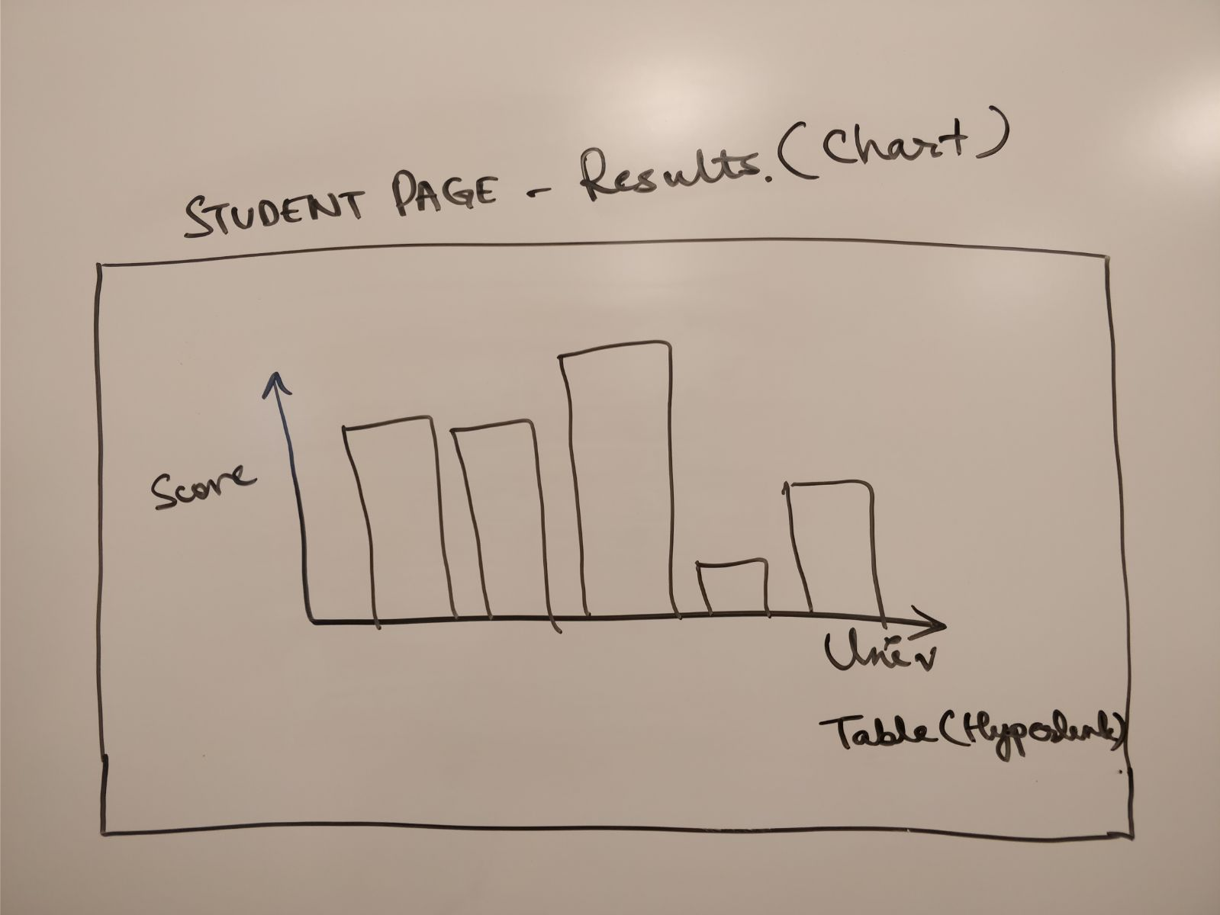

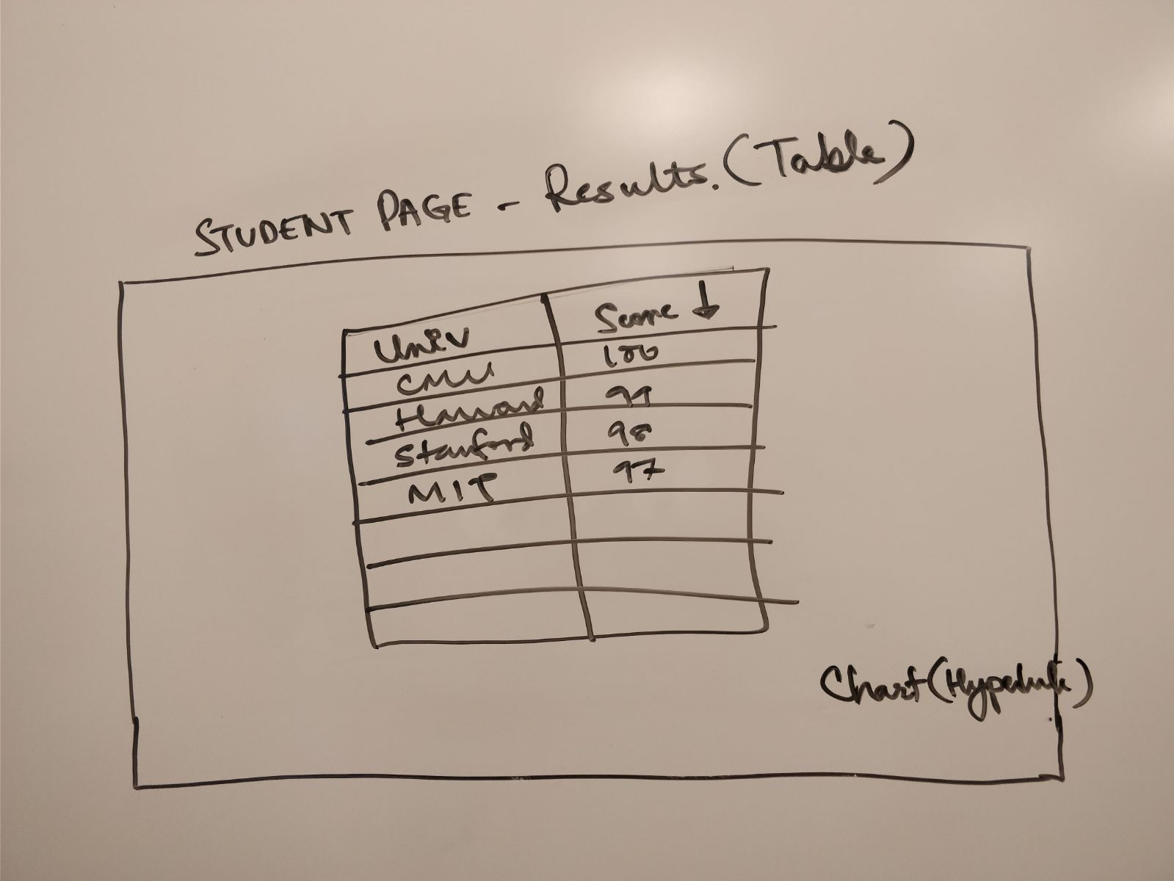

**EDUCATIONAL INSTITUTIONS**

If the user choses the option of “Educational Institution” on the landing page, the very next page displays the option of choosing the preferred “location”. Below is how the page will look like. This is used to segregate the universities based on locations.

1. Select Location

The educational institution will need to select the location of their interest and based on the location provided details of the respective colleges will be provided



1. **Results page**

On selecting the location, we split the next page into 4 sections which will rank colleges of the given location across National Rank, Employment, Quality of Education and Broad Impact. Seeing these results together would enable the institutions to make unbiased decisions.

