# A REPORT ON THE PROJECT

Diagnosis of injuries in lower limbs by segmentation from MRI of human leg muscles

# submitted by

**Student name(s) Exam seat no.(s)**

JADHAV SUKHADA SANJAY B120203076

MOHGAONKAR AVANI HEMANT B120203130

PORJE RENUKA SURESH B120203164

in partial fulfillment for the award of the degree of

# Bachelor of Engineering in ELECTRONICS AND

# TELECOMMUNICATION of SAVITRIBAI PHULE

# PUNE UNIVERSITY,

# 

# under the guidance of

**Prof. (Dr.) (Mrs.) Reena Kulsreshtha**

# Sponsored by : - Self

# M.K.S.S.S’s CUMMINS COLLEGE OF ENGINEERING FOR WOMEN, KARVENAGAR, PUNE – 411052 .

# 

**Academic year**

**2016 – 17**

a) Project title : - Diagnosis of injuries in lower limbs

by segmentation from MRI of human leg muscles.

b) Subject area : - Image Processing

c) Nature of the Project : - Software

This is to certify that

JADHAV SUKHADA SANJAY B120203076

MOHGAONKAR AVANI HEMANT B120203130

PORJE RENUKA SURESH B120203164

have successfully completed the work on their PROJECT TOPIC

**DIAGNOSIS OF INJURIES IN LOWER LIMBS BY SEGMENTATION FROM MRI OF HUMAN LEG MUSCLES**

in partial fulfillment for the award of the degree of

**Bachelor of Engineering in ELECTRONICS AND TELECOMMUNICATION**

**Of SAVITRIBAI PHULE PUNE UNIVERSITY,**

in

CUMMINSCOLLEGE OF ENGINEERING FOR WOMEN , KARVENAGAR ,

PUNE-52 .

**________________ _______________ ______________**

Internal Guide Head of the Department Principle

[Prof.(Dr.)(Mrs.)Reena [ Dr. Prachi Mukherji ] [Dr.(Mrs.)M.B.Khambete]

Kulsreshtha]

### **Acknowledgement**

We would like to express our sincere gratitude towards our project guide PROF.(Mrs.)(Dr.).Reena Kulshrestha for her constant encouragement and valuable guidance during the completion of this project work.

We would also like to thank PROF. PRACHI MUKHERJI for her continuous valuable guidance, support, valuable suggestions and her precious time in every possible way in spite of her busy schedule throughout our project activity.

We take this opportunity to express our sincere thanks to all the staff members of Electronics and Telecommunication Department for their help whenever required. Finally; we express our sincere thanks to all those who helped us directly or indirectly in many ways in completion of this project work.

JADHAV SUKHADA SANJAY B120203076

MOHGAONKAR AVANI HEMANT B120203130

PORJE RENUKA SURESH B120203164

**Abstract**

Medical imaging concerns the analysis and diagnosis of any image in MRI, CT scan or X-Ray format. Muscles injuries are found to be a condition which are diagnosed by MRI scans. The segmentation of leg muscles is carried out in approximately 20 hours manually. This causes the delay in the decision to perform surgery on the patient. An automated method is considered in which the region of interest of muscle images is segmented. The grade or intensity of the muscle tear is a critical diagnosis which is used for further surgical processes. The grade of the segmented image is checked for and then stored as an addition to the database. Then the MRI of new muscle injury is compared with the stored images and helps the surgeon in the pre-surgerical planning.

**Table of Contents**

1.Introduction……………………………………..………………….……………….9

2.Literature survey……………………………………………………………………11

2.1 Paper 1…………………………………………………………..11

2.2 Paper 2………………………………………………….….......12

2.3 Paper 3…………………………………………………………..11

2.4 Paper 4…………………………………………………….......12

3. Specification……………………………………………………………………….

4. Methodology..........................................................

5. Detailed design……………….…………………………………………………..13

5.1 Block diagram………………………………………………….

5.2 flowchart……………………

5.3 Algorithm………………………..

6.Application……………………………………………………………..…….........17

7.Conclusion…………………………………………………………..……………..18

8. Results …………………………………………………………………………....19

9.Future Work …………..………………………………………………….……….20

10. References………………………………………………………………….........21

List of Figures

1. Fig(1). Biomedical image processing……………………………………..11

2. Fig(2). Basic anatomy of lower limb………………………………………..18

3. Fig(3). Grading……………………………………..11

4. Fig(4). Grades………………………………………………..18

(4.1) Grade I…………………………………….

(4.2) Grade II…………………………………….

(4.3) Grade III…………………………………….

5. Fig(5). Block diagram of the system………………………………………..18

6. Fig(6). Flowchart………………………………………………..18

**List of Symbols, Abbreviations and Nomenclature**

1. MRI : Magnetic resonance imaging

2. MS : Multiple Sclerosis

3. HOG : Histogram of oriented gradients

### **1. Introduction**

**Medical imaging:**

Biomedical imaging concentrates on capturing of images for both diagnostic and therapeutic purposes. Biomedical imaging technologies utilize either x-rays (CT scans), sound (ultrasound), magnetism (MRI), radioactive pharmaceuticals (nuclear medicine: SPECT, PET) or light (endoscopy, OCT) to assess the current condition of an organ or tissue and can monitor a patient over time over time for diagnostic and treatment evaluation.

New imaging techniques bring new means for peering into the human body, helping to reduce the need for more invasive diagnostic and treatment procedures. It includes the analysis, enhancement and display of images captured via x-ray, ultrasound, MRI, nuclear medicine and optical imaging technologies.

Image processing software helps to automatically identify and analyze what might not be apparent to the human eye. Computerized algorithms can provide temporal and spatial analysis to detect patterns and characteristics indicative of tumours and other ailments. Depending on the imaging technique and what diagnosis is being considered, image processing and analysis can be used to determine the diameter, volume and vasculature of a tumour or organ.

**MRI Indications:**

Muscle disorders have a wide variety of causes, treatments, and prognoses. Given that the cause and severity of musculoskeletal disorders may be difficult to determine clinically, MRI commonly is used to target the location, severity, and extent of the pain generator. MRI is the imaging test of choice for evaluating muscle and tendon disorders.

**Basic anatomy of lower limb:**

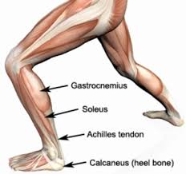

2. Fig(2). Basic anatomy of lower limb

**Diagnosis**

MRI facilitates the diagnostic process primarily by detecting alterations in muscle size or signal intensity. Although these alterations may be diagnostic in the appropriate clinical setting, a wide array of focal and systemic pathological conditions affecting muscle may have a similar appearance. Given that the potential causes for abnormal signal intensity in muscle are diverse, the differential diagnosis approach may be simplified by recognizing one of three basic patterns on MR images.

Three Basic Patterns of Abnormal Signal Intensity in Muscle

􀂾 The “muscle edema pattern” may be seen with recent trauma, as well as with subacute denervation, infectious or autoimmune myositis, rhabdomyolysis, vascular insult.

􀂾 The “fatty infiltration pattern” may be observed in the chronic setting after a high-grade myotendinous injury, as well as with other insults causing chronic muscle disuse or chronic denervation.

􀂾 The “mass lesion pattern” can be seen with traumatic injuries as well as with neoplasm, infection, and muscular sarcoidosis.

**Histogram of Oriented Gradients:**

Histogram of oriented gradients(HOG) descriptors, are feature descriptors used in computer vision and image processing for the purpose of object detection. The technique counts occurrences of gradient orientation in localized portions of an image.

**Euclidean distance:**

The Euclidean distance is the straight line distance between two pixels and is evaluated using Euclidean norm. Euclidean distance converts images into vectors according to gray levels of each pixel and then compares intensity differences pixel by pixel.

**Grading:**

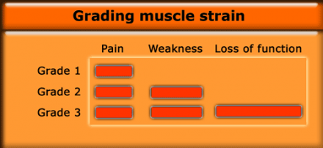

Fig(3). Grading

**Grading muscle strain:**

Clinically, the severity of a muscle injury is graded in terms of 1-3. Trying to grade a muscle injury by the signal intensity is tricky. Chronic injuries can show mild signal changes and yet still be high grade injuries according to the clinical classification.

Low grade muscle strain: On the left a low grade injury of the flexor hallucis longus. There is normal muscle architecture on the T1-weighted image, and increased signal on T2-weighted image and STIR. The injury will heal completely within a couple of weeks. This example shows edema with an epimysial pattern which is common around the flexor hallucis.

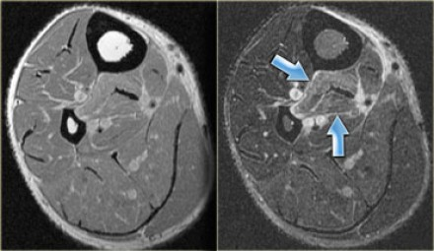

Fig(4.1). Grade I

Moderate grade muscle strain:

On the left the same patient. There is also a moderate grade injury to the medial head. Note the fluid accumulations around the muscle head. The more fluid, the higher the grade.

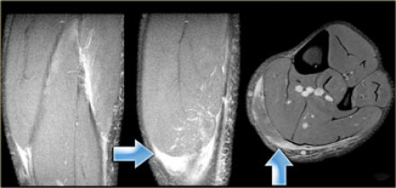

Fig(4.2). Grade II

On the left an example of a tear in the left pectoral muscle.  On T1-weighted image there is a gap in the muscle with a small amount of fat filling it up. 

The gradient echo demonstrates focal fluid accumulation and some increased signal within the muscle. It does not look that severe. However, when asked to fully contract the pectoral muscles there is an obvious asymmetry due to a complete tear in the muscle (blue arrow).   
This clinically is a grade 3 injury, with a complete loss of function of the muscle.

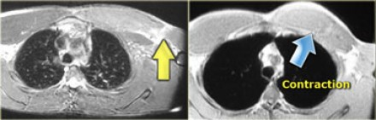

Fig(4.3). Grade III

### **2. Literature survey**

**2.1 PAPER 1**

3D-To-2D Mapping For User Interactive Segmentation Of Human Leg Muscles From MRI Data:

Nilanjan Ray1, Satarupa Mukherjee1, Krishna Kanth Nakka1, Scott T. Acton2, 3Silvia S. Blemker 3; 1 Computing Science, University of Alberta, Canada 2Dept. of Electrical & Computer Engineering, University of Virginia, USA 3Dept. of Biomedical Engineering, University of Virginia, USA;” 3D-To-2D Mapping For User Interactive Segmentation Of Human Leg Muscles From MRI Data”; IEEE transaction paper.

***Abstract:***

The automated computation of muscle volume from MRI of human legs is an open problem in the biomedical imaging community. Such automation has the potential to provide an objective measure of effectiveness of pre- and post surgery treatments. In this paper, we take a step toward automation by proposing a framework for user interactive segmentation of MRI of human leg muscles. After the first few tedious segmentation results are achieved, and once a small database of segmented muscles is built, user interaction is reduced. Further, as the database of segmented muscles grows, the user interaction becomes more efficient. At the heart of this proposed framework is a simple, computationally attractive 3D representation of muscles. By a generalized cylinder model, were present a 3D human leg muscle by two smooth 2D images, which enables application of 2D image processing and analysis methods in this complex multi-segment 3D problem. The smoothness of a leg muscle is modeled by the smoothness of the 2D images. Interdependence and relative positions of leg muscles are represented by a linear combination (basically, convolutions) of such 2D images.

We demonstrate that fitting and editing of these models during user interactive segmentation of MRI data are computationally efficient, because our linear interaction model can be represented in the Fourier domain.

**2.2 PAPER 2**

Detection of facial expression based on Morphological Face features and Minimum distance classifier:

Kenz Ahmed Bozed, Department of computer system design, Faculty of Information Technology, University of Benghazi,P.O.Box : 1308, Benghazi, Libya ,Osei Adjei, Ali Mansour, Department of Computer Science and Technology, University of Bedfordshire Park Square, Luton, LU1 3JU, UK.

***Abstract:***

A facial expression is one of the non-verbal information that plays an important role in understanding face-to-face communications. Therefore, facial expressions are the most important means of detecting emotions and behavioral analysis science. Although human being have ability recognize the face practically without any effort, but facial recognition system is still challenging by machine. This paper addresses the problem of detecting facial expressions of the human face through the analysis of images and subsequent application to video sequences. This work concentrates on the design of a facial expression detection system used to recognize facial emotions by focusing on the analysis of still images based on Morphological features and Minimum Distance Classifier (MDC) for classification.

**2.3 PAPER 3**

Robust Face Recognition by Computing Distances from Multiple Histograms of Oriented Gradients:

Mahir Faik Karaaba, Olarik Surinta, Lambert Schomaker and Marco A. Wiering Institute of Artificial Intelligence and Cognitive Engineering (ALICE), University of Groningen, Nijenborgh 9, Groningen, The Netherlands

***Abstract:***

The Single Sample per Person Problem is a challenging problem for face recognition algorithms. Patch-based methods have obtained some promising results for this problem. In this paper, we propose a new face recognition algorithm that is based on a combination of different histograms of oriented gradients (HOG) which we call Multi-HOG. Each member of Multi-HOG is a HOG patch that belongs to a grid structure. To recognize faces, we create a vector of distances computed by comparing train and test face images. After this, a distance calculation method is employed to calculate the final distance value between a test and a reference image. We describe here two distance calculation methods: mean of minimum distances (MMD) and a multi-layer perceptron based distance (MLPD) method.

To cope with aligning difficulties, we also propose another technique that finds the most similar regions for two compared images. We call it the most similar region selection algorithm (MSRS). The regions found by MSRS are given to the algorithms we proposed. Our results show that, while MMD and MLPD contribute to obtaining much higher accuracies than the use of a single histogram of oriented gradients, combining them with the most similar region selection algorithm results in state-of-the-art performances.

**2.4 PAPER 4**

Segmentation of Multiple Sclerosis Lesions in Intensity Corrected Multispectral MRI:

B. Johnston,M. **S.** Atkins," B. Mackiewich, *Member, IEEE,* and M. Anderson;” Segmentation of Multide Sclerosis Lesions in Intensity Corrected Multispectral MRI”; IEEE TRANSACTIONS ON MEDICAL IMAGING, VOL. 15, NO. 2, APRIL 1996

***Abstract:***

To segment brain tissues in magnetic resonance images of the brain, we have implemented a stochastic relaxation method which utilizes partial volume analysis for every brain voxel, and operates on fully three-dimensional (3-D) data. However, there are still problems with automatically or semi-automatically segmenting thick magnetic resonance (MR)slices, particularly when trying to segment the small lesions present in MR images of multiple sclerosis patients. To improve lesion segmentation we have extended our method of stochastic relaxation by both pre- and post-processing the MR images. The preprocessing step involves image enhancement using homomorphic filtering to correct for non homogeneities in the coil and magnet. Because approximately 95% of all multiple sclerosis lesions occur in the white matter of the brain, the post processing step involves application of morphological processing and

thresholding techniques to the intermediate segmentation in order to develop a mask image containing only white matter and Multiple Sclerosis (MS) lesion. This white lesion masked image is then segmented by again applying our stochastic relaxation technique.

The process has been applied to multispectral MRI scans of multiple sclerosis patients and the results compare favorably to manual segmentations of the same scans obtained independently by radiology health professionals.

**3. Specifications**

(1) Parameters:

INPUT required to the system : 2D slices of a 3D image (MRI).

OUTPUT of the system : Rupture detection or addition to database.

(2) Size of the image

Size of every sliced image : 8-16 bits

(3) Type of the image : Monochrome

(4) Accuracy : Improves with the size of the image.

**4. Methodology**

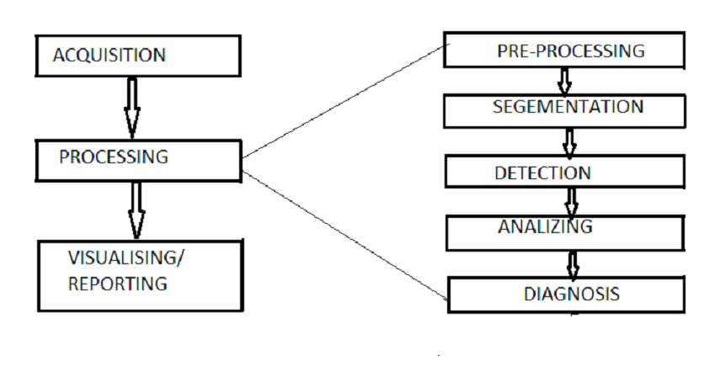

Fig(1). Biomedical image processing

The main aim of this project is to analyze a MRI sample of the lower limb and check for an injury and give the corresponding grade of injury. This is achieved by various functions executed on the input MRI image step by step. The image acquired firstly undergoes the function of preprocessing which includes converting image in gray scale format enhancing the image, noise filtration, edge detection, total black and white pixel distribution and segmentation of the image.

For further processing the image is sliced into 3 parts namely-X, Y and Z. These parts are analyzed individual to check the error in the image is analyzed and is compared with a trainer kit that contains the information or conditions to detect the errors. Then the Euclidean distance is calculated and the values are matched with trainer file values to check if the input sliced image contains an error or is a normal condition. The same procedure is executed for the second and third sliced part of the image. Once the error has been detected, the corresponding slice of the image is displayed and the results of all 3 slices of image in terms of normal or abnormal conditions is shown.

Further the image containing error is compared with an already existing database of previous MRI images which are also present in sliced format. Incase of image already being present in the database, the grade (3 grades) or depth of injury is displayed. However, if the image is not present, further analysis is carried out to obtain the grade of the image.

Grading, gives the extent of severity of the injury according to which the next treatment processes can be executed.

### **5. Detail Design**

### **5.1 Block diagram**

### **BLOCKDIAGRAM.png** Fig(5). Block diagram of system

### **5.2 Flowchart:**

### FLOWCHART.png

Fig(6). Flowchart

### **5.3 Algorithm**

### 1. Read MRI image

### 2. Divide each image into 3 parts depending on number of pixels vertically

### 3. Classify the parts as namely X,Y and Z

### 4. Identify the part which has injury present

### 5. If injury is not present display image as normal and go to 7

### 6. Display the corresponding image with the abnormal part

### 7. Compare this image with database

### 8. If match is found then go to step 11

### 9. If match is not found go to step 9

### 10. Detect the corresponding grade of injury

### 11. Store this in database

### 12. Display corresponding results

### **6. Applications**

### 

### (1) Effectively used for guidance and localization of injuries in leg muscles

### (2) Magnetic resonance imaging (MRI) include its non-invasiveness, portability, and lack of ionizing radiation.

### (3)Identification of structural changes within tissues and joints

### **7. Results**

1. Diagnosis of any rupture or injury in the leg muscles.

2. Addition to the database, if non-existent MRI is presented.

3. Predictability of sensitivity or damage to the muscles.

4. Overall reduction the diagnosis time.

5. Detection of section of muscle which has injury.

6. Detection grade of the muscle tear/injury.

For demonstration purpose, we have taken two MRI’s, one which is normal(with no injuries) and an abnormal one. Photographs of of module wise test results are presented below.

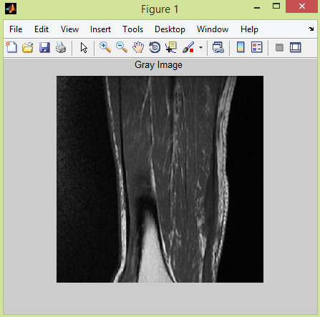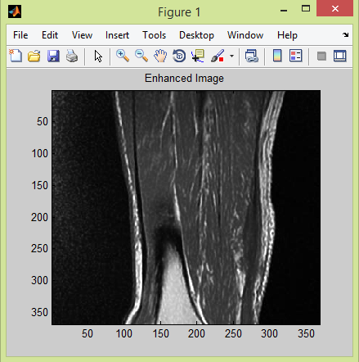

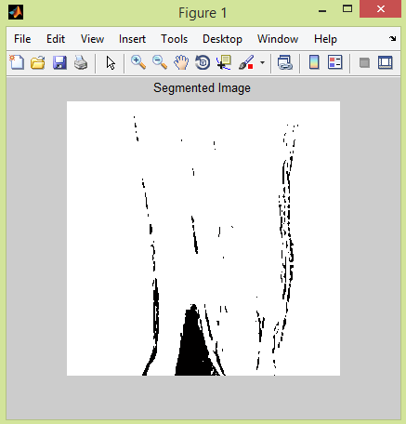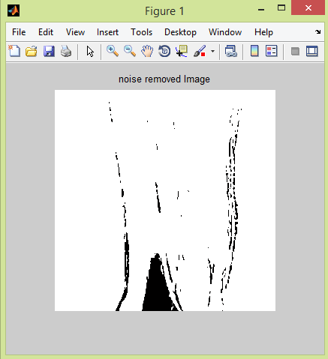

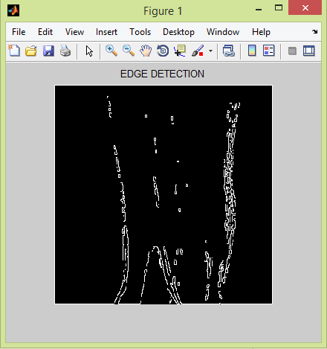 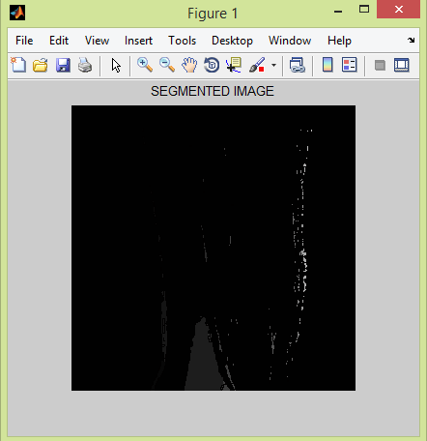

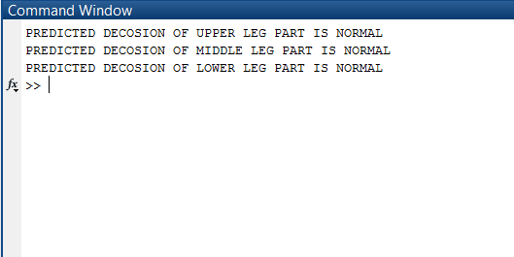

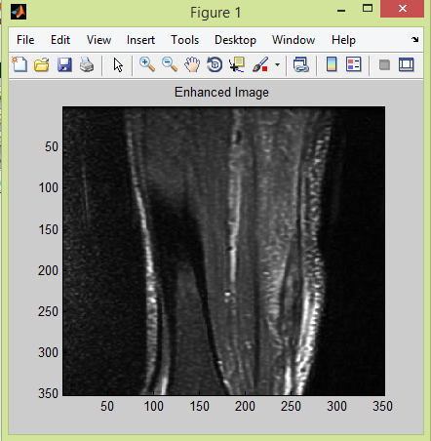 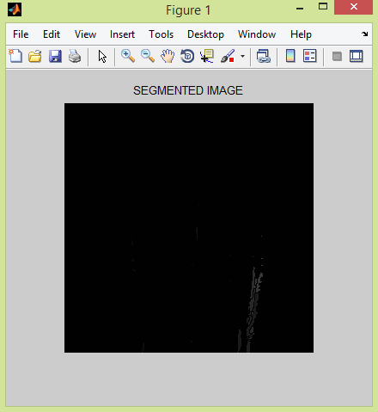

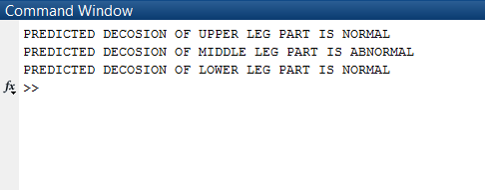

### **8. Conclusion**

*PROs:*

(1)An important goal has been achieved by using this time efficient technique:

It is used to provide affordable medical services to the patients and medical institutes who cannot afford highly expensive medical techniques and instruments to diagnose several injuries and damages.

(2)MRI has high sensitivity and low specificity. It is found more accurate than the mammography and ultrasound imaging.

(3)Satisfactory segmentation results are achieved by user interactive segmentation.

(4)Technique needs no external intervention and yields results very close to those obtained by doctor following manual segmentations.

*CONs:*

(1)Poor quality of image poses bigger challenges, since it could affect the decision making process.

(2)High noise levels, low contrast, poor resolution, etc. are some other factors causing problems in medical image processing.

### **9. Future scope**

(1)Here in this proposed project, muscles are taken into consideration. This could further be improved by considering bones as well. Detection of abnormalities in bones from an MRI would prove to be very helpful and can make this project more efficient.

(2) Project can be extended to also detecting injuries in the upper limbs well.

(3) User-interactive segmentation module can be improved by adding the number of tools in it. This will make it more convenient for the user.

(4) Bio-medical segmentation algorithms implemented in this project can be further worked on to reduce time and simultaneously increase accuracy.

**10. References**

[1]http://proceedings.spiedigitallibrary.org/proceeding.aspx?articleid=1847450

[2] https://www.hindawi.com/journals/cmmm/2015/450341/

[3] Nilanjan Ray1, Satarupa Mukherjee1, Krishna Kanth Nakka1, Scott T. Acton2,3Silvia S. Blemker3 ;1 Computing Science, University of Alberta, Canada2Dept. of Electrical & Computer Engineering, University of Virginia, USA3Dept. of Biomedical Engineering, University of Virginia, USA; ”3D-To-2D Mapping For User Interactive Segmentation Of Human Leg Muscles From MRI Data”;IEEE transaction.

[4] B. Johnston, M. **S.** Atkins," B. Mackiewich, *Member, IEEE,* and M. Anderson;” Segmentation of Multide Sclerosis Lesions in Intensity Corrected Multispectral MRI”;IEEE TRANSACTIONS ON MEDICAL IMAGING, VOL. 15, NO. 2, APRIL 1996

[5] Matthew C. Clark, Lawrence O. Hall,* Member, IEEE, Dmitry B. Goldgof, Senior Member, IEEE, Robert Velthuizen, Associate Member, IEEE, F. Reed Murtagh, and Martin S.Silbiger;“Automatic Tumor Segmentation Using Knowledge-Based Techniques”; IEEE TRANSACTIONS ON MEDICAL IMAGING, VOL. 17, NO. 2, APRIL 1998

[6] May DA, et al. Abnormal Signal Intensity in Skeletal Muscle at MR Imaging: Patterns, Pearls, and Pitfalls. RadioGraphics

2000; 20:295S.

Weishaupt D, et al. Injuries to the Distal Gastrocnemius Muscle: MR Findings. JCAT 2001; 25:677.

[7] <https://www.ncbi.nlm.nih.gov/pubmed/20486025>

[8] <https://www.ncbi.nlm.nih.gov/pubmed/12118828>

[9][https://www.embs.org/about-biomedical-engineering/our-areas-of- research/biomedical-imaging-image-processing/](https://www.embs.org/about-biomedical-engineering/our-areas-of-%20%20research/biomedical-imaging-image-processing/)

### Appendices

**Contents to be included : -**

a) Tables

b) Proofs

c) Test cases

e) Data sheets of Significant components ONLY .

d) USER MANUAL : - A SIMPLE STEP- BY-STEP

PROCEDURE for demonstrating

the working of the Project

set-up , should be given .

( A VIDEO file showing the

same should be submitted

alongwith the Soft-copy of the

Report.

Applicable ONLY for

SELF –Sponsored &

COLLEGE-Sponsored Projects.)

**In case of Hardware** Projects the

instructions should **begin from**

**the POWER – ON step**.

**In case of Software projects**

the instructions should **begin**

**from the step mentioning**

**the location and name of the**

**.exe file to OPEN the GUI , if**

**any or any other applicable**

**.exe file .**