**­­­­­­**A

Project Synopsis

On

**Gro-Field: Plant suggestion, fertilizer recommendation and leaf disease detection system**

*For the Degree of*

**Bachelor of Technology**

*In*

**Computer Science and Engineering**

*Submitted by*

**2019BTECS00014 Siddhi Lokhande**

**2019BTECS00027 Shrutika Adhav**

**2019BTECS00049 Bhavika Ghadage**

**2019BTECS00095 Vaishnavi Daware**

*Under the Guidance of*

**Prof. Pooja Mundada**

**Assistant Professor, WCE Sangli**



**Department of Computer Science and Engineering,**

**Walchand College of Engineering, Sangli.**

Synopsis Approval

The project synopsis report entitled “**Gro-Field: Plant suggestion, fertilizer recommendation and leaf disease detection system”** submitted by

**2019BTECS00014 Siddhi Lokhande**

**2019BTECS00027 Shrutika Adhav**

**2019BTECS00049 Bhavika Ghadage**

**2019BTECS00095 Vaishnavi Daware**

in partial fulfillment of the requirement for the degree of “***Bachelor of Technology*** *(****Computer Science and Engineering*)”** is reviewed by panel and approved as the Mega Project work for degree of Bachelor of Technology during the academic year ***2022-23***.

|  |  |  |
| --- | --- | --- |
| **Prof. Pooja Mundada**  Guide | **Prof Dr. Nitin Gavankar**  Panel Member | **Prof. Anil Surve**  Panel Member |

|  |
| --- |
| **Mrs. Dr. M. A. Shah**  Head  Department of Computer Science and Engineering |

**1. Problem Statement**

“To build an application that suggest crops, recommend fertilizers and detect leaf disease using machine learning and deep learning paradigm to leverage the agriculture capacities”

**2. Introduction**

Precision agriculture is in trend nowadays. Precision agriculture is a modern farming technique that uses the data of soil characteristics, soil types, crop yield data, weather conditions and suggests the farmers with the most optimal crop to grow in their farms for maximum yield and profit. This technique can reduce the crop failures and will help the farmers to take informed decision about their farming strategy.

**3. Motivation**

In order to mitigate the agrarian crisis in the current status quo, there is a need for better recommendation systems to alleviate the crisis by helping the farmers to make an informed decision before starting the cultivation of crops.

Half the question of right harvest is solved with right crop sowing. The second issue comes of the right nutrition. For that a fertilizer recommendation system is being built.

Getting rid of the pests has always remained a task in farming. But the first step to it is the correct identification of the disease, thus the idea of disease detection system

**4. Significance**

One of its kind of application that not only recommends the crops but also the appropriate fertilizers for the crop. The application also helps in detecting the leaf diseases.

**5. Literature Survey**

Paper [1] presents classification and detection techniques that can be used for plant leaf disease classification. Here pre-process is done before feature extraction. RGB images are converted into white and then converted into grey level image to extract the image of vein from each leaf. Then basic Morphological functions are applied on the image. Then the image is converted into binary image. After that if binary pixel value is 0 its converted to corresponding RGB image value. Finally by using pearson correlation and Dominating feature set and Naïve Bayesian classifier disease is detected.

In paper [2] there are four steps. Out of them the first one is gathering image from several part of the country for training and testing. Second part is applying Gaussian filter is used to remove all the noise and thresholding is done to get the all green color component. K-means clustering is used for segmentation. All RGB images are converted into HSV for extracting feature.

In paper [3] detection of unhealthy plant leaves include some steps are RGB image acquisition. Converting the input image from RGB to HSI format. Masking and removing the green pixels. Segment the components using Ostu’s method. Computing the texture features using color-co-occurrence methodology and finally classifying the disease using Genetic Algorithm.

Paper [4] includes tomato disease detection using computer vision. A gray scale image is turned into binary image depending on threshold value. The threshold algorithm is used for image segmentation. The threshold values are given color indices like red, green, blue. But the thresholding is not a reliable method as this technique only distinguishes red tomatoes from other colors. It becomes difficult to distinguish ripe and unripe tomatoes. For this K-means clustering algorithm is used to overcome the drawbacks. K-means create a particular number of non-hierarchical clusters. This method is numerical, unsupervised, non-deterministic and iterative. Then separating the infected parts from the leaf, the RGB image was converted into YcbCr to enhance the feature of the image. The final step is the calculation of the percentage of infection and distinguishing the ripe and unripe tomatoes.

The methodology for cucumber disease detection is presented in paper [5]. The methodology includes image acquisition, image pre-processing, feature extraction with gray level co-occurrence matrix (GLCM) and finally classified with two types: Unsupervised classification and supervised classification.

In paper [6] image processing technique are used to detect the citrus leaf disease. This system includes: Image pre-processing, segmentation of the leaf using K-means clustering to determine the diseased areas, feature extraction and classification of disease. Uses Gray-Level Co-Occurrence matrix (GLCM) for feature extraction and classification is done using support vector machine (SVM).

**6. Objectives**

Following are the objectives of the proposed dissertation work:

1. To study and analyze different ML and Deep learning algorithms
2. Apply the studied ML algorithms to accurately suggest crops and recommend

appropriate fertilizers for the same

1. Use studied Deep learning algorithms to detect the leaf diseases

**7. Methodology**

**a. Crop Suggestion and Fertilizer Recommendation**

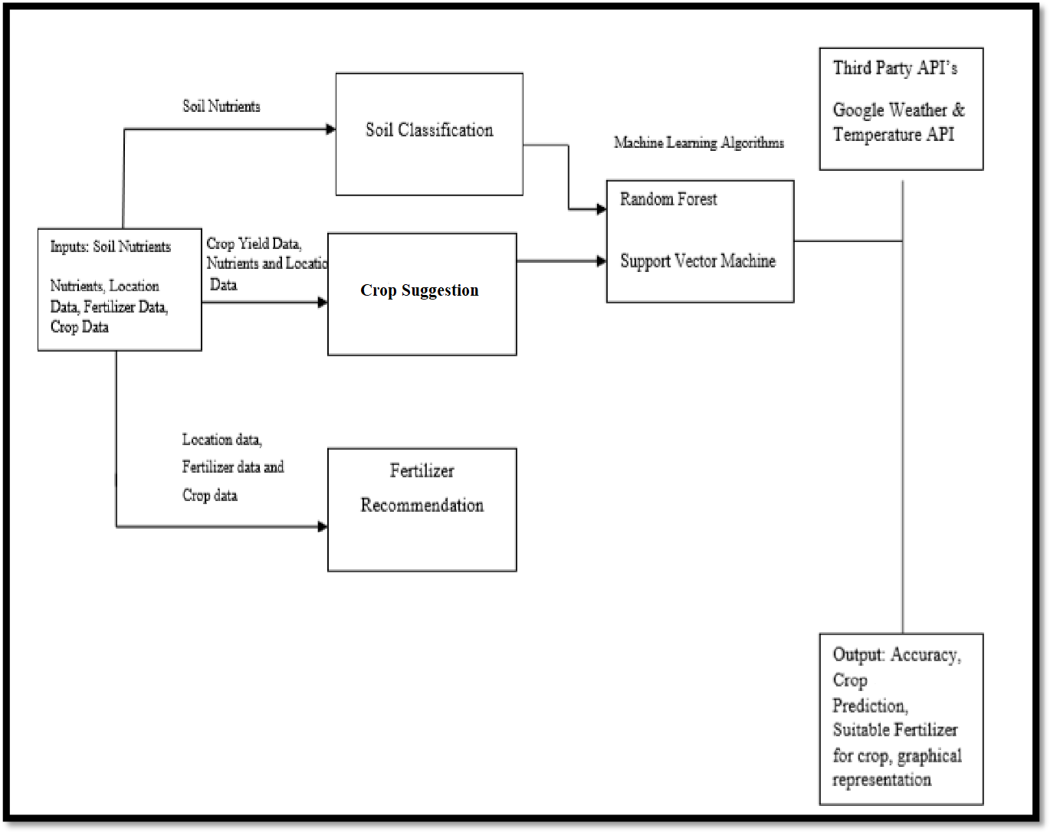

* From the inputs i.e soil nutrient contents , the soil shall be classified as mineral rich or deficient.The soil parameters and the weather information will be used to suggest the appropriate crops.
* Similarly for fertilizer suggestion, the type of crop and the soil nutrients will be used for rule-based fertilizer recommendation.

**b. Leaf Disease Detection**

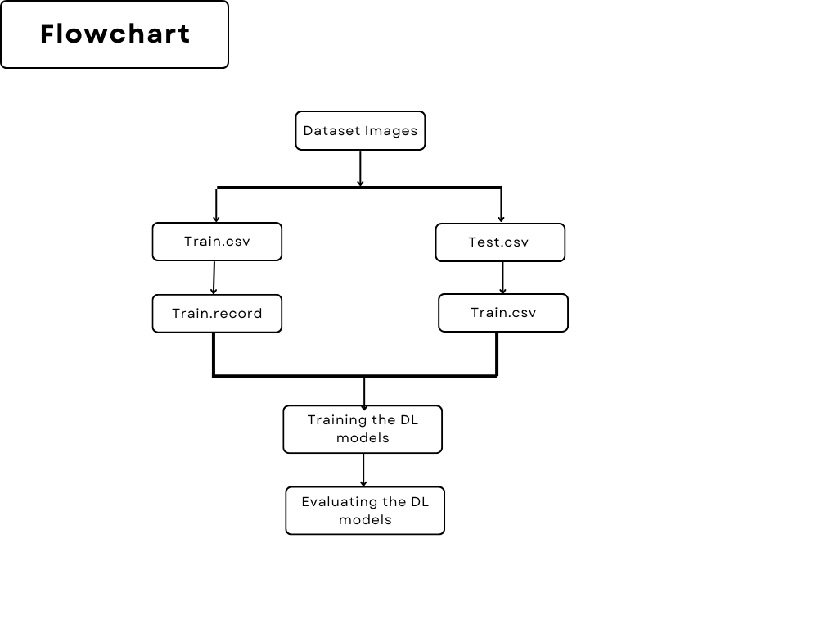

* The procured dataset shall be divided into training and testing subsets
* This would be followed by training the deep learning model using ResNet architecture.
* The result will be the class of disease and remedies for the same.

**8. Hardware / Software Requirement**

* Python Libraries: NumPy, Pandas, Matplotlib, Scikit-learn , PyTorch
* Web Tech Stack: MERN
* Deployment: Heroku

**9. Schedule**

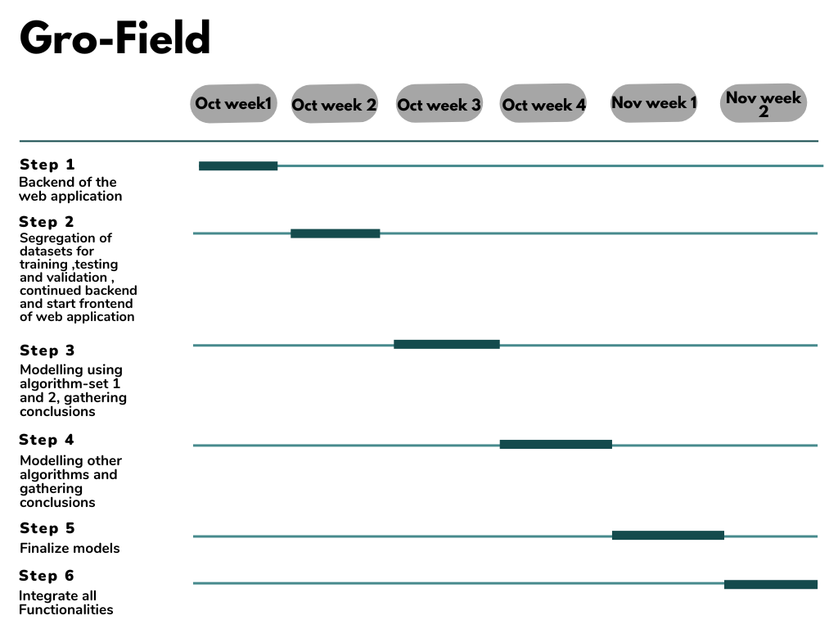

**10. Conclusion**

The key achievement of the application is that it suggests crops and fertilizers beforehand saving a lot of resources. The harnessing of deep learning algorithms to predict diseases adds to the usage. With the algorithms used and the datasets being used ,the system attempts to find the best suitable crops and fertilizers. The accuracy of the leaf disease system stands high with the ability of detecting the correct class of disease. Further optimizations in the algorithms can enhance the system to even more accurate output.

2019BTECS00014 Siddhi Lokhande

2019BTECS00027 Shrutika Adhav

2019BTECS00049 Bhavika Ghadage

2019BTECS00095 Vaishnavi Daware

**References**

Prof. Pooja Mundada

Guide

1. Dhiman Mondal, Dipak Kumar Kole, Aruna Chakraborty, D. Dutta Majumder" Detection and Classification Technique of Yellow Vein Mosaic Virus Disease in Okra Leaf Imagesusing Leaf Vein Extraction and Naive Bayesian Classifier., 2015, International Conference on Soft Computing Techniques and Implementations- (ICSCTI) Department of ECE, FET, MRIU, Faridabad, India, Oct 8-10, 2015.
2. Pranjali B. Padol, Prof. AnjilA.Yadav, "SVM Classifier Based Grape Leaf Disease Detection" 2016 Conference on Advances in Signal Processing(CAPS) Cummins college of Engineering for Women, Pune. June 9-11, 2016.
3. Detection of unhealthy plant leaves using image processing and genetic algorithm with Arduino2018 International Conference on Power, Signals, Control and Computation (EPSCICON)
4. Tanvimehera, vinaykumar,pragyagupta "Maturity and disease detection in tomato using computer vision" 2016 Fourth international conference on parallel, distributed and grid computing(PDGC)
5. Ms.Poojapawer ,Dr.varshaTukar, prof.parvinpatil "Cucumber Disease detection using artificial neural network"
6. Detection of leaf diseases and classification using digital image processing2017 International Conference on Innovations in Information, Embedded and Communication Systems (ICIIECS)