GitHub Repository Link
Repository:
https://github.com/9688balu/TravelMemory_Deployment

Application URL:
http://13.203.159.190

Load Balancer DNS:
http://travelmemory-alb-1622406655.ap-south-1.elb.amazonaws.com

Travel Memory Application Deployment on AWS EC2
Submitted By:
Dhilip Balaji Arulmani
Course:
DevOps
Date:
25-Oct-2026

The objective of this assignment was to deploy the Travel Memory MERN stack application on AWS EC2. The deployment involved configuring the backend, frontend, MongoDB Atlas database, Nginx reverse proxy, PM2 process manager, AWS Application Load Balancer, and Cloudflare DNS integration.

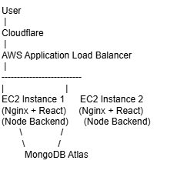

Users access the application through Cloudflare and AWS infrastructure. Requests are distributed using an Application Load Balancer to EC2 instances running React frontend and Node.js backend. MongoDB Atlas is used as the database layer.

The TravelMemory application source code was obtained from the following GitHub repository
https://github.com/UnpredictablePrashant/TravelMemory

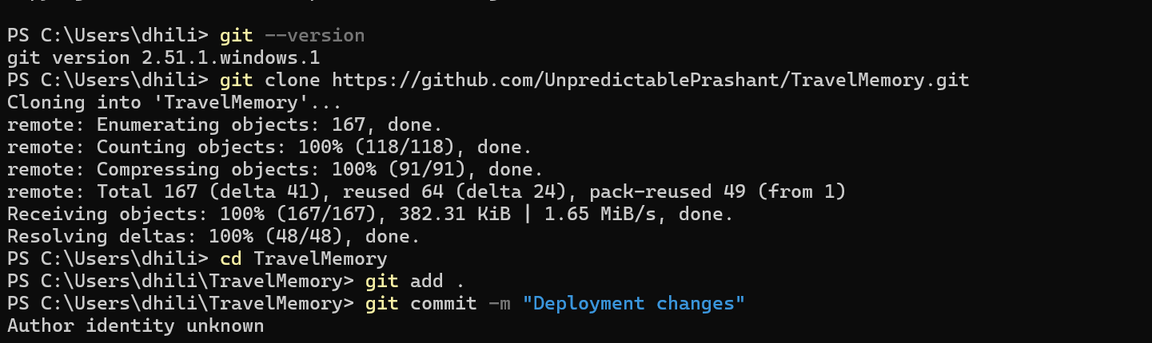

A MongoDB Atlas cloud database cluster was created to store application data.
The following activities were performed:
- Created a MongoDB Atlas account.
- Created a free-tier cluster.
- Created a database user with authentication credentials.
- Configured network access.
- Added the public IP access rule (0.0.0.0/0) for testing and deployment.
- Obtained the MongoDB connection string.
The connection string was used in the backend environment configuration.

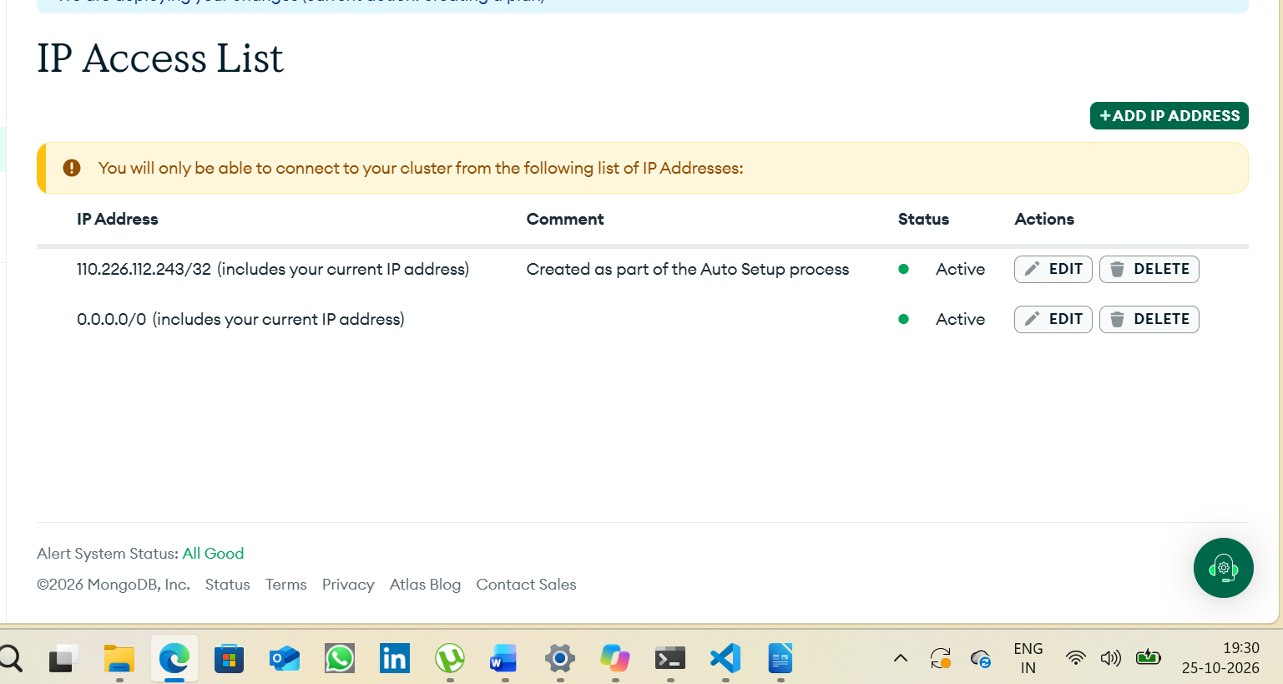
Backend application was configured using MongoDB Atlas and deployed successfully.
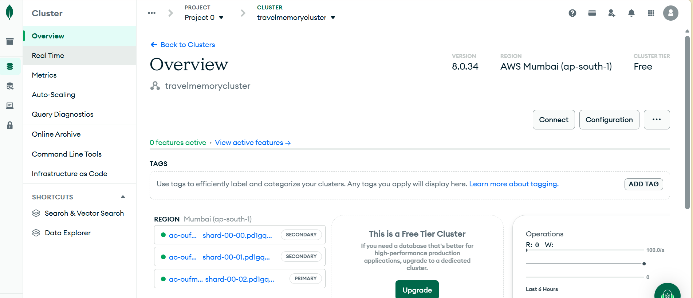
An Amazon EC2 Ubuntu instance was launched to host the application.

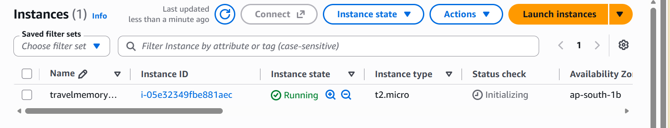

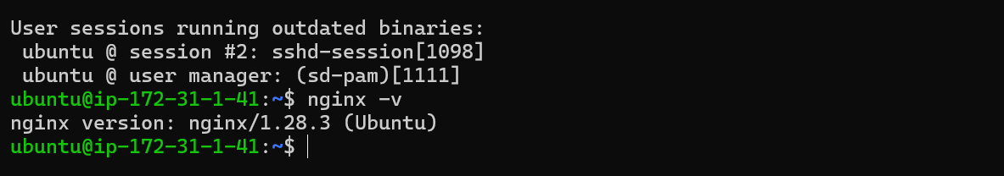
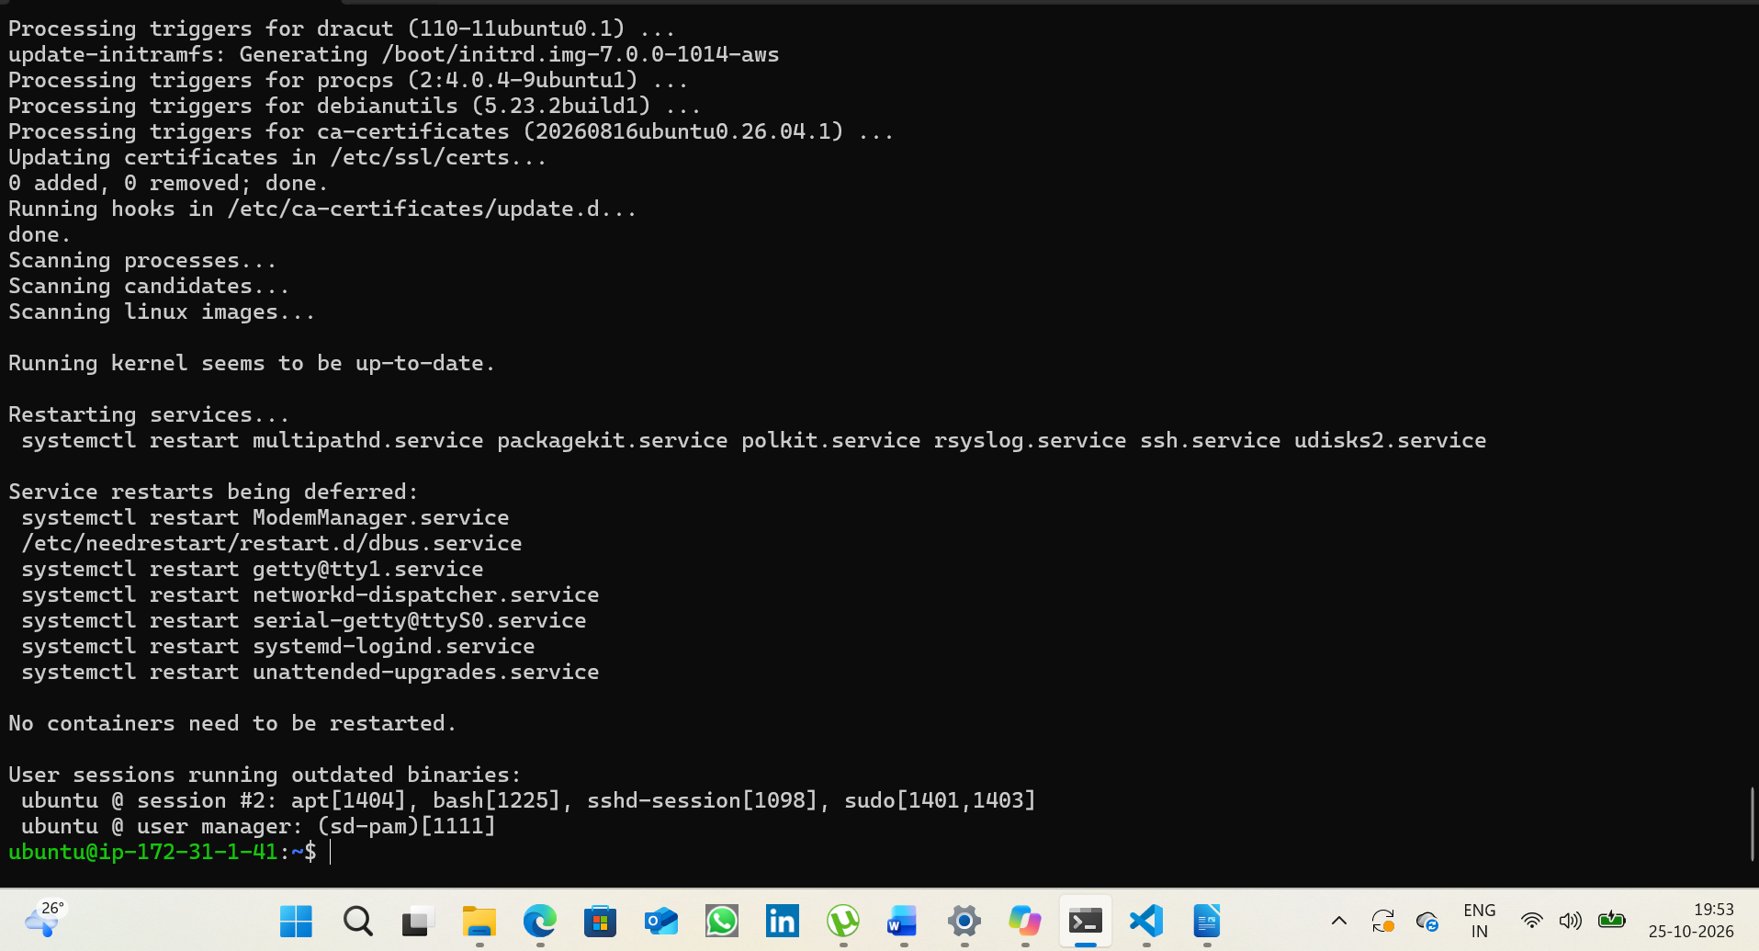
Frontend React application was configured and deployed through Nginx.

The following software was installed on the EC2 instance:

Git
Used for cloning and managing source code.

Node.js
Used to run the backend application.

NPM
Used for installing project dependencies.

Nginx
Used as a web server and reverse proxy.

PM2
Used for Node.js process management and automatic restart.

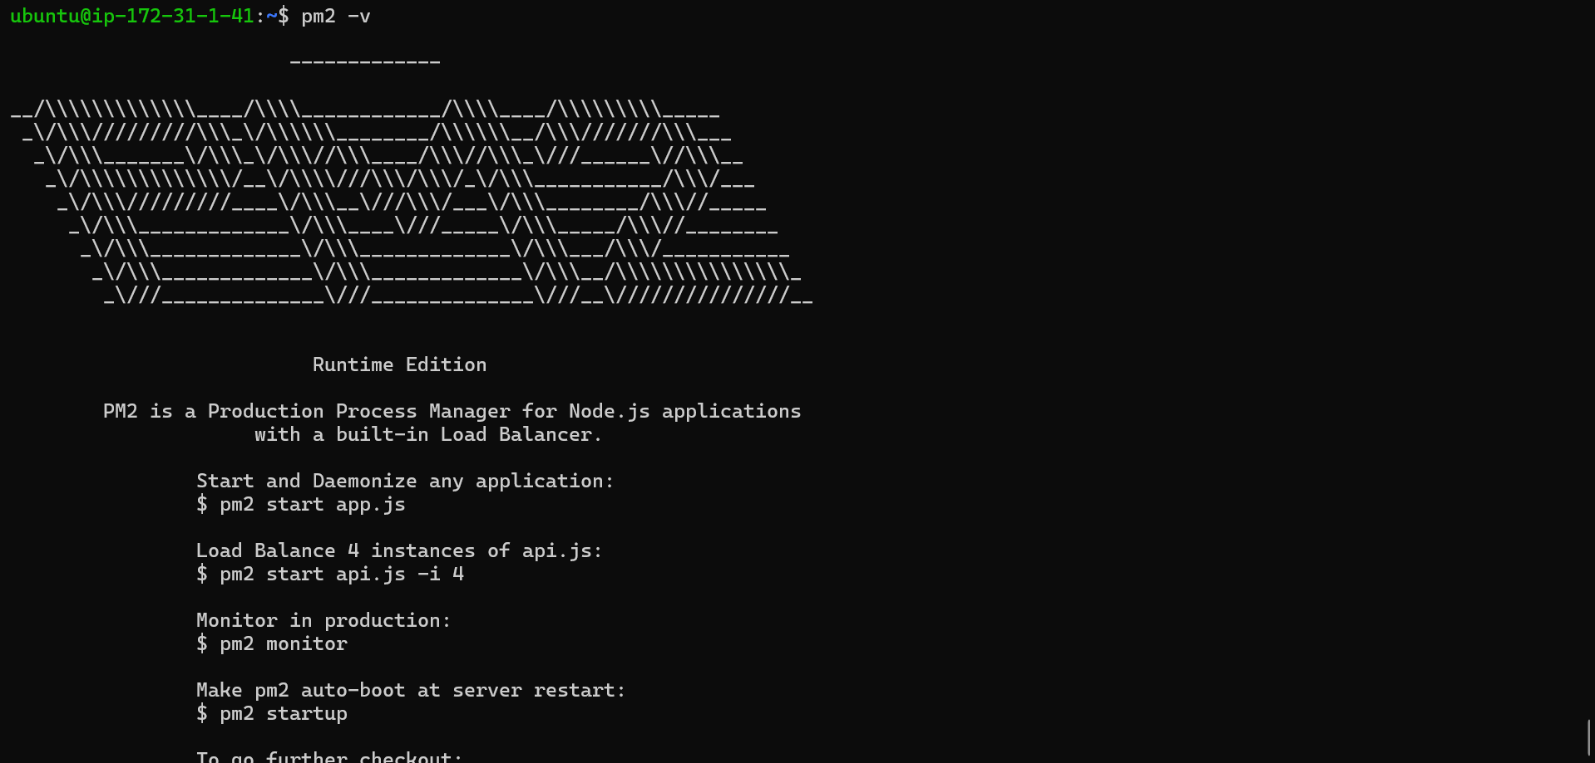
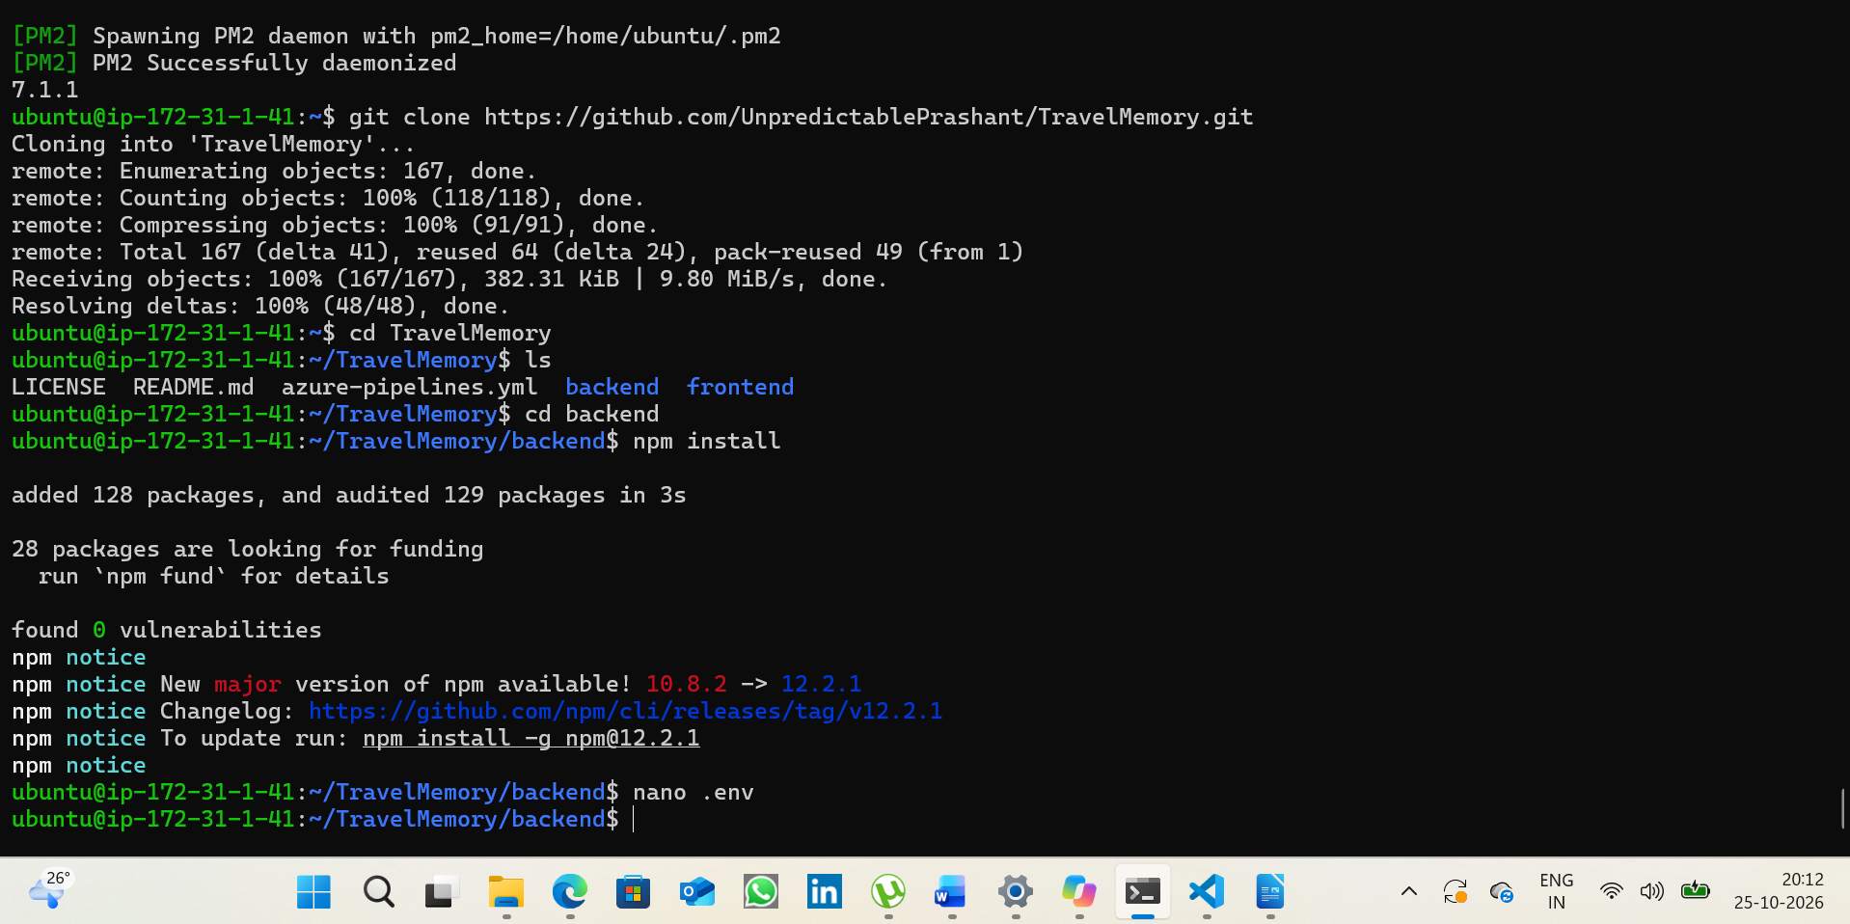
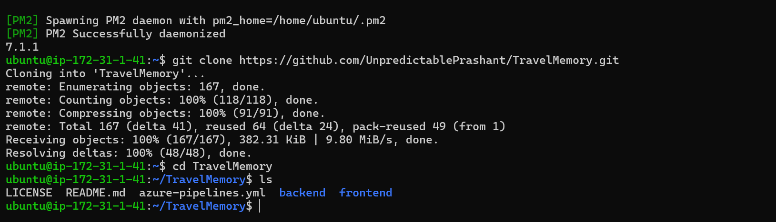
The backend source code was deployed on the EC2 instance.
Activities performed:
- Installed all Node.js dependencies.
- Created environment configuration (.env).
- Configured MongoDB Atlas connection.
- Configured application port settings.
- Verified successful database connectivity.
- Started the backend application.
- Managed backend services using PM2.

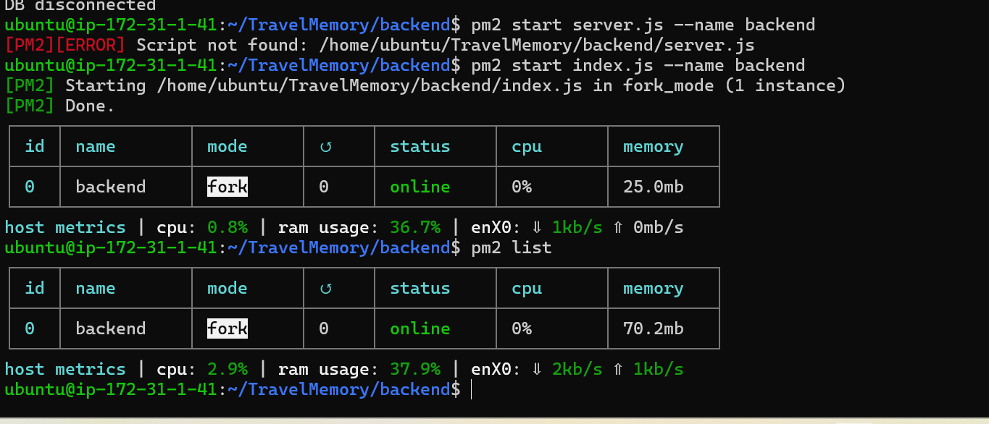
The React frontend application was configured and built for production deployment.
Activities performed:
- Installed frontend dependencies.
- Updated frontend API configuration.
- Configured backend communication URL.
- Generated production build using:
Shell

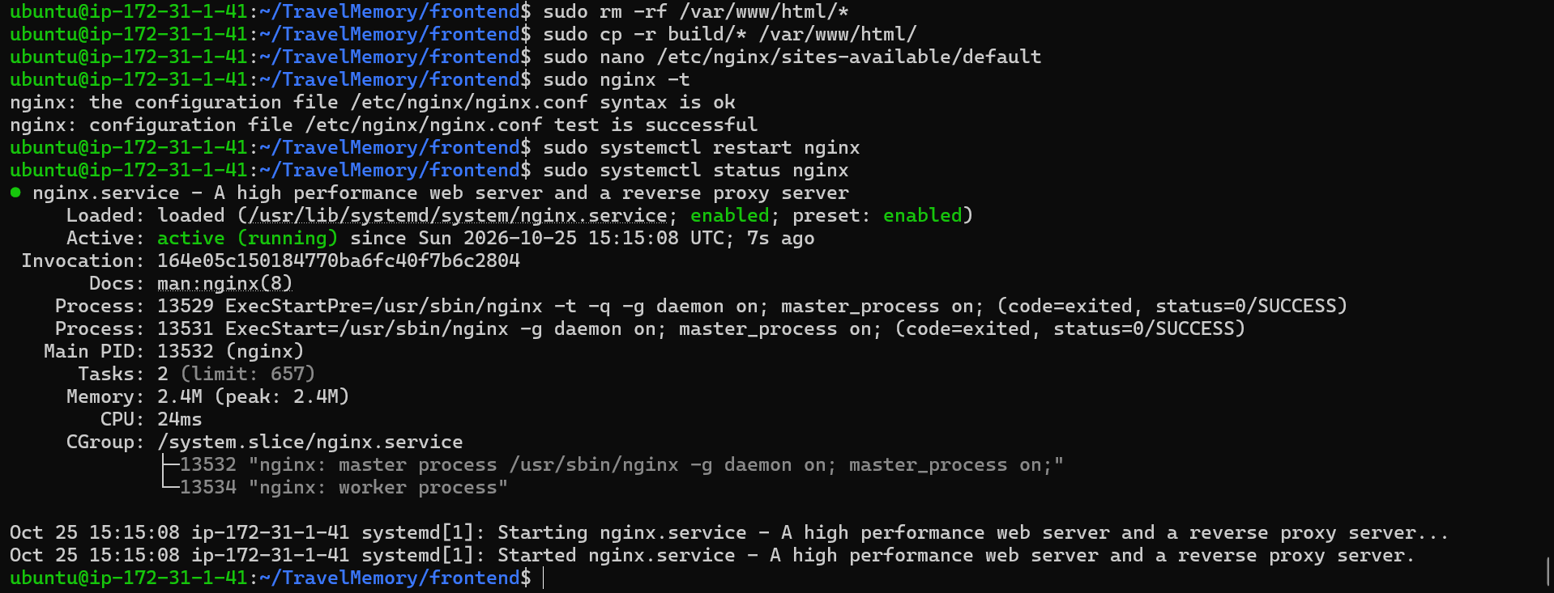
Nginx was configured to:
- Serve the React application.
- Forward API requests to the Node.js backend.
- Handle frontend-backend communication.
Testing was performed to verify:

Frontend Access
- Home Page
- Login Page
- Registration Page

Backend Access
- API responses
- Database communication

Database Operations
- Data retrieval
- Data storage

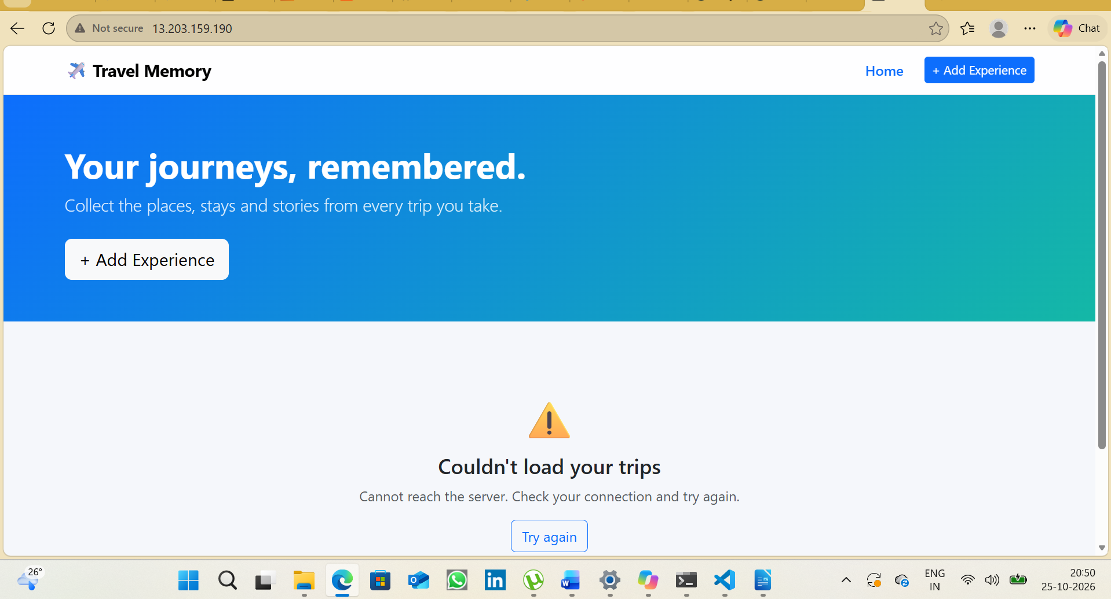
16

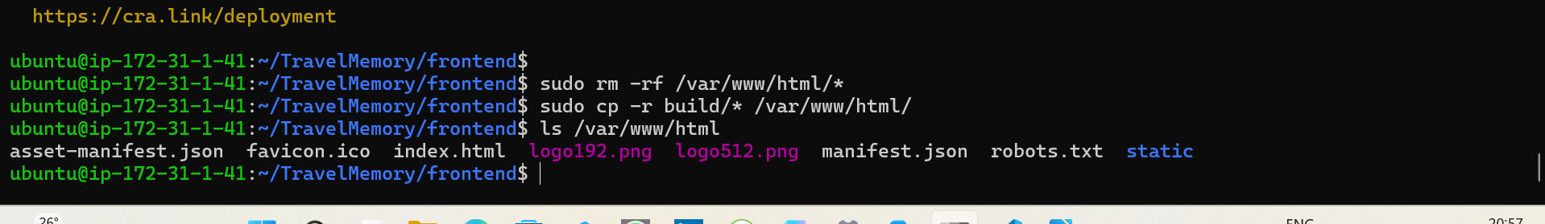
17Application testing confirmed successful frontend-backend communication.

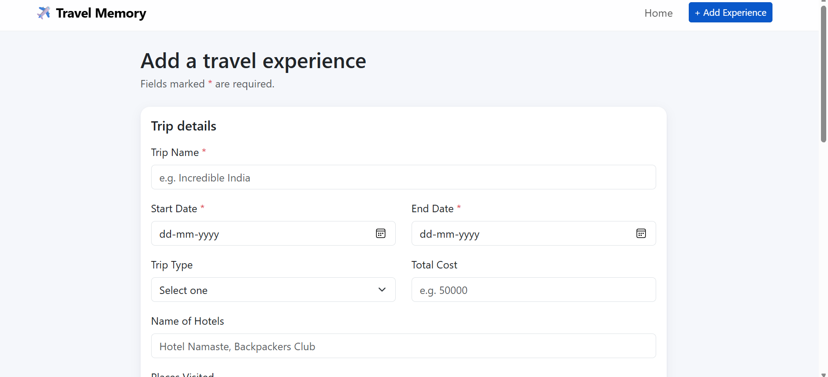
To satisfy scaling requirements:
- Additional EC2 instance(s) were created.
- Multiple application instances were configured.
- Instances were registered with AWS Target Groups.
- Health checks were configured and verified.
This architecture supports horizontal scaling and improved availability.

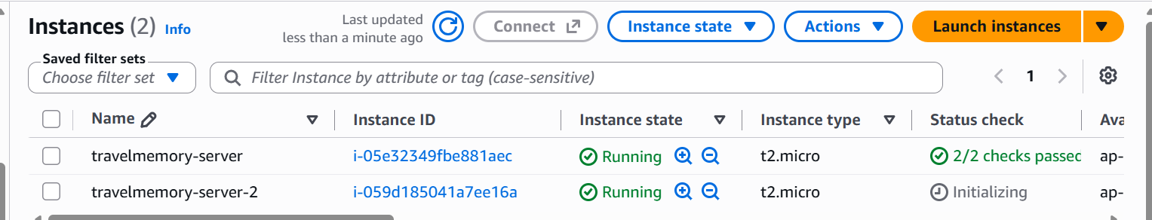
19

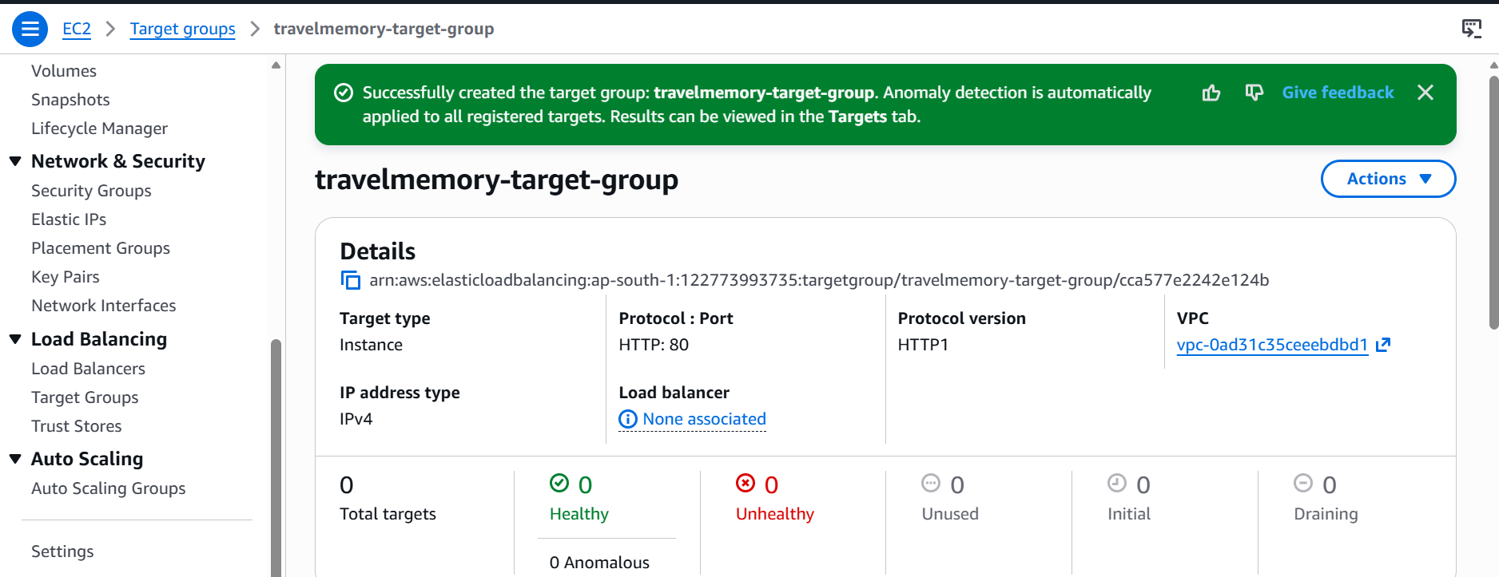
An AWS Application Load Balancer (ALB) was created.
Activities performed:
- Created Target Group.
- Registered EC2 instances.
- Configured listener rules.
- Configured health checks.
- Associated instances with the Load Balancer.

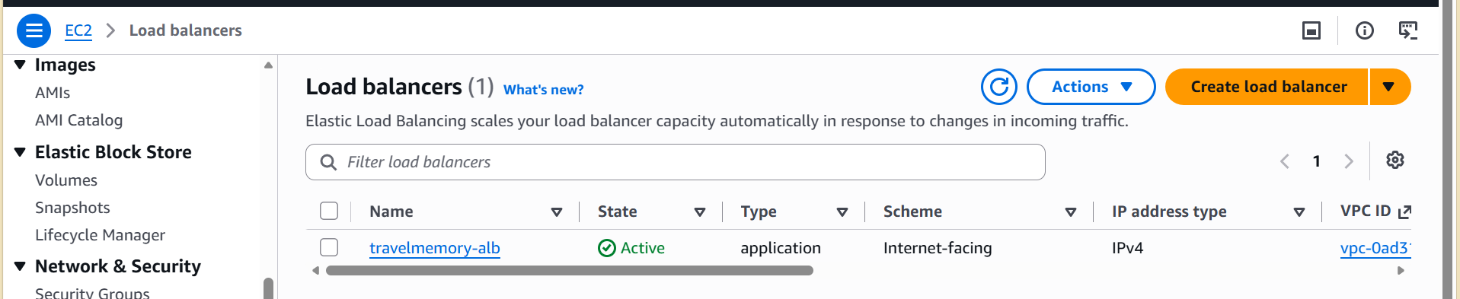
21

1
During deployment the following challenges were encountered and resolved:
- SSH private key permission issues.
- MongoDB Atlas connectivity configuration.
- Environment variable management.
- PM2 process configuration.
- Nginx reverse proxy setup.
- Target group health check validation.
- Load Balancer troubleshooting.
- Cloudflare DNS integration.

The TravelMemory MERN application was successfully deployed on AWS cloud infrastructure. MongoDB Atlas was configured as the database layer, Node.js was used for backend execution, React was used for frontend presentation, Nginx was configured as a reverse proxy, PM2 was used for process management, multiple EC2 instances were created for scalability, AWS Application Load Balancer was configured for traffic distribution, and Cloudflare DNS integration was implemented for domain management.
The deployment demonstrates cloud hosting, web server configuration, process management, DNS configuration, scalability, and DevOps deployment practices using industry-standard tools and services.

