IT18001730

T.S.Chethana Fernando

Doctor Registration View/Insert/Delete/Update

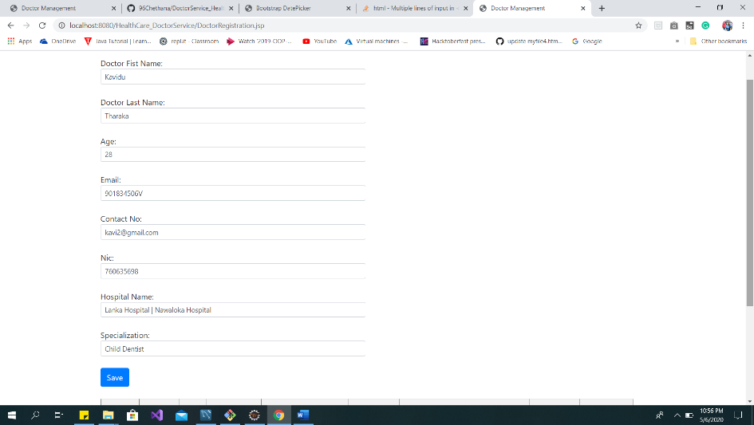

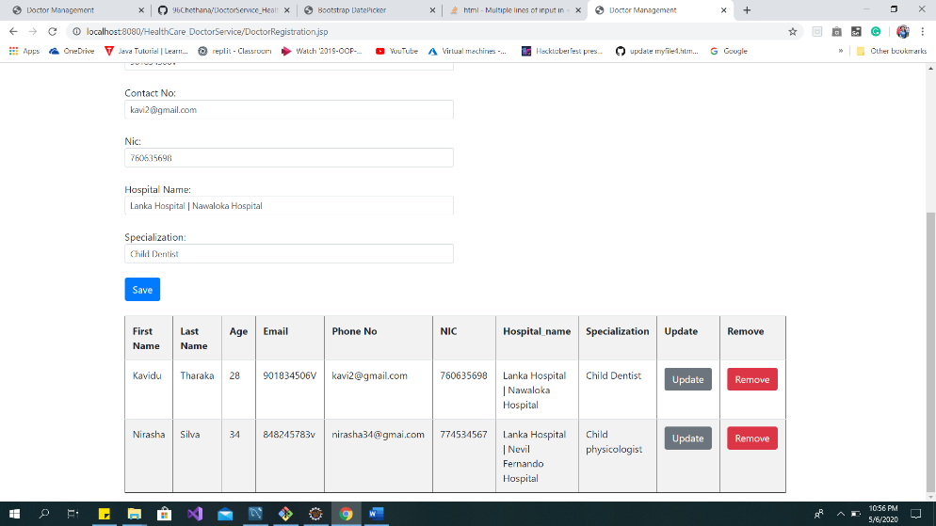

Doctor Feedback View/Insert/Delete/Update

