

Hardware Manual
Bubblegum96

Version：1.0

2015-11-26

Disclaimer
Circuit diagrams and other information relating to products of Actions Semiconductor Company, Ltd. (“Actions”) are included as a means of illustrating typical applications. Consequently, complete information sufficient for construction is not necessarily given. Although the information has been examined and is believed to be accurate, Actions makes no representations or warranties with respect to the accuracy or completeness of the contents of this publication and disclaims any responsibility for inaccuracies. Information in this document is provided solely to enable use of Actions’ products. The information presented in this document does not form part of any quotation or contract of sale. Actions assumes no liability whatsoever, including infringement of any patent or copyright, for sale and use of Actions’ products, except as expressed in Actions’ Terms and Conditions of Sale for. All sales of any Actions products are conditional on your agreement of the terms and conditions of recently dated version of Actions’ Terms and Conditions of Sale agreement Dated before the date of your order.
This information does not convey to the purchaser of the described semiconductor devices any licenses under any patent rights, copyright, trademark rights, rights in trade secrets and/or know how, or any other intellectual property rights of Actions or others, however denominated, whether by express or implied representation, by estoppel, or otherwise.
Information Documented here relates solely to Actions products described herein supersedes, as of the release date of this publication, all previously published data and specifications relating to such products provided by Actions or by any other person purporting to distribute such information. Actions reserves the right to make changes to specifications and product descriptions at any time without notice. Contact your Actions sales representative to obtain the latest specifications before placing your product order. Actions product may contain design defects or errors known as anomalies or errata which may cause the products functions to deviate from published specifications. Anomaly or “errata” sheets relating to currently characterized anomalies or errata are available upon request. Designers must not rely on the absence or characteristics of any features or instructions of Actions’ products marked “reserved” or “undefined.” Actions reserves these for future definition and shall have no responsibility whatsoever for conflicts or incompatibilities arising from future changes to them.
Actions’ products are not designed, intended, authorized or warranted for use in any life support or other application where product failure could cause or contribute to personal injury or severe property damage. Any and all such uses without prior written approval of an Officer of Actions and further testing and/or modification will be fully at the risk of the customer.
Copies of this document and/or other Actions product literature, as well as the Terms and Conditions of Sale Agreement, may be obtained by visiting Actions’ website at http://www.actions-semi.com/ or from an authorized Actions representative. The word “ACTIONS”, the Actions’ LOGO, whether used separately and/or in combination, is trademark of Actions Semiconductor Company, Ltd., Names and brands of other companies and their products that may from time to time descriptively appear in this product data sheet are the trademarks of their respective holders; no affiliation, authorization, or endorsement by such persons is claimed or implied except as may be expressly stated therein.

ACTIONS DISCLAIMS AND EXCLUDES ANY AND ALL WARRANTIES, INCLUDING WITHOUT LIMITATION ANY AND ALL IMPLIED WARRANTIES OF MERCHANTABILITY, FITNESS FOR A PARTICULAR PURPOSE, TITLE, AND AGAINST INFRINGEMENT AND THE LIKE, AND ANY AND ALL WARRANTIES ARISING FROM ANY COURSE OF DEALING OR USAGE OF TRADE.
IN NO EVENT SHALL ACTIONS BE RELIABLE FOR ANY DIRECT, INCIDENTAL, INDIRECT, SPECIAL, PUNITIVE, OR CONSEQUENTIAL DAMAGES; OR FOR LOST DATA, PROFITS, SAVINGS OR REVENUES OF ANY KIND; REGARDLESS OF THE FORM OF ACTION, WHETHER BASED ON CONTRACT; TORT; NEGLIGENCE OF ACTIONS OR OTHERS; STRICT LIABILITY; BREACH OF WARRANTY; OR OTHERWISE; WHETHER OR NOT ANY REMEDY OF BUYER IS HELD TO HAVE FAILED OF ITS ESSENTIAL PURPOSE, AND WHETHER ACTIONS HAS BEEN ADVISED OF THE POSSIBILITY OF SUCH DAMAGES OR NOT.

Additional Support
Additional product and company information can be obtained by visiting the Actions Website at：
http://www.actions-semi.com

Contents
Disclaimer 2
Contents 4
Revision History 6
1 Introduction 7
1.1 Board overview 9
2 PCB TOP & BOT Side 10
3 Getting started 11
3.1 Prerequisites 11
3.2 Starting the board for the first time 11
4 Bubblegum96 S900 Overview 12
4.1 System Block diagram 12
4.2 Processor 12
4.3 Memory 12
4.4 MicroSDHC 12
4.5 WiFi/BT 13
4.6 Display Interface 13
4.6.2 MIPI-DSI 13
4.7 Camera Interfaces 13
4.8 USB Ports 13
4.8.1 USB-Host ports 14
4.8.2 USB-Device port 14
4.9 Audio 14
4.10 DC-power and Battery Power 14
4.11 Measurements 14
4.12 Buttons 15
4.13 External Fan connection 15
4.14 UART 15
4.15 JTAG 15
4.17 Expansion Connector 16
4.18 Additional Functionality 16
4.18.1 ADFU Key 16
4.18.2 UART Debug Test Point 17
5 Low speed expansion connector 18
5.1 UART {0/1} 19
5.2 I2C {0/1} 19
5.3 GPIO {A-L} 19
5.4 SPI 0 20
5.5 PCM/I2S 20
5.6 Power and Reset 20
5.7 Power Supplies 20
6 High speed expansion connector 21
6.1 MIPI DSI 0 23
6.2 MIPI CSI {0/1} 23
6.3 I2C {2/3} 23
6.4 HSIC 23
6.5 Reserved 23
6.6 SD/SPI 23
6.7 Clocks 24
6.8 USB 24
7 Mechanical specifications 25
7.1 Board dimensions 25

Revision History
Date | Revision | Description
2015-11-26 | 1.0 | First Release

1 Introduction
The Bubblegum96 is a 96Boards compliant community board based on Actions S900 series of SoC’s.
The following table lists its key features:

Processor | Actions -S900  CPU:Quad-core ARM® Cortex® A53 at up to 1.6 GHz per core  64-Bit capable  GPU:imagination PowerVR G6230  OpenGL ES 3.1, OpenGL 3.2, DirectX 10,OpenCL 1.2EP
Memory/  Storage | 2GB LPDDR3 533MHz  8GB eMMC 4.51  SD 3.0
Video | 1080p@60fps HD video playback and capture with H.264 (AVC),  4096*2304@30fps playback with H.265 (HEVC)
Display | HDMI 1.4b with HDCP (HDMI connector type A/C), up to 4K Ultra
Audio | PCM/AAC+/MP3/WMA,
Connectivity | WLAN 802.11a/b/g/n 2.4GHz  Bluetooth 4.1  One USB 3.0 Type A (Host mode and ADB mode)  One USB 2.0 micro B (Host & device mode)  One USB 2.0 Type A(Host mode, not support USB Hub. )
I/O Interfaces | One 40-pin Low Speed (LS) expansion connector  • UART, SPI, I2S, I2C x2, GPIO x12, DC power  One 60-pin High Speed (HS) expansion connector  • 4L-MIPI DSI, USB, I2C x2, 2L+4L-MIPI CSI  The board can be made compatible using an add-on mezzanine board  One JTAG Header option.
External  Storage | Micro SD card slot
User Interface | Power/Reset Key  ADFU Key  6 LED indicators  • 4 - user controllable  • 2 - for radios (BT and WLAN activity)
OS-support | Android 5.1  Linux based on Debian
Power,  Mechanical and  Environmental | Power: +6.5V to +18V  Dimensions: 54mm by 85mm meeting 96Boards™ Consumer Edition standard  dimensions specifications.  Operating Temp: 0°C to +70°C  RoHS and Reach compliant

1.1 Board overview
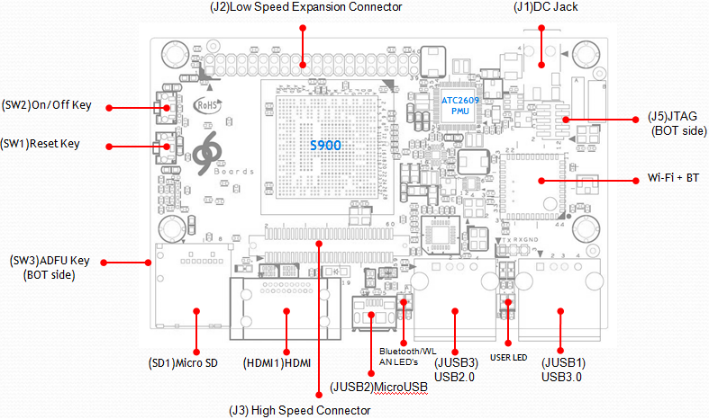

Part Ref | Description | Note |  | Part Ref | Description | Note
(J2) | LS EXPANSION CNT |  |  | (J1) | DC IN JACK
(SW2) | ON/OFF Key |  |  | (J5) | JTAG
(SW1) | Reset Key |  |  | (U4) | WiFi+BT Module
(SW3) | ADFU Key |  |  | (JUSB1) | USB3.0
(SD1) | Micro SD |  |  | (LED0~3) | USER LEDs
(HDMI1) | HDMI PLUG |  |  | (JUSB3) | USB2.0
(J3) | High Speed EXP CNT |  |  | (WiFi/BT LED) | WiFi/BT LEDs
(JUSB2) | Micro USB |  |  | (UP1) | PMIC-ATC2609
(U1-1) | SoC-S900

2 PCB TOP & BOT Side

Top side view of the Bubblegum96
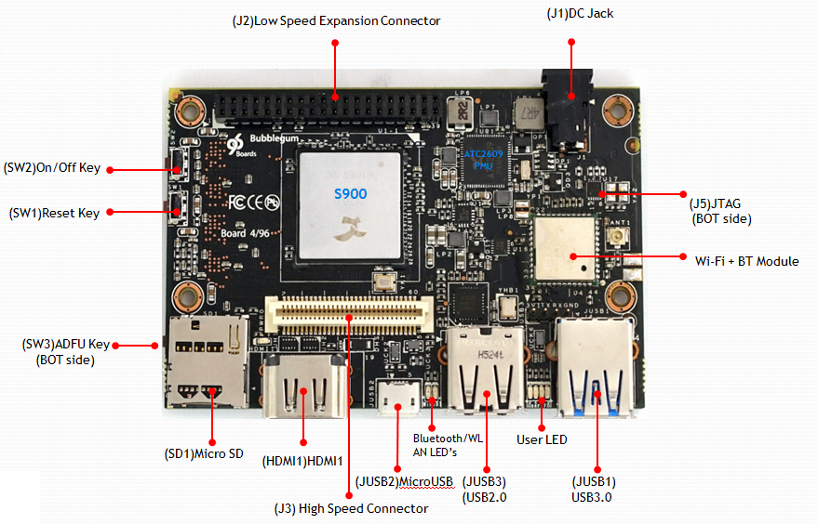

Bottom side view of the Bubblegum96
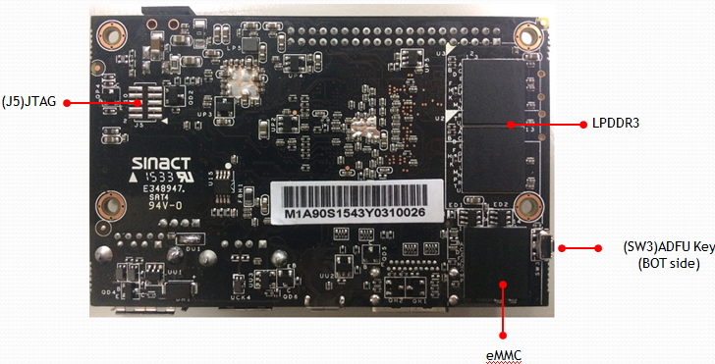

3 Getting started

3.1 Prerequisites
Before you power up your Bubblegum96 board for the first time you will need the following:
1.Bubblegum96 Board
- 2.96Boards compliant power supply 12V/2A (sold separately by Arrow).
- • 3.HDMI or DVI LCD Monitor that supports a resolution of 1080P/30Hz.
- • 4.HDMI-HDMI cable or HDMI-DVI cable to connect the board to the Monitor.
- • 5.computer keyboard with USB interface
- • 6.computer mouse with USB interface.

3.2 Starting the board for the first time
To start the board, follow these simple steps:
step 1. Connect the HDMI cable to the Bubblegum-96 Board HDMI connector and to the LCD Monitor.
step 2. Connect the keyboard to the boards USB connector marked USB3.0/USB2.0 Connector and the mouse to the USB3.0/2.0 connector (It doesn’t matter which order you connect them in. You can also connect via an external USB Hub to USB3.0 Connector.)
step 3. Connect the power supply to DC Jack.

Once you plug the power supply into a power outlet the board will start the booting process, and you should see Android boot up.
Please note that the first boot takes several minutes due to Androids initialization. Subsequent boot times should be faster.

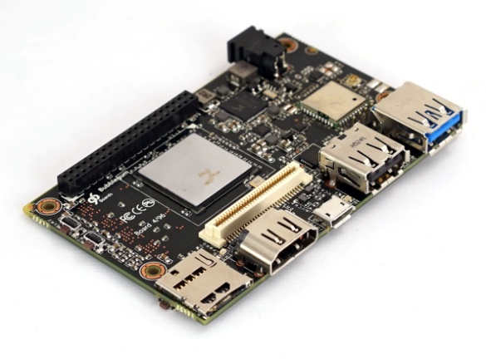

4 Bubblegum96 S900 Overview

4.1 System Block diagram
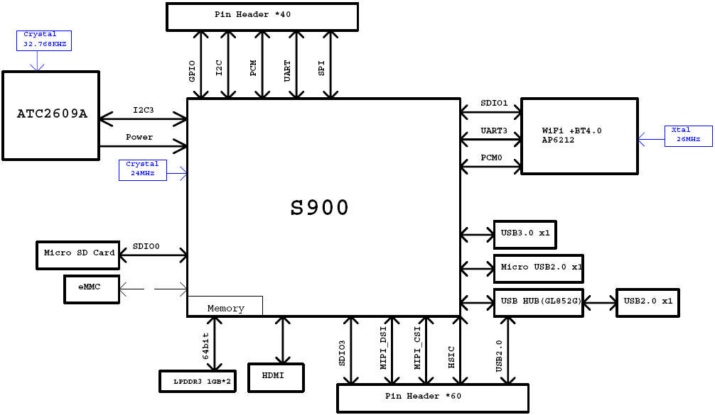

4.2 Processor
The Bubblegum96 is a 96Boards compliant community board based on Actions S900 series of SoC’s.
CPU Quad-core ARM® Cortex® A53 at up to 1.8 GHz per core ,supports both DDR3 / LP-DDR3 SDRAM interface,. 64-Bit capable
GPU:imagination PowerVR G6230
OpenGL ES 3.1, OpenGL 3.2, DirectX 10,OpenCL 1.2EP

4.3 Memory
The Bubblegum96 uses 2GB LPDDR3 DRAM & 8GB eMMC flash memory solution.
- The LPDDR3 is a 32bit width bus implementation interfacing directly to the S900 build-in LPDDR controller. The DDR clock up to 533Mhz
- The eMMC is an 8bit implementation interfacing with S900 N0 interface supporting eMMC 4.5 specifications.

4.4 MicroSDHC
The 96Boards specification calls for a microSDHC socket to be present on the board.
The Bubblegum96 SD slot (SD1) signals are routed directly to the S900 SDIO0 interface. The slot is a push-push type with a dedicated support for card detect signal (many SD slots do not have a dedicated CD pins, they use DATA3 state as the card detected signal). The Bubblegum-96 board uses GPIOE14 as the CARD_DT

4.5 WiFi/BT
The 96Boards specifications calls for a WiFi (minimally 802.11g/n) and Bluetooth 4.1 (Bluetooth Low Energy)
The Bubblegum96 board deployed Broadcom-43438 chip solution
- WLAN compliant with IEEE 802.11 b/g/n specifications, meeting 96Boards minimal requirements for WiFi.
- Bluetooth compliant with the BT specifications version 4.1 (BLE), meeting the 96Boards requirements for BT

4.6 Display Interface
4.6.1 HDMI
The 96Boards specification calls for an HDMI port to be present on the board. The S900 built-in HDMI interface Module consists of HDMI Video interface, HDMI Audio interface and HDMI Transmitter Core
Transmitter code witch HDCP and fully compliant with the HDMI 1.4b,MHL2.1,DVI 1.0 & HDCP 1.4 Specifications, so it can support 480P to 4K*2K@30Hz

4.6.2 MIPI-DSI
The 96Boards specification calls for a MIPI-DSI implementation via the High Speed Expansion Connector.
The S900 implemented a four-lane MIPI_DSI interface meeting this requirement. More information about this implementation can be found in High speed expansion connector(J3).

4.7 Camera Interfaces
The 96Boards specification calls for two camera interfaces.
The S900 implements two camera interfaces, one with a 4-lane MIPI_CSI interface and one with two-lane MIPI_CSI interface, meeting this requirement. More information about this implementation can be found in High speed expansion connector(J3).

4.8 USB Ports
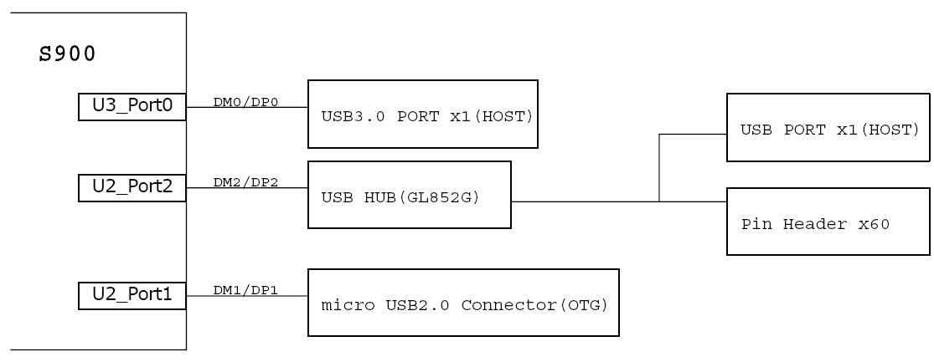

4.8.1 USB-Host ports
The 96Boards specification calls for three USB host ports. The S900 includes a 3 channel.
- S900 U3_Port0(see JUSB1 USB3.0 TypeA Connector) is USB3.0 Support Supper Speed(5Gb/s),High Speed(480Mb/s) and Full Speed(12Mb/s)Support in Host mode, and also can Support USB HUB,
U3 Port0 can support Device/ADB mode but need use UART Command to Change mode.
U3 Port0 can support Image Update(ADFU), Please see for detailed information on the “ADFU Operating Instructions.
- S900 U2_Port2(see JUSB2 USB2.0 TypeA Connector) is USB3.0 Support High Speed(480Mb/s) and Full Speed(12Mb/s)Support in Host mode, But it can’t support USB HUB over2 levels series.

4.8.2 USB-Device port
The 96Boards specification calls for a USB port to be implemented as an OTG port or a device port.
The Bubblegum96 board implements a device port. The port is located at JUSB2, a MicroUSB type B. Please note: Micro USB can work in one mode at a time, Host mode or Device mode, not both.

4.9 Audio
The 96Boards specifications calls for a minimum of single channel audio through two interfaces, BT and HDMI/MHL/DisplayPort
The Bubblegum96 meets this requirement,BT Audio From WiFi module use PCM Interface that connects directly to the S900 SoC, The S900 built-in HDMI interface Module that Included of HDMI Audio interface.

4.10 DC-power and Battery Power
The 96Boards specification calls for power to be provided to the board in one of the following ways:
- • An 8V to 18V power from a dedicated DC jack
- • An 8V to 18V power from the SYS_DCIN pins on the Low Speed Expansion Connector
- • A USB Type C port at 5V
The Bubblegum96 meets this requirement , but not support USB Port Provide Power.

4.11 Measurements
The 96Boards specification calls for support for measuring power consumptions of the board.
Bubblegum96 can use A 0.1ohm resistor is placed in line to the SYS_DCIN power line coming from J1 (please note that this power in measurement only works for SYS_DCIN from J1, it will not measure SYS_DCIN applied from the Low Speed Expansion Connector). Placing a probe over this resistor will provide a voltage measurement of the voltage drop across the resistor. Dividing this measurement by 0.1 will give you the amount of the current flowing into the board. The board provides a means to use ARM Energy probe for this measurement,
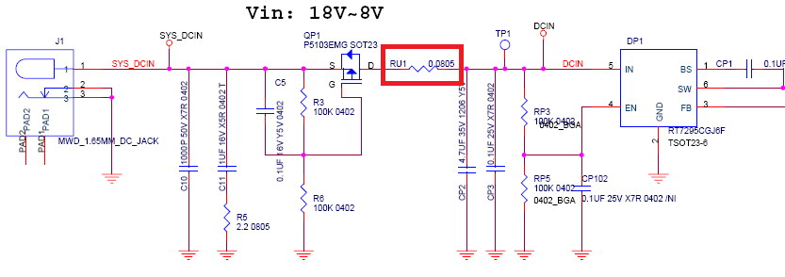

4.12 Buttons
The 96Boards specification calls for the present of two buttons, a Power on/sleep button and a Reset button. The Bubblegum96 meets these requirements. And has Additional (SW3)ADFU Key For Debug.
(SW1) – Reset Key.
(SW2) – ON/OFF Key
(SW3) – ADFU Key

4.13 External Fan connection
The 96Boards specification calls for support for an external fan. That can be achieved by using the 5V or the SYS_DCIN, both present on the Low Speed Expansion connector.

4.14 UART
The 96Boards specification calls for support for one SoC UART and an optional second UART both to be routed to the Low Speed Expansion Connector.
The Bubblegum96 meets these requirements ,one is 4-wire -UART2 & one is 2-wire-UART5

4.15 JTAG
The 96Boards specification does not call for a dedicated JTAG connector. The Bubblegum-96 meets these requirements , The J5 connector does have a JTAG connector pitch and pin define as follow.
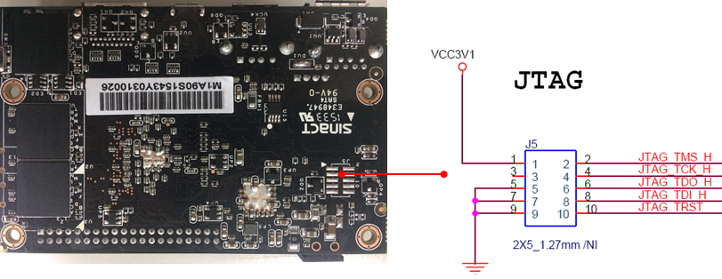

4.16 System and user LEDs
The 96Boards specifications calls for six LEDs to be implemented on the board. The specification defines the LEDs color and mechanical location on the board.
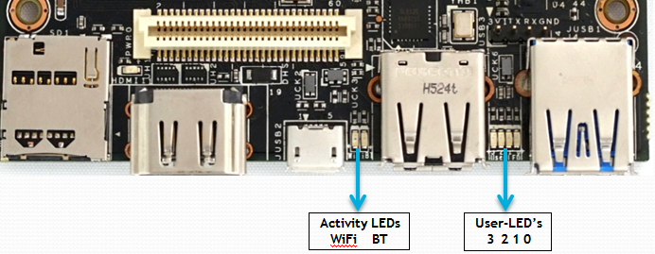
Two activity LEDs:
- WiFi activity LED – Bubble-96 board drives this Yellow LED via GPIOA14 from the S900.
- BT activity LED –Bubble-96 board drives this Blue LED via GPIOA18 from the S900..
Four User-LED’s:
The four user LEDs are surface mount Green in 0603 size located next to the two USB type A connector and labeled ‘USER LEDS 4 3 2 1’. The Bubblegum-96 board drives four LEDs from the S900
- LED0- S900 GPIOA19
- LED1- S900 GPIOA20
- LED2- S900 GPIOF1
- LED3- S900 GPIOF2.

4.17 Expansion Connector
The 96Boards specification calls for two Expansion Connectors, a Low Speed and a High Speed.
The Bubblegum96 meets this requirement, please review section 5.0 for detailed information regarding the Low Speed Expansion Connector and section 6.0 for detailed information regarding the High Speed Expansion Connector.

4.18 Additional Functionality
The 96Boards specifications allows for additional functionality provided that all mandatory functionality is available and there is no impact on the physical footprint specifications including height and do not prevent the use of the 96Boards CE low speed and high speed expansion facilities
The 96 board implements a few additional functions, which are listed in the following sub-chapters.

4.18.1 ADFU Key
U3 Port0 can support Image Update (ADFU), Please see for detailed information on the “ADFU Operating Instructions.

4.18.2 UART Debug Test Point
The Bubblegum96 And has Additional TP9(TX),TP11(RX) Key For Debug , it can print kernel log.
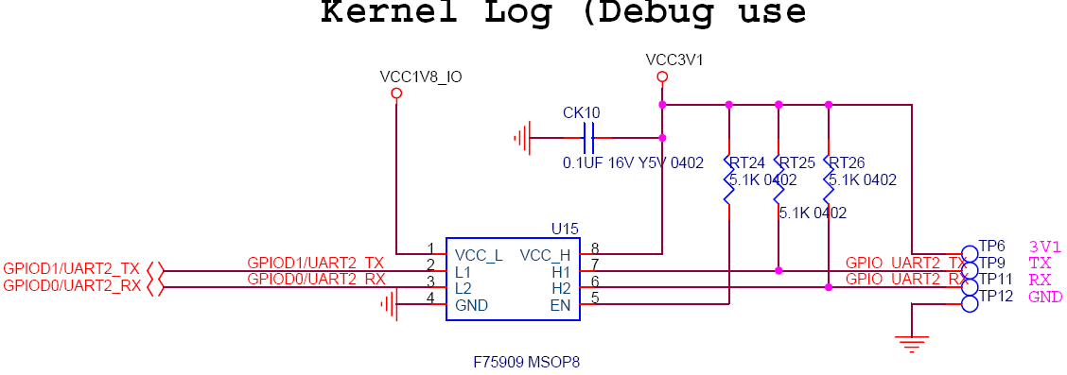
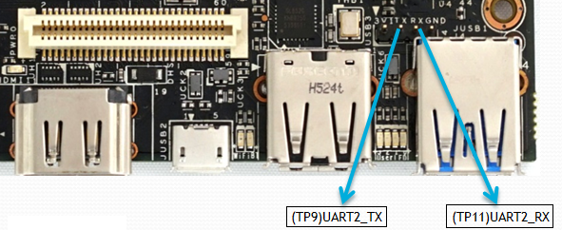

5 Low speed expansion connector

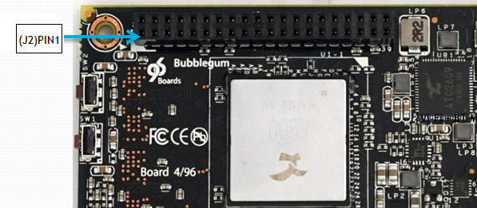

The following tables show the Low Speed Expansion Connector pin out:
PIN |  | 96Boards Signals | Bubblegum96-S900 | Note
1 | GND |  | GND
3 | UART0_CTS |  | GPIOB17/UART0_TX/UART2_CTSB | S900 UART2
5 | UART0_TxD |  | GPIOB15/UART2_TX | S900 UART2
7 | UART0_RxD |  | GPIOB14/UART2_RX | S900 UART2
9 | UART0_RTS |  | GPIOB16/UART0_RX/UART2_RTSB | S900 UART2
11 | UART1_TxD |  | GPIOA27/UART5_TX/SENS0_HSYNC/PWM2/ERAM_A11 | S900 UART5
13 | UART1_RxD |  | GPIOA25/UART5_RX/SENS0_VSYNC/PWM2/ERAM_A9 | S900 UART5
15 | I2C0_SCL |  | GPIOB22/I2C1_SCLK | S900 I2C1
17 | I2C0_SDA |  | GPIOB23/I2C1_SDATA | S900 I2C1
19 | I2C1_SCL |  | GPIOB24/I2C2_SCLK | S900 I2C2
21 | I2C1_SDA |  | GPIOB25/I2C2_SDATA | S900 I2C2
23 | GPIO-A |  | GPIOA0/SPI2_SCLK/PWM0/ETH_TXD0
25 | GPIO-C |  | GPIOA2/PWM2/ETH_TXEN
27 | GPIO-E |  | GPIOA4/SPI2_MISO/ETH_CRS_DV
29 | GPIO-G |  | GPIOA6/UART2_CTSB/PWM1/ETH_RXD0
31 | GPIO-I |  | GPIOA8/PWM2/UART2_RX/ETH_MDC
33 | GPIO-K |  | GPIOE27/N1_CLE
35 | +1V8 |  | VCC1V8_IO
37 | +5V |  | SYSPWR_4.8V
39 | GND |  | GND

PIN | 96Boards Signals | 96Board-S900 | Note
2 | GND | GND
4 | PWR_BTN_N | GPIOE22/SD3_D6/N1_D6
6 | RST_BTN_N | GPIOE23/SD3_D7/N1_D7
8 | SPI0_SCLK | GPIOB8/I2C3_SCLK/SPI0_SCLK
10 | SPI0_DIN | GPIOB11/I2C3_SDATA/SPI0_MOSI
12 | SPI0_CS | GPIOB9/I2S_LRCLK1/PCM1-0_OUT/PWM4/SPI0_SS
14 | SPI0_DOUT | GPIOB10/I2S_MCLK1/PCM1-0_IN/PWM5/SPI0_MISO
16 | PCM_FS | GPIOD7/PCM1_SYNC/OBN | Not Support I2S
18 | PCM_CLK | GPIOD6/PCM1_CLK/OBP | Not Support I2S
20 | PCM_DO | GPIOD5/PCM1_OUT/OCN | Not Support I2S
22 | PCM_DI | GPIOD4/PCM1_IN/OCP | Not Support I2S
24 | GPIO-B | GPIOA1/SPI2_SS/PWM1/ETH_TXD1
26 | GPIO-D | GPIOA3/PWM3/ETH_RXER
28 | GPIO-F | GPIOA5/UART2_RTSB/PWM0/ETH_RXD1
30 | GPIO-H | GPIOA7/SPI2_MOSI/UART4_TX/ETH_REF_CLK
32 | GPIO-J | GPIOA9/PWM3/UART2_TX/ETH_MDIO
34 | GPIO-L | GPIOE26/N1_ALE
36 | SYS_DCIN | SYS_DCIN
38 | SYC_DCIN | SYS_DCIN
40 | GND | GND

5.1 UART {0/1}
The 96Boards specifications calls for a 4-wire UART implementation, UART0 and an optimal second 2-wire UART, UART1 on the Low Speed Expansion Connector.
- The Bubblegum96 board implements UART2 as a 4-wire UART that connects directly to the S900 SoC. These signals are driven at 1.8V.
- The Bubblegum96 board implements UART5 as a 2-wire UART that connects directly to the S900 SoC. These signals are driven at 1.8V.

5.2 I2C {0/1}
The 96Boards specification calls for two I2C interfaces to be implemented on the Low Speed Expansion Connector.
The Bubblegum96 board implements both interfaces, I2C1 and I2C2 that connects directly to the S900 SoC. A 2K2 resistor is provided as pull-up for each of the I2C lines per the I2C specifications, these pull-ups are connected to the 1.8V voltage rail.

5.3 GPIO {A-L}
The 96Boards specifications calls for 12 GPIO lines to be implemented on the Low Speed Expansion Connector. Some of these GPIOs may support alternate functions for DSI/CSI control
The Bubblegum96 board implements this requirement. 12 GPIOs are routed to the S900 SoC. It is a 1.8V signal.

5.4 SPI 0
The 96Boards specification calls for one SPI bus master to be provided on the Low Speed Expansion Connector.
The Bubblegum96 board implements a full SPI master with 4 wires, CLK, CS, MOSI and MISO all connect directly to the S900 SoC. These signals are driven at 1.8V.

5.5 PCM/I2S
The 96Boards specification calls for one PCM/I2S bus to be provided on the Low Speed Expansion Connector. The CLK, FS and DO signals are required while the DI is optional.
The Bubblegum96 implements a PCM1 with 4 wires, CLK, FS, DO and DI signal are routed to the S900 SoC. The PCM1 signals are connected directly to the S900 SoC. These signals are driven at 1.8V.

However the S900 PCM1 Can’t Change to I2S Functions, this issue will be addressed on a future revision of the 96Board board.

5.6 Power and Reset
The 96Boards specification calls for a signal on the Low Speed Expansion Connector that can power on/off the board and a signal that serves as a board reset signal.
- The Bubblegum96 board routes the PWR_BTN_N (named GPIOE22/PWR_BTN_N on S900 schematic).
- The Bubblegum96 board routes the RST_BTN_N (named GPIOE23/RST_BTN_N on S900 schematic)

5.7 Power Supplies
The 96Boards specification calls for three power rails to be present on the Low Speed Expansion Connector:
- +1.8V : Max of 100mA
- +5V : Able to provide a minimum of 5W of power (1A).
- SYS_DCIN : 9-18V input with enough current to support all the board functions or the output DCIN from on-board DC Connector able to provide a minimum of 7W of power.

The Bubblegum96 board supports these requirements as follows:
- +1.8V : Driven by ATC2609 PMIC LDO7 can provide 200mA,so it meets the 96Boards requirement.
- +5V : Driven by the 3.5A 5.0V buck switcher (DP1). This buck switcher powers both USB limit current devices (each at 1A max). The remaining capacity provides a max current of 1.5A to the Low Speed Expansion Connector, for a total of 7.5W which meets the 96Boards requirements.
- SYS_DCIN: Can serves as the board’s main power source or can receive power from the board.

6 High speed expansion connector
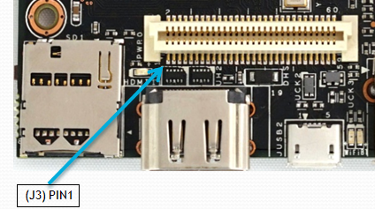
The following table shows the High Speed Expansion Connector pin out:
PIN | 96Boards Signals | Bubblegum-96 S900 Signals | Note
1 | SD_DAT0/SPI1_DOUT | GPIOE16/SD3_D0/N1_D0
3 | SD_DAT1 | SGPIOE17/SD3_D1/N1_D1
5 | SD_DAT2 | GPIOE18/SD3_D2/N1_D2
7 | SD_DAT3/SPI1_CS | GPIOE19/SD3_D3/N1_D3
9 | SD_SCLK/SPI1_SCLK | GPIOE29/SD3_CLK/N1_CEB1
11 | SD_CMD/SPI1_DIN | GPIOE25/SD3_CMD/N1_DQSN
13 | GND | GND
15 | CLK0/CSI0_MCLK | GPIOC4/SEN_PCLK
17 | CLK1/CSI1_MCLK | GPIOC11/SEN_CKOUT
19 | GND | GND
21 | DSI_CLK+ | GPIOD24/PCM1_IN/DSI_CP
23 | DSI_CLK- | GPIOD25/PCM1_OUT/DSI_CN
25 | GND | GND
27 | DSI_D0+ | GPIOD26/PCM1_CLK/DSI_DP0
29 | DSI_D0- | GPIOD27/PCM1_SYNC/DSI_DN0
31 | GND | GND
33 | DSI_D1+ | GPIOD22/UART2_RTSB/DSI_DP1
35 | DSI_D1- | GPIOD23/UART2_CTSB/DSI_DN1
37 | GND | GND
39 | DSI_D2+ | GPIOD28/UART4_RX/DSI_DP2
41 | DSI_D2- | GPIOD29/UART4_TX/DSI_DN2
43 | GND | GND
45 | DSI_D3+ | GPIOD20/UART2_RX/DSI_DP3
47 | DSI_D3- | GPIOD21/UART2_TX/DSI_DN3
49 | GND | GND
51 | USB_D+ | USBHUB1_DPC | From USB Hub(GL852G)
53 | USB_D- | USBHUB1_DMC | From USB Hub(GL852G)
55 | GND | GND
57 | HSIC_STR | HSIC_DQS
59 | HSIC_DATA | HSIC_DQ

PIN | 96Boards Signals | Bubblegum-96 S900 Signals | Note
2 | CSI0_C+ | GPIOB31/SENS0_D1/SENS0_HSYNC/CSI0_CP
4 | CSI0_C- | GPIOB30/SENS0_D0/SENS0_VSYNC/CSI0_CN
6 | GND | GND
8 | CSI0_D0+ | GPIOB27/SENS0_D3/CSI0_DP0
10 | CSI0_D0- | GPIOB26/SENS0_D2/CSI0_DN0
12 | GND | GND
14 | CSI0_D1+ | GPIOB29/SENS0_D5/CSI0_DP1
16 | CCSI0_D1- | GPIOB28/SENS0_D4/CSI0_DN1
18 | GND | GND
20 | CSI0_D2+ | GPIOC1/SENS0_D7/CSI0_DP2
22 | CSI0_D2- | GPIOC0/SENS0_D6/CSI0_DN2
24 | GND | GND
26 | CSI0_D3+ | GPIOC3/SENS0_D9/CSI0_DP3
28 | CSI0_D3- | GPIOC2/SENS0_D8/CSI0_DN3
30 | GND | GND
32 | I2C2_SCL | GPIOB18/UART4_RX/I2C4_SCLK
34 | I2C2_SDA | GPIOB19/UART4_TX/I2C4_SDATA
36 | I2C3_SCL | GPIOB13/SPDIF/I2C5_SCLK/UART0_TX
38 | I2C3_SDA | GPIOB12/I2S_MCLK1/I2C5_SDATA/UART0_RX
40 | GND | GND
42 | CSI1_D0+ | GPIOC6/SENS0_D1/SENSOR0_CKOUT/CSI1_DP0
44 | CSI1_D0- | GPIOC5/SENS0_D0/SENSOR0_PCLK/CSI1_DN0
46 | GND | GND
48 | CSI1_D1+ | GPIOC8/SENS0_D3/CSI1_DP1
50 | CSI1_D1- | GPIOC7/SENS0_D2/CSI1_DN1
52 | GND | GND
54 | CSI1_C+ | GPIOC10/SENS0_D5/CSI1_CP
56 | CSI1_C- | GPIOC9/SENS0_D4/CSI1_CN
58 | GND | GND
60 | RESERVED | RESERVED

6.1 MIPI DSI 0
The 96Boards specification calls for a MIPI-DSI to be present on the High Speed Expansion Connector. A minimum of one lane is required and up to four lanes can be accommodated on the connector.
The Bubblegum96 meets this requirement , S900 implementation supports a full four lane MIPI-DSI interface that is routed to the High Speed Expansion Connector, MIPI-DSI signals are routed directly to/from the S900

6.2 MIPI CSI {0/1}
The 96Boards specification calls for two MIPI-CSI interfaces to be present on the High Speed Expansion Connector. Both interfaces are optional. CSI0 interface can be up to four lanes while CSI1 is up to two lanes.
The Bubblegum96 board implementation supports a full four lane MIPI-CSI interface on CSI0 and two lanes of MIPI-CSI on CSI1. All MIPI-CSI signals are routed directly to/from the S900

6.3 I2C {2/3}
The 96Boards specification calls for two I2C interfaces to be present on the High Speed Expansion Connector. Both interfaces are optional unless a MIPI-CSI interface has been implemented. Then an I2C interface shall be implemented.
The Bubblegum96 board implementation supports two MIPI-CSI interfaces and therefore must support two I2C(TWI4,TWI5) interfaces.
For MIPI-CSI0 the companion I2C is TWI4 that routed directly from the S900. For MIPI-CSI1, the companion I2C is TWI5
Note: Both interfaces, TWI4 and TWI5 have an on-board 2K2 pull-up resistors pulled-up to the 1.8V voltage rail.

6.4 HSIC
The 96Boards specification calls for an optional MIPI-HSIC interface to be present on the High Speed Expansion Connector.
The Bubblegum board implementation support this optional requirement., HSIC signals are routed directly to/from the S900.

6.5 Reserved
The 96Boards specification calls for a 10K pull-up to 1.8V to be connected to pin 60 of the High Speed Expansion Connector.
The Bubblegum96 board implementation does not support this requirement. This issue will be addressed on a future revision of the 96Board board.

6.6 SD/SPI
The 96Boards specification calls for an SD interface or a SPI port to be part of the High Speed Expansion Connector.
The Bubblegum96 board implements a SD signals are routed directly to the S900 SD3 interface-SD3_D0~D3,SD3_CLK,SD3_CMD ,all connect directly to the S900 SoC. These signals are driven at 1.8V.

6.7 Clocks
The 96Boards specification calls for one or two programmable clock interfaces to be provided on the High Speed Expansion Connector. These clocks may have a secondary function of being CSI0_MCLK and CSI1_MCLK. If these clocks can’t be supported by the SoC than an alternative GPIO or No-Connect is allowed by the specifications.
The Bubblegum board implements two CSI clocks, CSI0_MCLK via S900_ GPIOC4/SEN_PCLK and CSI1_MCLK via S900_ GPIOC11/SEN_CKOUT . These signals are driven at 1.8V.

6.8 USB
The 96Boards specification calls for a USB Data line interface to be present on the High Speed Expansion Connector.
The Bubblegum board implements this requirements by routing S900_U2 Port2 from the USB HUB(GL852G) to the High Speed Expansion Connector.

Note: High speed Expansion Connector USB Data not support USB Hub , Because in Host mode can’t support USB HUB over2 levels series, Bubblegum96 already use the on board USB Hub IC(GL852G)

7 Mechanical specifications

7.1 Board dimensions
2D Reference Drawing
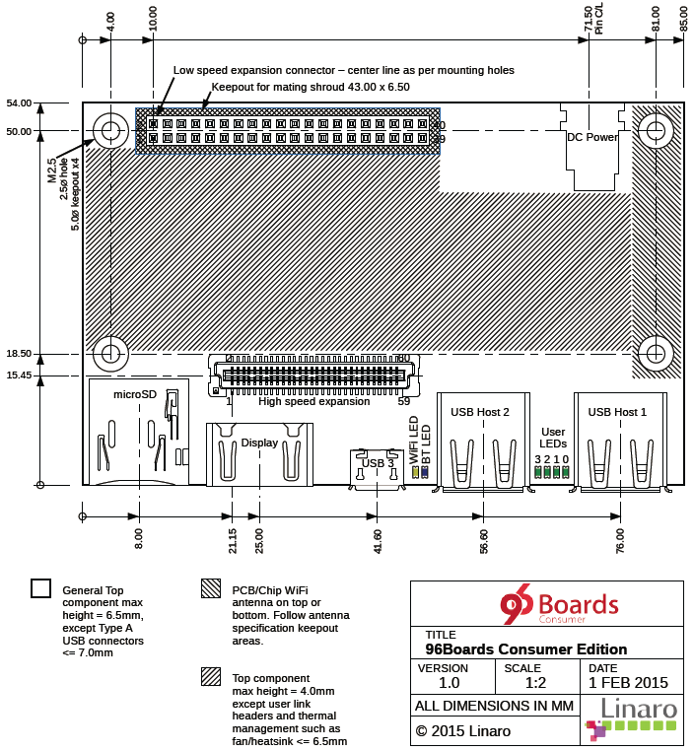

Actions(Zhuhai)Technology Co.,Limited
Address:No.1/C, Ke Ji Si Road, Hi-Tech Zone, Tangjia , Zhuhai
Tel：+86-756-3392353
Fax：+86-756-3392251
Post Code：519085
http://www.actions-semi.com
Business Email: mp-sales@actions-semi.com
Technical Service: mp-cs@actions-semi.com

