1. Stop and Wait
   1. UDP packet sent to server by client
   2. Client waits for ACK until a timeout of 1500 us.
   3. If ACK arrives send next packet
   4. If timeout occurs resend current packet

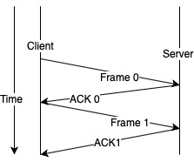

1. Sliding window

Assumes two-way communication (full duplex). It uses two types of frames:

* 1. Data
  2. Ack (sequence number of last correctly received frame)

The basic idea of sliding window protocol is that both sender and receiver keep a ``window'' of acknowledgment. The sender keeps the value of expected acknowledgment; while the receiver keeps the value of expected receiving frame. When it receives an acknowledgment from the receiver, the sender advances the window. When it receives the expected frame, the receiver advances the window.

1. Unreliable Test

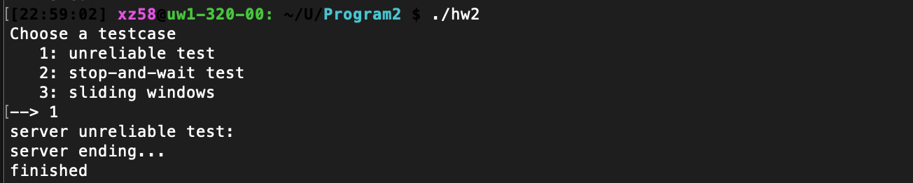

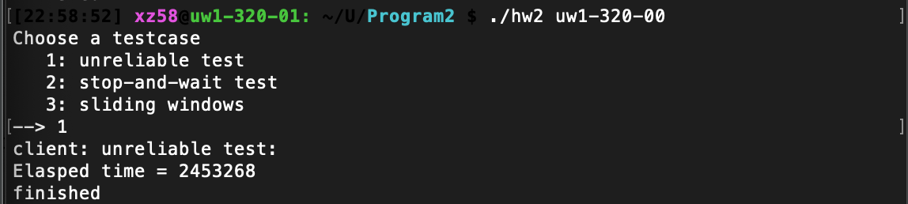

1. Stop and Wait

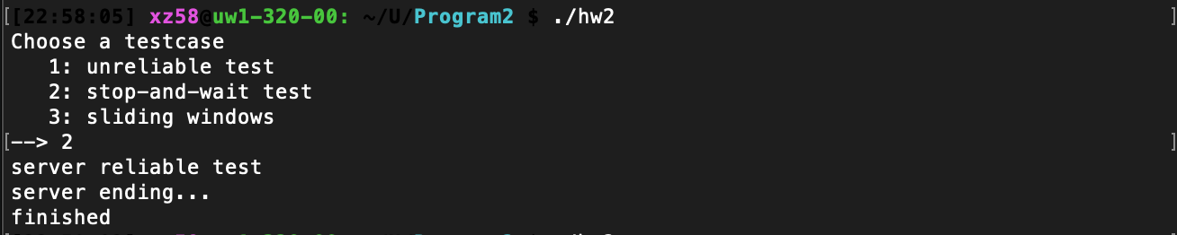

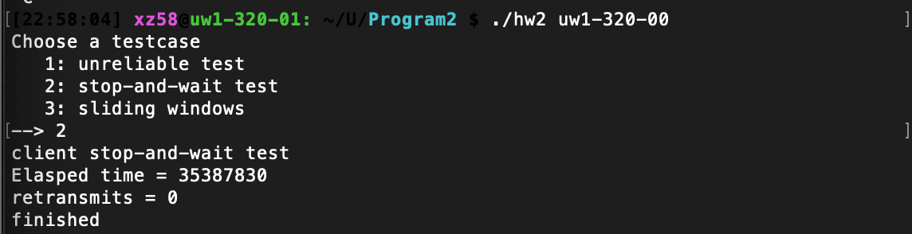

1. Sliding Window

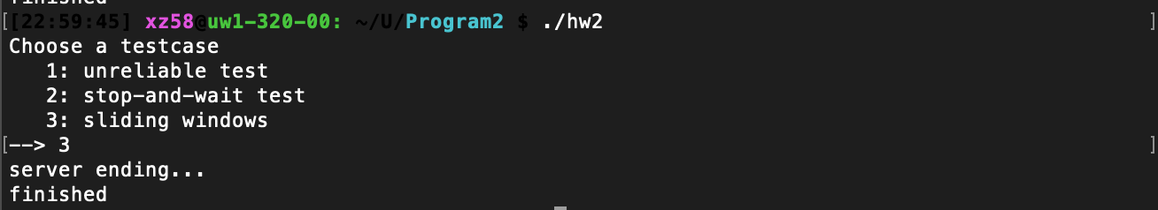

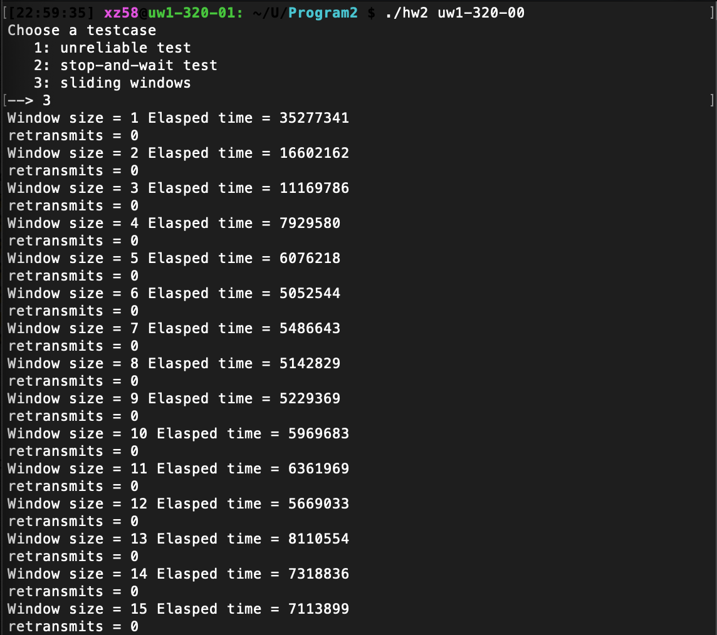

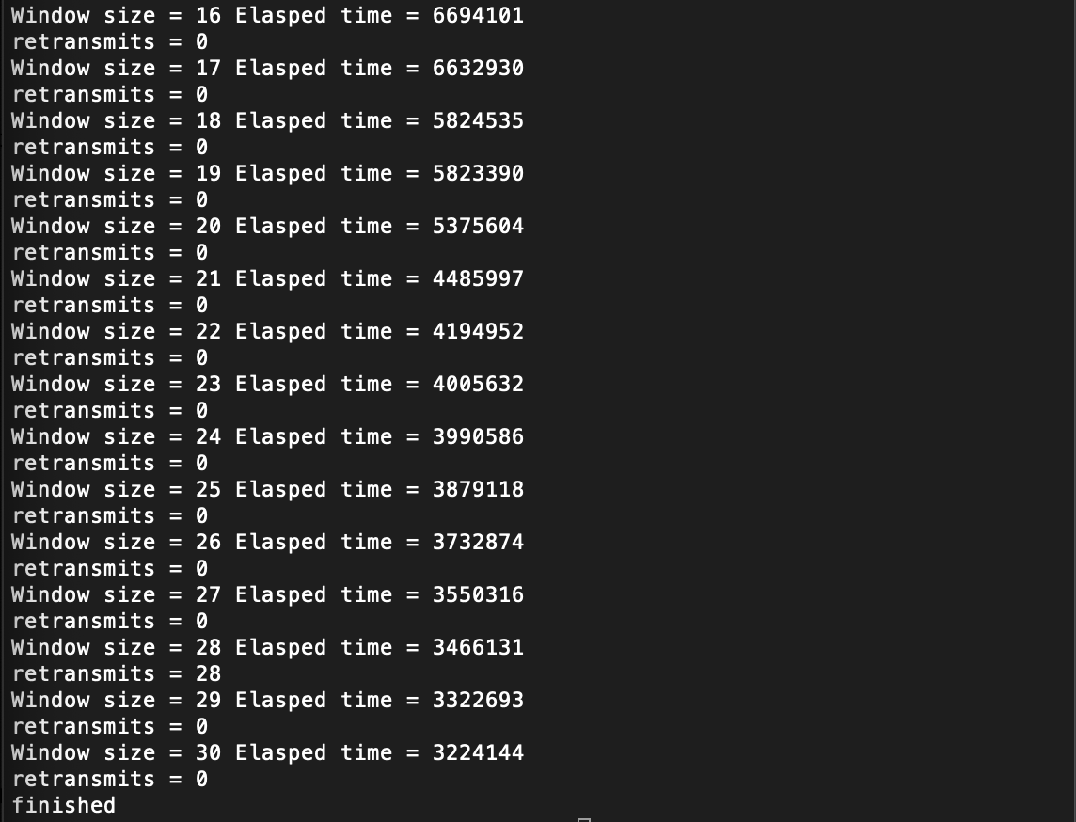

1. Performance Results

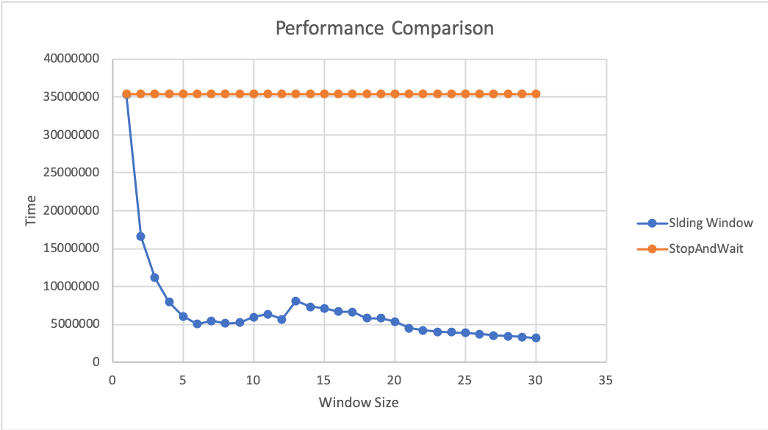

* Stop and Wait averaged at 35387830 usec.
* As we can see from above, for sliding window algorithm, Time has negative correlation with the window size, the larger window size is, the less time it takes client to send to server.
* In general, sliding window is a better fit than stop and wait on 1G network, based on the test in Linux lab.