**Master Cucumber Framework**

**Description:** It is Hybrid Framework where we are following both BDD (Behavior Driven Development) as well as DDD (Data Driven Development)

In this Framework we are getting data from feature file as well as External files such as excel file, CSV, Json, XML, property files etc.,

**Features:** This framework will help Automation Testing Companies to test their application using automation to reduce the manual time.

**Build Type**: **–** Maven.

**Code Style:** Standard.

**Technology Used:** Java, TestNg, Playwright, Cucumber(BDD), Maven.

**Design Pattern Used:** Page Object Model (POM).

**Prerequisites:** Before working with this framework an individual should know concepts of BDD and cucumber.

**Project object model (Pom.xml): -**

1) It is an XML file which provide the information about the project and configuration details used by maven to build the project.

2) We have added necessary dependencies and plugins which helps for execution.

**The Dependencies such as**

1 Selenium-Java

2 AspectJWeaver

3 WebDriver Manager

4 Java-Client

5 Jackson-Databind

6 JavaFaker

7 JSout

8 Ashot

9 ExtentReports

10 Javax.mail

11 commons io

12 monte-screen-recorder

13 Zt-zip

14 Json-Simple

15 Common-CSV

16 DOM

17 poi-ooxml

18 openCSV

19 testng

20 snakeyaml

21 awaitility

22 fillo

23 Json

24 Jsonpath

25 jna-platfrom

26 thucydides-core

27 cucumber-core

29 cucumber-reporting

30 cucumber-java

31 cucumber-testng

32 extentreports-cucumber6-adapter

33 allure-cucumber7-JVM

34 reporting plugins

35 agents-java-cucumber

**Plugins:**

1. Surefire Plugin
2. Clean Plugin
3. Compiler Plugin

**Commonly Used Files:**

1. Feature File

2. Step Definition

3. Pages class

4. Runner file

**Required Files:**

1. Utilities

2. Listeners

3. Hooks

4. Reports

**Framework Architecture:**

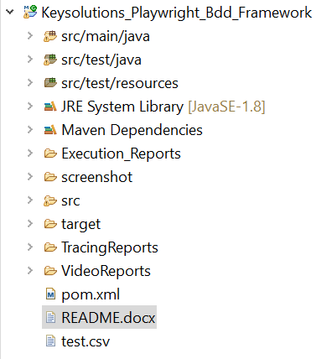

**src/main/java:**

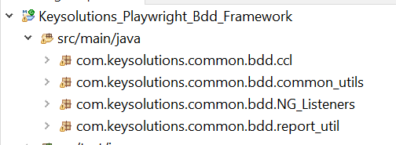

**src/test/java:**

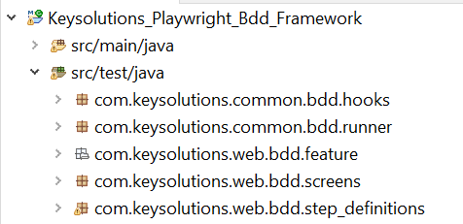

**src/test/resources:**

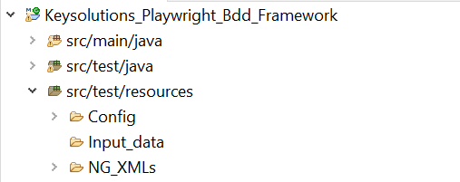

**Execution Reports / outputs:**

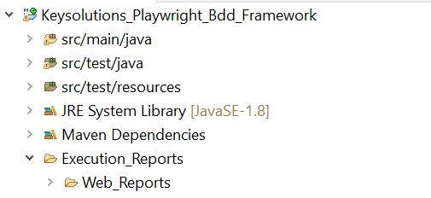

**Tests:** (Provide example how to run the code. For Example: How to run the script for Web application.)

After writing cucumber step definition file map it in a runner file

Right click on runner file -> click on run as -> click on run configuration

Double click on maven build

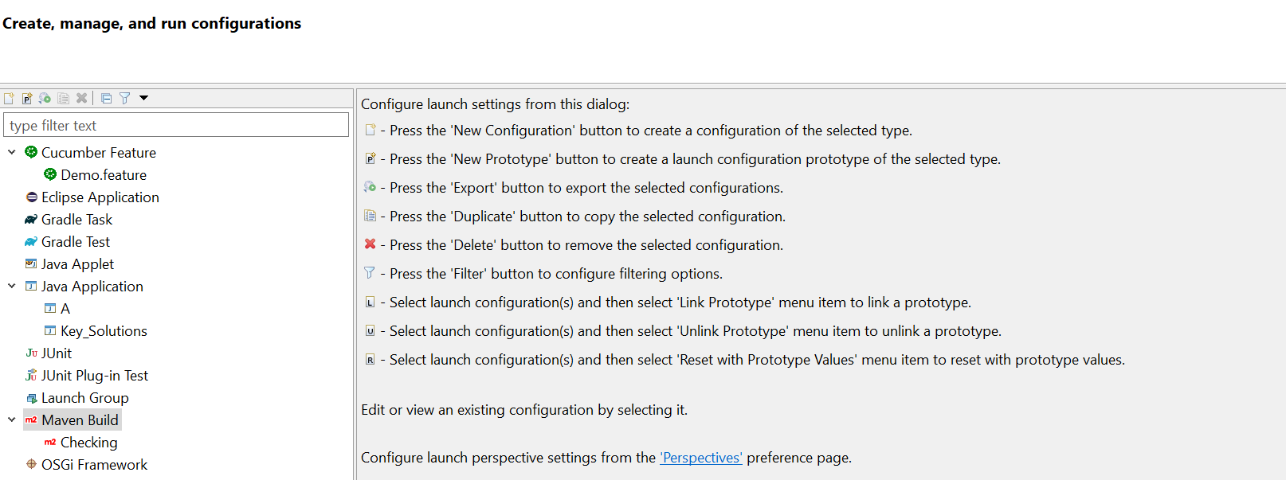

Select your running workspace and click on framework.

Add Goals

Go to JRE

Add VM Arguments

Then click on Apply and Run

**Extent Report:**



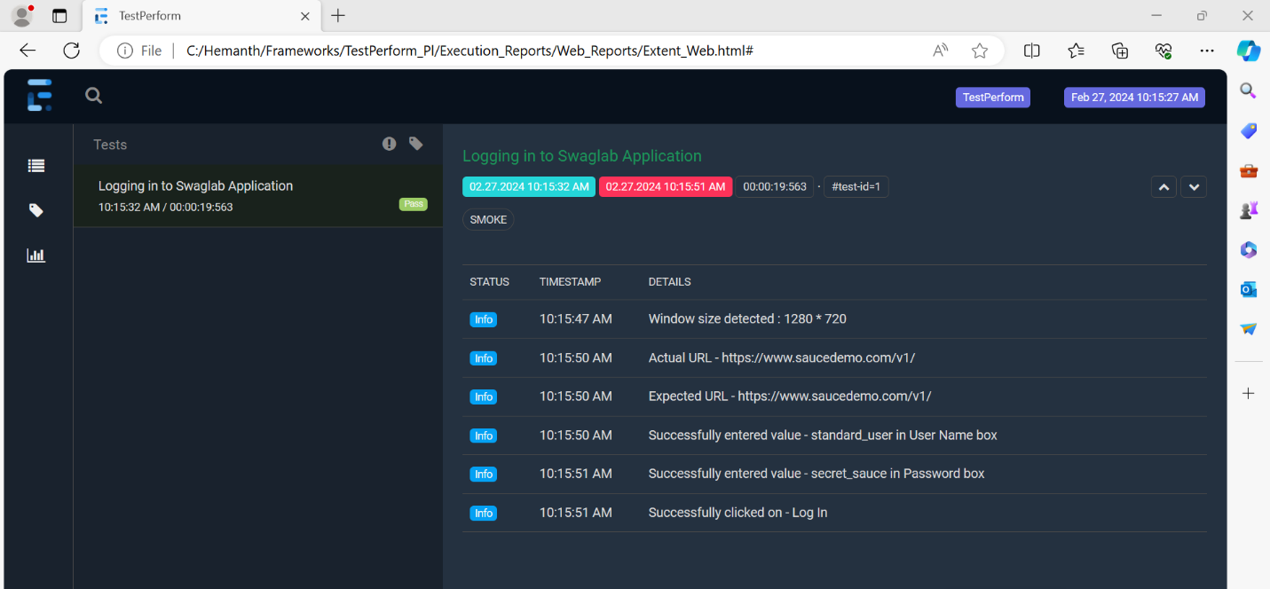

**Advanced cucumber report:**

This report will be generated after the execution completed in the console like

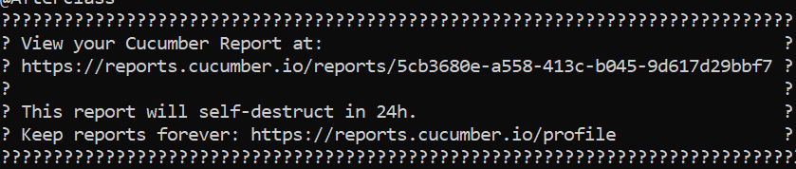

Copy the URL and paste in any of the browser the cucumber advanced report will be generated like

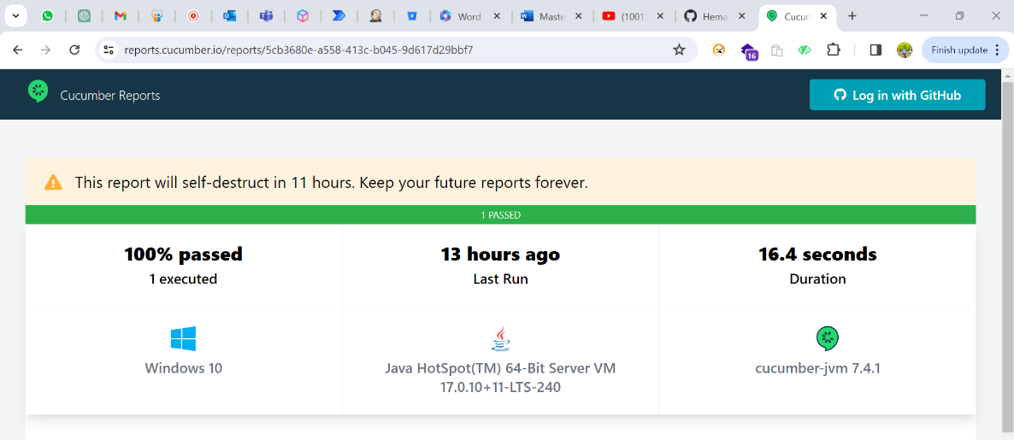

**Cucumber pretty report:**

