1. What is a network protocol? Give at least five examples of a network protocol.
   1. A network protocol defines format, order or messages sent and received among network entities, and actions taken on message transmission/receipt.
   2. TCP – Transmission Control Protocol
   3. IP – Internet Protocol
   4. HTTP – Hyper Text Transfer Protocol
   5. FTP – File Transfer Protocol
   6. UDP – User Datagram Protocol
2. List at least five types of access networks. Draw the diagram for each of the listed access networks? Explain the architecture and working for each of the listed access networks.
   1. DSL – Digital Subscriber Line
      1. Uses an existing telephone line to central office DSLAM. Data goes to Internet and voice goes to telephone net. Has less than 2.5 Mbps upstream transmission rate (typically less than 1 Mbps) and less than 24 Mbps downstream transmission rate (typically less than 10 Mbps).
      2. 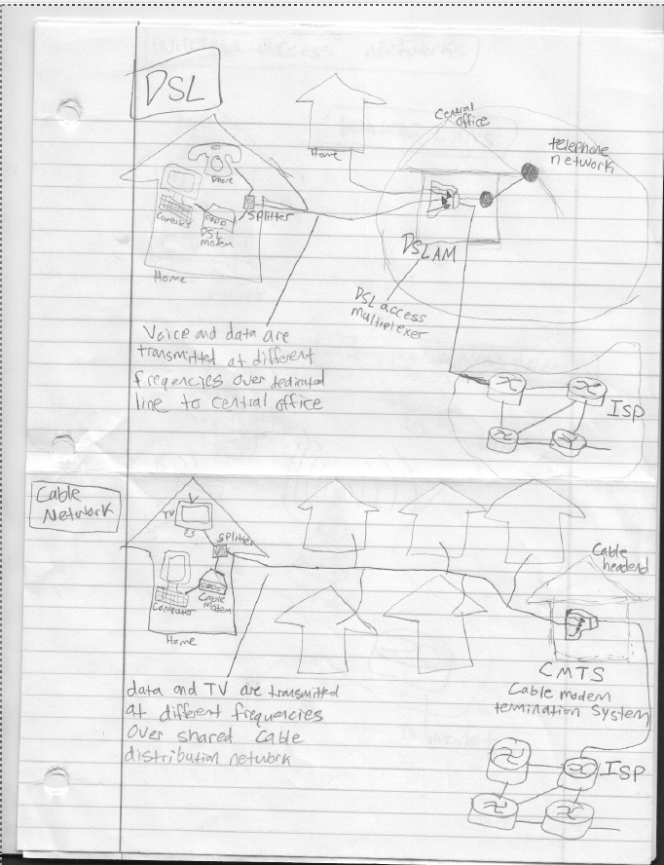diagram
   2. Cable Network
      1. Uses Frequency Division Multiplexing (FDM) which transmits different channels in different frequency bands. Uses a hybrid fiber coax (HFC) which is asymmetric and has up to 30Mbps downstream transmission rate and 2 Mbps upstream transmission rate. It is a network of cables, a fiber attaches homes to the ISP router. Homes share access network to cable headend.
      2. diagram
   3. Home Network
      1. Combines cable modems or DSL with wireless LAN technologies to create a home network. Consists of a roaming laptop a wired PC, a wireless access point, a cable modem, and a router.
      2. 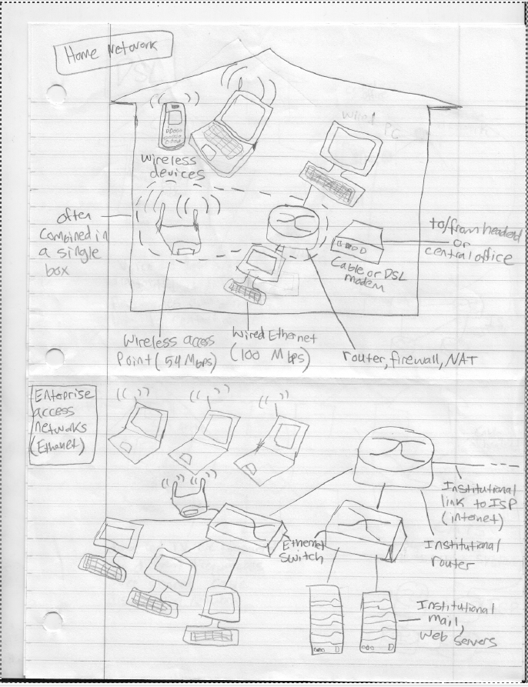diagram
   4. Enterprise Access Networks – Ethernet
      1. Usually used by companies and universities. Transmission rates are either 10 Mbps, 100Mbps, 1Gbps, or 10 Gbps. End systems usually connect into Ethernet switch.
      2. diagram
   5. Wireless Access Networks
      1. Connects end system to the router via base station/access point. There are wireless LANs and wide area wireless access.
      2. 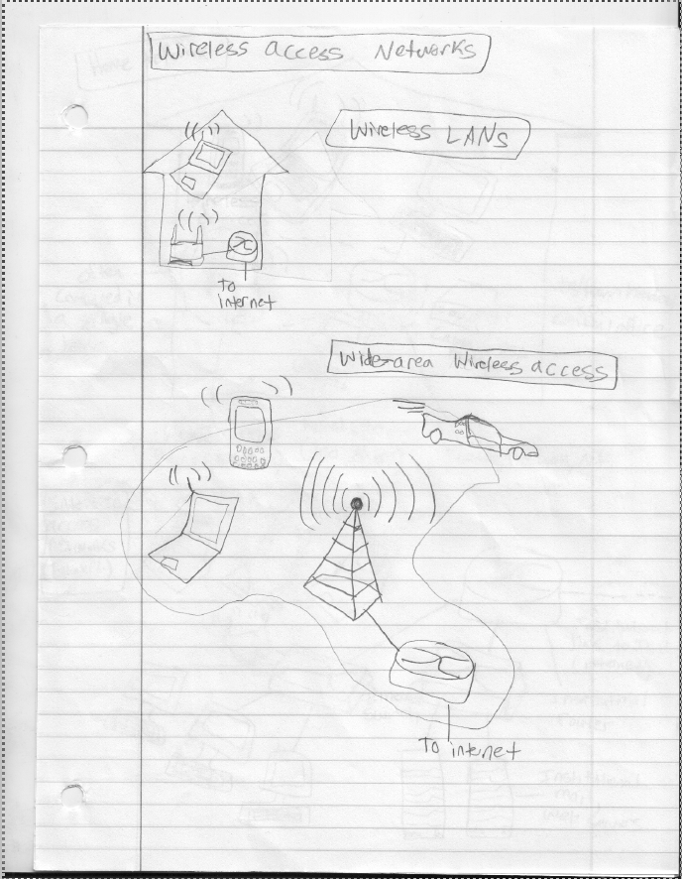Diagram wireless LANs and wide area wireless access
3. What is physical media used in networking? List the categories of physical media? Explain each category of the listed physical media. Give at least three examples of physical media in each category.
   1. Transmits bits of data between transmitter/receiver pairs through a physical link.
   2. Guided media – signals propagate in solid media
      1. Unshielded twisted pair
      2. Coaxial cable
      3. Fiber optic cable
   3. Unguided media – signals propagate freely (not through a solid media)
      1. Radio
      2. Microwave
      3. Satellite
4. How long does it take a packet of length 4KB to travel over three links (connection) with a transmission rate of 2 Mbps? These three links are connected by two routers. Assume there is no propagation delay, no processing delay, and no queuing delay.
   1. 3L/R = 3\*(4KB)/(2Mbps) = 3\*(4\*8\*10^3 bits)/(2\*10^6 bits/sec) = 0.048 seconds
5. Differentiate (at least four differences) between packet switching and circuit switching.
   1. Packet switching
      1. Packets may be dropped if the queue fills up
      2. Lost packets can be retransmitted
      3. Allows more users to use network
      4. Resource sharing
      5. Simpler, no call setup
      6. Excessive congestion possible, there is packet delay and loss if queue fills up
      7. Protocols are needed for reliable data transfer and congestion control
   2. Circuit switching
      1. End to end resources are allocated to and reserved for a call between source and destination
      2. There are dedicated resources, meaning that there is no sharing
      3. Circuit segment is idle if not being used by call
      4. Used by telephone networks
      5. Can divide users with FDM or TDM
6. Briefly explain the two key network core functionalities.
   1. Routing determines source destination route taken by packets
   2. Forwarding moves packets from router’s input to appropriate router output
7. Differentiate (at least two differences) between FDM and TDM.
   1. FDM
      1. The frequency spectrum of a link is divided up among the connections established across the link.
      2. Each circuit continuously gets a fraction of the bandwidth.
   2. TDM
      1. Time is divided into frames of fixed duration, and each frame is divided into a fixed number of time slots.
      2. Each circuit gets all of the bandwidth periodically during brief time intervals.