1. Explain Boolean algebra precedence.
   1. The order of precedence is to first evaluate expressions in parentheses. Then evaluate the NOT’s from left to right. Then evaluate the AND’s from left to right. Then evaluate the OR’s from left to right.
2. List at least eight properties (laws) of Boolean algebra with their equivalent Boolean expressions?
   1. Commutative
      1. X*Y = Y*X
      2. X+Y = Y+X
   2. Associative
      1. X*(Y*Z) = (X*Y)*Z
      2. X+(Y+Z) = (X+Y)+Z
   3. Distributive
      1. X*(Y+Z) = X*Y + X*Z
      2. X+(Y*Z) = (X+Y)*(X+Z)
   4. Absorption
      1. X+X*Y = X
      2. X*(X+Y) = X
   5. Combining
      1. X*Y+X $\overline{Y}$* = X
      2. (X+Y)*(X+ $\overline{Y}$) = X
   6. Null Elements
      1. X+1 = 1
      2. X*0 = 0
   7. Idempotent Law
      1. X+X=X
      2. X*X=X
   8. Involution Law
      1. $\overline{\overline{X}}$ = X
3. State DeMorgan’s Laws for three input variables?
   1. $\overline{A+B+C }$ = $\overline{A}$ $\overline{B}$ $\overline{C}$

$\overline{A*B*C}$* *
   2. = $\overline{A}$ + $\overline{B}$ + $\overline{C}$
4. What are universal gates? Why is it called so and describe them with their truth table?
   1. The universal gates are NAND and NOR gates. They are called universal gates because you can create all other types of gates with only NAND or NOR gates.

|  |  |  |
| --- | --- | --- |
| NAND Truth Table | | |
| Input A | Input B | Output Y |
| 0 | 0 | 1 |
| 0 | 1 | 1 |
| 1 | 0 | 1 |
| 1 | 1 | 0 |

|  |  |  |
| --- | --- | --- |
| NOR Truth Table | | |
| Input A | Input B | Output Y |
| 0 | 0 | 1 |
| 0 | 1 | 0 |
| 1 | 0 | 0 |
| 1 | 1 | 0 |

1. 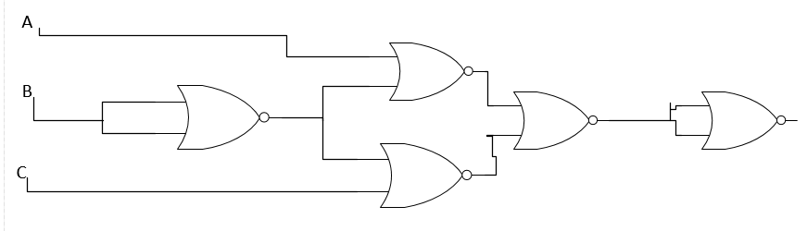Draw the gate level circuit for the function G1(a, b, c) = a’b + bc’ using only NOR gate.
$\overline{(A}B)+(B\overline{C})=\overset{̿}{\overline{A}B+B\overline{C}}=\overline{\overline{\overline{A}B}*\overline{B\overline{C}}}=\overline{\overset{̿}{A}+\overline{B}*\overline{B}+\overset{̿}{C}}=\overline{A+\overline{B}*\overline{B}+C}=\overline{A+\overline{B}}+\overline{\overline{B}+C}=\overset{̿}{\overline{A+\overline{B}}+\overline{\overline{B}+C}}$

2. Draw the gate level circuit for the function G2(a, b, c) = (a’+b’)(a+c) using only NAND gate.
   1. 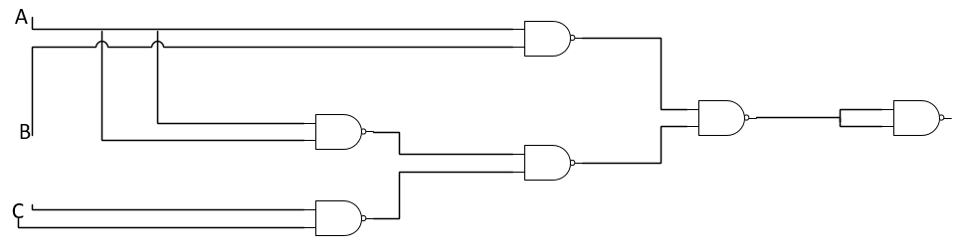($\overline{A}+\overline{B})*\left(A+C\right)= \overset{̿}{\left(\overline{A}+\overline{B}\right)*\left(A+C\right)}=\overset{̿}{\overline{\overline{A}+\overline{B}}+\overline{A+C}}=\overline{\overset{̿}{A}*\overset{̿}{B}+\overline{A}*\overline{C}}=\overline{A*B+\overline{A}*\overline{C}}=\overline{AB}*\overline{\overline{A}*\overline{C}}=\overset{̿}{\overline{A*B}*\overline{\overline{A}*\overline{C}}}$
3. Evaluate the function F1(a, b, c) = ab’c + a’bc’ + a’b + b’c and F2(a, b, c) = a’bc + abc + b’c’ + ac’ when:
   1. a = 1, b = 1, and c = 0
      1. F1(1,1,0) = 1 $\overline{1}$**0 + $\overline{1}$*1 $\overline{0}$* + $\overline{1}$*1 + $\overline{1}$*0

= 1*0*0 + 0*1*1 + 0*1 + 0*0

= 0 + 0 + 0 + 0

= 0

* + 1. F2(1,1,0) = *1*0 + 1*1*0 + * + 1*

= 0*1*0 + 1*1*0 + 0*1 + 1*1

= 0 + 0 + 0 + 1

= 1

* 1. a = 0, b = 0, and c = 0
     1. F1(0,0,0) = 0 $\overline{0}$**0 + $\overline{0}$*0 $\overline{0}$* + $\overline{0}$*0 + $\overline{0}$*0

= 0*1*0 + 1*0*1 + 1*0 + 1*0

= 0 + 0 + 0 + 0

= 0

* + 1. F2(0,0,0) = *0*0 + 0*0*0 + $\overline{0}$ $\overline{0}$* + 0 $\overline{0}$

*

= 1*0*0 + 0*0*0 + 1*1 + 0*1

= 0 + 0 + 1 + 0

= 1

1. Use algebraic manipulation to convert the following function F3 (a, b, c, d) = a’(c + b) + a(b’ + c)’ + a’(b + d)’c to sum-of-products (SOP) form and simplify the function. Clearly state the laws, axioms, and identities used.

|  |  |
| --- | --- |
| $$F3\left(A,B,C,D\right)=\overline{A}\left(C+B\right)+A\left(\overline{\overline{B}+C}\right)+\overline{A}\left(\overline{B+D}\right)C$$ | |
| $\overline{A}C+\overline{A}B+A\left(\overline{\overline{B}+C}\right)+\overline{A}$ ( $\overline{B+D})C$ | distributive |
| $\overline{A}C$ + $\overline{A}B$ +A( $\overset{̿}{B}\overline{C})+\overline{A}\left(\overline{B+D}\right)C$ | Demorgans |
| $\overline{A}C$ + $\overline{A}B$ +A( $B\overline{C})+\overline{A}\left(\overline{B+D}\right)C$ | Involution |
| $\overline{A}C$ + $\overline{A}B$ +A( $\overset{̿}{B}\overline{C})+\overline{A}\left(\overline{B}*\overline{D}\right)C$ | Demorgans |
| $\overline{A}C$ + $\overline{A}B$ +A( $\overset{̿}{B}\overline{C})+\overline{A}*\overline{B}*\overline{C}*\overline{D}$ | Commutative |
| $$\overline{A}C+B\overline{C}$$ | KMAP (below) to simplify |

|  |  |  |  |  |  |  |  |  |  |
| --- | --- | --- | --- | --- | --- | --- | --- | --- | --- |
|  |  |  |  |  | D | C | D | C | $$\overline{D}$$ |
| $\overline{A}$ | $\overline{B}$ | 0 | | 0 | | 1 | | 1 | |
| $\overline{A}$ | B | 1 | | 1 | | 1 | | 1 | |
| A | B | 1 | | 1 | | 0 | | 0 | |
| A | $\overline{B}$ | 0 | | 0 | | 0 | | 0 | |

1. Is function F1 described in question 7 equal to ab’c + a’bc’ + a’bc + a’b’c. Use Boolean algebra laws, axioms, and identities to show if the functions are equal. Clearly state the laws, axioms, and identities used.

|  |  |
| --- | --- |
| $A\overline{B}C+\overline{A}B\overline{C}+\overline{A}B+\overline{B}C$ | |
| $A\overline{B}C+B(\overline{A}\overline{C}+\overline{A})+\overline{B}C$ | Distributive |
| $A\overline{B}C+B(\overline{A}(\overline{C}+1))+\overline{B}C$ | Distributive |
| $A\overline{B}C+B(\overline{A}(1))+\overline{B}C$ | Theorem 2 |
| $A\overline{B}C+\overline{A}B+\overline{B}C$ | Theorem 3 |
| $\overline{B}C(A+1)+\overline{A}B$ | Distributive |
| $\overline{B}C(1)+\overline{A}B$ | Theorem 2 |
| $\overline{B}C+\overline{A}B$ | Theorem 3 |

|  |  |
| --- | --- |
| A $\overline{B}C$ + $\overline{A}B\overline{C}+\overline{A}BC+\overline{A}\overline{B}C$ | |
| A $\overline{B}C$ + $\overline{A}(B\overline{C}+BC+\overline{B}C)$ | Distributive |
| A $\overline{B}C$ + $\overline{A}(B(\overline{C}+C)+\overline{B}C)$ | Distributive |
| A $\overline{B}C$ + $\overline{A}(B(1)+\overline{B}C)$ | Theorem 8 |
| A $\overline{B}C$ + $\overline{A}(B+\overline{B}C)$ | Theorem 3 |
| A $\overline{B}C$ + $\overline{A}B+\overline{A}\overline{B}C$ | Distributive |
| $\overline{B}\left(AC+\overline{A}C\right)+\overline{A}B$ | Distributive and commutative |
| $\overline{B}\left(C(A+\overline{A})\right)+\overline{A}B$ | Distributive |
| $\overline{B}\left(C(1)\right)+\overline{A}B$ | Theorem 8 |
| $\overline{B}C+\overline{A}B$ | Theorem 3 |

YES, the functions are equal.

1. Is function F2 described in question 7 equal to ab’c + a’bc’ + abc’ + abc. Use Boolean algebra laws, axioms, and identities to show if the functions are equal. Clearly state the laws, axioms, and identities used.

|  |  |
| --- | --- |
| $\overline{A}BC+ABC+\overline{B}\overline{C}+A\overline{C}$ | |
| $B(\overline{A}C+AC)+\overline{B}\overline{C}+A\overline{C}$ | Distributive |
| $B(C(\overline{A}+A))+\overline{B}\overline{C}+A\overline{C}$ | Distributive |
| $B(C(1))+\overline{B}\overline{C}+A\overline{C}$ | Theorem 8 |
| $BC+\overline{B}\overline{C}+A\overline{C}$ | Theorem 3 |

|  |  |
| --- | --- |
|  | |
|  | Distributive |
| $A\overline{B}C+B(\overline{C}(\overline{A}+A)+AC)$ | Distributive |
| $A\overline{B}C+B(\overline{C}(1)+AC)$ | Theorem 8 |
| $A\overline{B}C+B(\overline{C}+AC)$ | Theorem 3 |
| $A\overline{B}C+B\overline{C}+ABC$ | Distributive |
| $C\left(A\overline{B}+AB\right)+B\overline{C}$ | Distributive |
| $C\left(A(\overline{B}+B)\right)+B\overline{C}$ | Distributive |
| $C\left(A(1)\right)+B\overline{C}$ | Theorem 8 |
| AC+B $\overline{C}$ | Theorem 3 |

NO, the functions are not equal.

1. A museum has three rooms, each with a PIR (motion) sensor (P1, P2, and P3) that outputs 1 when motion is detected. A security guard walks from room to room at night to monitor the rooms. The alarm system in the museum sounds an alarm (by setting the output to 1) if motion is detected in more than one room at a time. Express the alarm system as a simplified Boolean function. Draw the gate-level circuit for the simplified alarm system. Use only AND, OR, and NOT gates. Clearly state the assumptions made, if any.

|  |  |  |  |
| --- | --- | --- | --- |
| P1 | P2 | P3 | Output |
| 0 | 0 | 0 | 0 |
| 0 | 0 | 1 | 0 |
| 0 | 1 | 0 | 0 |
| 0 | 1 | 1 | 1 |
| 1 | 0 | 0 | 0 |
| 1 | 0 | 1 | 1 |
| 1 | 1 | 0 | 1 |
| 1 | 1 | 1 | 1 |

Kmap to get simplified function

|  |  |  |  |
| --- | --- | --- | --- |
|  |  | $\overline{P3}$ | P3 |
| $\overline{P1}$ | $\overline{P2}$ | 0 | 0 |
| $\overline{P1}$ | P2 | 0 | 1 |
| P1 | P2 | 1 | 1 |
| P1 | $\overline{P2}$ | 0 | 1 |

Function: P2P3+P1P3+P1P2

