1. **Delete database “Knowledge”**
2. Click “Restore Database...”

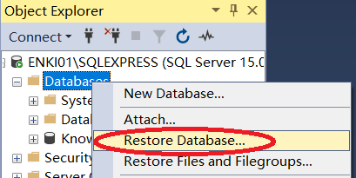

1. Choose Device as source and add the .bak file. Click “OK”,

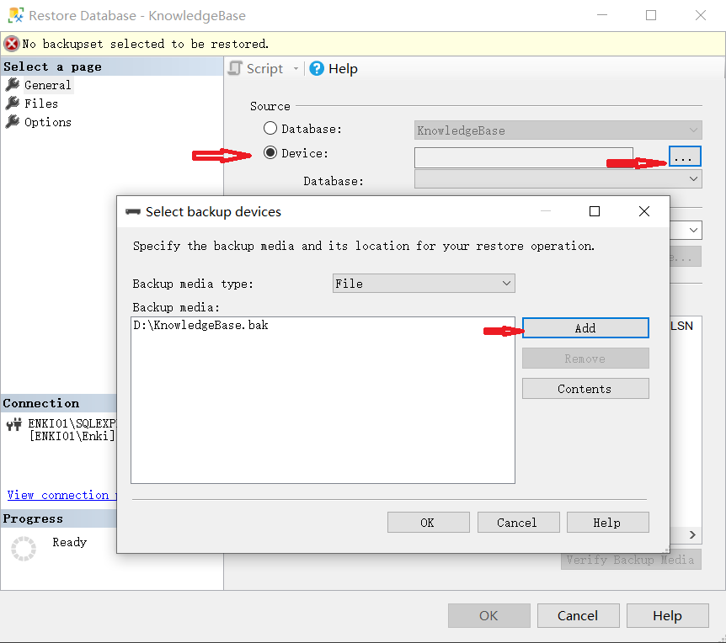

1. click “OK”

