step-1: copy paste below link in the browser

<https://www.eclipse.org/downloads/>

step2:

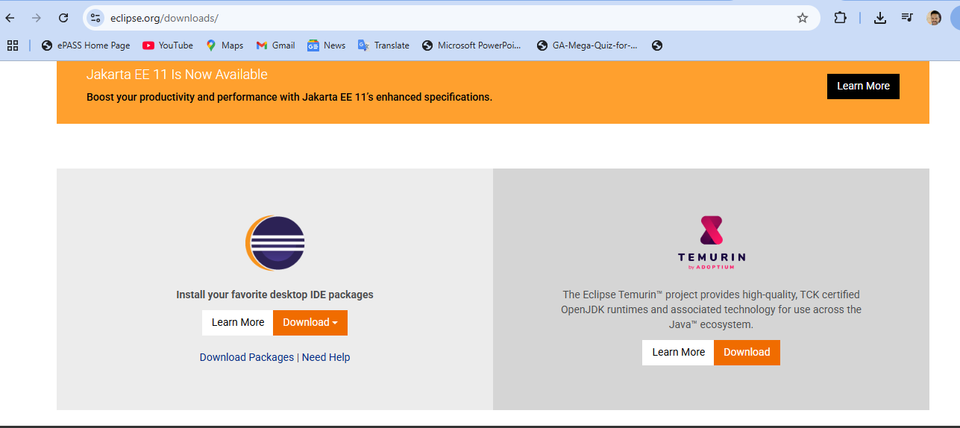

Step3: select the first option under the downloads:

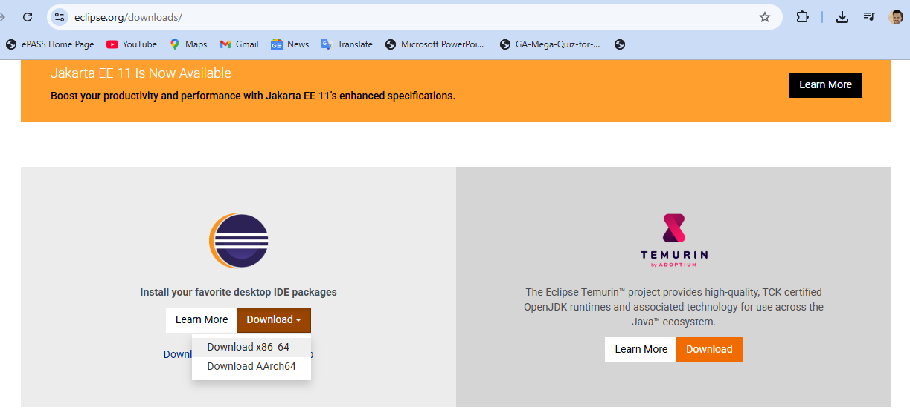

Than it will be do.

