DocumentStatus:Approved

Reviewed by:
Approved by:

Revision / Document History
Ver. | Date | Changed by | Modifications
1.0 | 21/07/2025 | Routhu Rambabu | Initial version of document, Database design is included in this document, review changes implemented
Note: Present content to be deleted and revision history to be updated with project's document history, when used in Projects

List of Abbreviations

DFD Data Flow Diagram
ER Entity Relationship
FHD Function Hierarchy Diagram
HLD High Level Design
LLD Low Level Design
GUI Graphical User Interface
IEEE Institute of Electrical and Electronic Engineers
S/W Software
SDL Specification Description Language
StrD Structured

TABLE OF CONTENTS
1. INTRODUCTION 4
2. DESIGN SCOPE 4
3. DESIGN METHODOLOGY 4
4. DESIGN NOTATIONS 4
5. DESIGN CONSIDERATIONS 5
6. DESIGN OVERVIEW 5

7. DECOMPOSITION 6 - 18

DH-1-1 Appointment

DH-1-2 Users

DH-1-3 Roles

DH-1-4 Patient

DH-1-5 Doctor

DH-1-6 Doctor Rating

DH-1-7 Medical Records

DH-1-8 OTP

DH-1-9 Prescriptions

DH-1-10 Diagnostic Tests

DH-1-11 Bill

DH-1-12 Bill Items

DH-1-13 Registration

DH-1-14 Nurse CheckUps

DH-1-15 AppointmentServiceImpl

DH-1-16 RoleServiceImpl

DH-1-17 UserServiceImpl

DH-1-18 PatientServiceImpl

DH-1-19 DoctorServiceImpl

DH-1-20 DoctorRatingServiceImpl

DH-1-21 BillServiceImpl

DH-1-22 BillItemServiceImpl

DH-1-23 RegistrationServiceImpl

DH-1-24 NurseCheckUpsServiceImpl

DH-1-25 MedicalRecordsServiceImpl

DH-1-26 PrescriptionsServiceImpl

DH-1-27 DiagnosticTestsServiceImpl

DH-1-28 OtpServiceImpl
8. INTERFACE DESIGN 18
8.1 User Interface 18
9. DATA DESIGN
9.1 Data structure (data types, arrays, and structures) 20
10. REUSABILITY 20
11. DESIGN ALTERNATIVES
13. ADDITIONAL HARDWARE AND SOFTWARE REQUIRED 21
14. TESTING STRATEGY 21
15. TRACEABILITY MATRIX 21
16. REFERENCES 21

Introduction

This project aims to create a digital solution for Sarvotham's Spine Care hospital to efficiently manage outpatient appointments and treatments. The system will automate patient registration, doctor assignments, and status tracking to replace manual record-keeping. It enables seamless coordination between front desk staff, doctors, nurses and billing departments. Patients gain online access to their medical records, test results and payment information. The platform will improve hospital operations by reducing wait times and administrative workload. Ultimately, it enhances patient care through better organization and real-time information sharing across all departments.

Design Scope

The Outpatient Schedule Tracking System project is designed to transform the manual appointment and patient management processes at Sarvotham's Spine Care into a comprehensive digital solution.The system's scope encompasses all key aspects of outpatient care management, from initial patient registration through final billing, while specifically excluding inpatient services and other hospital operations. It will establish an integrated platform for scheduling appointments, tracking patient flow, managing doctor assignments, recording treatments, processing diagnostic reports, and handling billing operations. The solution focuses on creating seamless coordina tion between front desk staff, medical professionals, support personnel, and billing departments, while providing patients with secure access to their health information. Importantly, the project scope is carefully bounded to outpatient services only, explicitly excluding inpatient care management, pharmacy operations, inventory control, and human resources functions to maintain focus on core outpatient workflow improvements. By implementing this system, the hospital aims to significantly enhance operational efficiency, reduce administrative burdens, and improve the overall quality of patient care through digitization and process optimization.

1. Doctor
a. Manage clinic availability (days/times) with specialization-specific slots for spine care consultations.
b. Review and confirm outpatient appointment requests (accept/decline with reasons).
c. Access and update spine treatment plans, diagnostic reports (X-rays/MRIs), and prescription records during consultations.
d. Track patient progress across visits with integrated medical history and prior consultation notes.
2. Patient
a. Search for spine specialists by availability, expertise (e.g., disc herniation, scoliosis), and consultation fees.
b. Book/reschedule/cancel in-person or follow-up appointments with real-time slot validation.
c. View/upload spine-related documents (MRI reports, prescriptions) to their profile.
d. Receive notifications for appointment reminders, test results, and billing updates.
e. Access digital bills with itemized charges (consultation, tests, physiotherapy sessions).
3. Support Staff (Nurses/Lab Technicians)
a. Update pre-consultation vitals and spine-specific health metrics (e.g., pain levels, mobility range).
b. Upload and label diagnostic reports (CT scans, nerve tests) linked to patient records.
c. Assist in appointment prioritization based on urgency (e.g., acute pain cases).
4. Front Desk
a. Assign patients to spine specialists based on symptoms and doctor availability.
b. Monitor real-time appointment statuses (checked-in, in-progress, discharged).
c. Handle walk-ins by integrating them into the digital queue.
5. Billing Desk
a. Generate spine treatment-specific bills (consultation, procedures, braces/equipment).
b. Process insurance claims for spine-related treatments with coverage validation.

Design Methodology
Object Oriented Analysis and Design (OOAD) methodology has been used for breaking down the
specification into functionally independent units.

Design Notations
The naming conventions followed conform to Unified Modelling Language (UML) as Object Oriented
Analysis and Design (OOAD) is followed.

Design Considerations
Not Applicable.

6. Design Overview

Appointment Microservice

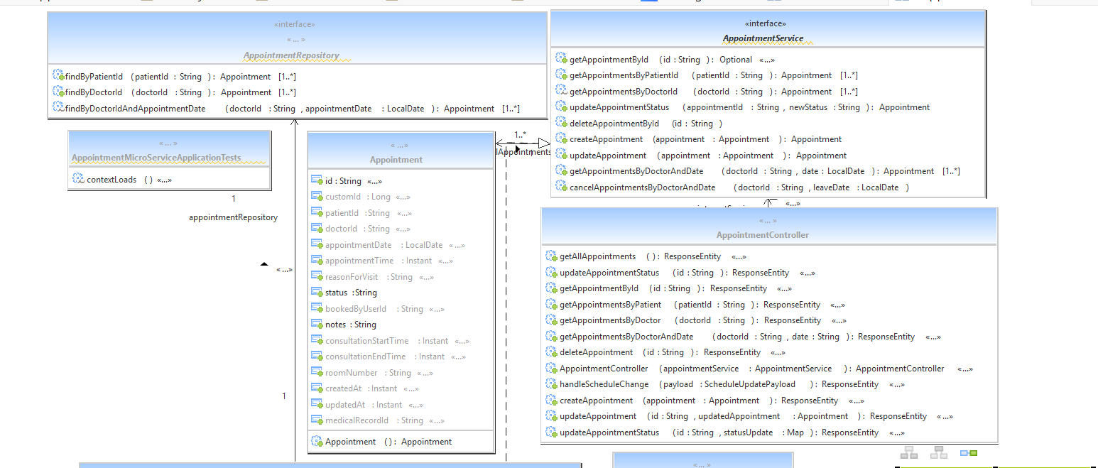

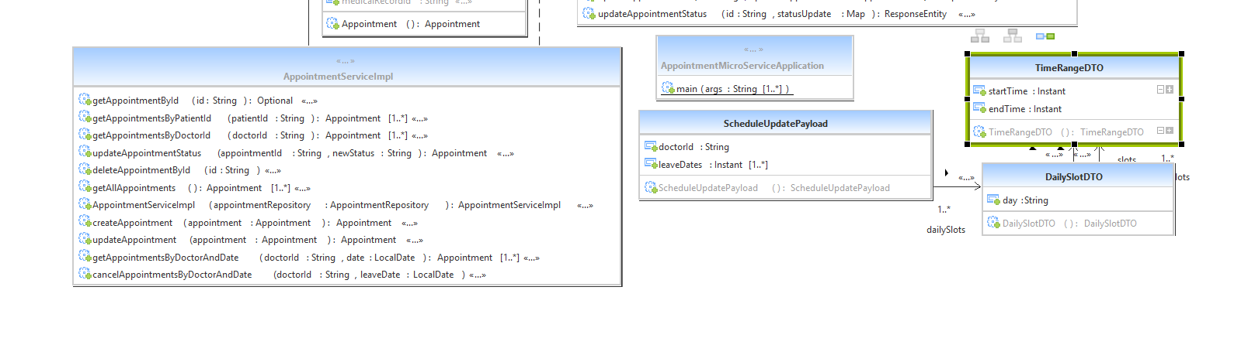

Bill Microservice :

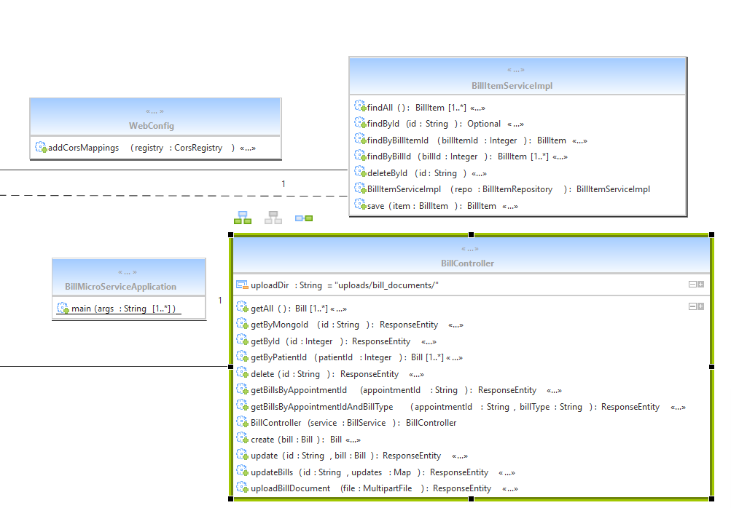

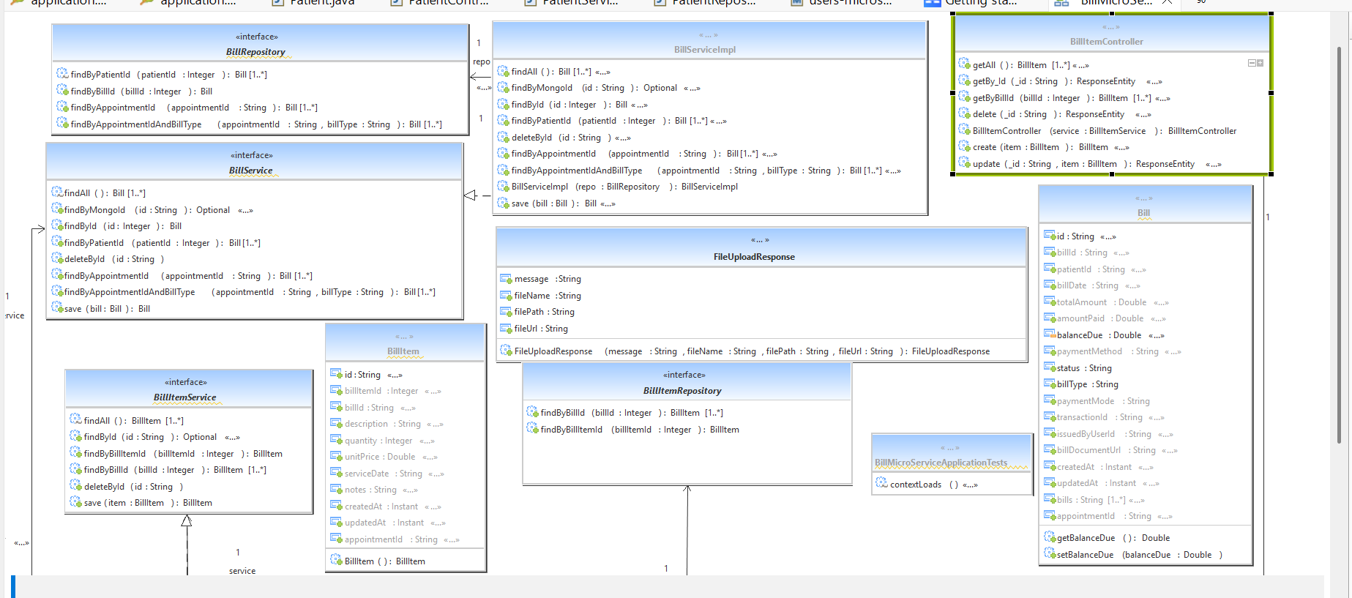

Doctor MicroService

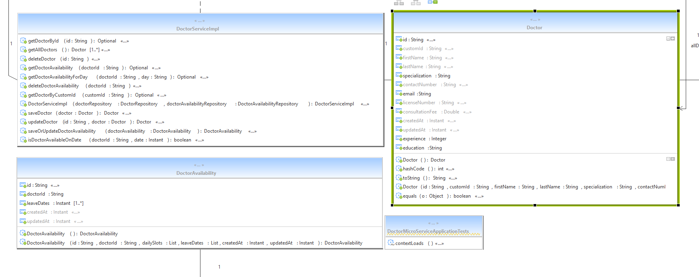

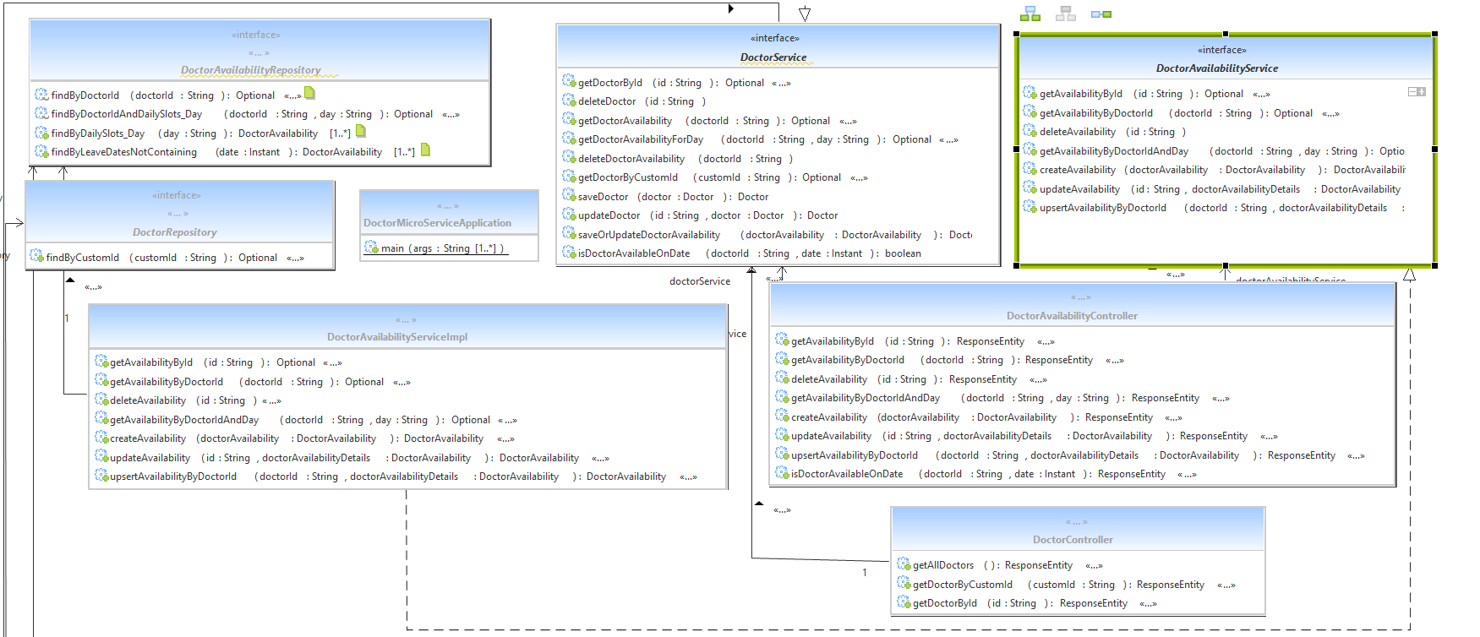

DoctorRating MicroService

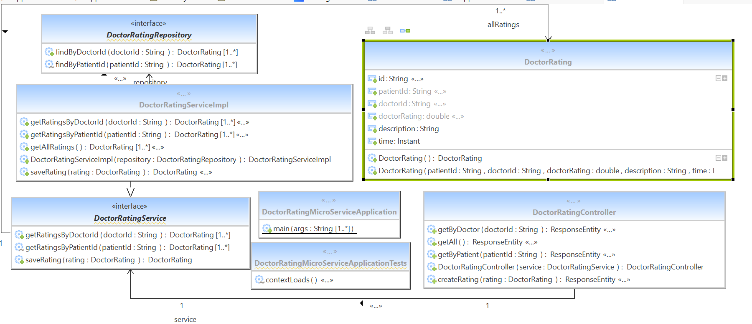
Email MicroService



Login Microservice

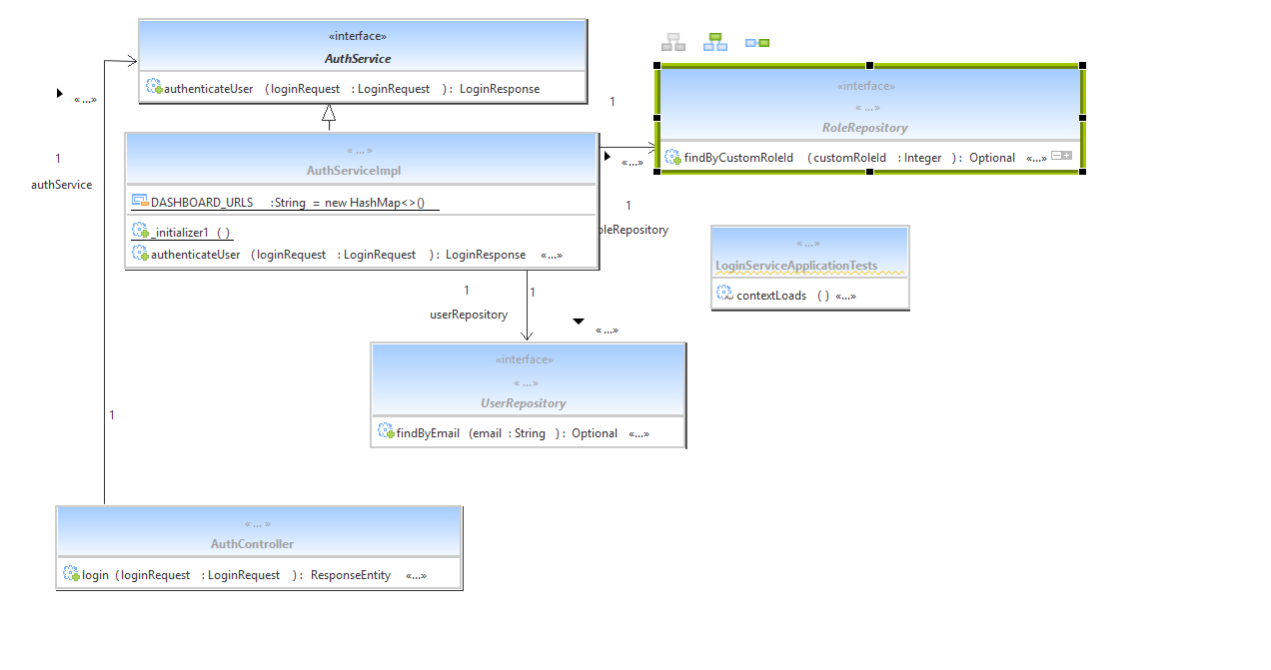

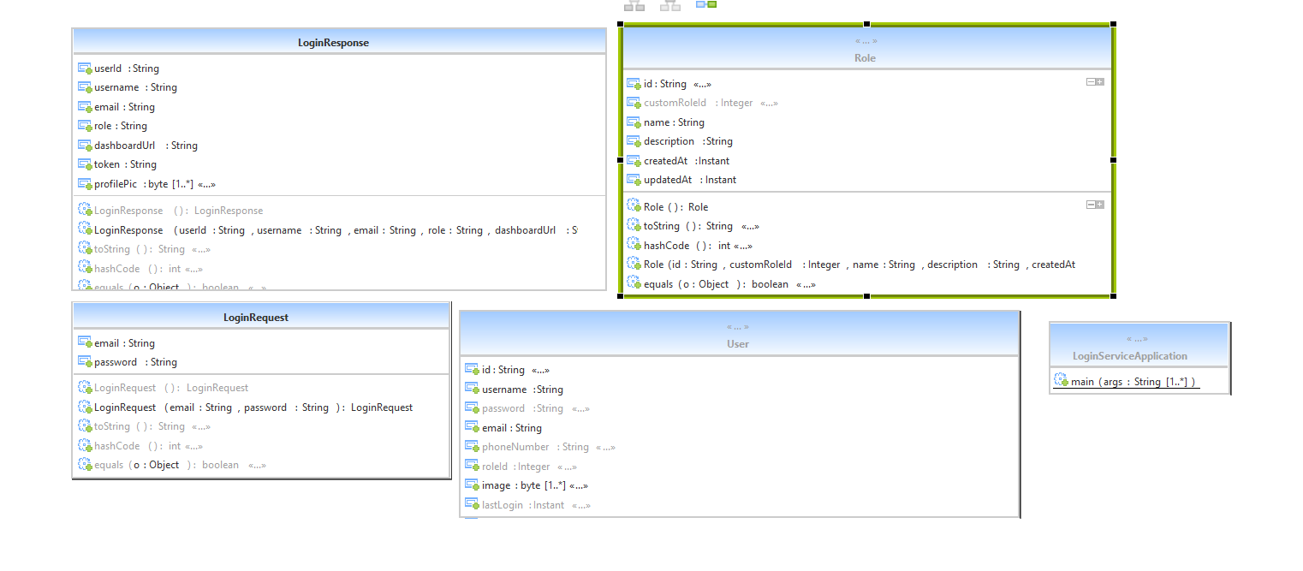

Nurse Chcekup MicroService

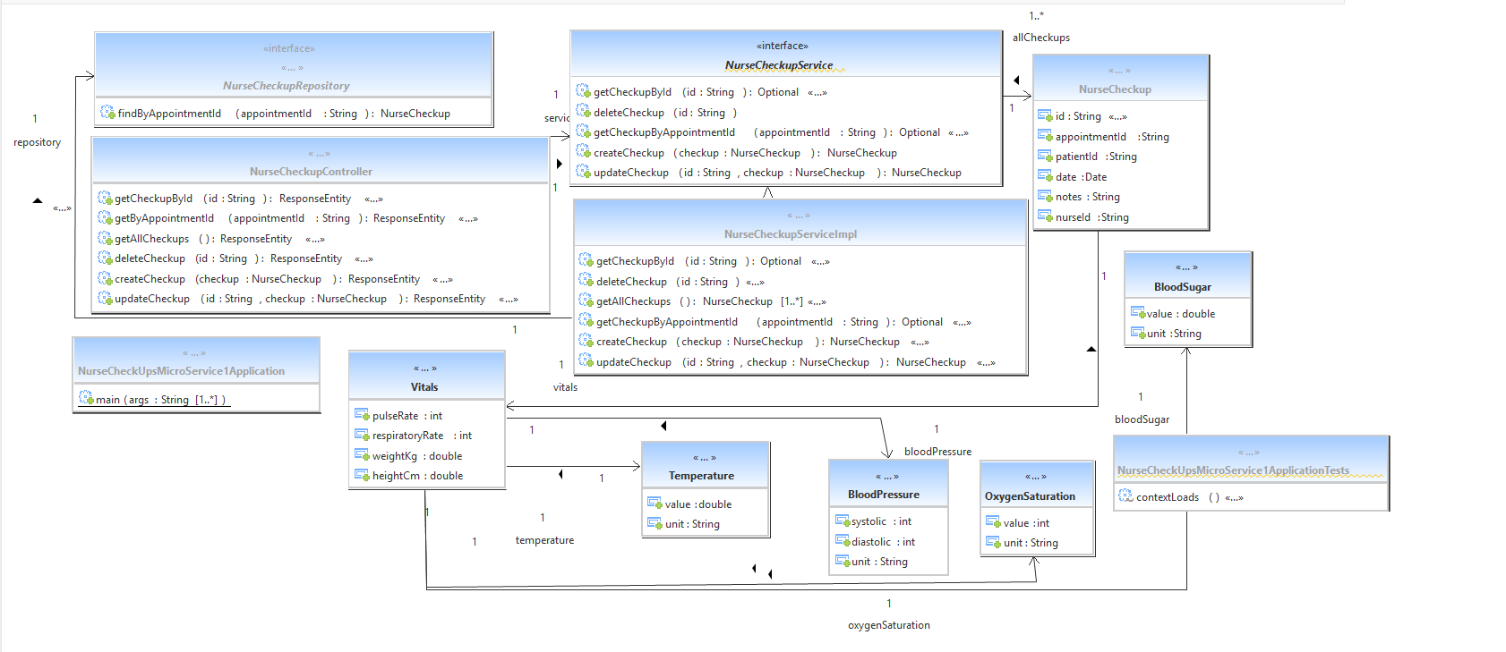

OTP MicroService

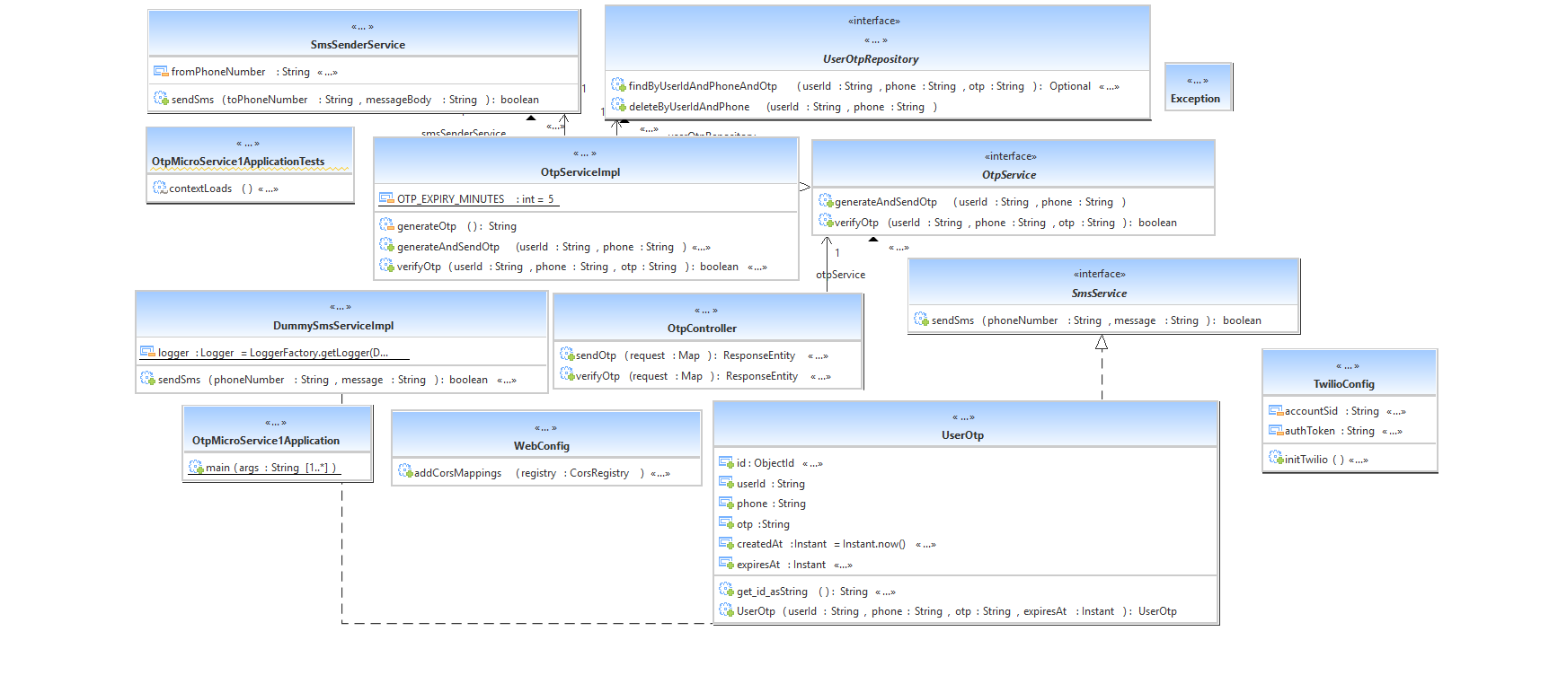

Patient MicroService

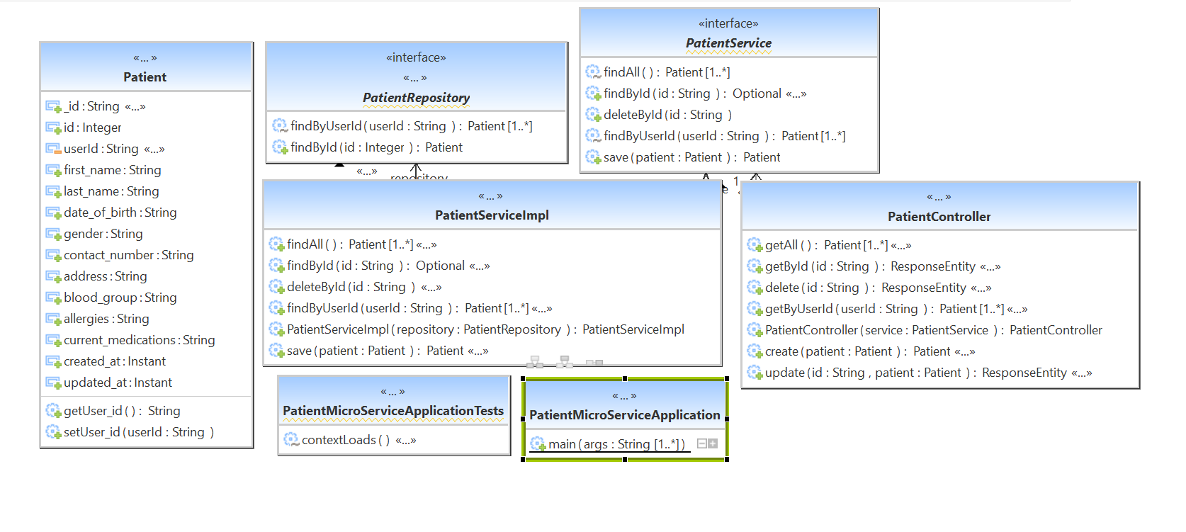

Registration MicroService

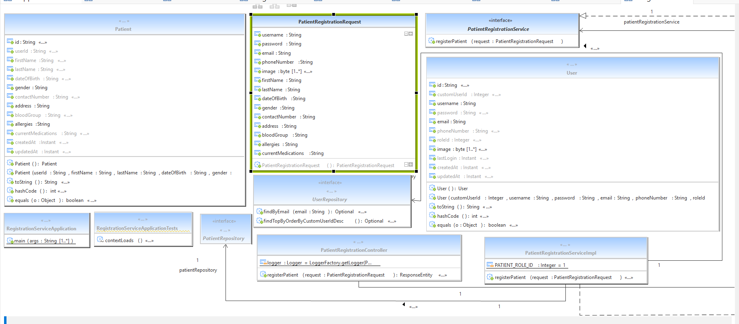

Role Microservice

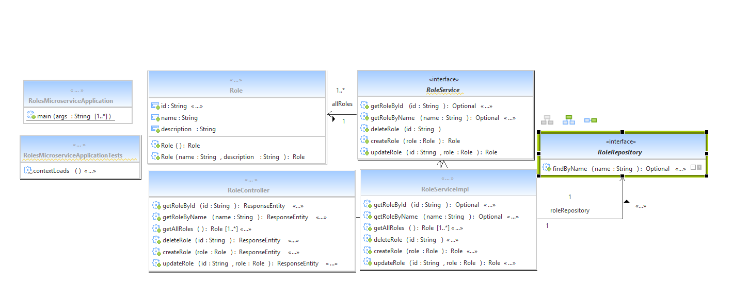

UserMicroService

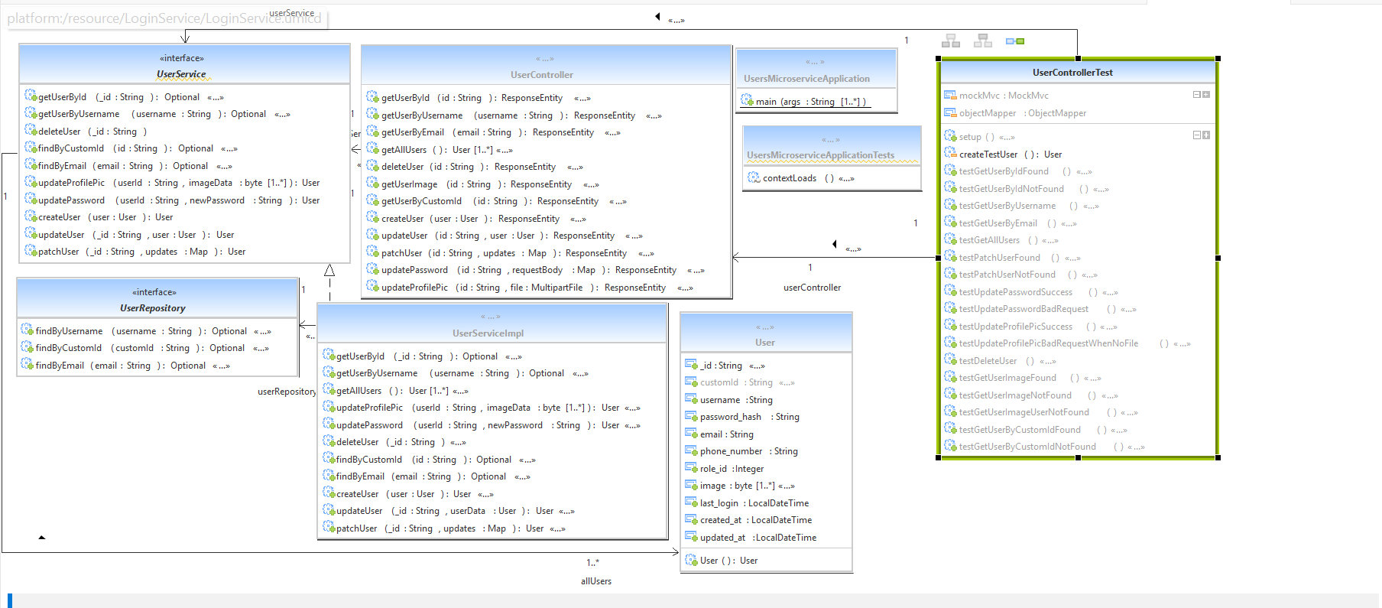

7. Decomposition

DH-1-1 Appointment

Inputs: Set the appointment in details.
Outputs: Get the appointment in details.
Scope: Specific

This class is a model class for the database collection appointment.

DH-1-2 Users
Inputs: Set the users details.
Outputs: Get the users details.
Scope: Specific
This class is a model class for the database collection users.

DH-1-3 Roles
Inputs: Set the role details.
Outputs: Get the role details.
Scope: Specific

This class is a model class for the database collection roles.

DH-1-4 Patient
Inputs: Set the patient details.
Outputs: Get the patient details.
Scope: Specific

This class is a model class for the database collection patient.

DH-1-5 Doctor

Inputs: Sets the Doctor details.
Outputs: Get the Doctor details.
Scope: Specific

This class is a model class for the database collection Doctor.

DH-1-6 Doctor Rating

Inputs: Set the Doctor Rating Details.
Outputs: Get the Doctor Rating Details.
Scope: Specific

This class is a model class for the database collection Doctor Rating

DH-1-7 Medical Records

Inputs: Sets the Medical Records Details .
Outputs: Get the Medical Records Details.
Scope: Specific

This class is a model class for the database collection Medical Records.

DH-1-8 OTP

Inputs: Set the OTP Details .
Outputs: Get the OTP Details.
Scope: Specific

This class is a model class for the database collection OTP.

DH-1-9 Prescriptions
Inputs: Sets the Prescriptions Details
Outputs: Get the Prescriptions Details.
Scope: Specific

This class is a model class for the database collection Prescriptions.

DH-1-10 Diagnostic Tests

Inputs: Set the Diagnostic Tests
Outputs: Get the Diagnostic Tests
Scope: Specific

This class is a model class for the database collection Diagnostic Tests

DH-1-11 Bills
Inputs: set the Bills
Outputs: Get the Bills.
Scope: Specific

This class is a model class for the database collection Bills

DH-1-12 Bill Items

Inputs: Set the Bill Items Details
Outputs: get the Bill Items Details
Scope: Specific

This class is a model class for the database collection Bill Items

DH-1-13 Registration

Inputs: api calls and request details
Outputs: response entities to front end.
Scope: Specific

This class used to manage api calls in Admin service

DH-1-14 Nurse CheckUps

Inputs: api calls and request details
Outputs: response entities to front end
Scope: Specific

This class used to manage api calls in Nurse CheckUps
service

DH-1-15 AppointmentServiceImpl

Inputs: The details to be updated, selected or deleted.
Outputs: The result of selection, updating or deletion.
Scope: Specific

This class implements the AppointmentService interface.

DH-1-16 RoleServiceImpl
Inputs: The details to be updated, selected or deleted.
Outputs: The result of selection, updating or deletion.
Scope: Specific

This class implements the RoleService interface

DH-1-17 UserServiceImpl

Inputs: The details to be updated, selected or deleted.
Outputs: The result of selection, updating or deletion.
Scope: Specific

This class implements the UserService interface

DH-1-18 PatientServiceImpl

Inputs: The details to be updated, selected or deleted.
Outputs: The result of selection, updating or deletion.
Scope: Specific

This class implements the PatientService interface

DH-1-19 DoctorServiceImpl
Inputs: The details to be updated, selected or deleted.
Outputs: The result of selection, updating or deletion.
Scope: Specific

This class implements the DoctorService interface

DH-1-20 DoctorRatingServiceImpl

Inputs: The details to be updated, selected or deleted.
Outputs: The result of selection, updating or deletion.
Scope: Specific

This class implements the DoctorRatingService interface

DH-1-21 BillServiceImpl

Inputs: The details to be updated, selected or deleted.
Outputs: The result of selection, updating or deletion.
Scope: Specific

This class implements the BillService interface
.

DH-1-22 BillItemServiceImpl

Inputs: The details to be updated, selected or deleted.
Outputs: The result of selection, updating or deletion.
Scope: Specific

This class implements the BillItemService interface.

DH-1-23 RegistrationServiceImpl

Inputs: The details to be updated, selected or deleted.
Outputs: The result of selection, updating or deletion.
Scope: Specific

This class implements the RegistrationService interface.

DH-1-24 NurseCheckUpsServiceImpl

Inputs: The details to be updated, selected or deleted.
Outputs: The result of selection, updating or deletion.
Scope: Specific

This class implements the NurseCheckUpsService interface.

DH-1-25 MedicalRecordsServiceImpl

Inputs: The details to be updated, selected or deleted.
Outputs: The result of selection, updating or deletion.
Scope: Specific

This class implements the MedicalRecordsServiceImpl
interface.

DH-1-26 PrescriptionsServiceImpl

Inputs: The details to be updated, selected or deleted.
Outputs: The result of selection, updating or deletion.
Scope: Specific

This class implements the PrescriptionsService interface.

DH-1-27 DiagnosticTestsServiceImpl

Inputs: The details to be updated, selected or deleted.
Outputs: The result of selection, updating or deletion.
Scope: Specific

This class implements the DiagnosticTestsService interface.

DH-1-28 OtpServiceImpl

Inputs: The details to be updated, selected or deleted.
Outputs: The result of selection, updating or deletion.
Scope: Specific

This class implements the OtpService interface.

8. Interface Design

8.1 User Interface
NA

9. Data design
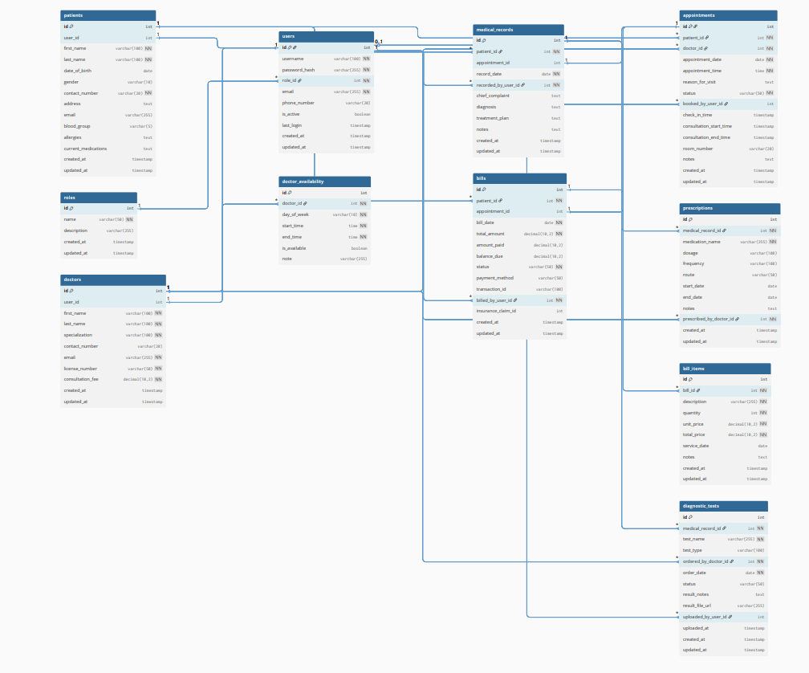

<The entity relationship diagram prepared for the database has to be defined here.>

9.2 Data structure (data types, arrays, and structures)
Not applicable.

10. Reusability
- Authentication
- Validation
- ResourceManager

11. Design Alternatives

NA
12. Design Feasibility
We have used the OOAD approach in this project. This methodology has been chosen based on our analogy of the user requirements, feasibility study and based on the experience of the co-ordinators. It has been seen that several other project groups developing similar projects have chosen the same methodology.

The OOAD assures properties such as reusability, modularity, efficiency.

Additional Hardware and Software required
This requirement is based on the future stages of development. Therefore as of now this is not applicable

14. Testing Strategy
The various stages of testing to be followed for our application includes white unit and integration testing.
We will carry out all such testing in a simulated environment only.

15. Traceability Matrix

As per the requirements-HLD tagging shown in the document “Requirement_Traceability.xls” each of the requirements has been mapped to the appropriate classes. Both the requirements and classes have been tagged according to the tag standards of IQGateway.

16. References
List of all external sources of information referenced in this document.

Sl. No. | Description | Date | Vers. | Location
1. | Software Requirements Specification Document | 11/08/2025 | 1.0 | SRS.doc
2.
3.

Description, date, and version shall uniquely identify the information source, and the location shall specify where it is to be found.

