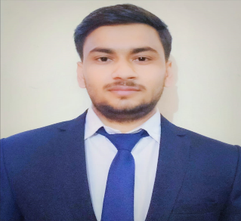

**SHIVAM PARASHAR**

Artauni

Agra

282007

<shivam.parashar_cs20@gla.ac.in>

+91 9719966914

**EDUCATION**

**Bachelor of Technology in CSE, GLA University, Mathura**May 2024

**Intermediate, AVMD Institute , Agra** May 2019

**High School, Saraswati vidya mandir , Agra** May 2017

# INTERNSHIP EXPERIENCE_____________________________________________________________________________

**Job Oriented Value Added Course (JOVAC) , GLA University , Mathura** June 2022 – July 2022Learnt many Technologies such as HTML , CSS , Javascript , JQuery , Bootstrap.

## PROJECTS

**Job board website**  Sept 2022 – Nov 2022

* Provided a platform to find a good job and post a job for job seekers.

work as a platform between job seekers and hiring members

* Responsibility : organizes , guides , update project management software
* Technologies : HTML , CSS , Javascript , firebase.

**Autobiography website** June 2022 – July 2022

**.** Team leader, Role : building an attractive interface

**.** Provided a platform to write autobiographies and connect with people by sharing their journey with others

and also explore popular personalities autobiographies.

**.** Responsibility : organizes , guides , wide-ranging and update project management software

**.** Technologies : HTML , CSS , Javascript , firebase.

## SKILLS

**Technical**

* Technologies : JAVA , HTML5 , CSS3 , JavaScript , SQL , MongoDb .
* Data Structures and Algorithm
* Competitive programming

**Professional**

* Effective Analytical Skills
* Time Management Skills
* Problem Solving Skills

## EXTRA/CO-CURRICULAR ACTIVITIES

**.** Attended Frontend Web Development Bootcamp , devtown

**.** Completed course on Responsive HTML and CSS & javascript Websites , Infosys SpringBoard.

**.** 80+ problems solved on LEETCODE <https://leetcode.com/Shivam_Parashar/>

. 100+ problems solved on CODECHEF <https://www.codechef.com/users/shivam2984>

# DECLARATION________________________________________________________________________________________

I hereby declare that all the above mention information is true and correct to the best of my knowledge.