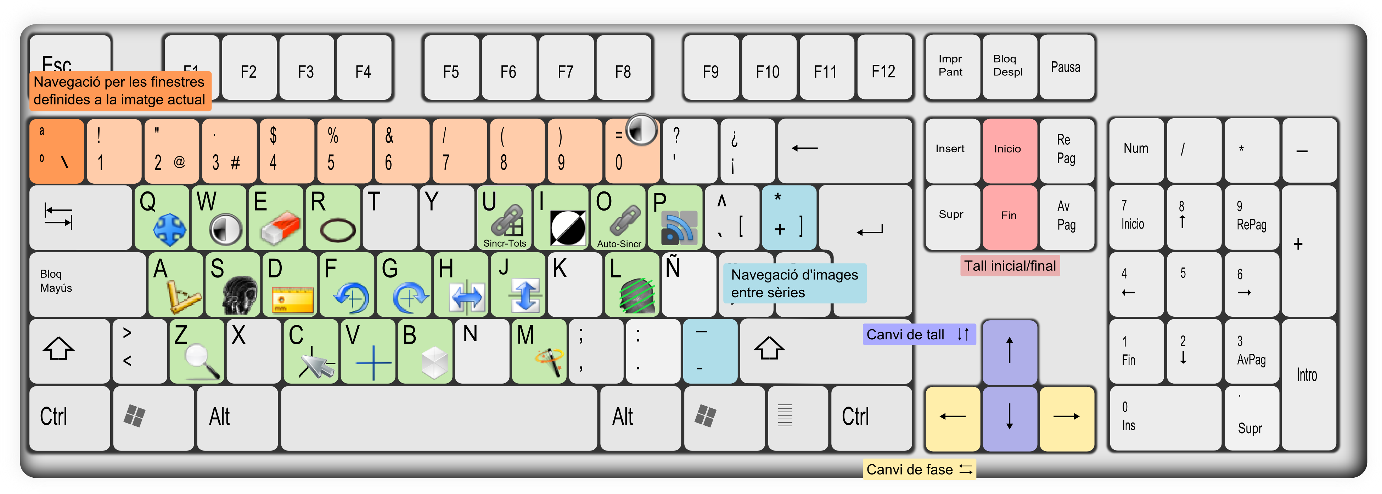

|  |  |  |  |  |  |  |  |  |
| --- | --- | --- | --- | --- | --- | --- | --- | --- |
| C:\Documents and Settings\Roger\starviewer\src\main\images\axial.png | Vista axial | Ctrl + 1 | C:\Documents and Settings\Roger\starviewer\src\main\images\new.png | Nova finestra | Ctrl + N | nonClosedAngle.png | Angle obert | ⇧ + A |
| C:\Documents and Settings\Roger\starviewer\src\main\images\sagital.png | Vista sagital | Ctrl + 2 | C:\Documents and Settings\Roger\starviewer\src\main\images\open.png | Obre un fitxer | Ctrl + O | C:\Documents and Settings\Roger\starviewer\src\main\images\polyline.png | Àrea poligonal | ⇧ + R |
| C:\Documents and Settings\Roger\starviewer\src\main\images\coronal.png | Vista coronal | Ctrl + 3 | C:\Documents and Settings\Roger\starviewer\src\main\images\openDICOMDIR.png | Obre un DICOMDIR | Ctrl + D | eraserViewer.png | Esborra totes les anotacions | Ctrl + E |
| C:\Documents and Settings\Roger\starviewer\src\main\images\photo.png | Captura la imatge actual | Ctrl + S | C:\Documents and Settings\Roger\starviewer\src\main\images\database.png | Explora estudis locals | Ctrl + L | restore.png | Restaura | Ctrl + R |
| Captura tota la sèrie | Ctrl + A | C:\Documents and Settings\Roger\starviewer\src\main\images\pacsQuery.png | Busca al PACS | Ctrl + P | fullscreen.png | Maximitza a vàries pantalles | Ctrl +⇧+ M |
| C:\Users\Roger\Documents\trueta\starviewer\src\main\images\unlinkAll.png | Desincronitza tots els visors | ⇧ + U | C:\Users\Roger\Documents\trueta\starviewer\src\main\images\magnify.png | Lupa | ⇧ + Z |  | Canvia la finestra de pantalla | Ctrl +⇧+ |