**Starviewer: Dreceres de teclat** v.0.9

v.0.9

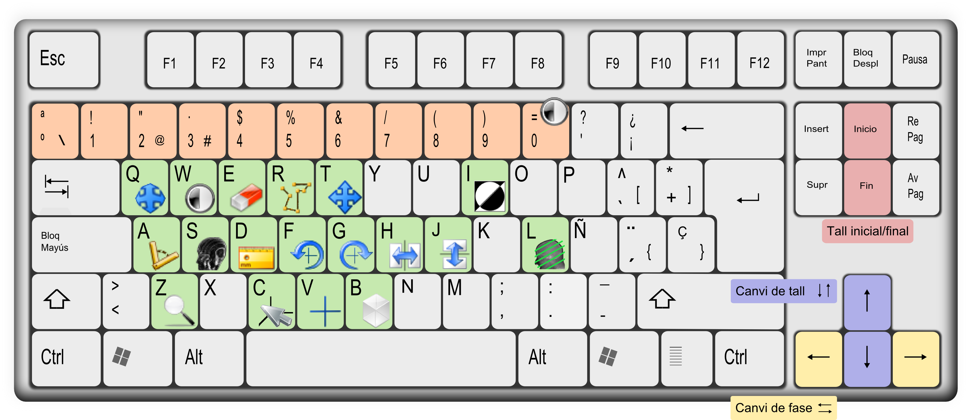

|  |  |  |  |  |  |  |  |  |  |  |
| --- | --- | --- | --- | --- | --- | --- | --- | --- | --- | --- |
| C:\Documents and Settings\Roger\starviewer\src\main\images\axial.png | Vista axial | Ctrl + 1 |  | C:\Documents and Settings\Roger\starviewer\src\main\images\new.png | Nova finestra | Ctrl + N |  | nonClosedAngle.png | Angle obert | ⇧ + A |
| C:\Documents and Settings\Roger\starviewer\src\main\images\sagital.png | Vista sagital | Ctrl + 2 |  | C:\Documents and Settings\Roger\starviewer\src\main\images\open.png | Obrir un fitxer | Ctrl + O |  | eraserViewer.png | Esborrar totes les anotacions | Ctrl + E |
| C:\Documents and Settings\Roger\starviewer\src\main\images\coronal.png | Vista coronal | Ctrl + 3 |  | C:\Documents and Settings\Roger\starviewer\src\main\images\openDICOMDIR.png | Obrir un DICOMDIR | Ctrl + D |  | restore.png | Restaurar | Ctrl + R |
| C:\Documents and Settings\Roger\starviewer\src\main\images\photo.png | Capturar la imatge actual | Ctrl + S |  | C:\Documents and Settings\Roger\starviewer\src\main\images\database.png | Explorar estudis locals | Ctrl + L |  | fullscreen.png | Pantalla completa | Ctrl + ↵ |
| Capturar tota la sèrie | Ctrl + A |  | C:\Documents and Settings\Roger\starviewer\src\main\images\pacsQuery.png | Buscar al PACS | Ctrl + P |  |  |  |  |