

How manipulation of playing area dimensions in ball possession games constrains physical effort and technical actions in under-11, under-15 and under-23 soccer players.

NUNES, Nuno André <http://orcid.org/0000-0002-2321-4998>, GONÇALVES, Bruno <http://orcid.org/0000-0001-7874-4104>, DAVIDS, Keith
<http://orcid.org/0000-0003-1398-6123>, ESTEVES, Pedro
<http://orcid.org/0000-0002-4675-2959> and TRAVASSOS, Bruno
<http://orcid.org/0000-0002-2165-2687>

Available from Sheffield Hallam University Research Archive (SHURA) at: https://shura.shu.ac.uk/26476/

This document is the Accepted Version [AM]

Citation:

NUNES, Nuno André, GONÇALVES, Bruno, DAVIDS, Keith, ESTEVES, Pedro and TRAVASSOS, Bruno (2020). How manipulation of playing area dimensions in ball possession games constrains physical effort and technical actions in under-11, under-15 and under-23 soccer players. Research in Sports Medicine, 1-15. [Article]

Copyright and re-use policy

See http://shura.shu.ac.uk/information.html

Sheffield Hallam University Research Archive
http://shura.shu.ac.uk

How manipulation of playing area dimensions in ball possession games constrains physical effort and technical actions in under-11, under-15 and under-23 soccer players

Abstract

Recent research has suggested that practice in small-sided and conditioned games (SSCGs) can improve physical, technical, tactical and psychological performances of players in team sports. However, there is a need for more information to understand how the constraints of SSCGs shape performance of athletes at different developmental stages. Therefore, the aim of this study was to explore the effects of playing area dimension manipulation (20x15m, 25x20m and 30x25m) on internal perceptions (rate of perceived exertion, RPE) and external loads (total distance covered, distance covered while walking, running, and sprinting, number of sprints, maximum sprint speed, number of kicks with dominant and non-dominant foot, and maximum kick speed) during 4v4 SSCGs in under-11 (U11s), under-15 (U15s)and under-23 (U23s) yr old football players. Results showed higher values in the large playing area for the under-11 group for distance covered in different speed zones (all p = < .001, moderate/large effects), for U15s in sprint numbers (p < .01, moderate effect) and maximum sprint speed (p = .02, moderate effect), and for U23 group in both rate of perceived exertion (RPE) and number of sprints completed (p < .01, small moderate). The results highlighted that the same SSCG practice context, applied to different age groups, promoted different response outcomes from participants. Greater changes were demonstrated in younger age groups and on larger pitches. Overall data suggests that, depending on their intended goals, coaches can manipulate pitch dimension to obtain a variety of desired outcomes in different age group players.

Introduction

Small-sided and conditioned games (SSCGs) seem to originate from street football, where children are constantly challenged to adapt the rules to the evolving playing constraints, in terms of available space, time to play and number of available players (S. Hill-Haas, Dawson, Impellizzeri, & Coutts,
2011). There has been growing interest in the study of SSCGs as a powerful training tool to enhance the effectiveness of the learning process (Travassos, Vilar, Araujo, & McGarry, 2014). Importantly, SSCGs allow the coach to act as designer by manipulating task constraints to develop players’ and teams’ performance in a deliberate and intentional way than in street football. For example, the manipulation of constraints in SSCGs allows replication of specific interpersonal patterns of coordination (e.g., Silva et al., 2014; Vilar, Araujo, et al., 2014), development of specific space-time relationships on the use of space and ball possession (e.g., Travassos, Coutinho, Goncalves, Pedroso,
& Sampaio, 2018; Travassos, Goncalves, Marcelino, Monteiro, & Sampaio, 2014) and specific effort regimes (e.g., David Casamichana, Castellano, González-Morán, García-Cueto, & García-López,
2011; Safania, Alizadeh, & Nourshahi, 2011). That is, SSCGs allow coaches to promote the development of players' technical and tactical skills, while at the same time improving physiological parameters such as strength, agility and endurance (Sgrò, Bracco, Pignato, & Lipoma, 2018) in order to simulate the demands of competitive performance ( Olthof, Frencken, & Lemmink, 2018). However, to achieve that aim, there is a need to understand effects of manipulating specific practice task constraints on the technical, tactical and physical performance of players and teams (S. Hill- Haas et al., 2011).

Previous research has reported effects of manipulating game constraints such as pitch size (Kelly & Drust, 2009; Owen, Twist, & Ford, 2004), number of players (Katis & Kellis, 2009), duration of games (Tessitore, Meeusen, Piacentini, Demarie, & Capranica, 2006), or even the combination between different game constraints (S. V. Hill-Haas, Dawson, Coutts, & Rowsell, 2009; Jones & Drust, 2007; Rampinini et al., 2007). For instance, it was observed that playing area dimensions influence the intensity of the game and the actions of the players. Large-sized pitches are associated with an increase in the intensity of exercise (D. Casamichana & Castellano, 2010) effective playing
space and surface coverage (Silva et al., 2014), while small-sized pitches appear to foster technical development (Dellal, Lago-Penas, Wong, & Chamari, 2011; Kelly & Drust, 2009). Also, some studies have investigated how pitch-area restrictions influence the players’ physical and tactical performance. Goncalves et al. (2017) analyzed effects of restricted spacing, contiguous spacing and free spacing in large-sided soccer games. They concluded that free spacing promoted higher levels of movement synchronisation between teammates, while restricted spacing designs promoted tactical

behaviours at a proximal scale of interaction between performers (1vs1 situations; short-distance passing). In this vein, Coutinho et al. (2018) analysed effects of playing SSCGs with and without spatial references and concluded that inclusion of spatial references contributed to a more structured pattern of play along with a greater level of positional regularity. Conversely, a decrease in levels of synchronization in positioning between team players, average speed and distance covered at different speeds, was reported. Spatial pitch configuration has also been investigated by comparing different conditions related to pitch boundaries. Results suggested that better performance was associated with a pitch configuration more representative of a formal match due to a higher level of familiarisation of the players to their actual competitive conditions.

Manipulation of pitch size and format are the most common task constraints manipulated in SSCGs and yet little is known about their modulating effects on emergent behaviours in players at different age groups and expertise levels. One of the few studies on this topic showed that tactical behaviours of athletes from different skill levels (national vs regional level) were greatly impacted by pitch dimensions, especially in terms of length and width exploration and distance to nearest opponent
(Silva et al., 2014). It has also been reported that athletes from different age groups perform
differently within the available playing space. For instance, increased frequency of high intensity actions and sprinting (S. B. H. Olthof, W. G. P. Frencken, & K. Lemmink, 2018) was observed as age of learners increased, in larger areas of play during offensive phases of play. These performance outcomes also, decreased during offensive phases of play, as levels of tactical synchronisation between players increased (Barnabe, Volossovitch, Duarte, Ferreira, & Davids, 2016).

In practice, coaches manipulate constraints in SSCGs to achieve specific levels of exercise intensity or to develop specific technical or tactical skills in learners (Alves, Clemente, Malico Sousa, Pinheiro, & dos Santos, 2017; Dellal, Jannault, Lopez-Segovia, & Pialoux, 2011). Additionally, the selection of task constraints to be manipulated must reflect the level and competence of the players (Clemente, Martins, & Mendes, 2014). However, more research is needed, for example, to understand how pitch dimension manipulations in SSCGs constrain players’ performance across different age groups, with different levels of maturation and playing experience. This information may critically inform the development of dedicated intervention programs aimed enhancing performance and transferring skills and capacities from practice environments to competitive settings (Barnabe et al., 2016; Travassos et al., 2018).

The aim of this study was to evaluate effects of playing area manipulations in SSCGs on ball possession in teams of different age groups. Specifically, it sought to explore how the manipulations constrained physical and technical actions of players of different age groups when practising to

maintain ball possession in SSCGs. We expected that larger pitches would afford greater opportunities for attacking teams to maintain ball possession. Conversely, we expected that defending teams would experience fewer opportunities to intercept the ball due to the larger distances between players. In addition, we also predicted that larger sized pitches would benefit the performance of younger players by allowing them to overcome the technical and tactical limitations associated with their lower levels of skill.

Methods

Participants

Fifty-two participants from three different football team age groups participated in this study (, U11, n=16, age 10.00.7 y, body mass: 33.02.34 kg, height: 141.0 4.6 cm; under-15, U15, n=16, age

14.01.3 y, body mass: 58.013.4, height: 169.010.1 cm; under-23, U23, n=16, age 211.60 y,

body mass: 66.510.1, height: 174.54.3 cm. All participants were part of the same team and experienced three weekly training sessions plus one game on weekends. While the U23 team played
11-a-side football format; the U15 team played 8-a-side, on a half pitch; and the U11 team 5-a-side football on a futsal dimension pitch. All players trained for around 40 weeks per season. The experimental protocol and investigation were approved by the local Institutional Research Ethics Committee. For the U11 and U15 teams, written informed consent was obtained from parents of the players. The same written informed consent procedure was also undertaken with the U23 participants.

Procedures

Participants performed in a series of 4-a-side SSCGs on different playing area dimensions (Owen et al., 2004; Williams & Owen, 2007): Small pitch (20x15m), Medium pitch (25x20m) and Large pitch
(30x25m). Head coaches assigned players into four teams, balanced for skill levels (A, B, C, D). Each team performed for four sets of four minutes each (AxB, CxD, AxC, BxD), with four minutes of active recovery between games (totaling sixteen minutes of intermittent exercise for each participant). Three sessions were completed on three different days, with each session occurring on the same pitch size. Before the beginning of each session, the players performed a general warm-up that included running at various intensities and joint mobilization and stretching, for an average of twenty minutes duration. Due to the purpose of the exercise (maintaining and recovering ball

possession), no goalkeeper or any type of goal or target was used. The coach did not intervene during the SSCG with any corrective feedback during the course of the game. If the ball went out of play, other strategically placed balls allowed an immediate restart from a pass.

Data collection

The Borg Scale CR10 was used to evaluate RPE and presented to participants 4 minutes after the end of each SSCG. The RPE value was chosen because it correlates well with traditional ways of obtaining information on training intensity in SSCGs (Heart Rate and Blood Lactate). It was used in this study to monitor exercise intensity and the effects of training stimuli (Coutts, Rampinini, Marcora, Castagna, & Impellizzeri, 2009). Data on the external workload variables were collected through a GPS system (Global Position System) included in the ZEPP Play Soccer system, which uses 2 MEMS sensors to measure motion. Each player had a microchip (each with 2 internal sensors:
3-Axis Accelerometer + 3-Axis Gyroscope) attached to each of their shins to record displacement data. Later, Zepp's computer software (version 1.6.0 (20180520001)) was used to compute the values of total distance covered (m), distance differentiated by walking ( 9 km/h), running (9-18 km/h) and sprinting (>18 km/h), number of sprints (n), maximum sprint speed (km/h), number of kicks (ball contacts) with dominant and non-dominant foot (n), and maximum kick speed (km/h). A ball contact was counted as a pass when the ball travelled at least 5 meters. Zepp Play Soccer, from Zepp Labs, Inc, was tested by Audix Technology Co., Ltd, to confirm compliance with all the FCC Part 15 Subpart C requirements, for all the tested components.

Statistical Analysis

A descriptive analysis was performed using mean and standard deviations. A one-way repeated measured analysis of variance (ANOVA) was conducted to evaluate differences in performance variables for each age group according to pitch dimension (i.e., small (S), medium (M) and large pitch (L)). The statistical analysis was performed using the Statistical Package for Social Sciences software (SPSS Inc., Chicago, IL), and the statistical significance level was set at p < .05.

Pairwise differences (S vs. M, S vs. L and M vs. L pitch) for each age group were assessed via differences in group means expressed in raw units with 90% confidence limits (CL). The threshold for a change to be considered practically important (the smallest worthwhile difference) was 0.2 x of standard deviation. Uncertainty in the true effects of the conditions was evaluated based on non-

clinical inferences. The following magnitudes of clear effects were considered: <0.5%, most unlikely; 0.5–5%, very unlikely; 5–25%, unlikely; 25 to 75%, possibly; 75% to 95% likely; 95% to
99%, very likely; >99% most likely large (Hopkins, Marshall, Batterham, & Hanin, 2009). Also, the pairwise comparisons were assessed via standardised mean differences and respective 95% confidence intervals. Thresholds for effect sizes statistics were 0.2, trivial; 0.6, S; 1.2, moderate; 2.0, large; and >2.0, very large (Hopkins et al., 2009). These statistical computations were processed with a specific post-only crossover spreadsheet for each age group (Hopkins, 2017).

Results

Figure 1 shows the descriptive analysis for all dependent variables across the different age groups performed in the S, M and L pitch conditions. Table 1 shows the effect of pitch conditions on the different performance variables for each age group. Table 2 indicates the pairwise differences, with
±90% confidence limits, between the pitch conditions for each age group. Finally, the magnitude of differences from the above-mentioned comparisons are presented in figure 2.

Under-11 age group

We found significant differences in the distance covered while walking, running and sprinting, as well as in the number of sprints (all p = < .001). The main differences were related to the L pitch, which promoted an increase in all external load measures with a moderate/large effect (with the exception of walking which moderately decreased in this pitch format). The players also increased their max speed when playing on the L pitch, rather than the S pitch (very likely: difference in means; ±90% CL, 2.0; ±1.0 km/h) and M pitch condition: (most likely: difference in means; ±90% CL, 1.9; ±0.7 km/h). Interestingly, despite performance on the L pitch being more physically demanding, higher RPE values were associated with playing on the M pitch (all p = < .01). We found that, compared to the S pitch, RPE values tended to increase on the M pitch (0.7; ±0.6 a.u., small effect), and when compared to L pitch, increased on the M pitch (very likely increased 1.0; ±0.5, moderate effect).

Despite the small effect, likely increases were noted in number of ball contacts for passes (2.6; ±2.2 in counts) and touches with both dominant (1.9; ±1.8 in counts) and non-dominant foot (0.7; ±0.8 in counts) when compared between the S vs. L pitches.

Under-15 age group

We found significantly higher values for the number of sprints (p < .01) and maximum speed (p =
.02) for larger pitch areas when compared to the small playing areas (S < M < L). Pairwise comparisons showed that players likely increased the distance while running in the L pitch (S vs. L:
24.8 ±28.1 m, and M vs. L: 30.3 ±27.2 m) and sprinting in larger pitches (S vs. M: 6.5; ±5.2 m and S vs. L: 5.3; ±4.0 m). Also, a small change in walking was observed when compared S and L pitches (possible decrease: S vs. L: -11.1; ±13.7 m). Larger pitches presented higher values of RPE, with likely increases when compared S with M pitches (S vs. M: 0.4; ±0.4 in score) and possible increases when compared S with L pitches (S vs. L: 0.3; ±0.5 in score). Despite the small effects, possible increases were observed for maximum kick speed on S vs L pitches (2.6; ±2.8 km/h). Also, possible decreases in kick number (-1.1; ±1.7 in counts) and dominant foot touches (-1; ±1.3 in counts) were observed in M pitch vs L pitch. Finally, possible increases for non-dominant touches were observed for S pitch vs L pitch (0.2; ±0.5 in counts).

Under-23 age group

We found significantly higher values for the number of sprints (both p < .01), having greater values on L playing areas than for S and M pitches. Possibly decreases were noted for S vs M pitch in running distance (-15.0; ±24.1 m) and maximum kick speed (-2.2; ±3.4 km/h), and likely increases were noted in maximum speed in L pitch when compared with S and M pitches (1.1; ±1 km/h). Statistical differences were also found (both p < .01) in the L pitch condition with greater RPE scores than in M pitches. Higher RPE scores were also observed for S pitch than for M pitch condition (very likely decreases, S vs. M pitch: -0.6; ±0.4 in score). Despite the small effect, likely decreases were noted in the global number of kicks (-2; ±1.5 in counts S vs L pitch; -1.7; ±1.5 in counts M vs L) and also in the dominant (-1.3; ±1.2 in counts S vs L pitch; -1; ±1 in counts M vs L pitch) and non-dominant foot touches (-0.8; ±0.6 in counts S vs L; -0.7; ±0.7 in counts M vs L).

Discussion

Several types of SSCG formats are commonly used by team sports coaches to constrain skill acquisition, conditioning and development of players and teams in training. The efficacy of this process depends on a deep understanding of the effects of manipulating practice tasks with players of different ages and experience levels in SSCGs (Travassos et al., 2018). This study aimed to understand the impact of different playing area dimensions on football players’ performance in

SSCGs, by considering the modulating effect of age. In general, our results indicate that the manipulation of pitch dimension has a differential effect on the external load, the perception of exertion and the skill demands of for players of different ages.

First, we found that the external workload tends to increase in intensity as the pitch becomes larger, especially for the U11 age group. In accordance with findings of Casamichana and Castellano
(2010), as the pitch size increases, actual playing time, total distance covered, and distance covered at different speeds (except walking) tend to increase. Interestingly, it is the U11 age group that revealed greater differences on external load between conditions. These data suggest that, as the players’ age increased, team adaptations to the available playing space becomes more evident, decreasing the need of individual adaptations to the available space. That is, with age increases, players adjust their individual performance behaviours to the space covered and game dynamics of their own team, to the opposing team and the ball position, in order to explore, the space available for play. These adaptations save energy and improve the functionality of their actions according to the specificities of game context (Travassos et al., 2018). Conversely, athletes from all age groups tended to cover greater distances at higher intensities (sprinting, number of sprints and max sprint) in the L pitch condition, developing the anaerobic energy system. This finding is important for training periodisation: the information provides understanding of the differential effects of manipulating pitch dimensions when designing SSCG tasks in order to promote the development of specific energy systems. The findings from this study provide evidence that in higher age groups, playing area dimensions are task constraints which have to used carefully in practice. For example, S and M playing areas can be used to develop aerobic system capacities during practice, while L dimensions may improve the anaerobic system.

With regard to the internalized perception of workloads, we noted relevant differences in RPE when participants practice on different pitches dimensions. Both U11 and U15 age groups reported higher mean scores in RPE for M pitches, while the U23 age group presented higher mean scores for the L pitch. Contrary to expectations, the U11 age group reported lower scores of RPE on L playing areas and the U23 reported higher RPEs on S, compared to M, playing areas. In most studies, larger pitches have tended to be associated with more intense physical responses in participants (D. Casamichana & Castellano, 2010; S. V. Hill-Haas et al., 2009; Owen et al., 2004; Rampinini et al.,
2007). Others report that smaller pitches make the exercises more intense (Tessitore et al., 2006), as observed in the U11 age group. These findings suggest that c should be aware that players in younger age groups seem not to perceive exercise in the same way as older players, or that they cannot work at the same performance levels of older players. Specifically, the data suggest that

young children should not be treated as ‘mini-adults’ and have different needs and capacities, compared to older age group athletes, in general. At this stage, it is important to use other tools that go beyond subjective internal load measures to monitor exercise intensity levels in younger players (total distance covered, distance covered at different speeds, heart rate, breathing rate, sweat).

With regard to skill-based performance evaluation, passing actions were observed more frequently in the L playing area in the younger groups, while for the older-age groups the tendency was the opposite. There was a clear age by playing area interaction for the completion of passing actions. The U11 age group performed more passing actions (including use of the dominant and non- dominant foot) on the L playing area, and the U15s performed more passing actions on the M pitch. For the U23 age group more passes were completed on the S area. These results indicated that larger sized pitches greatly increased the affordances (opportunities) for younger players to perform a pass, given th reduced level of pressing to intercept the ball as the defenders had to cover more space and distance than on a S playing area. According to Gibson (1979) affordances are related to effectivities or capacities of individuals. The implication of this idea is that players at early stages of development should train on L dimension fields which have greater area per individual, since these performance spaces may allow more time for players to search for the most effective passing solution (Sgrò et al.,
2018; Vilar, Duarte, Silva, Chow, & Davids, 2014). The emergent performance tendencies observed in the U23 age group also imply an affordance and effectivities relationship. The results are coincident with findings reported by Casamichana and Castellano (2010). They showed that the performance of football passing skills tended to increase in frequency, compared to other skills such as dribbling, as the playing area was reduced in dimensions. In fact, on S playing areas the distance between opponents is smaller and more experienced performers increased the frequency of passing actions, relative to other actions, to adapt to these performance constraints. From a practical point of view, the coaches should consider the possibility to reduce the available space in order to push the development of more experienced players in terms of technical execution and decision-making for passing. Conversely, the U15 age group revealed small differences in technical actions with changes in game conditions. A possible explanation for these results is that players at this age group are usually in the middle of puberty and this may affect their ability to perform technical skills. Their bodies are changing and it’s usually a time when they want to try different skills and discover other ways to perform certain techniques, possibly by coping strategies (Malina, 2004). Participants in this age group may also be experiencing a change in growth and maturation with an increase in strength beginning to appear. These changes in physical properties could provide the impetus for the players

to perform other skills such as dribbling with the ball past defenders, rather than passing more frequently at a younger age.

Conclusion

To summarise, the findings from thus study suggest how coaches can use space manipulation in SSCGs as an important task constraints shape player performance behaviours across different age groups, during learning. High intensity running can be facilitated by use of larger playing areas, especially for younger players. The findings suggest that coaches should carefully design and monitor the impact of high intensity exercises, given that it seems that pitch manipulation as a pedagogical methodology has a differential effect on the internalized perception of workload across age groups. Space manipulation during SSCGs should also be considered as a major task constraint to facilitate and shape skill adaptations and development in learners, along with decision making. The use of smaller playing areas seems to favour the increase of passing actions in older players while, in turn, increases in playing area appear to alter the available time for younger players to practice skills without the major constraint of pressing. As children grow older, they develop effectivities or capacities which allow them to explore a wider range of performance solutions to penetrate space on field. Interestingly, we found a reduced impact of playing area manipulations on the different dependent variables for the U15 yrs age group. We speculate that most of these players were in the middle of puberty, and were experiencing rapid perceptual-motor and cognitive development, which allowed them to explore how to perform in different game situations.

Further studies should be conducted to understand the effects of practice task designs and age group variations in different types of SSCGs. For instance, investigators could compare differences in participant maturation levels, relative to variations in scaling of space and number of players involved, so that coaches can better understand the impacts of training designs on players development (Fitzpatrick, Davids & Stone, 2018; Woods, et al., 2019).

References

Alves, G., Clemente, F. M., Malico Sousa, P., Pinheiro, V., & dos Santos, F. J. L. (2017). How and why do soccer coaches use small-sided games in the training process? Human Movement,

2017(5), 117-124. Retrieved from https://www.termedia.pl/Journal/-132/pdf-31887-
10?filename=HM18_5 117_124.pdf. doi:10.5114/hm.2017.73624
Barnabe, L., Volossovitch, A., Duarte, R., Ferreira, A. P., & Davids, K. (2016). Age-related effects of practice experience on collective behaviours of football players in small-sided games. Hum Mov Sci, 48, 74-81. Retrieved from https://www.ncbi.nlm.nih.gov/pubmed/27132155. doi:10.1016/j.humov.2016.04.007
Casamichana, D., & Castellano, J. (2010). Time-motion, heart rate, perceptual and motor behaviour demands in small-sides soccer games: effects of pitch size. J Sports Sci, 28(14), 1615-1623. Retrieved from https://www.ncbi.nlm.nih.gov/pubmed/21077005
https://www.tandfonline.com/doi/full/10.1080/02640414.2010.521168. doi:10.1080/02640414.2010.521168
Casamichana, D., Castellano, J., González-Morán, A., García-Cueto, H., & García-López, J. (2011). Demanda fisiológica en juegos reducidos de fútbol con diferente orientación del espacio. (Physiological demand in small-sided games on soccer with different orientation of space). RICYDE. Revista Internacional de Ciencias del Deporte, 7(23), 141-154. Retrieved from https://www.cafyd.com/REVISTA/ojs/index.php/ricyde/article/download/386/232. doi:10.5232/ricyde2011.02306
Clemente, F. M., Martins, F. M. L., & Mendes, R. S. (2014). Developing Aerobic and Anaerobic Fitness Using Small-Sided Soccer Games: Methodological Proposals. National Strength and Conditioning Association, 36(3), 76-87.
Coutinho, D., Goncalves, B., Travassos, B., Abade, E., Wong, D. P., & Sampaio, J. (2018). Effects of pitch spatial references on players' positioning and physical performances during football
small-sided games. J Sports Sci, 37(7), 741-747. Retrieved from
https://www.ncbi.nlm.nih.gov/pubmed/30306840
https://www.tandfonline.com/doi/full/10.1080/02640414.2018.1523671. doi:10.1080/02640414.2018.1523671
Coutts, A. J., Rampinini, E., Marcora, S. M., Castagna, C., & Impellizzeri, F. M. (2009). Heart rate and blood lactate correlates of perceived exertion during small-sided soccer games. J Sci Med Sport, 12(1), 79-84. Retrieved from https://www.ncbi.nlm.nih.gov/pubmed/18068433
https://www.jsams.org/article/S1440-2440(07)00193-4/fulltext. doi:10.1016/j.jsams.2007.08.005
Dellal, A., Jannault, R., Lopez-Segovia, M., & Pialoux, V. (2011). Influence of the Numbers of Players in the Heart Rate Responses of Youth Soccer Players Within 2 vs. 2, 3 vs. 3 and 4 vs. 4 Small-
sided Games. J Hum Kinet, 28, 107-114. Retrieved from
https://www.ncbi.nlm.nih.gov/pubmed/23487546
https://www.ncbi.nlm.nih.gov/pmc/articles/PMC3592099/pdf/jhk-28-107.pdf. doi:10.2478/v10078-011-0027-8
Dellal, A., Lago-Penas, C., Wong, D. P., & Chamari, K. (2011). Effect of the Number of Ball Contacts Within Bouts of 4 vs. 4 Small-Sided Soccer Games. International Journal of Sports Physiology and Performance, 6, 322-333.
Goncalves, B., Esteves, P., Folgado, H., Ric, A., Torrents, C., & Sampaio, J. (2017). Effects of Pitch Area-Restrictions on Tactical Behavior, Physical, and Physiological Performances in Soccer Large-Sided Games. Journal of Strength and Conditioning Research, 31(9), 2398-2408.
Hill-Haas, S., Dawson, B., Impellizzeri, F. M., & Coutts, A. J. (2011). Physiology of Small-Sided Games Training in Football: A Systematic Review. Sports Med, 41(3), 199-220. doi:0112-
1642711/0003-0199/$49.95/0
Hill-Haas, S. V., Dawson, B. T., Coutts, A. J., & Rowsell, G. J. (2009). Physiological responses and time–motion characteristics of various small-sided soccer games in youth players. Journal of

Sports Sciences, 27(1), 1-8. Retrieved from
https://www.tandfonline.com/doi/full/10.1080/02640410902761199. doi:10.1080/02640410802206857
Hopkins, W. G. (2017). Spreadsheets for Analysis of Controlled Trials, Crossovers and Time Series. Sportscience, 2017(21), 1-4. Retrieved from sportsci.org/2017/wghxls.htm
Hopkins, W. G., Marshall, S. W., Batterham, A. M., & Hanin, J. (2009). Progressive Statistics for Studies in Sports Medicine and Exercise Science. Medicine and Science in Sports and Exercise, 41(1), 3-12. Retrieved from <Go to ISI>://WOS:000262187400002. doi:Doi
10.1249/Mss.0b013e31818cb278
Jones, S., & Drust, B. (2007). Physiological and Technical Demands of 4 v 4 and 8 v 8 Games in Elite Youth Soccer Players. . Kinesiology, 39(2), 150-156.
Katis, A., & Kellis, E. (2009). Effects of SSG on physical conditioning and performance in young soccer players. Journal of Sports Science and Medicine, 8, 374-380. Retrieved from https://www.ncbi.nlm.nih.gov/pmc/articles/PMC3763282/pdf/jssm-08-374.pdf.
Kelly, D., & Drust, B. (2009). The effect of pitch dimensions on heart rate responses and technical demands of small-sided soccer games in elite players. Sports Medicine Australia, 12, 475-
479.
Malina, R. (2004). Growth and Maturation: Basic Principles and Effects of Training. In I. d. U. d. Coimbra (Ed.), Children and Youth in Organized Sports. Coimbra.
Olthof, S. B. H., Frencken, W. G. P., & Lemmink, K. (2018). Match-derived relative pitch area changes the physical and team tactical performance of elite soccer players in small-sided
soccer games. J Sports Sci, 36(14), 1557-1563. Retrieved from
https://www.ncbi.nlm.nih.gov/pubmed/29125029
https://www.tandfonline.com/doi/pdf/10.1080/02640414.2017.1403412?needAccess=true. doi:10.1080/02640414.2017.1403412
Olthof, S. B. H., Frencken, W. G. P., & Lemmink, K. A. P. M. (2018). A Match Derived Relative Pitch Area Facilitates the Tactical Representativeness of Small-Sided Games for the Official Soccer Match. Journal of Strength and Conditioning Research.
Owen, A., Twist, C., & Ford, P. (2004). Small-Sided Games: The Physiological and Technical Effect of Altering Pitch Size and Player Numbers. Insight, 7(2), 50-53.
Rampinini, E., Impellizzeri, F. M., Castagna, C., Abt, G., Chamari, K., Sassi, A., & Marcora, S. M. (2007). Factors influencing physiological responses to small-sided soccer games. J Sports Sci,
25(6), 659-666. Retrieved from https://www.ncbi.nlm.nih.gov/pubmed/17454533
https://www.tandfonline.com/doi/full/10.1080/02640410600811858. doi:10.1080/02640410600811858
Safania, A. M., Alizadeh, R., & Nourshahi, M. (2011). A Comparison of Small-Side Games and Interval Training on Same Selected Physical Fitness Factors in Amateur Soccer Players. Journal of Social Sciences, 7(3), 349-353.
Sgrò, F., Bracco, S., Pignato, S., & Lipoma, M. (2018). Small-Sided Games and Technical Skills in Soccer Training: Systematic Review and Implications for Sport and Physical Education Practitioners. Journal of Sports Science, 6(1). doi:10.17265/2332-7839/2018.01.002
Silva, P., Travassos, B., Vilar, L., Aguiar, P., Davids, K., Araujo, D., & Garganta, J. (2014). Numerical relations and skill level constrain co-adaptive behaviors of agents in sports teams. PLoS One,
9(9), e107112. Retrieved from https://www.ncbi.nlm.nih.gov/pubmed/25191870
https://www.ncbi.nlm.nih.gov/pmc/articles/PMC4156427/pdf/pone.0107112.pdf. doi:10.1371/journal.pone.0107112

Tessitore, A., Meeusen, R., Piacentini, M. F., Demarie, S., & Capranica, L. (2006). Physiological and technical aspectos of “6-a-side” soccer drills. Journal of Sports Medicine and Physical Fitness,
46(1), 36-42.
Travassos, B., Coutinho, D., Goncalves, B., Pedroso, P., & Sampaio, J. (2018). Effects of manipulating the number of targets in U9, U11, U15 and U17 futsal players' tactical behaviour. Hum Mov
Sci, 61, 19-26. Retrieved from https://www.ncbi.nlm.nih.gov/pubmed/30005844.
doi:10.1016/j.humov.2018.06.017
Travassos, B., Goncalves, B., Marcelino, R., Monteiro, R., & Sampaio, J. (2014). How perceiving additional targets modifies teams' tactical behavior during football small-sided games. Hum Mov Sci, 38, 241-250. Retrieved from https://www.ncbi.nlm.nih.gov/pubmed/25457422. doi:10.1016/j.humov.2014.10.005
Travassos, B., Vilar, L., Araujo, D., & McGarry, T. (2014). Tactical performance changes with equal vs unequal numbers of players in small-sided football games. International Journal of Performance Analysis in Sport, 14, 594-606.
Vilar, L., Araujo, D., Davids, K., Travassos, B., Duarte, R., & Parreira, J. (2014). Interpersonal coordination tendencies supporting the creation/prevention of goal scoring opportunities in
futsal. Eur J Sport Sci, 14(1), 28-35. Retrieved from
https://www.ncbi.nlm.nih.gov/pubmed/24533492
https://www.tandfonline.com/doi/full/10.1080/17461391.2012.725103. doi:10.1080/17461391.2012.725103
Vilar, L., Duarte, R., Silva, P., Chow, J. Y., & Davids, K. (2014). The influence of pitch dimensions on performance during small-sided and conditioned soccer games. J Sports Sci, 32(19), 1751-
- Retrieved from https://www.ncbi.nlm.nih.gov/pubmed/24915106 https://www.tandfonline.com/doi/full/10.1080/02640414.2014.918640.
doi:10.1080/02640414.2014.918640
Williams, K., & Owen, A. (2007). The impact of player numbers on the physiological responses to small sided games. Journal of Sports Science and Medicine, 6, 99-102.

Number of sprints
250

200

150

100

50

0






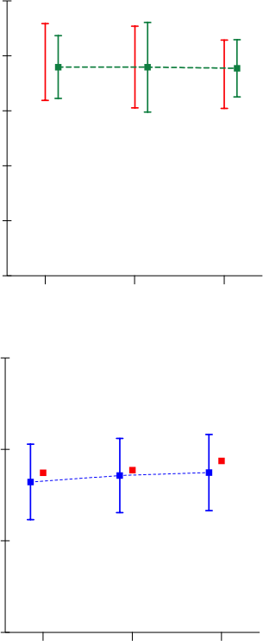

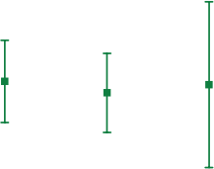

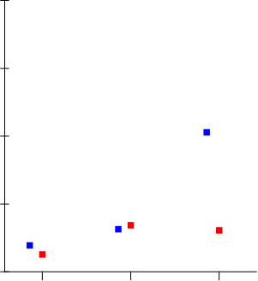
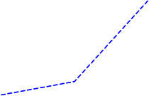
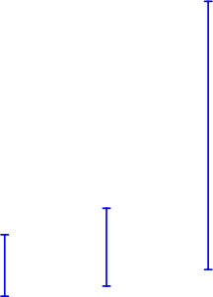

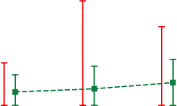





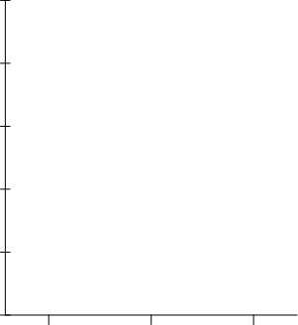




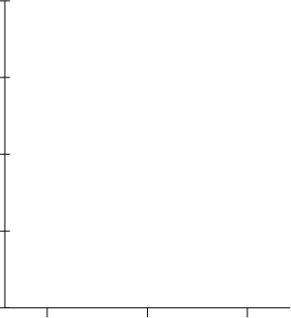




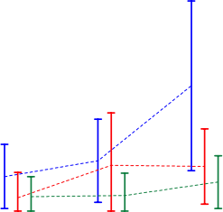






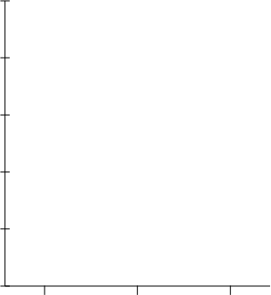









Dominant foot
Km/h Meters
Scale (a.u.) Km/h
Walking
Running
Sprinting
Maximum speed
Maximum kick speed
60
Meters
250

200

150

100

50

0

20

15
Counts
10

5

0
20

Number of kicks

Meters
Counts
60

45

30

15

0

20

15

10

5

0
Counts
Counts
8

6

4

2

0

5

4

3

2

1

0

Non-dominant foot

Small Medium Large
Size of the pitch
25

20

15

10

5

0

8

6

4

2

0

Borg scale CR10

Small Medium Large
Size of the pitch

U23

40

0

Small Medium Large
Size of the pitch

Small Medium Large
Size of the pitch

Small Medium Large
Size of the pitch

U11 U15

Figure 1. Descriptive analysis for all age groups, when playing in different pitch sizes.

Table 1. Results of the one-way repeated measured analysis of variance for each age group considering the pitch dimension effect.

U11
U15
U23
Variables

η²p
F
p
F
p
η²p
F
p
η²p

11.53 < .001 .27
Walking (m)
0.85 .43
.03
0.01 .99 .00

9.76 < .001 .24
Running (m)
2.00 .15
.06
0.62 .53 .02

24.31 < .001 .44
Sprinting (m)
2.84 .07
.08
1.89 .16 .06

22.58 < .001 .42
Sprint number (counts)
6.70 < .01 .18
5.41 < .01 .15

Max speed (km/h) 2.02 .15 06
4.49 .02
.13
0.27 .76 .01

Max kick speed (km/h) 0.12 .89 00
1.37 .26
.04
0.24 .73 .01

Kick number (counts)
2.02 .15
.06
0.87 .39
.03
2.79 .07 .08

Dominant foot (counts)
1.87 .17
.06
0.97 .37
.03
2.07 .14 .06

Non-dominant foot (counts)
1.54 .23
.05
0.28 .72 .01
2.91 .06 .09

6.83 < .01 .18
RPE (a.u.)
5.97 < .01
.16
1.25 .29
.04

Table 2. Inferences for each age group on players’ performance measures.
Group comparison outcomes as:
Mean changes with ±90% confidence limits Practical inferences
Variables |  | U11 |  |  | U15 |  |  | U23
 | S vs. M | S vs. L | M vs. L | S vs. M | S vs. L | M vs. L | S vs. M | S vs. L | M vs. L
Walking (m) | 6.5; ±12.1 | -24.8; ±8.7 | -31.3; ±13.6 | -4.7; ±14.9 | -11.1; ±13.7 | -6.4; ±14.9 | -0.1; ±13.5 | -1.1; ±12.4 | -1; ±14.3
 | unclear | most likely ↓ | most likely ↓ | unclear | possibly ↓ | unclear | unclear | unclear | unclear
Running (m) | 14.1; ±25.4 | 59.1; ±19.0 | 44.9; ±26.0 | -5.6; ±27 | 24.8; ±28.1 | 30.3; ±27.2 | -15; ±24.1 | 0; ±26 | 15; ±29.1
 | unclear | most likely ↑ | very likely ↑ | unclear | likely ↑ | likely ↑ | possibly ↓ | unclear | unclear
Sprinting (m) | 3.6; ±2.5 | 25.0; ±7.4 | 21.5; ±8.3 | 6.5; ±5.2 | 5.3; ±4.0 | -1.1; ±5.4 | 0.8; ±2 | 2.3; ±2.1 | 1.6; ±2.2
 | possibly ↑ | most likely ↑ | most likely ↑ | likely ↑ | likely ↑ | unclear | unclear | likely ↑ | possibly ↑
Sprint number (counts) | 0.4; ±0.4 | 2.5; ±0.7 | 2.1; ±0.8 | 0.9; ±0.5 | 0.9; ±0.4 | 0; ±0.5 | 0; ±0.2 | 0.4; ±0.2 | 0.4; ±0.2
 | possibly ↑ | most likely ↑ | most likely ↑ | very likely ↑ | very likely ↑ | unclear | unclear | very likely ↑ | very likely ↑
Max speed (km/h) | 0.0; ±1.1 | 2.0; ±1.0 | 1.9; ±0.7 | 2.1; ±1.1 | 2.2; ±1.2 | 0.1; ±1.1 | -0.7; ±1.3 | 0.3; ±0.9 | 1.1; ±1
 | unclear | very likely ↑ | most likely ↑ | very likely ↑ | very likely ↑ | unclear | unclear | unclear | likely ↑
Max kick speed (km/h) | 1.4; ±3.3 | 2.0; ±2.8 | 0.7; ±3.7 | 0.6; ±3.8 | 2.6; ±2.8 | 2; ±4 | -2.2; ±3.4 | -0.7; ±5.8 | 1.6; ±4.7
 | unclear | possibly ↑ | unclear | unclear | possibly ↑ | unclear | possibly ↓ | unclear | unclear
Kick number (counts) | 0.8; ±1.7 | 2.6; ±2.2 | 1.8; ±2.8 | 1.1; ±1.9 | 0; ±1 | -1.1; ±1.7 | -0.3; ±1.6 | -2; ±1.5 | -1.7; ±1.5
 | possibly ↑ | likely ↑ | possibly ↑ | unclear | unclear | possibly ↓ | unclear | likely ↓ | likely ↓
Dominant foot (counts) | 0.1; ±1.5 | 1.9; ±1.8 | 1.8; ±2.3 | 0.8; ±1.5 | -0.3; ±0.9 | -1; ±1.3 | -0.3; ±1.1 | -1.3; ±1.2 | -1; ±1
 | unclear | likely ↑ | possibly ↑ | unclear | unclear | possibly ↓ | unclear | likely ↓ | possibly ↓
Non-dominant foot (counts) | 0.7; ±0.6 | 0.7; ±0.8 | 0.0; ±0.9 | 0.3; ±0.7 | 0.2; ±0.5 | -0.1; ±0.7 | -0.1; ±0.7 | -0.8; ±0.6 | -0.7; ±0.7
 | likely ↑ | likely ↑ | unclear | unclear | possibly ↑ | unclear | unclear | likely ↓ | likely ↓
RPE (a.u.) | 0.7; ±0.6 | -0.3; ±0.4 | -1.0; ±0.5 | 0.4; ±0.4 | 0.3; ±0.5 | -0.2; ±0.4 | -0.6; ±0.4 | 0.3; ±0.3 | 0.9; ±0.5
 | likely ↑ | possibly ↓ | very likely ↓ | likely ↑ | possibly ↑ | unclear | very likely ↓ | possibly ↑ | very likely ↑
Abbreviations: U11= under 11 age group; U15= under 15 age group; U23= under 23 age group; S = small pitch; M = medium pitch; L = large pitch; ↑ = increase; ↓ = decrease.


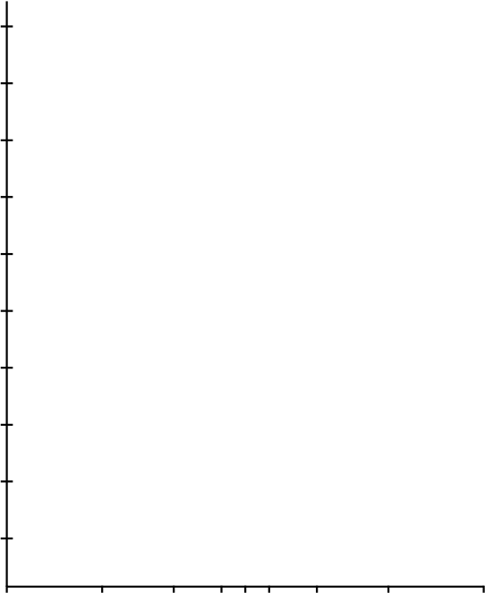






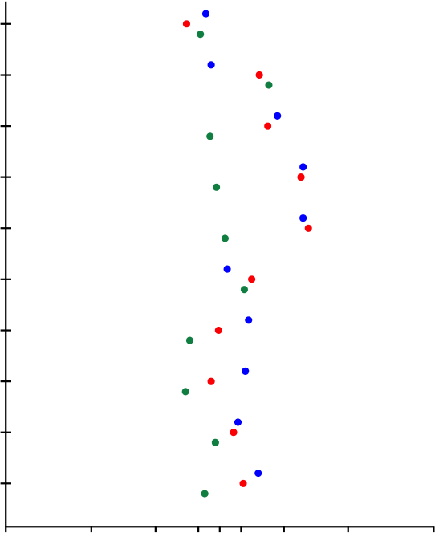
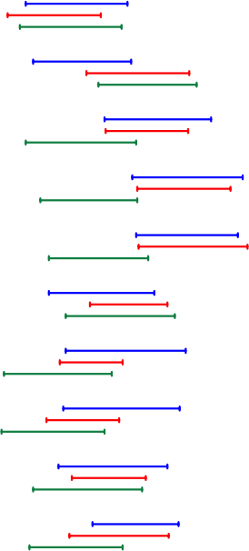

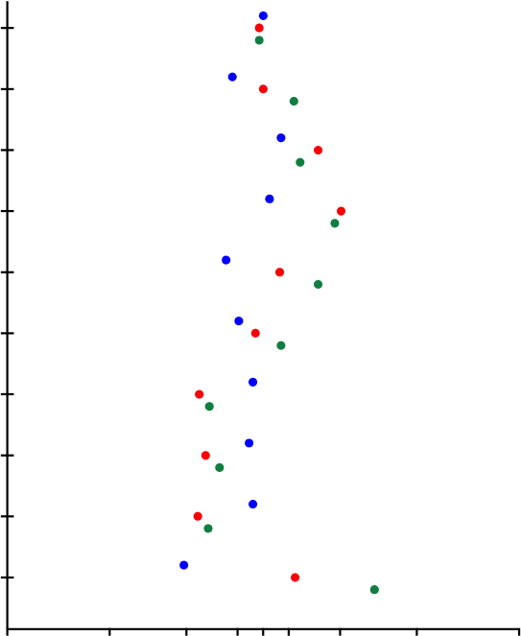
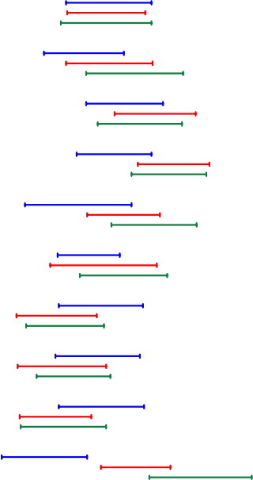
Higher in Group 1

Under-11
Higher in Group 2
Higher in Group 1

Under-15
Higher in Group 2
Higher in Group 1

Under-23
Higher in Group 2
Non-dominant foot (counts)
Sprint number (counts)
Max kick speed (km/h)
Dominant foot (counts)
Kick number (counts)
Max speed (km/h)
Sprinting (m)
Walking (m)
Running (m)
RPE (a.u.)
-2
L
-1.2
M
-0.6
S
-0.2 0
T
0.2
S
0.6
M
1.2
L
2
L
M
S
T
S
M
L
-2
-1.2 -0.6 -0.2 0 0.2 0.6
1.2
2
L
S
T
S
M
L
-2
1.2
2
Standardized (Cohen) differences
Standardized (Cohen) differences

Small vs Medium

Small vs Large

M
-1.2 -0.6 -0.2 0 0.2 0.6
Standardized (Cohen) differences

Medium vs Large

Figure 2. Standardised (Cohen) differences for considered variables according the age group. Error bars indicate uncertainty in true mean changes with 90% confidence intervals.

