1.多选删除不了数据
http://www.nbfy1.com/Backend/Member/Index/index.html
http://www.nbfy1.com/Backend/Member/Common/index.html
http://www.nbfy1.com/Backend/Member/Personer/index.html
http://www.nbfy1.com/Backend/Member/Company/index.html
http://www.nbfy1.com/Backend/Member/Level/index.html
http://www.nbfy1.com/Backend/Shop/Shop/index.html
http://www.nbfy1.com/Backend/Shop/Theme/index.html
http://www.nbfy1.com/Backend/Shop/Pendingshop/index.html
http://www.nbfy1.com/Backend/Products/Products/index.html
http://www.nbfy1.com/Backend/Products/Language/index.html
http://www.nbfy1.com/Backend/Products/Language/index/pid/1.html
http://www.nbfy1.com/Backend/Products/Language/index/pid/2.html
http://www.nbfy1.com/Backend/Products/Language/index/pid/3.html
http://www.nbfy1.com/Backend/Products/Language/index/pid/4.html
http://www.nbfy1.com/Backend/Products/Language/index/pid/87.html
http://www.nbfy1.com/Backend/Products/Industry/index/pid/21.html
http://www.nbfy1.com/Backend/Products/Industry/index/pid/22.html
http://www.nbfy1.com/Backend/Products/Industry/index/pid/31.html
http://www.nbfy1.com/Backend/Products/Industry/index/pid/32.html
http://www.nbfy1.com/Backend/Products/Industry/index/pid/33.html

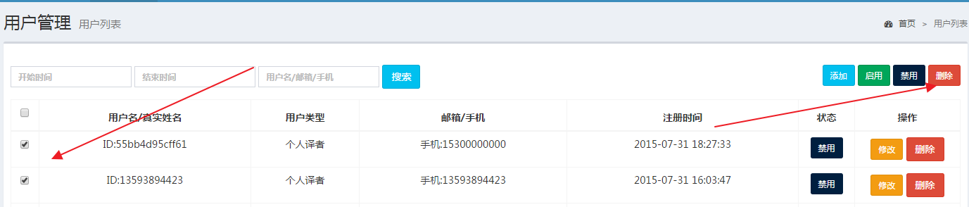

2.商品管理》商品列表》搜索按钮有问题，点击之后搜索不到商品，会跳转到语种设置页面
http://www.nbfy1.com/Backend/Products/Products/index.html
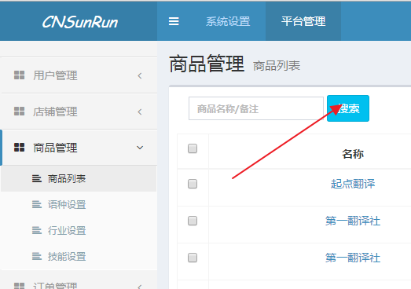

3.商品管理》语种设置》搜索框提示文字不对
http://www.nbfy1.com/Backend/Products/Language/index.html
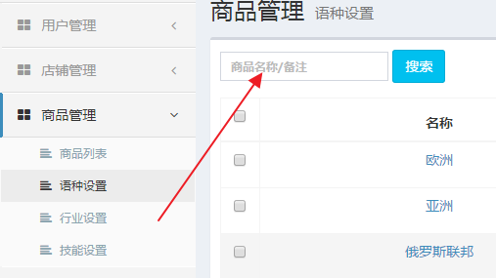

4.商品管理》语种设置》亚洲语种里面推荐的语言在首页不展示
http://www.nbfy1.com/Backend/Products/Language/index/pid/2.html
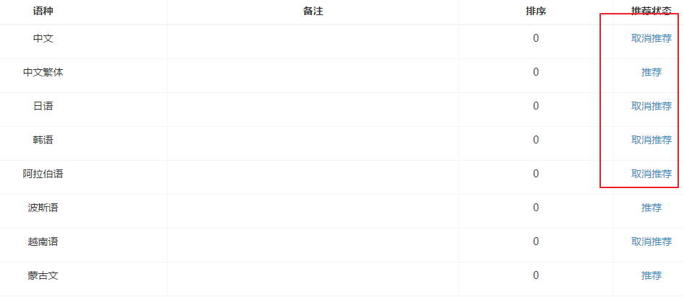

5.财务管理》资金记录交易类型，账号类型，收入方信息，交易时间信息不完整
http://www.nbfy1.com/Backend/Finance/Record/index.html

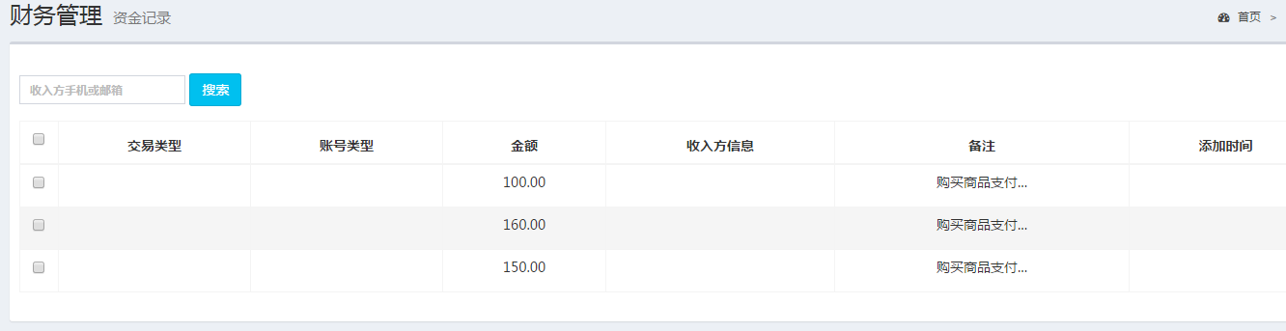

6.店铺管理》待审核店铺查看不了资质
http://www.nbfy1.com/Backend/Shop/Pendingshop/index.html
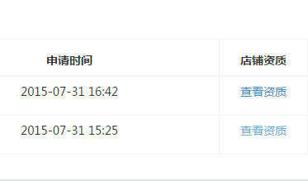

7.商品管理》语种设置》添加语种操作失败
http://www.nbfy1.com/Backend/Products/Language/add/pid/1.html

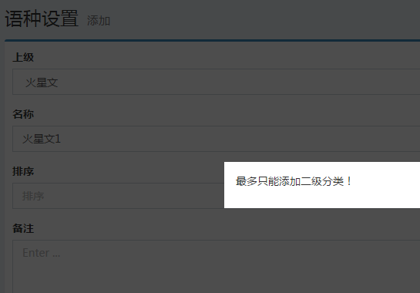

8.技能设置》删除数据出现底层错误，用户体验很不好
http://www.nbfy1.com/Backend/Products/Ability/index/pid/36.html
http://www.nbfy1.com/Backend/Products/Ability/index/pid/37.html
http://www.nbfy1.com/Backend/Products/Ability/index/pid/56.html
http://www.nbfy1.com/Backend/Products/Ability/index/pid/88.html
http://www.nbfy1.com/Backend/Products/Ability/index/pid/89.html

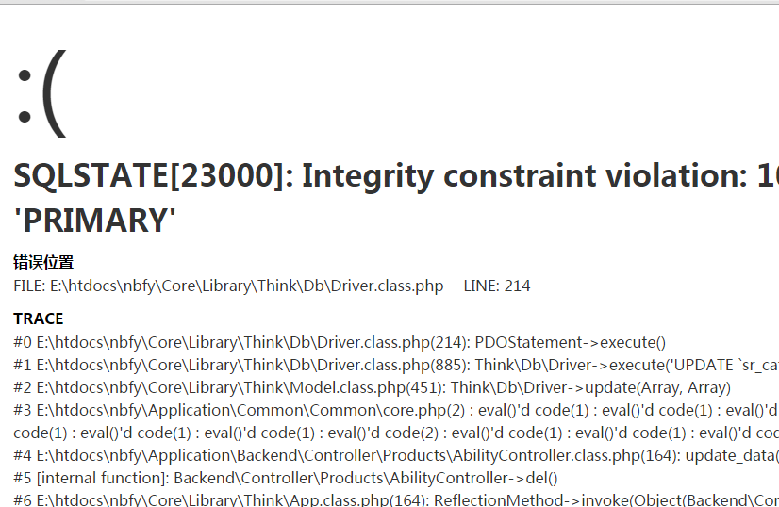

9.订单管理》订单列表》产品名称信息没有显示出来
http://www.nbfy1.com/Backend/Order/Order/index.html
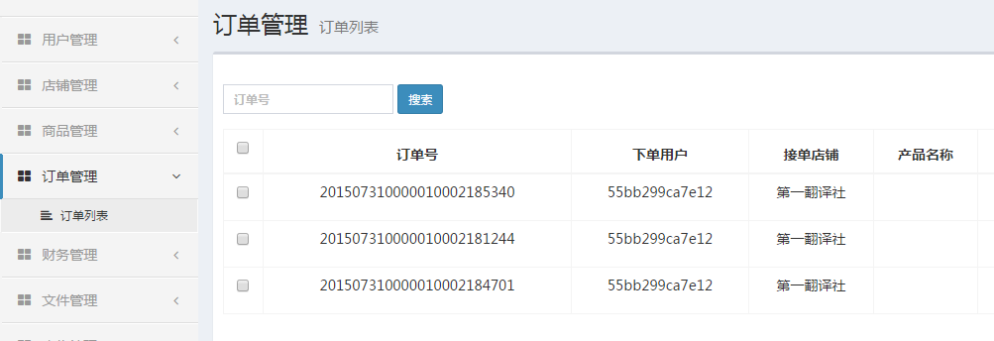

10.订单管理》订单列表》全选之后没有可操作选项（比如删除）
http://www.nbfy1.com/Backend/Order/Order/index.html
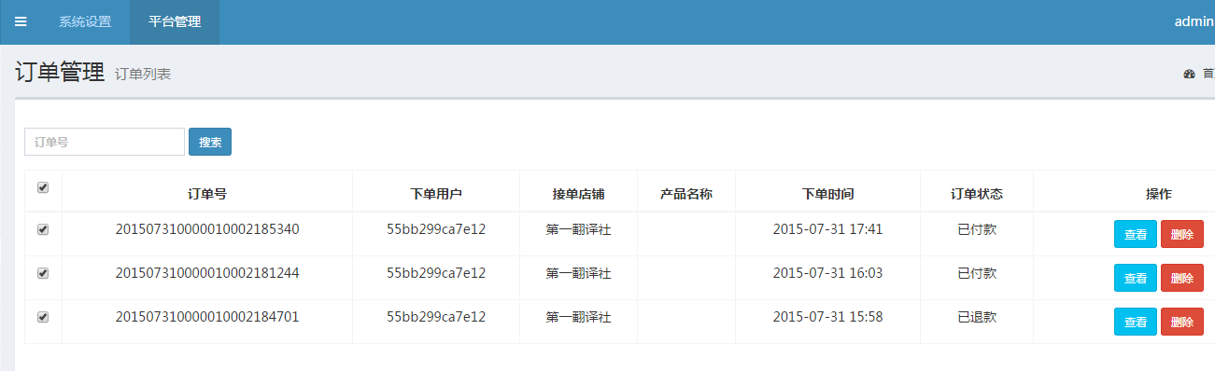

11.财务管理》积分记录找不到对应模块
http://www.nbfy1.com/Backend/Finance/Integration/index.html

12.内容管理》图片管理 店铺图片禁用之后前台还可以显示出来。
http://www.nbfy1.com/Backend/Contents/Picture/index/status/-1/ids/13.html




13.内容管理》资讯管理新闻列表没有显示出来
http://www.nbfy1.com/Backend/Contents/News/index.html
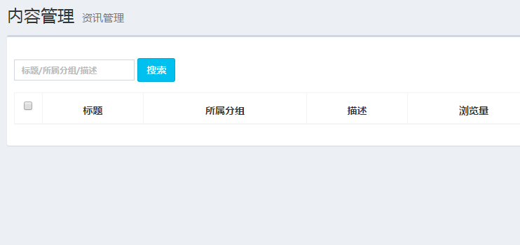
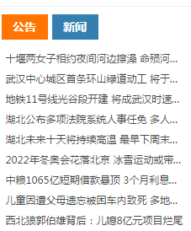

14.内容管理》公告管理管理公告列表没有显示出来
http://www.nbfy1.com/Backend/Contents/Notice/index.html
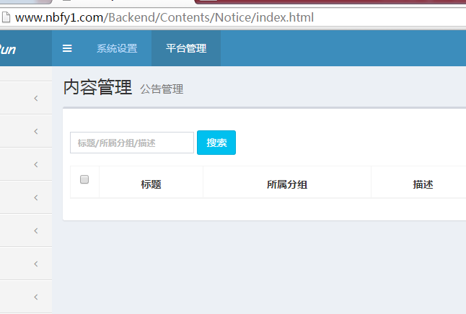
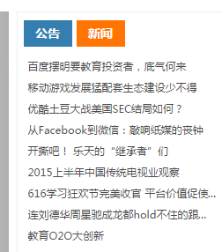
15.消息通知》消息列表没有显示出来
http://www.nbfy1.com/Backend/Message/Letter/index.html
