**MURANG’A UNIVERSITY OF TECHNOLOGY**

**PROGRAMMING AND DATABASE PRACTICUMGORDON OTIENOSC212/1269/2017HOUSE RENTAL MANAGEMENT PORTALREPORT**

**Abstract**

We are stuck with technology when what we really want is just stuff that works. With the current paradigm shift in technological field, there is an urgent need to embrace and appreciate the powerof technology. Housing sector remains vigilant to face the challenges of change by employing anew strategy that facilitates easy management of rental houses. Hence there is need to develop arental house management system that can simplify work for the rental managers so that all theirwork can be efficient and effective. The Rental Management System is Searching in Based on theApartment Paying Guest, Office, House in metropolitan cities. The Rental Management System isBased on the Owners and the Customers. The Owner is updated on the Apartment, Office details,House, Paying Guest details. The Customer is details about the Room space, Room rent and theAddress Details also. The Rental Management System is best Suitable the owners because timesave and the only contact and the eligible person and there is no need to explain the room detailson the speak. The Rental Management System is best application in the city place The customercontact and the easily search and the suitable place of Apartment, Office, PG, House and basedthe Money, Limit Person is based on the suitable house. The Rental Management System is savethe time also. The Rental Management System is used to easily identify the suitable place in Savetime, cost also. The Rental Management System is best way to search the house, Apartment office,Paying Guest. Hence this system is best applicable for the above reasons making House rental aneasy process through an online system

**Acknowledgement**

At the beginning I am very much grateful to almighty God for giving me strength and opportunityand sound mind to complete the House Rental Management report. I want to bid my heartiestthanks to my Lecturer, Dr. Tirus, for guiding and giving me the opportunity to initiate this report.Then I want to thank Jionme Real Estate Ltd for giving me the opportunity to do my research intheir organization. Thanks again to my colleagues Thomas, Joseph and Steve Amani withoutforge

tting the 3 Idiots Team.I would also like to thank Murang’a University for their library and

internet facilities from where I got enormous information.

*Trusted by over 1 million members*

Try Scribd **FREE** for 30 days to access over 125 million titles without ads or interruptions!

[**Start Free Trial**](https://www.scribd.com/archive/pmp_checkout?doc=428244636&metadata=%7B%22context%22%3A%22pmp%22%2C%22action%22%3A%22start_trial%22%2C%22logged_in%22%3Afalse%2C%22platform%22%3A%22mobile%22%7D)

Cancel Anytime.

**Table of Content**

Abstract ...................................................................................................................................1

CHAPTER ONE .........................................................................................................................5

Introduction .................................................................................................................................5

1.1 Problem Statement .............................................................................................................5

1.2 Background .......................................................................................................................5

1.2.1 How House Rental Services Work ..................................................................................5

1.2.2 Benefits of Online House Rental Services .......................................................................5

1.3 Aims & Objectives ............................................................................................................6

1.4 Purpose, Scope and Applicability: .....................................................................................6

1.4.1 Purpose ...........................................................................................................................6

1.4.2 Scope ..............................................................................................................................7

1.4.3 Applicability ...................................................................................................................7

CHAPTER TWO ........................................................................................................................7

SURVEY OF TECHNOLOGIES ................................................................................................7

2.1 About PHP ........................................................................................................................7

2.4 Connecting PHP Application to MySQL Database.............................................................9

2.5 Introduction to MySQL: .................................................................................................. 10

Basic administration (supervisory level) ............................................................................ 11

General management (functional level) .............................................................................. 11

Strategic management ........................................................................................................ 12

CHAPTER THREE ................................................................................................................... 12

REQUIREMENTS AND ANALYSIS ....................................................................................... 12

3.1 HARDWARE & SOFTWARE REQUIREMENT ............................................................ 12

3.1.1 HARDWARE: .............................................................................................................. 12

 3.1.2 SOFTWARE: ............................................................................................................... 12

3.2 Functional Requirements ................................................................................................. 13

3.3 Non-Functional Requirements ......................................................................................... 13

3.4 CONCEPTUAL MODELS .............................................................................................. 14

Data Flow Diagram (DFD) .................................................................................................... 14

Functions of Customer: ......................................................................................................... 15

Functions of System Administrator ........................................................................................ 15

Functions of Landlord: .......................................................................................................... 15

USE-CASE DIAGRAMS .......................................................................................................... 16

Actor and Use Case Description ............................................................................................ 16

Use Case Diagram ................................................................................................................. 18

Use-Case Dependency Diagram ............................................................................................ 19

Class Diagram ....................................................................................................................... 19

CHAPTER FOUR ..................................................................................................................... 20

SYSTEM DESIGN ................................................................................................................... 20

Tenant Registration Module .................................................................................................. 20

House Listing Module ........................................................................................................... 21

LANDLORD REGISTRATION MODULE .......................................................................... 23

SALE HOUSE MODULE ..................................................................................................... 24

POST HOUSE ....................................................................................................................... 28

Book House ........................................................................................................................... 31

Contact and feedback ............................................................................................................ 31

ADMIN LOGIN MODULE .................................................................................................. 35

Manage pages ........................................................................................................................ 36

Security ................................................................................................................................. 37

 The system provides username and password to prevent the system from unauthorized access.

The staffs’ password must be greater than eight characters.

 ................................................... 37

Test Cases Design ................................................................................................................. 37

CHAPTER FIVE ....................................................................................................................... 40

IMPLEMENTATION AND TESTING ..................................................................................... 40

5.2 TESTING ...................................................................................................................... 40

5.3 Installation and project description .................................................................................. 41

CHAPTER 6 ............................................................................................................................. 47

CONCLUSION ......................................................................................................................... 47

6.2 Limitation of the system .................................................................................................. 48

6.3 REFERENCES ................................................................................................................ 48

Books Used: .......................................................................................................................... 48

References Used: ................................................................................................................... 48

GLOSSARY ......................................................................................................................... 48

Table of figures

ER diagram Figure 1 ................................................................................................................. 14Level 0 DFD diagram for House Rental management system Figure 2 ...................................... 14Figure 3Level 1 DFD of Online House Rental System ............................................................... 16Figure 4: Use Case Diagram ...................................................................................................... 18Figure 5Dependency Use Case Diagram .................................................................................... 19Figure 6 Class Diagram ............................................................................................................ 19

**CHAPTER ONEIntroduction**

**1.1 Problem Statement**

House Rental is a house/Apartment/home that can be used temporarily for a fee during a specified period. The individual who needs a house must contact a rental car company and contract out fora room/home/apartment. This system increases customer retention and simplify House and staffmanagement.

**1.2 Background1.2.1 How House Rental Services Work**

A House rental is a house that can be used temporarily for a period of time with a fee. Renting ahouse assists people to live in a comfortable house when they do not have access to build theirown personal homes/houses or. The individual who want to rent a house/room/apartment/homemust first contact the House rental company for the desire House/Home/apartment. This can bedone online. At this point, this person has to supply some information such as; dates of rental, andtype of house. After these details are worked out, the individual renting the house must present avalid Identification Card.Most companies throughout the industry make a profit based of the type of house that are rented.The rental houses are categorized into modern Homes, Colonial, apartment, Rentals etc. Andcustomers are free to choose any house of their choice based on their purse and availability of suchhouses at the time of booking.

**1.2.2 Benefits of Online House Rental Services**

•

This online house rental solution is fully functional and flexible.

•

It is very easy to use.

•

This online House rental system helps in back office administration by streamlining andstandardizing the procedures.

•

It saves a lot of time, money and labor.

•

Eco-friendly: The monitoring of the Housing activity and the overall business becomes easyand includes the least of paper work.

•

The software acts as an office that is open 24/7.

•

It increases the efficiency of the management at offering quality services to the customers.

•

It provides custom features development and support with the software.

**1.3 Aims & Objectives**



To produce a web-based system that allow customer to register and reserve houses onlineand for the company to effectively manage their House rental business.



To ease customer’s task whenever they need to rent a house.



To Transform the manual process of renting a house to an online and computerized system



To validate the house rental system using user feedback and testimonies



To produce the documentation such as Software Requirement specification, SoftwareDesign Description and Software Development References

**1.4 Purpose, Scope and Applicability:1.4.1 Purpose**

The advancement in Information Technology and internet penetration has greatly enhancedvarious business processes and communication between companies (services provider) and theircustomers of which Real Estate/House Rentals industry is not left out. This House Rental Systemis developed to provide the following services:

•

Enhance Business Processes: To be able to use internet technology to project the rentalcompany to the global world instead of limiting their services to their local domain alone, thusincrease their return on investment.

•

Online House/Room Booking: A tools through which customers can book availableRooms/House/Apartment online prior to their date of using the house instead of walkingaround and asking for a vacant house.

•

Customer’s registration: A registration portal to hold

customer’s details, monitor their

transaction and used same to offer better and improve services to them and user account wherehe/she can view her/his details instead of the poor existing systems where only theadministrators control their customer details.

•

Rentals Notice and Blog: A tool where customers can see and view the details of nearbyavailable House for rent/sale, and also view the current economic design of houses/apartments.

**1.4.2 Scope**

This project traverses a lot of areas ranging from business concept to computing field, and requiredto perform several researches to be able to achieve the project objectives. The area covers include:

•

Real Estate Company: This includes study on how the Real Estate business is being done, process involved and opportunity that exist for improvement.

•

PHP Technology used for the development of the application.

•

General customers as well as the company’s staff will be able to use the system effectively.

•

Web-platform means that the system will be available for access 24/7 except when there is atemporary server issue which is expected to be minimal.

•

Existing Systems: This involves studying the existing systems and learning their weaknesshence developing a new system to cater for the challenges the local and world domains faceswhen dealing with house rental issues.

**1.4.3 Applicability**

House Rental is a house/Apartment/home that can be used temporarily for a fee during a specified period. The individual who needs a house must contact a House Rental Owners Through Houserental Online System by first checking the available Houses, booking it then The system willcontact the house owners to check the House and contract out for a room/home/apartment. Thissystem increases customer retention and simplify House and staff management. The System can be used by Real Estate Companies to increase the house rental market around the world. Thesystem will also help people to rent apartments/houses easily instead of walking and manuallyrenting houses. It is also applicable for landlords who wants to expand their house rental business.

**CHAPTER TWO**

**SURVEY OF TECHNOLOGIES**

**2.1 About PHP**

**PHP: Hypertext Pre-processor**

 is a widely used, general-purpose

scripting language that wasoriginally designed for web development to produce dynamic web pages. For this purpose, PHP

 code is embedded into the HTML source document and interpreted by a web server with a PHP processor module, which generates the web page document.As a general-purpose programming language, PHP code is processed by an interpreter applicationin command-line mode performing desired operating system operations and producing programoutput on its standard output channel. It may also function as a graphical application. PHP isavailable as a processor for most modern web servers and as standalone interpreter on mostoperating systems and computing platforms.PHP was originally created by Rasmus Lerdorf in 1995 and has been in continuous developmentever since. The main implementation of PHP is now produced by the PHP Group and serves as the

*de facto*

 standard for PHP as there is no formal specification. PHP is free software released underthe PHP License.PHP is a general-purpose scripting language that is especially suited to server-side webdevelopment where PHP generally runs on a web server. Any PHP code in a requested file isexecuted by the PHP runtime, usually to create dynamic web page content. It can also be used forcommand-line scripting and client-side

GUI applications. PHP can be deployed on most webservers, many operating systems and platforms, and can be used with many relational databasemanagement systems. It is available free of charge, and the PHP Group provides the completesource code for users to build, customize and extend for their own use.

Originally designed to create dynamic web pages, PHP now focuses mainly on server sidescripting, and it is similar to other server-side scripting languages that provide dynamic content

from a web server to a client, such as Microsoft's Active Server Pages, Sun Microsystems’ Java

Server Pages, and mod_perl. PHP has also attracted the development of many frameworks that provide building blocks and a design structure to promote rapid application development (RAD).Some of these include CakePHP, Symfony, Code Igniter and Zend Framework, offering featuressimilar to other web application frameworks.

**2.2 PHP Syntax:**

 HTML and PHP code is written on the same page, and to distinguish PHP code from HTML, thePHP code is enclosed within <? php ?> Tags.For example:

 <html><head><title>php basics</title></head><body><h2>HELLO</h1> <?phpecho "hello";?></body></html>In the above example PHP code is embedded within HTML. In this way PHP and HTML codingis combined on the same page.Since PHP is a server side scripting language, the PHP coding cannot be seen by the end userthrough view source option, due to this feature PHP is very secure.PHP is a parsed language; therefore PHP environment is necessary at the server for running PHPscripts.

**2.3 Working Of PHP:**

When a client requests web page containing PHP code from the server, then the requested PHP pages are parsed under PHP environment and interaction with database is made if required.After server side processing, the resulting HTML pages are passed to client and displayed on the browser.In this way the working of php is complete.

**2.4 Connecting PHP Application to MySQL Database**

Make a connection variable to the database:$con= mysql_connect ("localhost","servername","password");Here $con is a connection variable to database.Select database over that connection variable

 $db=mysql_select_db("databasename",$con);Prepare a sql query to execute:$qry= Select * from abc;Run the sql query:$result=mysql_query($qry);Iterate over the result:while($row = mysql_fetch_array($result)){//some logic}

**2.5 Introduction to MySQL:**

**MySQL**

 is a relational database management system (RDBMS) that runs as a server providingmulti-user access to a number of databases. MySQL is officially pronounced ("My S-Q-L"), but isoften pronounced ("My Sequel"). It is named for original developer Michael Widenius's daughterMy.The MySQL development project has made its source code available under the terms of the GNUGeneral Public License, as well as under a variety of proprietary agreements. MySQL is ownedand sponsored by a single for-profit firm, the Swedish company MySQL AB, now owned by SunMicrosystems, a subsidiary of Oracle Corporation.MySQL code uses C and C++. The SQL parser uses yacc and a home-brewed lexer, sql_lex.cc.MySQL works on many different system platforms, including AIX, BSDi, FreeBSD, HPUX,i5/OS, Linux, Mac OS X, NetBSD, Novell NetWare, OpenBSD, OpenSolaris, eComStation, OS/2Warp, QNX, IRIX, Solaris, Symbian, SunOS, SCO OpenServer, SCO UnixWare, Sanos, Tru64and Microsoft Windows. A port of MySQL to OpenVMS also exists.All major programming languages with language-specific APIs include Libraries for accessingMySQL database. In addition, an ODBC interface called MyODBC allows additional programming languages that support the ODBC interface to communicate with a MySQLdatabase, such as ASP or ColdFusion. The HTSQL - URL based query method also ships withMySQL adapter allowing direct interaction with MySQL database from any web client viastructured URLs. The MySQL server and official libraries are mostly implemented in ANSIC/ANSI C++.

**2.6 Introduction to APACHE SERVER:**

*Trusted by over 1 million members*

Try Scribd **FREE** for 30 days to access over 125 million titles without ads or interruptions!

[**Start Free Trial**](https://www.scribd.com/archive/pmp_checkout?doc=428244636&metadata=%7B%22context%22%3A%22pmp%22%2C%22action%22%3A%22start_trial%22%2C%22logged_in%22%3Afalse%2C%22platform%22%3A%22mobile%22%7D)

Cancel Anytime.

 In this project apache server is used to parse and execute PHP pages, before

deploying websiteson the server, the website should be tested at the developer side to get a feel of how the websitewill work on actual server.Therefore apache server is like a local server on the developer side, apache server should beinformed about the environment on which it should work.In our project apache server is configured to work with PHP, in this way all the PHP pages are parsed and executed by the server.When apache is installed on the system, then its services is controlled by apache service monitor.The following are the database entities used in this system;

**Houses**

: House information, Rental or sale/Buy agreement administration, credit control, cashflow control, compatibility with accounting principles and practices and existing systems, accurate bookkeeping, owner reporting and identifying of key performance indicators.

**Tenant**

: general tenant information (name and contact details), finding space for a tenant, accuraterent billing and collection, handling of payments, accounting and general ledger (GL) functions.

**Landlord, Client or Body Corporate:**

general details (name and contact details), shareholding ifapplicable.

**Basic administration (supervisory level)**

Repair and maintenance schedules are required by the House manager, as well as a diary to “flag”important dates for tenant’s works, rent review and lease renewal dates. A good software program

should also provide for a forward planning facility.

**General management (functional level)**

Aptly summarises the requirements at this level as follows:

“In terms of accounting procedures, the main property management related tasks will comprise•

Rent invoicing and income connection

•

Recovery of expenditure

•

Disbursements/outgoings

•

Service charge costing and apportionment

•

Client and tenant accounts

•

Report production.Any rent invoicing system should record amounts owing from tenants quickly and accurately and bill them accordingly. Receipts will need to be processed quickly and credit control systemsmaintained. Rent demands and accounts should be easily accessible as should rent apportionedover periods not concurrent with a normal rent review period. Interest on unpaid rent should becalculable and a stop on rent collection made if necessary. Full analysis of

rents, classified bytenant, property or client should also be possible. Service charge accounting is often provided asa separate module. This will need to cater for multi tenanted buildings where perhaps some tenantsdo not contribute to some services. Separate schedules may well need to be set up in such cases.In addition, a full analysis of property expenditure, service suppliers, tenant expenditure, servicecharges, wages and salaries, and V

AT on expenditure should be possible”.

Strategic managementLastly, a software programme should provide the information necessary to make strategicdecisions. Such decisions include the performance and valuation of individual properties and property portfolios, as well as development appraisals. Features that are required comprise, amongother things, tenancy and tenure details, the calculation of yields and profitability, discounted cashflows, cost, financing, tax implications and the valuation of both freeholds and leaseholds. Allthese should be supported by good menu-driven features and help facilities.Technical aspects and user interface requirements are discussed below.

**CHAPTER THREEREQUIREMENTS AND ANALYSIS**

**3.1 HARDWARE & SOFTWARE REQUIREMENT3.1.1 HARDWARE:**

Processor Pentium-II or higherProcessor Speed 533 MHZHard Disk Space 20 GB (min.)Ram Memory 32 MB (64 MB recommended)

**3.1.2 SOFTWARE:**

Operating System Windows 95/98/NT/2000 /10/7/8Database Server MySql /XAMP/WAMP

 Front end PHPText Editor Notepad++

**3.2 Functional Requirements**

Requirement analysis is a software engineering technique that is composed of the various tasksthat determine the needs or conditions that are to be met for a new or altered product, taking intoconsideration the possible conflicting requirements of the various users.Functional requirements are those requirements that are used to illustrate the internal workingnature of the system, the description of the system, and explanation of each subsystem. It consistsof what task the system should perform, the processes involved, which data should the systemholds and the interfaces with the user. The functional requirements identified are:



Customer’s registration: The system sho

uld allow new users to register online.



Online reservation of House: Customers should be able to use the system to make bookingand online reservation.



Automatic update to database once reservation is made or new customer registered:

Whenever there’s new

reservation or new registration, the system should be able updatethe database without any additional efforts from the admin.



Feedbacks to customers: It should provide means for customers to leave feedback.

**3.3 Non-Functional Requirements**

It describes aspects of the system that are concerned with how the system provides the functionalrequirements. They are:

a.

Security

**:**

The subsystem should provide a high level of security and integrity of the data held by the system, only authorized personnel of the comp

any can gain access to the company’s

secured page on the system; and only users with valid password and username can login to

view user’s page.

b.

Performance and Response time:

The system should have high performance rate when

executing user’s input and sho

uld be able to provide feedback or response within a short timespan usually 50 seconds for highly complicated task and 20 to 25 seconds for less complicatedtask.

c.

Error handling:

Error should be considerably minimized and an appropriate error message that

guides the user to recover from an error should be provided. Validation of user’s input is highly

essential. Also the standard time taken to recover from an error should be 15 to 20 seconds.

d.

Availability:

This system should always be available for access at 24 hours, 7 days a week.Also in the occurrence of any major system malfunctioning, the system should be available in1 to 2 working days, so that the business process is not severely affected

**3.4 CONCEPTUAL MODELS**

ER diagramER diagram is a graphical representation of a system entities their attributes and the relationship between them as shown in the figure below

*ER diagram Figure 1*

**Data Flow Diagram (DFD)**

A Data Flow Diagram (DFD) is a graphical representation that depicts the information flow andthe transforms that are applied as data moves from input to output.

*Level 0 DFD diagram for House Rental management system Figure 2*

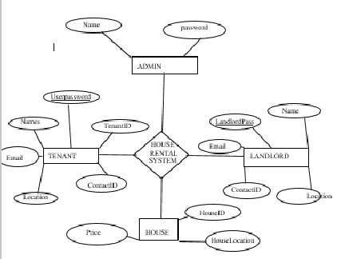

 Level 0 DFD of Online House Rental Systemin this diagram, Customer,Landlords and System Administrator are entity sets.

**Functions of Customer:**



 New Registration



Login Request



Registration Confirmation by the System



Reserve House



House Issued by the System



Email received for Reserved House.

**Functions of System Administrator**



Add Customers/Tenants/landlords



Send E-Mails for Reserved House



View Transaction reports



Post Vacant Houses

**Functions of Landlord:**



Register in the system



Post a New house



Send House Confirmation to System Administrator

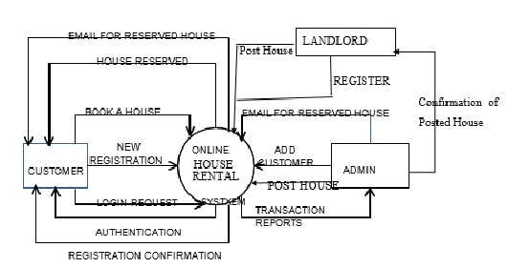

*Figure 3 Level 1 DFD of Online House Rental System*

**USE-CASE DIAGRAMSActor and Use Case Description**

Actor and use case description shows the detail description of interaction between the actors andtheir use cases. The description enables to have a proper understanding of how actor interacts withthe system through their use cases.

**Actor**

**Use Case**

**Use Case Description**

 Customer Registermemberas This use case describes the activities of the customer to registeronline and become a member. Customer's details are required as part of the registration. Customer chooses his login details byentering user name and password registration.

House Details

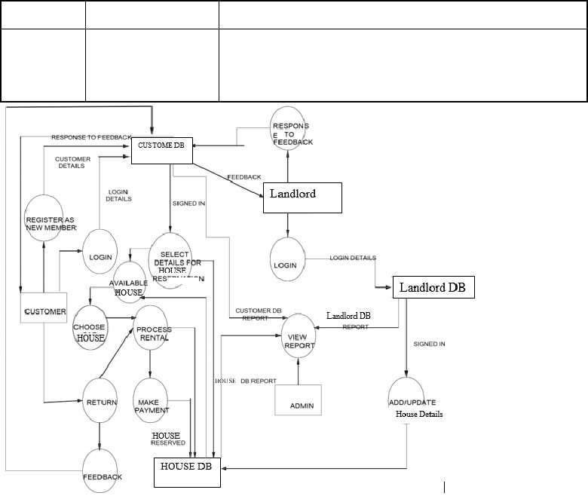

 MakereservationThis use case enable customer to search and make reservation. Non-register customer will be directed to register before theirreservation can be confirmed. Notification is automatically sendto the customer after the task is completed.AccountmanagementThis use case describes the event of customer setting his accountand viewing his bookings.Give feedbackAnd testimonies andsubscriptionThis use case is used by the customer to provide feedbacks andTestimonies to the company; The user also subscribes to the newsfeeds to automatically get news on the available houses. aconfirmation notification will be send to the customer once afeedback has been submitted.LandlordAdd new HouseThis use case is used by the landlords to add new and vacant housefor rent or sale to the company's fleet database. Landlord willneeded to login to activate this use case.Update HousedetailsThis use case is used by the Landlord to edit and modify Housedetails whenever there is new renewal(images, fees). It allows the company to keep up-to-date recordsof their fleetReply to

customer’s feedback

 This use case describes the event by which Landlords sends reply tocustomer's earlier feedback. It depends on `give feedback' use casefrom the customer.Process rental This use case described the event by which landlord updates thesystem when customer take the houseAdmin Add new landlord This use case describes the event by which Admin add new landlorddetail to the company's landlord database.It is invoke whenever a new landlord join the company.View report This use case is used by the Admin to view transaction report.Post House This use case is used by admin to add/edit new houseManage pages This use case allows admin to manage system pages by eitheradding,deleting or editingManage Testimonies This use case allows admin to view and manage CustomersTestimoniesManage Bookings This use case describes the event by which admin views and confirmhouse bookings from the customer and the send the customer aconfirmation message



 Manage users This use case allows admin to add, edit, delete new customerManageCounty/State/AreaThis use case allows admin to add, delete or edit county, state, areaof the propertiesManage listing Types This use case describe how admin can add, delete or edit house listingTypesManage Subscribers This use case allows admin to edit system subscribers.Table: Actors and Use Case Description

**Use Case Diagram**

*Figure 4: Use Case Diagram*

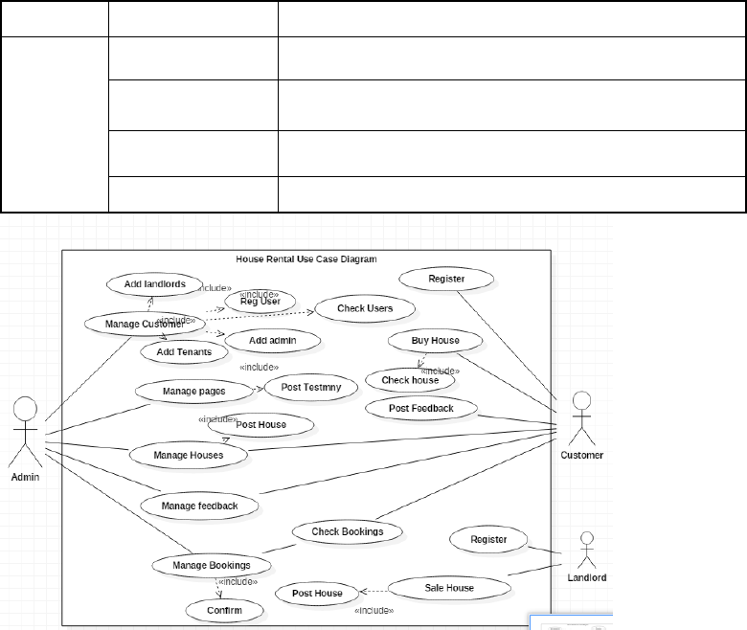

**Use-Case Dependency Diagram**

*Figure 5Dependency Use Case Diagram*

**Class Diagram**

*Figure 6 Class Diagram*

Reply to customer's

feedback

View transaction

report

View customer’s

details

Give feedback/

comments

Udate House details

Process rental

Register as

Member

 Add newMake reservation

To-Date

View report

Contractr

Renew House contract

From Date

>>

include

<<

<<

>>

include

Depends on

<<

>>

extend

>>

extend

<<

Depends on

<<

extend

>>

<<

extend

>>

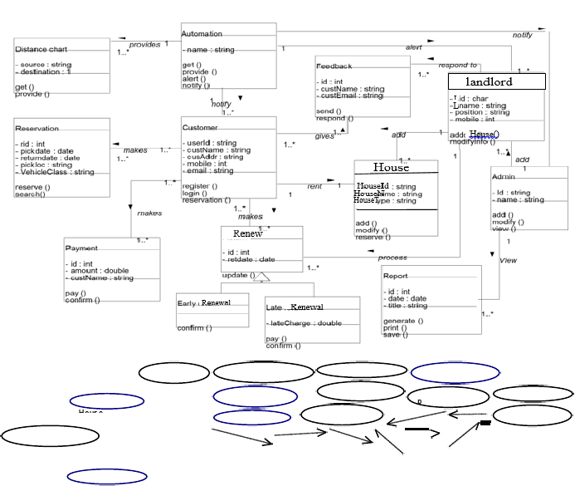

























**CHAPTER FOURSYSTEM DESIGN**

**Tenant Registration Module**

This module allows Tenants or the system users to register and log in in case they want to makeany inqueries in the system

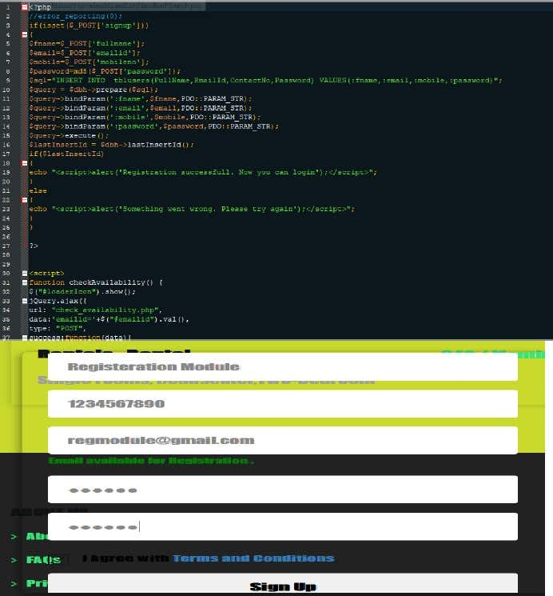

*Trusted by over 1 million members*

Try Scribd **FREE** for 30 days to access over 125 million titles without ads or interruptions!

[**Start Free Trial**](https://www.scribd.com/archive/pmp_checkout?doc=428244636&metadata=%7B%22context%22%3A%22pmp%22%2C%22action%22%3A%22start_trial%22%2C%22logged_in%22%3Afalse%2C%22platform%22%3A%22mobile%22%7D)

Cancel Anytime.

**House Listing Module**

This module allows the system the system to query the uploaded Houses or property and displaythem in the web portal page called house listing

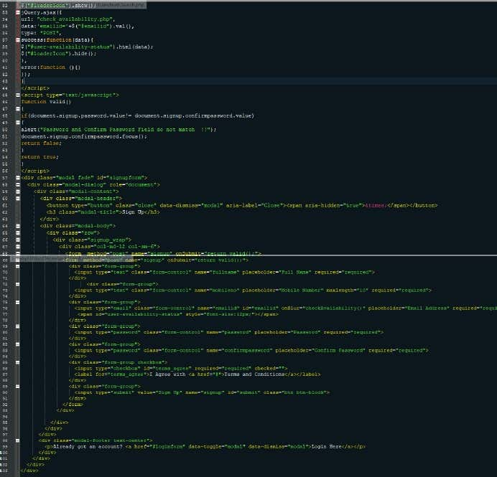

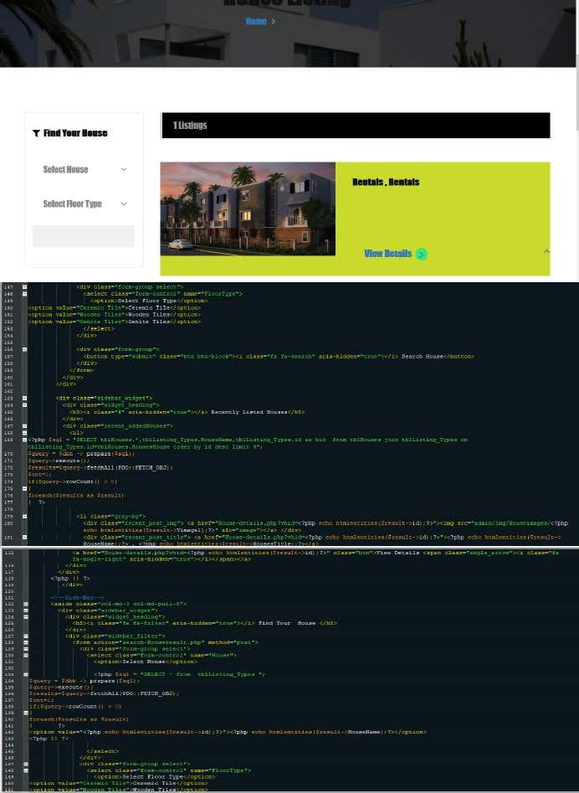

**LANDLORD REGISTRATION MODULE**

This module allows property owners or landlords to register or log in incase the want to posttheir properties in the system without contacting system administrator to do it.

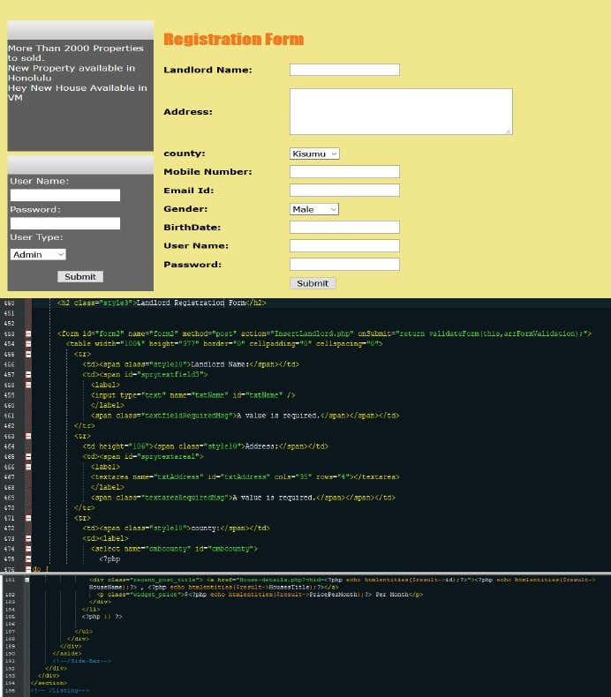

**SALE HOUSE MODULE**

This module allows Landlord to post a property in the system after successful registration orlogin.

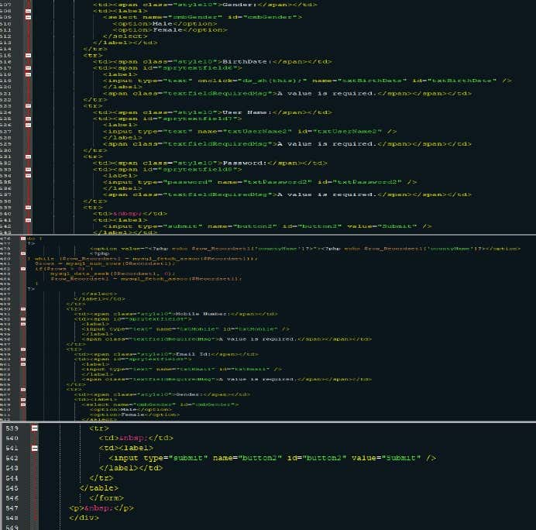

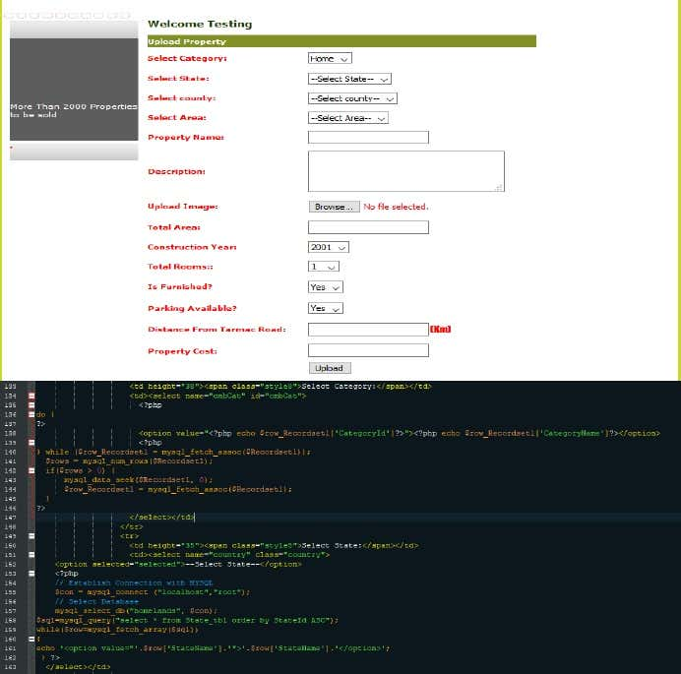

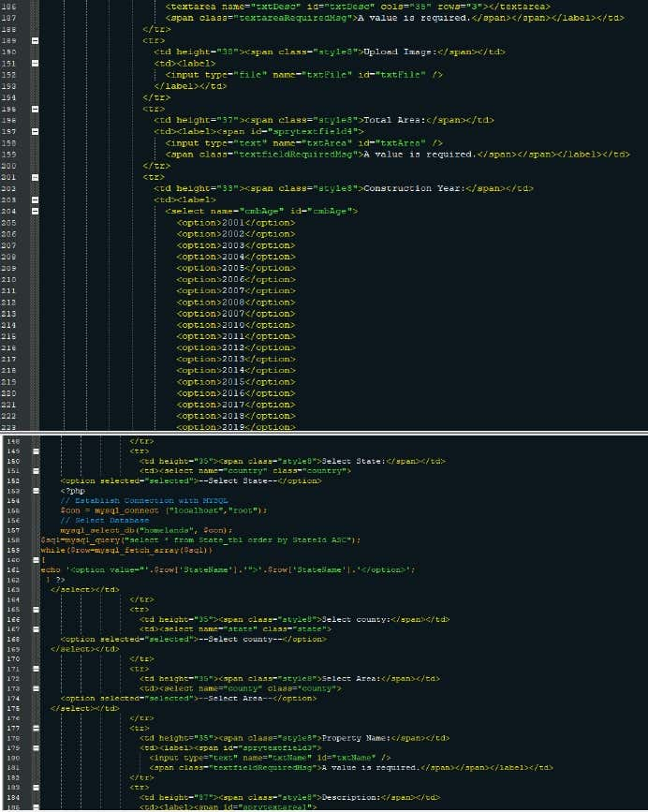

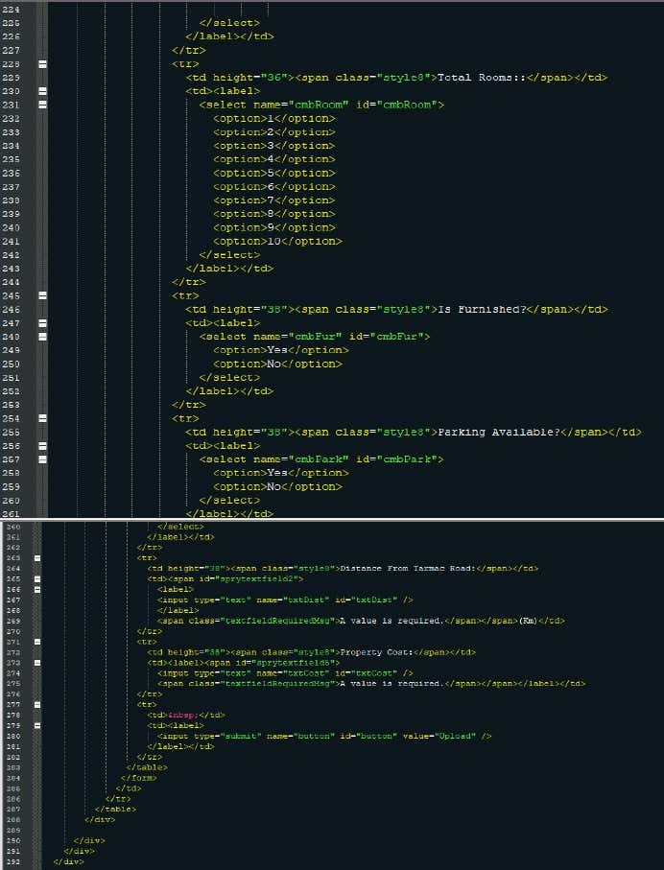

**POST HOUSE**

This module allows System administrator to mange by editing ,adding or posting a new house

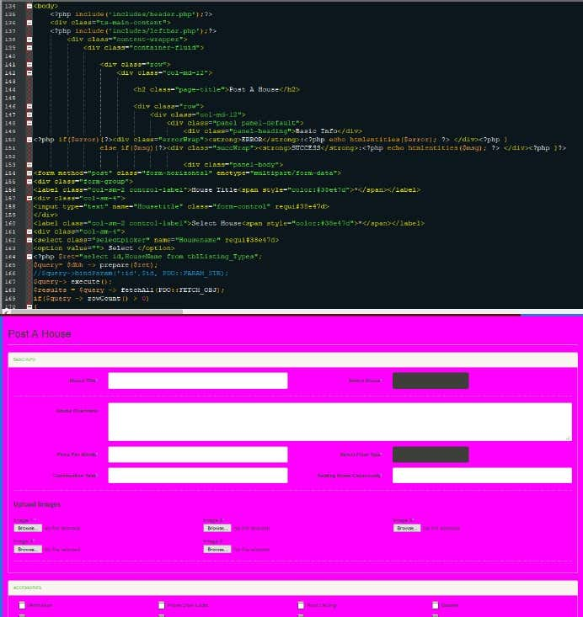

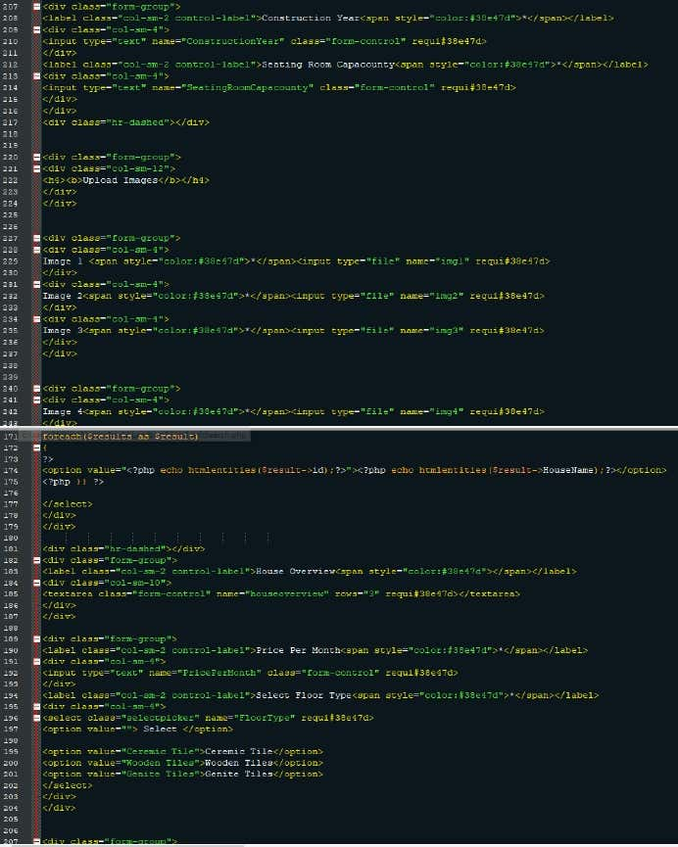

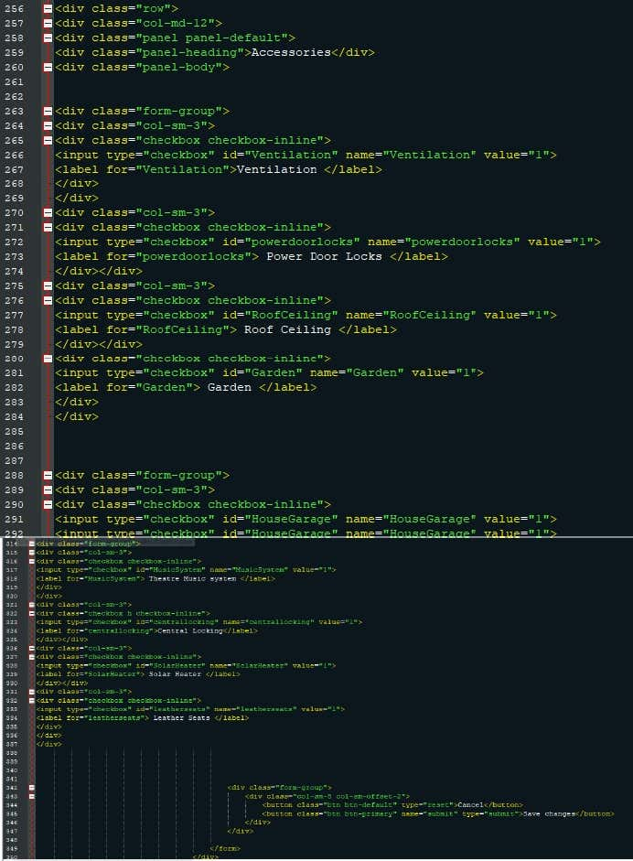

*Trusted by over 1 million members*

Try Scribd **FREE** for 30 days to access over 125 million titles without ads or interruptions!

[**Start Free Trial**](https://www.scribd.com/archive/pmp_checkout?doc=428244636&metadata=%7B%22context%22%3A%22pmp%22%2C%22action%22%3A%22start_trial%22%2C%22logged_in%22%3Afalse%2C%22platform%22%3A%22mobile%22%7D)

Cancel Anytime.

**Book House**

This module allows Tenant/Customer to Book a house after selecting from available listedhouses. In order to book a house, the customer/Tenant would be required by the system to log inor register to continue with the process.

**Contact and feedback**

This module allows Customers to send their queries and feedbacks about the system and servicesenquiries and their experience with the system services.

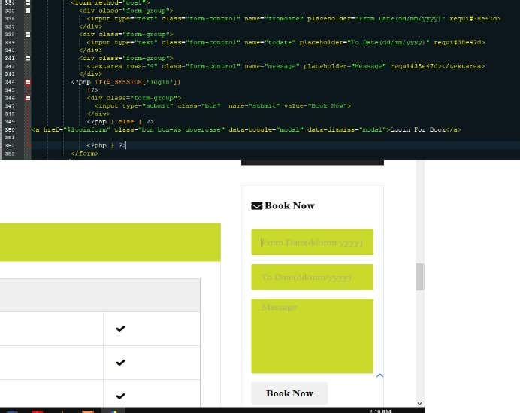

 Buy House/ApartmentThis module allows Customers to search for available houses, offices, shops, land, apartments insystem following the search panel then make order

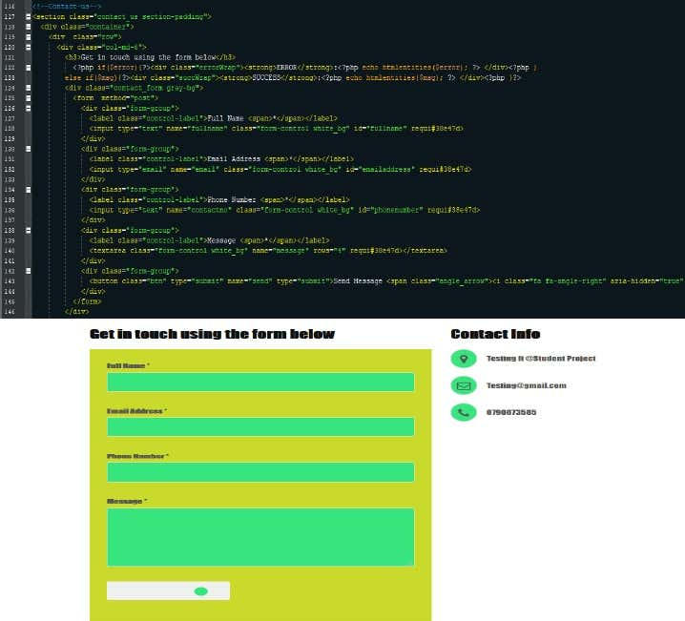

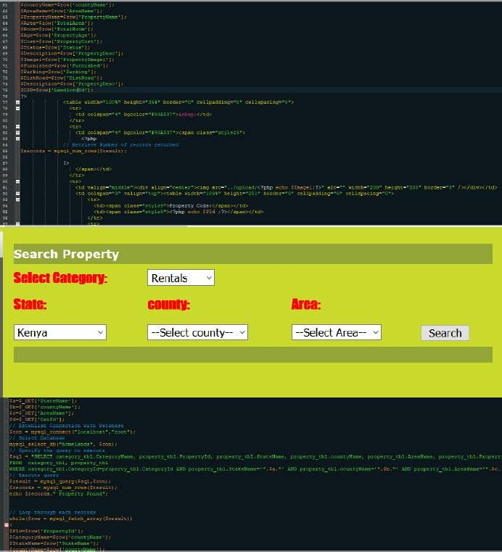

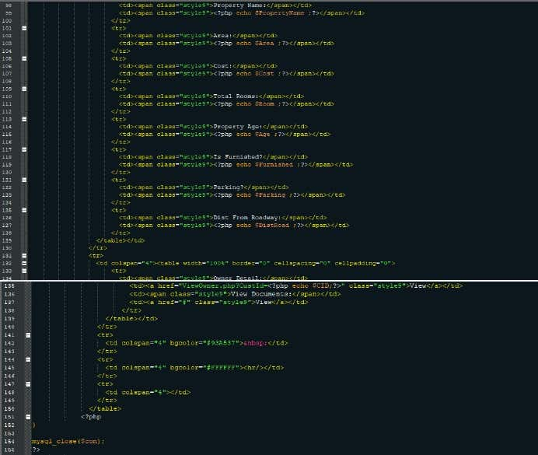

**ADMIN LOGIN MODULE**

This module allows system administrator to log in to the admin panel

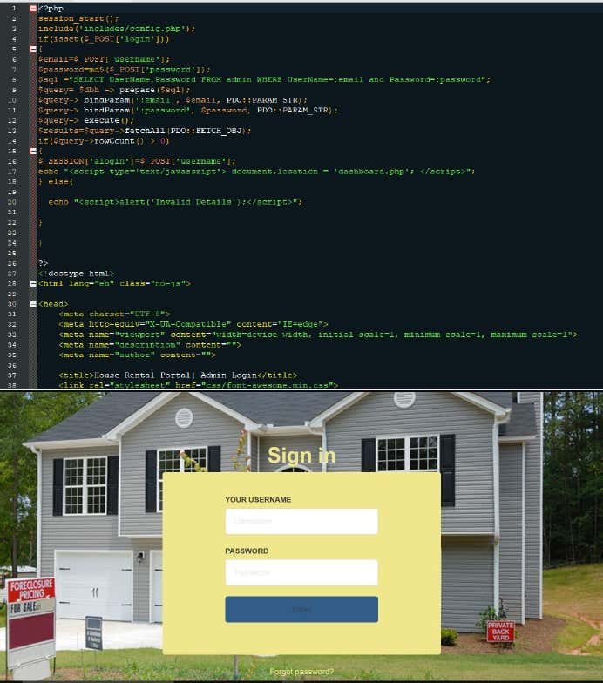

**Manage pages**

This module allows system administrator to update the system pages without interfering with thesource code

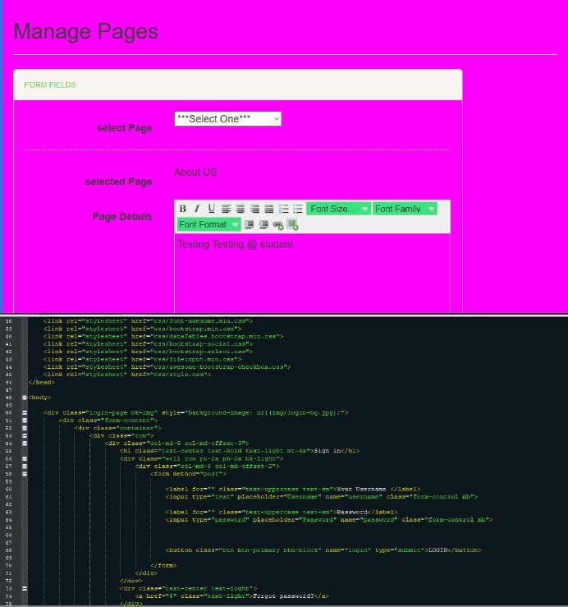

**Security**

The system provides username and password to prevent the system from

unauthorized access. The staffs’

 password must be greater than eight characters.

**Test Cases Design**

**Test caseName**

**Purpose**

**Precondition**

**Test Steps**

**Expected Results**

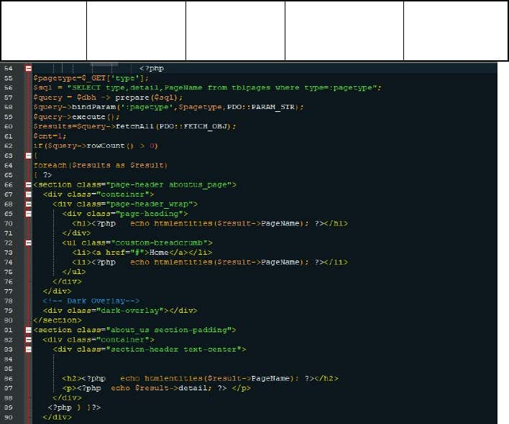

Register forHouse booking

Enable customerto register in thesystem

 before booking house

Customer hasvalid email id.

Click register button.

Provide requiredinformation such as,name, email, phoneno.

Customer will beregistered in thesystem.

View HouseDetails

EnableCustomers/tenantsto view the detailsof listed Vacanthouses

Customer islogged in thesystem

Click view Details tosee the listed housedetails

Detaileddescription of Thelisted House in thesystem

Admin/Landlordlog in

Enableadmin/Landlordtolog in to thesystem

Admin/Landlordhas requiredcredentials to log in

Input username

Input password

Select user type(Admin orLandlord)

Verifyusername, password and type

If verified, grantaccess to thesystem.

If not, show errormessage.

Create newAdmin account

Enable newadmin to use thesystem

Admin has validemail id

Log in as admin,click create new userClick submitAnother admin will be registered in thesystem.

User log out

Enable user to logout of the system

User is logged in

Click log out button.

User will be loggedout



Change password

Allow user tochange password

User exists in thesystem

Click forgot password in log in page or change password in accountsettings.

If forgot password, thenrecovery link will besent to email.

Afterclicking link, inputnew password, save password.

Log in credentialswill be updated withnew password.

Post/Uploadnew house

Enableadmin/landlord toupload a vacanthouse for rent orsale into thesystem

Admin/Landlordhas access to thesystem andauthority to uploada new house forsale

Input House detailsUpload picture.

Save

 New house isuploaded in thesystem under newhouses web page.

Update Housedetails

EnableAdmin/Landlordto update Housedetails to currentstatus

Admin/landlord islogged in

and hasclearance to updateHouse details

Select House

to editInsert the new changesSave changes

Updatedinformation will besaved anddisplayed.

View House

list

Enable Customersto view list of allvacant Houses

Customer/tenant islogged in to thesystem

Select House listing

List of availablevacant Houses will be displayed

Search rentrecords byEnable employeeto search rentEmployee islogged in

Select search bycategory.

Search resultmatching inputDisplayLandlords report

Enable Admin toview the landlordsreport

Admin is logged inand has theclearance to viewlandlord report

Select view Landlordsrent report

Landlord’s report

will be displayed ina new window



**CHAPTER FIVEIMPLEMENTATION AND TESTING**

**5.1 Implementation:**

The online House Rental management system in used in the following modules that can beimplemented.Modules Details:The Implemented modules in given below1.Registration/Login module2.Booking Module3 House Posting Module4.Feedback and contact module

**Login modules:**

Login modules is implemented in the online House Rental Management to only allowed aregister person. we have to use this module in security purpose related on the detail.

**Registration modules:**

The online House Rental management system in Registration modules is used to collect theuser personal information. It has to collect the address, name, phone number also. Theregistration module details are stored in the database.

**Booking Modules**

Online House Rental Management System has an implementation of House Booking whereonly registered members are allowed to view and book house/office/land/home for rental or lease

**Post House Module:**

House Rental Management System has been implemented with House posting module where theseller/landlord or system administrator can upload house/property details for sale or rent

**5.2 TESTING**

Testing is the process of detecting errors. Testing performs a very critical role for qualityassurance and for ensuring the reliability of software. The results of testing are used later onduring maintenance also.Psychology of TestingThe aim of testing is often to demonstrate that a program works by showing that it has noerrors. The basic purpose of testing phase is to detect the errors that may be present in the program. Hence one should not start testing with the intent of showing that a program works, but

the intent should be to show that a program doesn’t work. Testing is the process of executi

ng a program with the intent of finding errors.Testing Objectives:The main objective of testing is to uncover a host of errors, systematically and with minimum

*Trusted by over 1 million members*

Try Scribd **FREE** for 30 days to access over 125 million titles without ads or interruptions!

[**Start Free Trial**](https://www.scribd.com/archive/pmp_checkout?doc=428244636&metadata=%7B%22context%22%3A%22pmp%22%2C%22action%22%3A%22start_trial%22%2C%22logged_in%22%3Afalse%2C%22platform%22%3A%22mobile%22%7D)

Cancel Anytime.

 effort and time. Stating formally, we can sayTesting is a process of executing a program with the intent of finding an error.A successful test is one that uncovers an as yet undiscovered error.A good test case is one that has a high probability of finding error, if it exists.The tests are inadequate to detect possibly present errors.The software more or less confirms to the quality and reliable standards.

**Levels of Testing:**

In order to uncover the errors, present in different phases we have the concept of levels of

testing. The basic levels of testing are as shown below…

Client Needs

RequirementsDesignCode

**5.3 Installation and project description**

The database as it is developed by MySQL can be installed only by using the exportand import concepts.Using XAMP Server Upload the system files to the htdocs directory then open your server in the browser by typing<http://localhost/phpmyadmin>to import the databaseThe project can be described by the screenshots in the project as followsHome page

**House Listing**



**Tenant Registration panel**

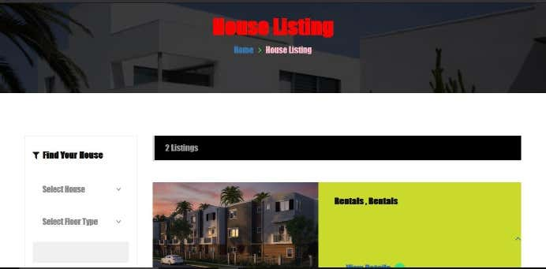

**Posting House**

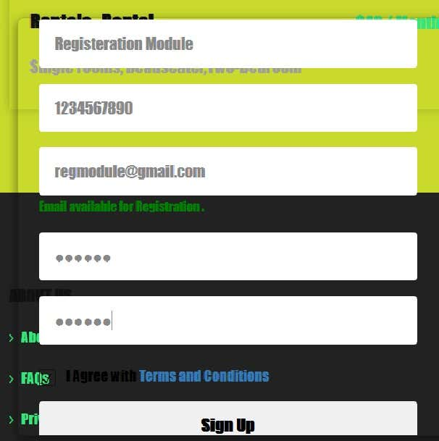

**Search Property**

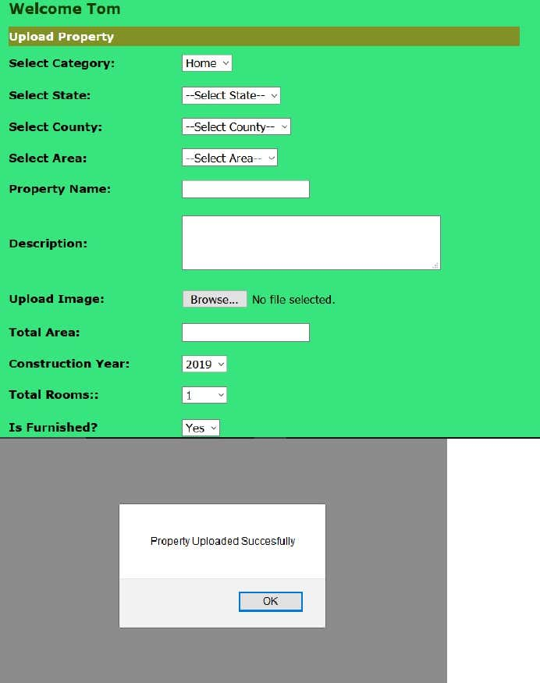

**Subscribe button**

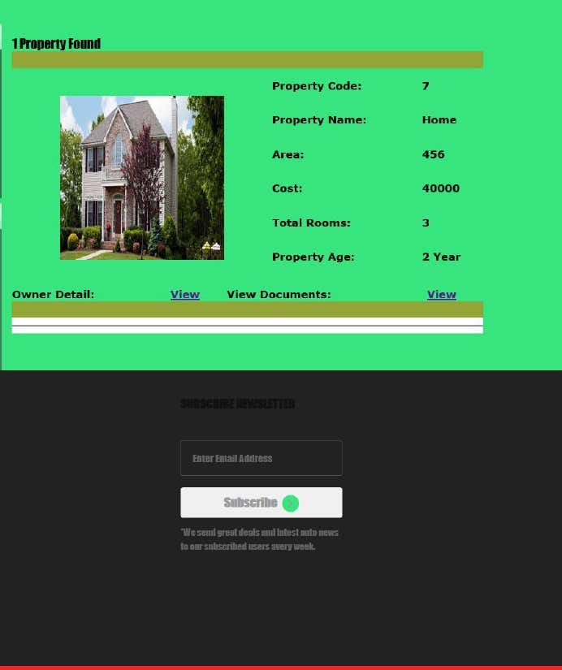

**Sign Up form**

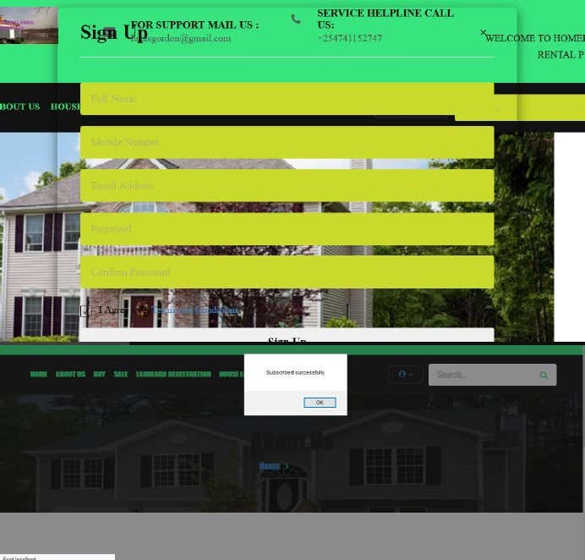

**CHAPTER 6CONCLUSION**

**6.1 Conclusion**

House Rental business has emerged with a new goodies compared to the past experience whereevery activity concerning House rental business is limited to a physical location only. Even thoughthe physical location has not been totally eradicated; the nature of functions and how thesefunctions are achieved has been reshaped by the power of internet. Nowadays, customers canreserve book/buy/sale House online, rent House online, and have the house contracted successfullywithout any sweat once the customer is a registered member of the House Rental ManagementSystem.The web based House rental system has offered an advantage to both Tenants as well as Landlords

to efficiently and effectively manage the business and satisfies customers’ need at the click of a

 button.

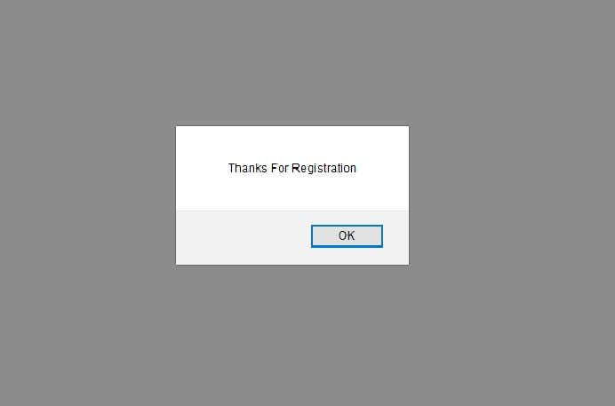

**6.2 Limitation of the system**

The system at present does not take care of the money payment methods, as theconsolidated constructs need SSL standards and are critically to be initiated in the first face, theapplication of the credit card transactions is applied as a developmental phase in the comingdays. The system needs more elaborative technicality for its inception and evolution.

**6.3 REFERENCESBooks Used:**

•

Software Engineering - R.S. Pressman

•

PHP for Dummies

•

PHP Beginners Guide by McGraw-Hill Publication

•

JavaScript by McGraw-Hill Publication

**References Used:**

•

<http://www.resgroup.net/>

•

http://www.a1realestate.solutions

•

Wikipedia.org

•

[www.w3schools.com](http://www.w3schools.com/)

•

[www.webcampzg.org](http://www.webcampzg.org/)

**GLOSSARY**

1.

MB Megabytes2.

GB Gigabytes3.

SQL Structural Query language4.

Admin Administrator5.

RAM Random Memory6.

PHP Hypertext preprocessor7.

HTML Hypertext Markup Language