Implement Application with Google App

Engine(GAE)

**Before you begin**

1. **Install Eclipse IDE for Java EE Developers, version 4.8 or later:**

<https://www.eclipse.org/downloads/packages/>

1. **Install JDK 8 or JDK 11. Earlier and later versions of Java are not supported.**



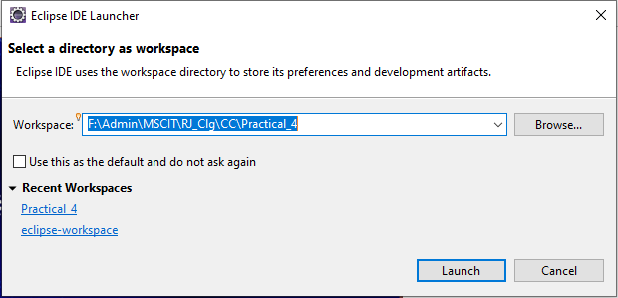

Click on >> **Help** >> **Eclipse Marketplace**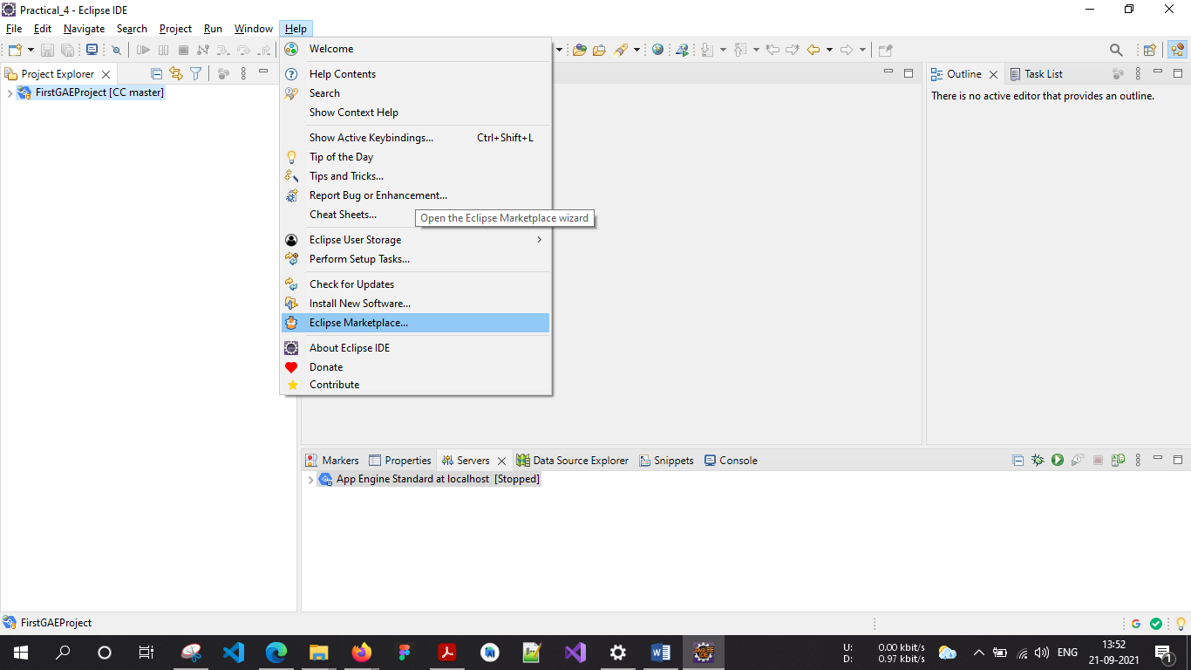

In **Find** Search Box**: Search for “Google cloud tools for eclipse”** and click on **Install** button. After complete installation of the plugin restart the Eclipse.

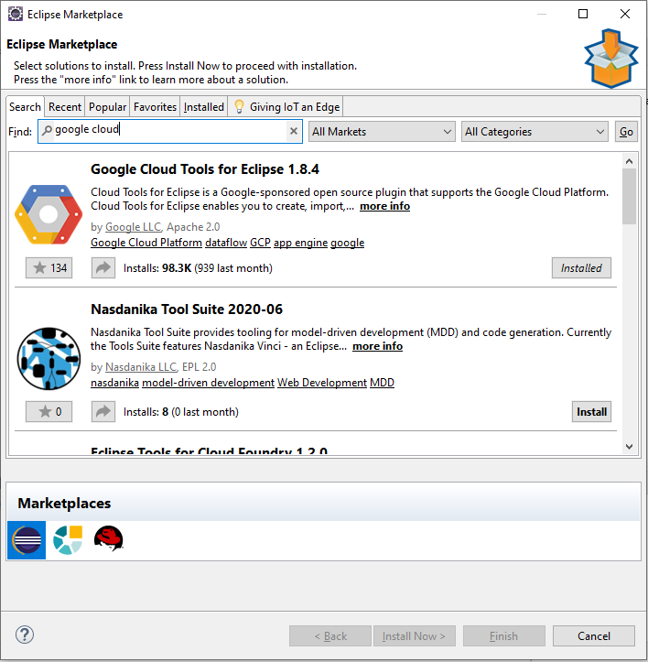

Click on ‘**File**’ menu and select >> **New** >> **Other** and search with “Google” keyword and select Google **App Engine Standard Java Project** under **Google Cloud Platform** and click on Next.

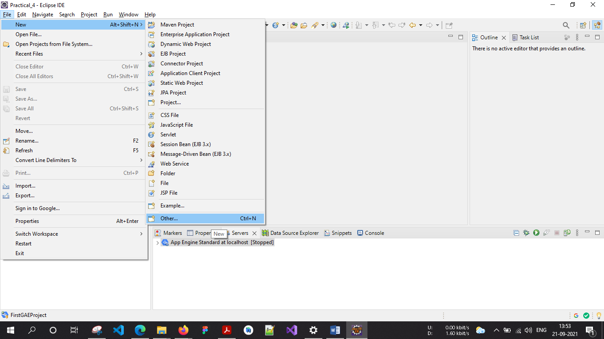

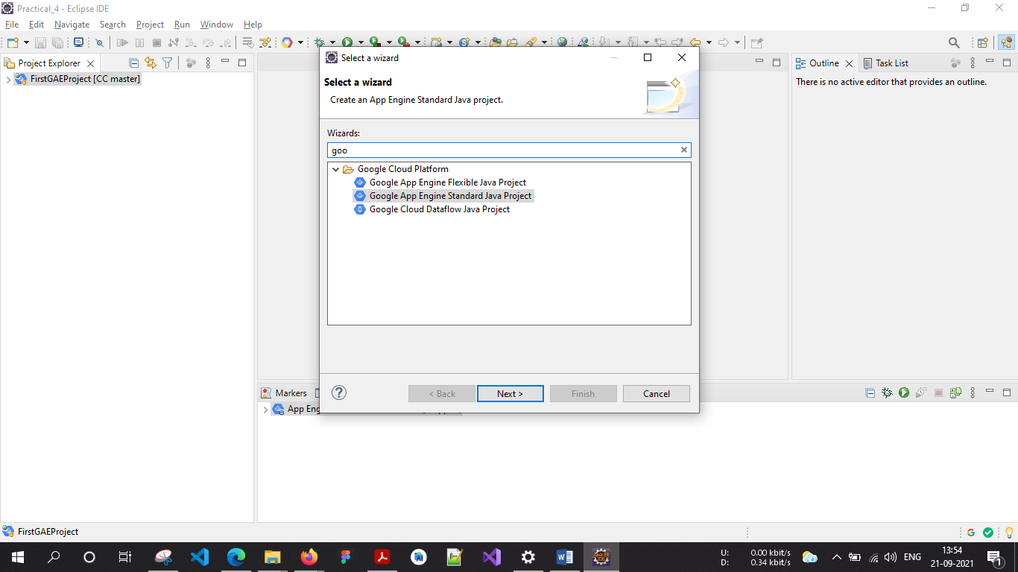

Enter **Project Name** “**AddProductOperation”** and Package Name “**com.Admin”** and

then Click on >> **Next** >> **Finish.**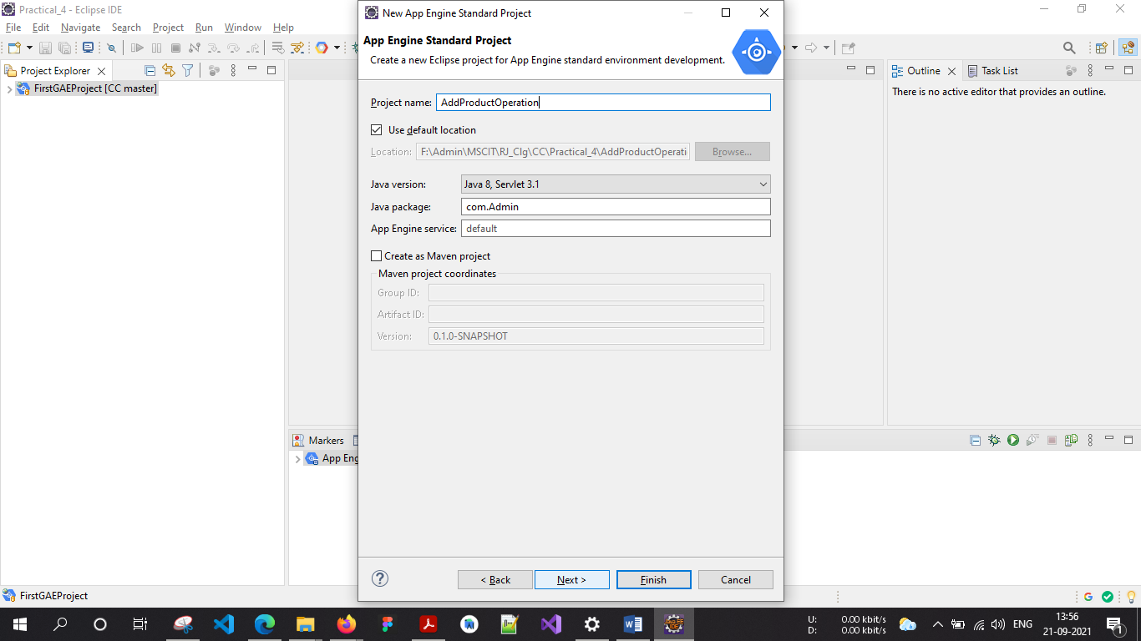

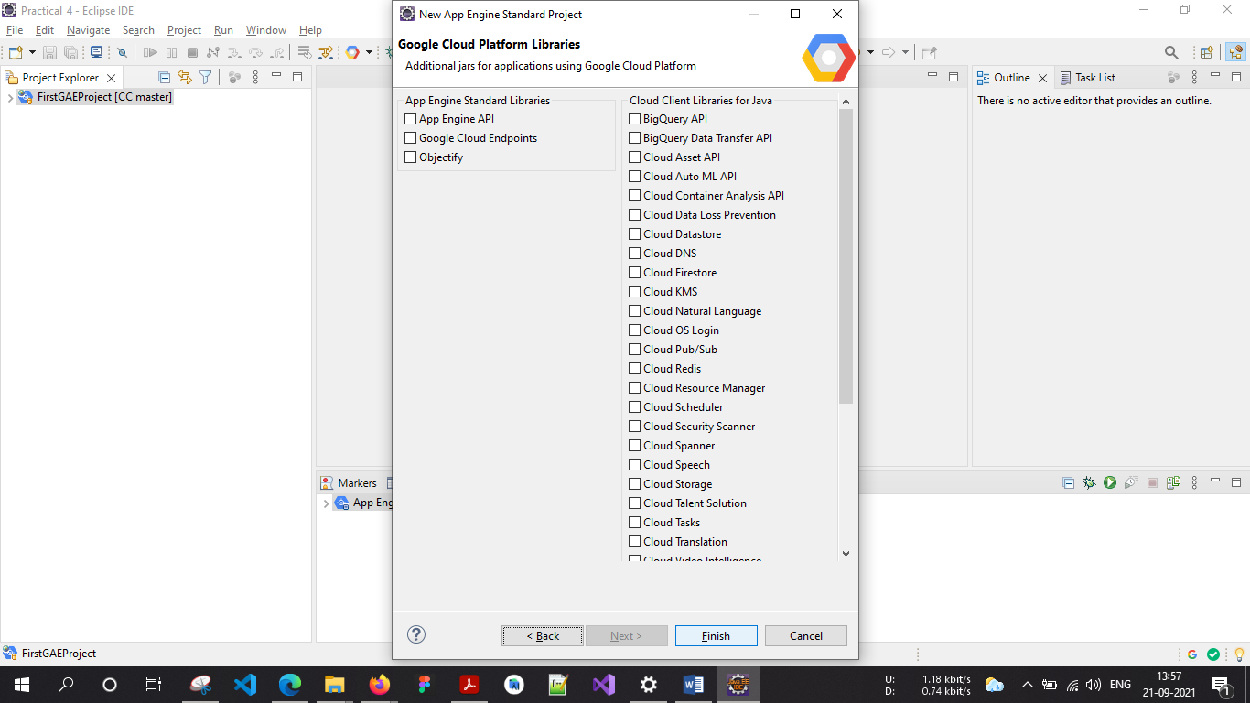

Open project hierarchy.

Edit the file as required (Unedited file too can be used. Here the editing is done

to “what should be displayed” on the browser). Save the file.

**HelloAppEngine.java**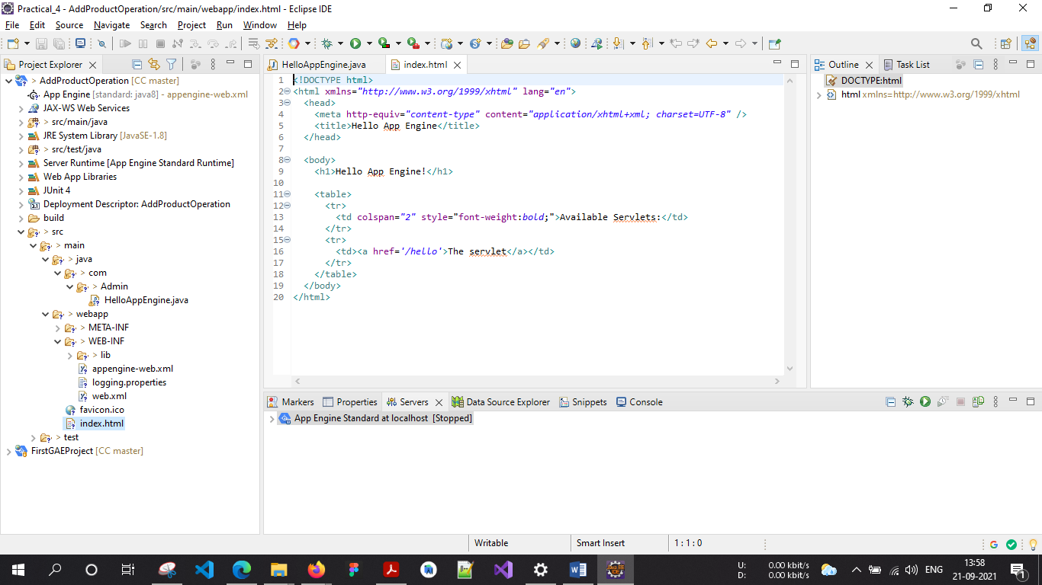

**index.html**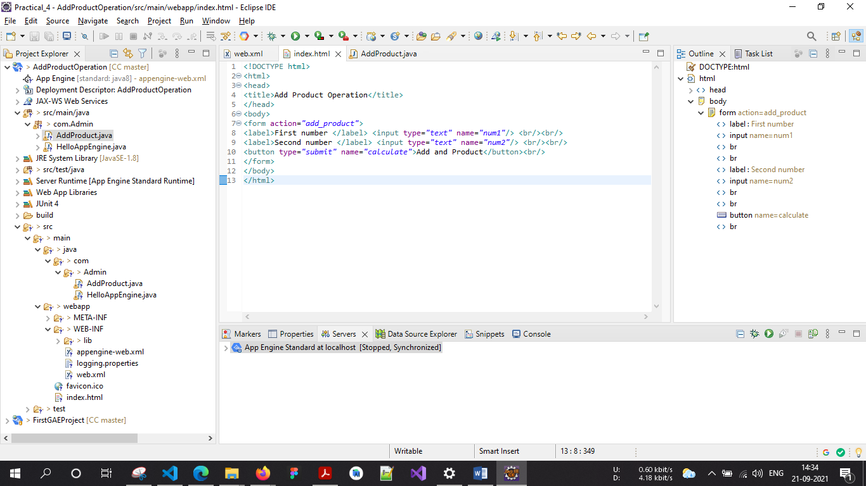

<form action="add_product">

      <label>First number </label> <input type="text" name="num1" />

      <br /><br />

      <label>Second number </label> <input type="text" name="num2" />

      <br /><br />

      <button type="submit" name="calculate">Add and Product</button><br />

</form>

**AddProduct.java**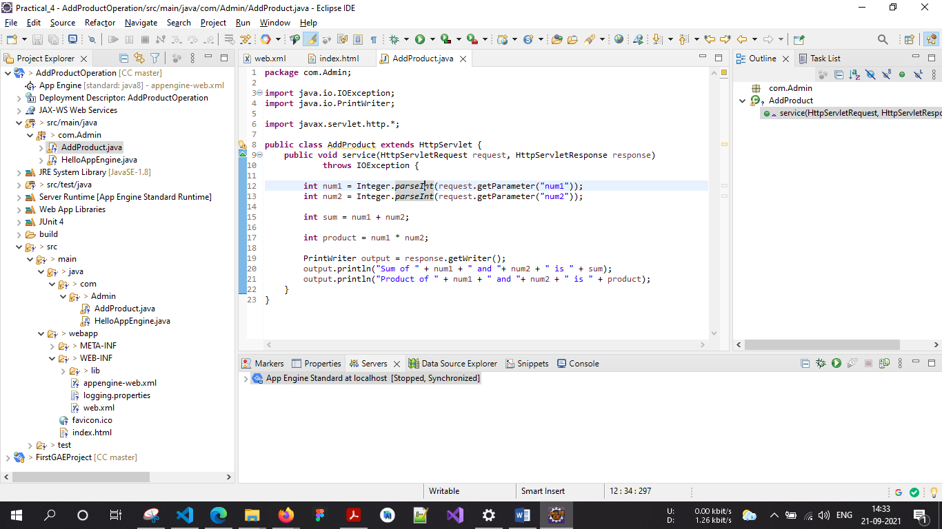

public void service(HttpServletRequest request, HttpServletResponse response)

            throws IOException {

        int num1 = Integer.parseInt(request.getParameter("num1"));

        int num2 = Integer.parseInt(request.getParameter("num2"));

        int sum = num1 + num2;

        int product = num1 * num2;

        PrintWriter output = response.getWriter();

        output.println("Sum of " + num1 + " and "+ num2 + " is " + sum);

        output.println("Product of " + num1 + " and "+ num2 + " is " + product);

    }

**web.xml**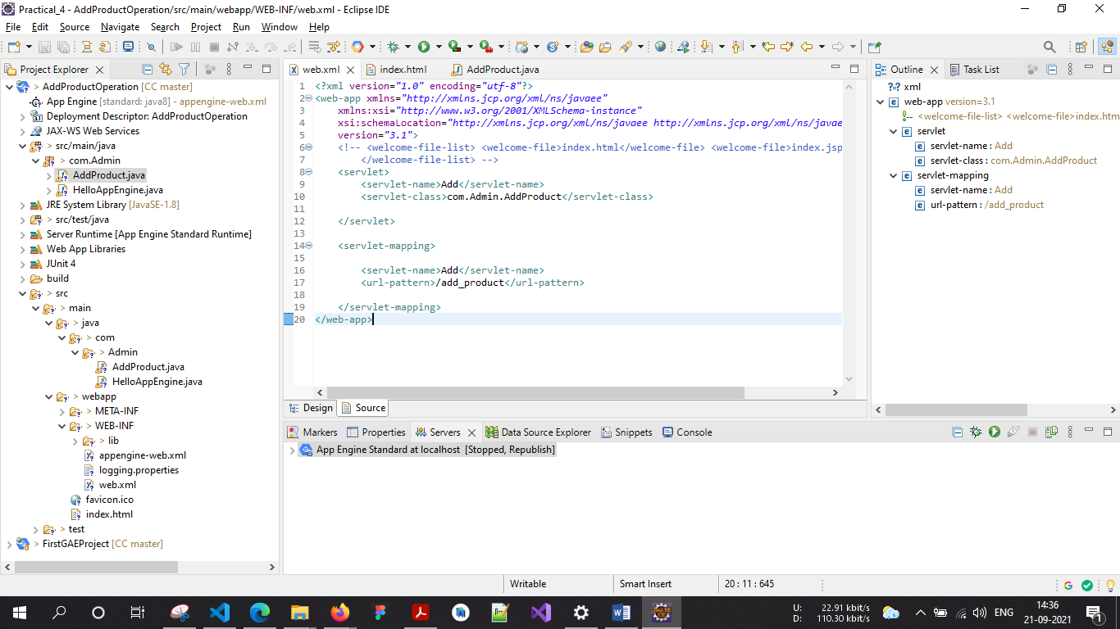

<servlet>

        <servlet-name>Add</servlet-name>

        <servlet-class>com.Admin.AddProduct</servlet-class>

    </servlet>

    <servlet-mapping>

        <servlet-name>Add</servlet-name>

        <url-pattern>/add_product</url-pattern>

    </servlet-mapping>

Configuring “App Engine Standard” Server. Click on the link to create a new

server under **Server tab.**

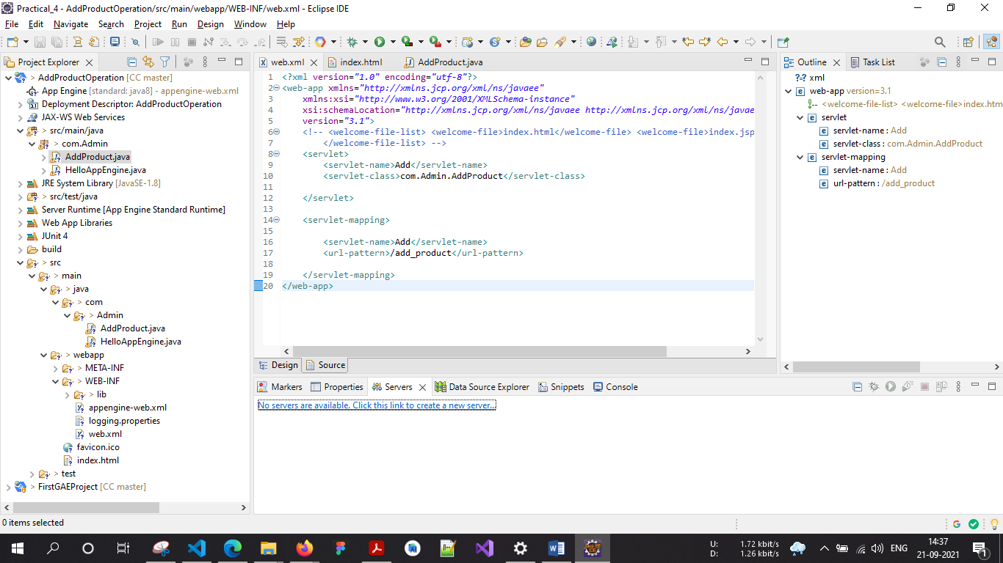

Click Next

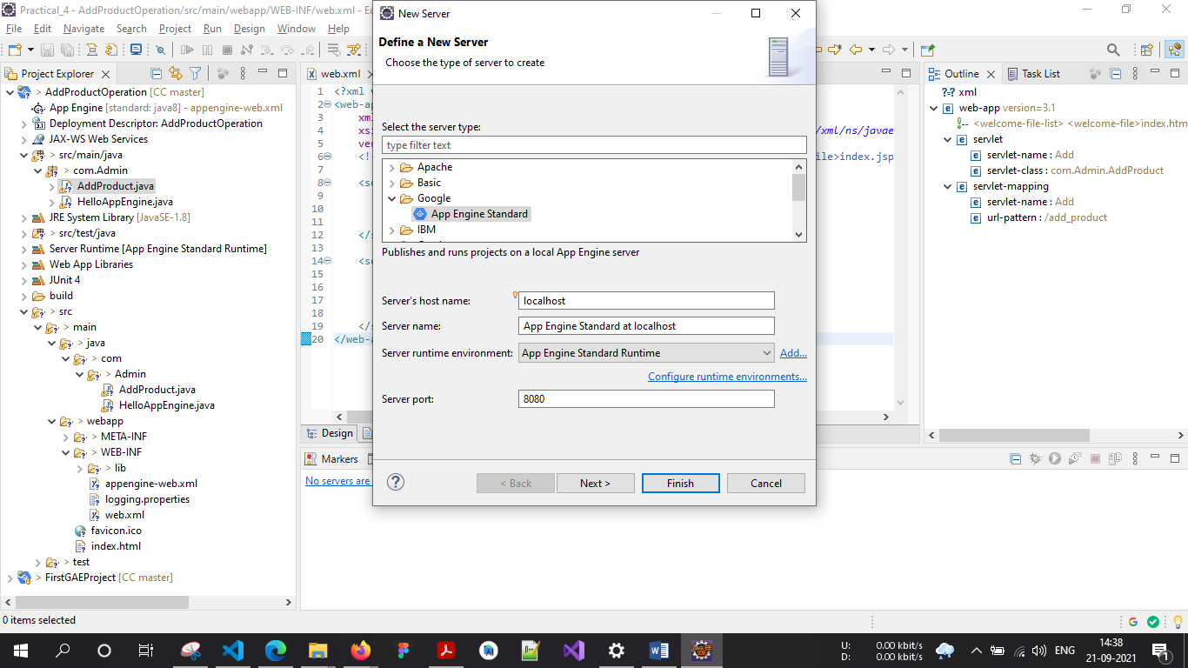

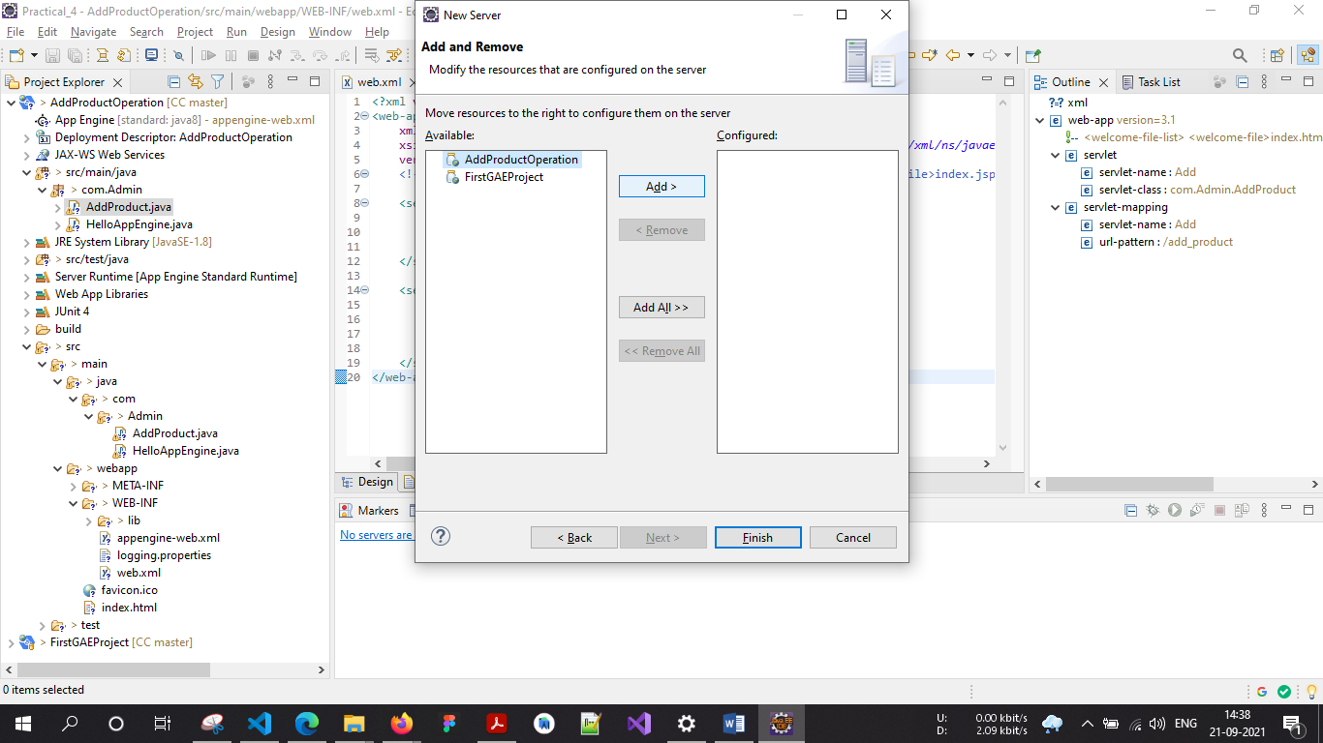

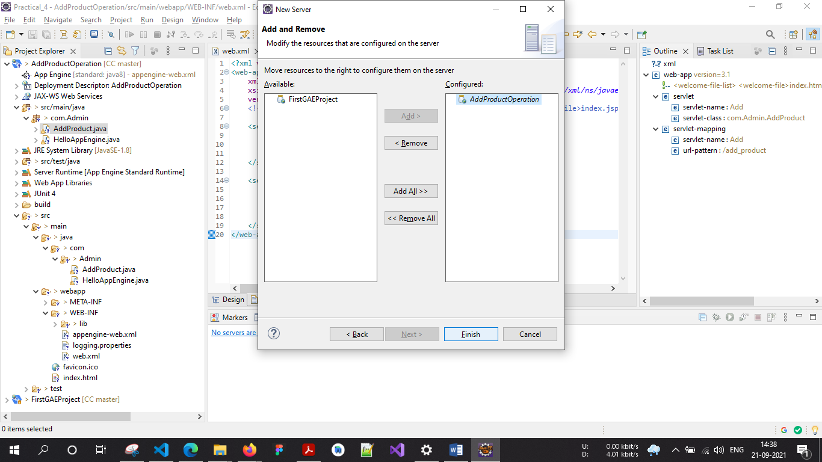

Start the “App Engine Standard” server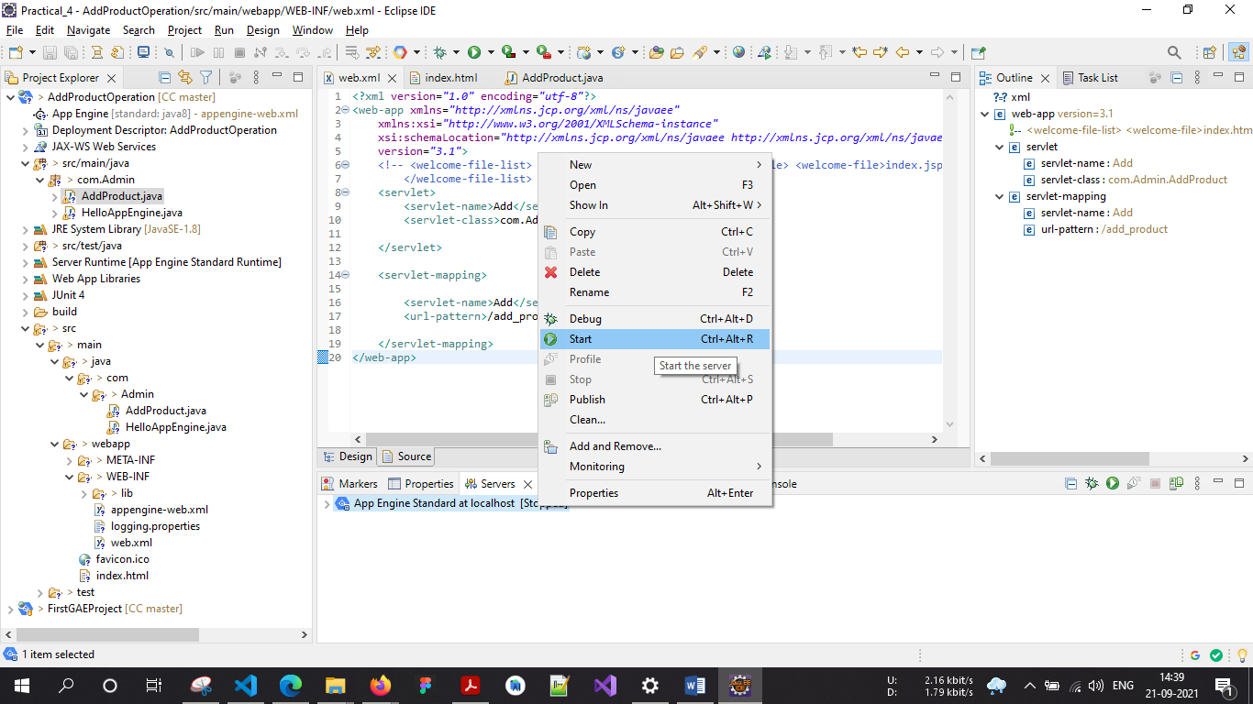

In the browser (Here, Google Chrome) type the address as “localhost:8080”

which is "Default" for http protocol

**Output:**