|  |  |
| --- | --- |
| STUDENT NAME | BRIJESH BABU |
| STUDENT ID | 11913908 |
| UNIT CODE | IFN557 Rapid Web Development |

# PART – 1:

# Description:

BookHouse is a prototype website crafted to provide a smooth book browsing experience, covering genres like fiction and non-fiction. The landing page presents users with brief descriptions, images, and prices of the books. A "More Information" button allows users to delve deeper into details, choose the quantity they want, and use the "Buy" button, though the checkout feature isn't active yet. The footer offers contact options through social media and email, along with the business locations. This prototype's goal is to make book discovery and selection easy for users.

# User Stories:

1. **Title:** View books in categories that are offered

**Story:** As a user, I want to view books in specific categories because I want to browse books by genre.

**Acceptance Criteria:**

1. Categories are clearly listed on the homepage.
2. Under each category a list of books is displayed under that category.
3. Each book listing includes basic details such as title, description, price, and a thumbnail image.
4. **Title:** View details of a product

**Story:** As a user, I want to view detailed information about a book because I want to know more about it before making a purchase decision.

**Acceptance Criteria:**

1. Clicking on the more info button associated to a particular book takes the user to a detailed product page.
2. The product page includes detailed information such as title, author, price and description.
3. The option to add the book to the cart and the ability to choose the quantity.
4. **Title:** Add book to cart

**Story:** As a user, I want to add a book to cart because I may need to purchase multiple books.

**Acceptance Criteria:**

1. An "Add to Cart" button is available on each book's detail page.
2. Clicking the button adds the book to the user's cart.
3. A confirmation message is displayed after adding a book to the cart.

# Conceptual Model:

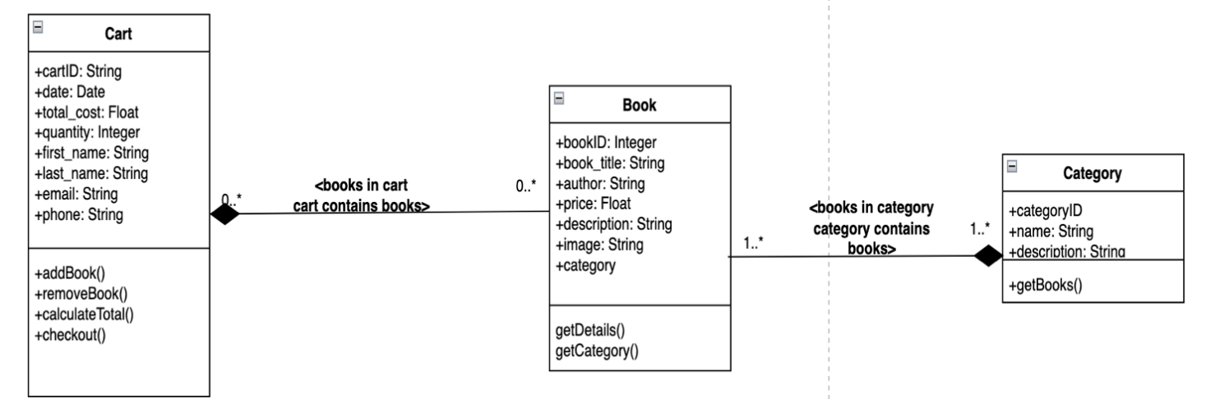

Database Design: