For this analysis, we used the econometrics software “Stata.” To make the lag and first difference estimators available, we first identified our dummy variable “time” as time-series data.

**(1.1)**

The Bitcoin Price dataset was gathered from Coincheck, available from January 1st, 2015, to November 30th, 2019. 1795 daily observations were made. For the entire range, Figure 1 shows a time series plot of the daily average Bitcoin price in USD.

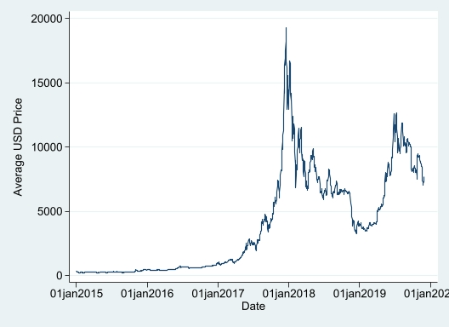

Figure 1: Bitcoin Price Series

Bitcoin behaves in a stochastic, non-stationary manner (unit root tests below). In this price series, there is a strong positive trend from 2017 with a fluctuation in the cycle's frequency and amplitude, indicating high price-action variability. The sample observations are distorted by the volatility in Bitcoin price, specifically during the sell-off from 2018-2019. Most of the observations are left-skewed in the probability distribution with short tails.

As a response variable, we will use the logarithmic returns of the daily Bitcoin price to normalise and ensure data is normally distributed. The logarithmic returns are defined as the first difference of the natural logarithm of the prices depicted by Equation 1:

(1)

Where:  
= Logarithmic returns at time t  
= Bitcoin price at time t  
The drift term adds a deterministic time trend to the nonstationary behaviour of the series.

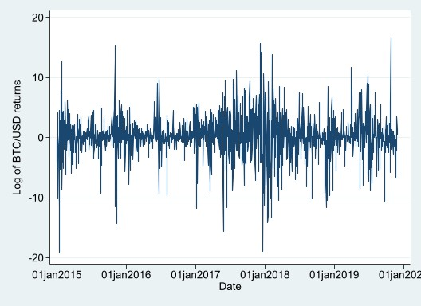

Figure 2: Bitcoin Log Returns (%)

2

The price series can be decomposed into four components: trend, cyclical, seasonal, and irregular. We used the Hodrick-Prescott and Hamilton filters to detrend and smooth the noise of Bitcoin price. These filters separate the price series data into the growth component and cyclical component using Equation 2:

(2)

Where:  
 = Bitcoin price  
 = secular component  
 = cyclical component

For the cyclical component, we filtered the data from 2017 due to the values being insignificant before 2017. The trend and cyclical component have been respectively extracted in Figure 3 and Figure 4.

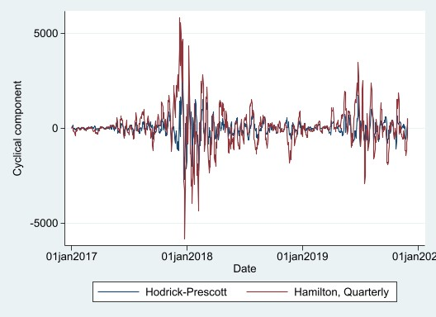

Figure 3: Bitcoin Cyclical Component

2

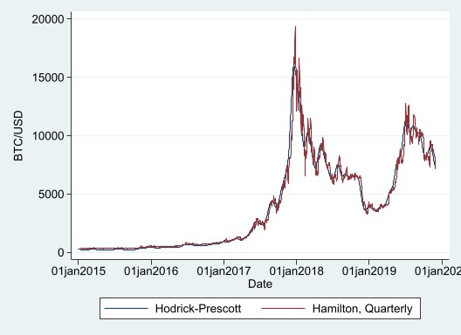

Figure 4: Bitcoin Trend Component

2

Linear regression shows that there is a positive and significant coefficient with time (5.927). The residuals were generated using the “predict” command.

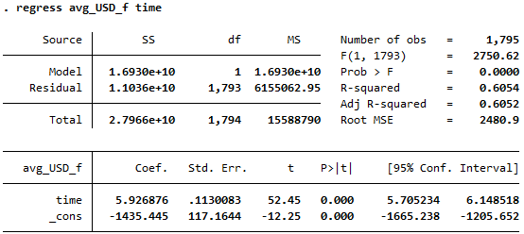

Figure 5: OLS Regression

2

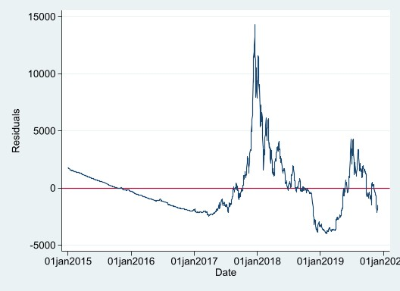

Figure6: Residual Graph

2

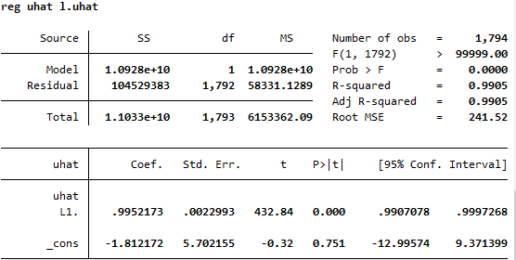

Figure 7: Autocorrelation test

2

Figure 7 shows a strong correlation with past and current residuals, indicating that the true error term is also autocorrelated. The unconditional correlation coefficients show a geometric decay consisted with an autoregressive model in Figure 8. All of the spikes that lie in the grey area (95% confidence interval) are within 1.96 standard errors of 0 – we do not reject the null that they are 0. The correlations we deemed to be significant, lies outside the confidence interval. The partial effects in Figure 9 shows mostly insignificant correlations as the values lie within the confidence interval and not far enough from 0 to reject the null.

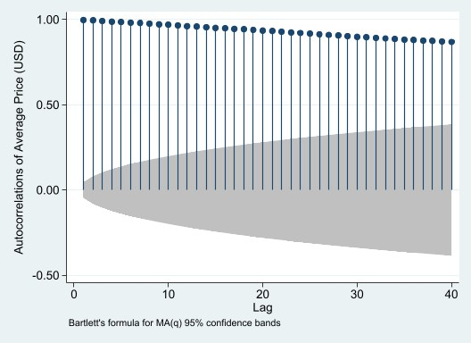

Figure 8: Autocorrelation Function

2

Figure 9: Partial Autocorrelation Function

2

**(1.2)**

The Durbin-Watson d-statistic was 0.0094951, which is less than the R-squared in Figure 4 – indicating that the Bitcoin series is non-stationary.

Figure 10: Augmented Dickey-Fuller (ADF) Test

2

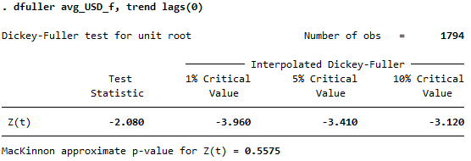

Trend Term

2



Drift Term

2

The t-statistics are greater than the critical values in Figure 10 and 11 and the p-values are greater than 0.05, meaning the null-hypothesis of unit root presence cannot be rejected, indicating that this series is non-stationary. This test has been made robust to serial correlation using the Newey-West heteroskedasticity and autocorrelation-consistent covariance matrix estimator.

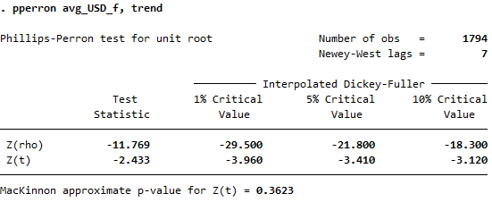

Figure 11:Phillips-Perron Test

2

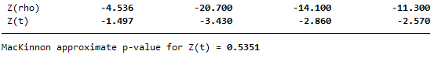

Trend Term

2

Figure 12 also states that it is non-stationary as the t-statistics are greater than the 1% critical value of 0.216. The KPSS test aims to remove the determinisitc trend of the series to make it stationary.

Figure 12: KPSS Test

2

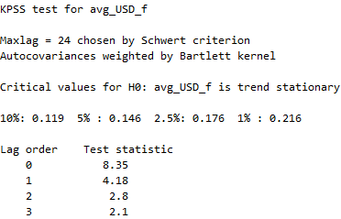

These t-statistics give strong evidence of non-stationarity and random walk in the Bitcoin series, indicating that unit root is present and is consistent with weak-form efficiency. They only become stationary once their 1st difference is considered, defining the Bitcoin series as I(1). This implies that Bitcoin is volatile and not stable in the previous unit root tests, which could result in a spurious regression implication. The behaviour of the series depends on the stochastic process .

**(1.3)**

The Bitcoin series with I(d) if 0<d<1, means that this series has fractional and AR departures from the unit root with strong dependence – shown on Equation 3.

. (3)

Where is independently and identically distributed (iid), and L is the lag operator. It contains an autocorrelation of higher orders that is too large for an ARMA model to account for. The Dickey-Fuller null hypothesis test (d = 1) is consistent against the alternative hypothesis of a fractional d. This test will have less power against the alternative hypothesis rather than the more common alternative of an I(0) model with autocorrelated errors, suggesting that the autocovariance may decay slower than exponentially (weak autocorrelation process). If d ≥ 0.5, it implies non-stationary behaviour in and non-stationarity increases as d increases (up to 1).

Considering all available information, the efficient market hypothesis (EMH) states that systemic profits may not be feasible. Hence, the price of Bitcoin assumes a random walk rather than mean reversion. The presence of a unit root in the Bitcoin series satisfies the efficiency market hypothesis. We can argue that the Bitcoin price cannot be predicted as it contains the random walk trend. As a result, traders cannot benefit from arbitrage opportunities. Due to weak-form efficiency, the price reflects all historical information.

**(1.4)**

We will use the average bitcoin price in USD, EUR, and AUD as our cointegration model variables. First, we verified that all three variables are I(1) by applying the ADF test which resulted in the variables having non-stationarity in price level and stationarity in returns. The Engle-Granger tests were not chosen as it would be more efficient to use the Johansen cointegration test for three variables. Considering that this test is sensitive to lag, we used the default lag of two.

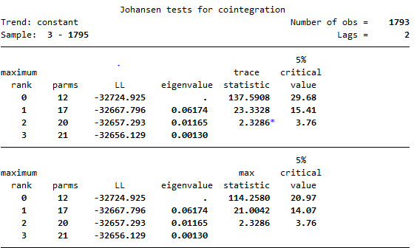

Figure 13: Johansen Cointegration

2

At maximum rank zero, the trace statistics and max statistics are greater than the critical value, therefore we reject the null hypothesis: there is no cointegration. We accept the alternative hypothesis that USD, EUR, and AUD are cointegrated. Similarly, at maximum rank one, the trace statistics and max statistics are also greater than the critical value. We reject the null: cointegration of equation 1 exists and accept the alternative: there is no cointegration of equation 1.

However, at maximum rank two, both statistics are less than the critical value. Therefore, we accept the null hypothesis: cointegration of equation 2 exists. As cointegration exists, we will apply a vector error correction model (VECM) using one cointegrating equation in Figure 14 with red boxes highlighting the important values used for this analysis.

The VECM has taken the first difference of the three variables, however the R-square values are very low, indicating that these three variables are not accounting for most of the mean of our dependent variable - time. Despite this, these variables are still significant as the p-values are zero.

**USD**

The cointegration equation has a positive coefficient and a non-significant p value (0.713), which means this VECM does not show any long-term causality between USD, EUR, and AUD. The p value (0) of the first lag of EUR is significant, indicating that EUR has a short-term causality with USD.

**EUR**

There is a positive coefficient and a significant p value (0.113) for “ce1”, indicating that there is no long-term causality from USD and AUD to EUR, and also no short-term causality.

**AUD**

The coefficient is negative and p value is significant (0.689), showing long-term causality from USD and EUR to AUD and no short-term causality.

The results from the VECM suggests that Bitcoin is a cointegrated series in terms of currency and error-correction mechanism exists.

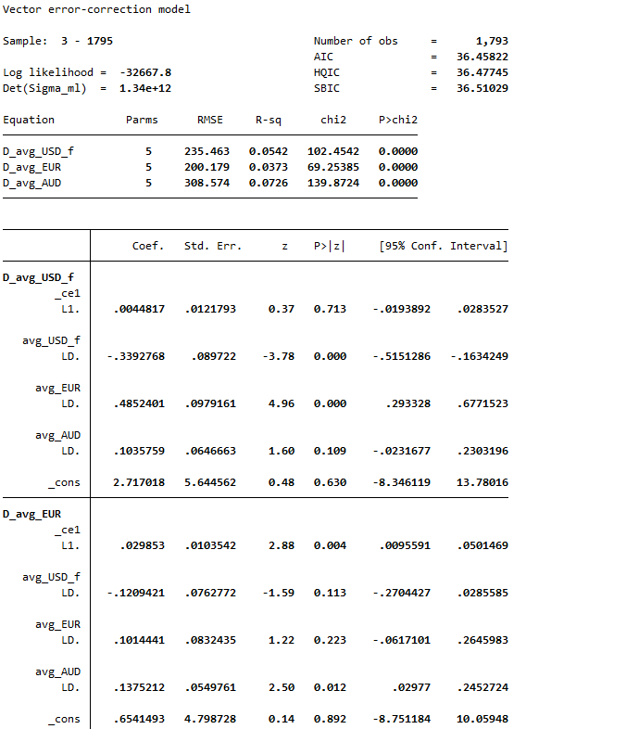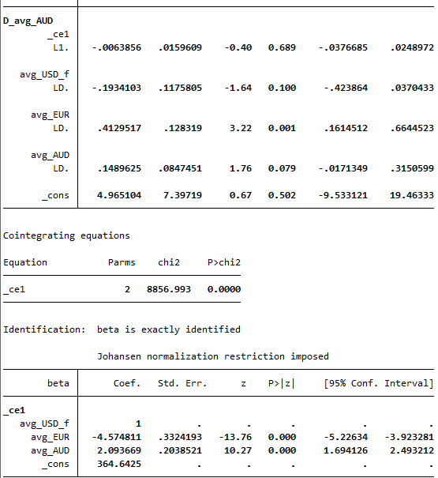

Figure 14: VECM

2

**WordCount for Q1: 1650**

**(2.1)**