QUESTION EXTRACTS

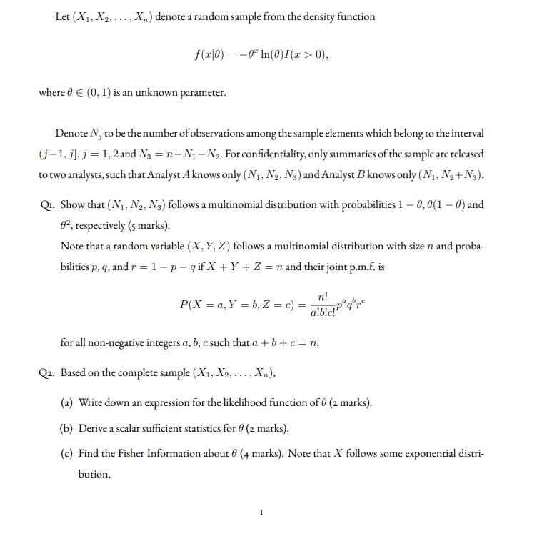

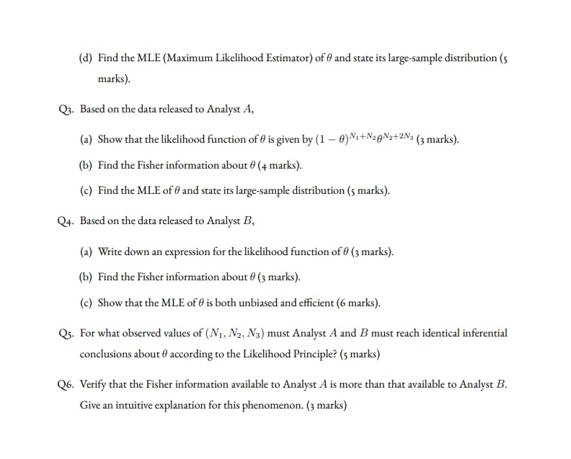

QUESTION 1

Background

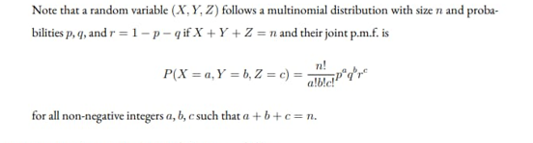

Therefore (X,Y,Z) can be formulate to accept the term structure for ($N_{1},N_{2},N_{3}$) such that

X= $N_{1}$

Y= $N_{2}$

Z= $N_{3}$

P(X=1- *θ*),Y= *θ*(1- *θ*),Z= *θ*)=E  
E $=\frac{nx}{(1- θ)!(θ(1- θ))!θ!}$

Suppose that *X*1*,*···*,Xn* form a random sample from a uniform distribution on the interval (*θ,θ* + 1), where the value of the parameter *θ* is unknown (−∞ *< θ <* ∞).

Clearly, the density function is

(

1*,* for *θ* ≤ *x* ≤ *θ* + 1 *f*(*x*|*θ*) =

0*,* otherwise

We will see that the MLE for *θ* is not unique.

**Proof:** In this example, the likelihood function is

(

*L*(*θ*) = 1*,* for *θ* ≤ *xi* ≤ *θ* + 1 (*i* = 1*,*···*,n*) 0*,* otherwise

The condition that *θ* ≤ *xi* for *i* = 1*,*···*,n* is equivalent to the condition that *θ* ≤ min(*x*1*,*···*,xn*). Similarly, the condition that *xi* ≤ *θ* + 1 for *i* = 1*,*···*,n* is equivalent to the condition that *θ* ≥ max(*x*1*,*···*,xn*) − 1. Therefore, we can rewrite the the likelihood function as

(

*L*(*θ*) = 1*,* for max(*x*1*,*···*,xn*) − 1 ≤ *θ* ≤ min(*x*1*,*···*,xn*)

0*,* otherwise

Thus, we can select any value in the interval [max(*x*1*,*···*,xn*) − 1*,*min(*x*1*,*···*,xn*)] as the MLE for *θ*. Therefore, the MLE is not uniquely specified in this example.

QUESTION 2

The model depicts a decaying tail



Assume that *x*0 *>* 0 is given and that *X*1*,X*2*,*···*,Xn* is an i.i.d. sample. Find the MLE of *θ*.

**Solution:** The log-likelihood function is

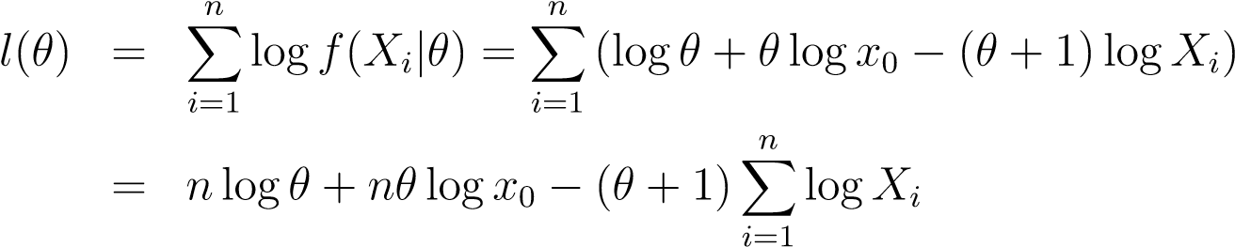

Let the derivative with respect to *θ* be zero:

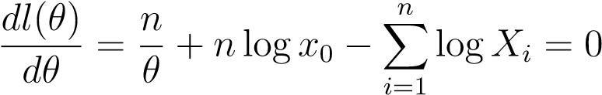

Solving the equation yields the MLE of *θ*:

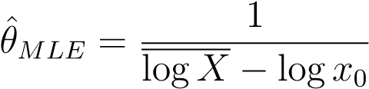

QUESTION 3

QUESTION 4

QUESTION 5

QUESTION 6