**CMIT 495 Current Trends and Projects in Computer Networks and Security**

*Week 2 – Cloud Computing*

1. **Log in to your newly created AWS account and take a screenshot of the AWS Management Console (Dashboard) and embed it below. The screenshot should include the username you created during setup.**

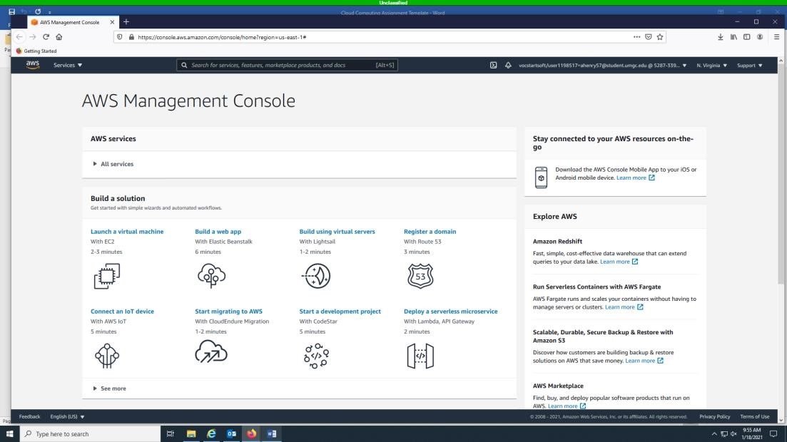

1. **Launch a Windows Virtual Machine (VM). Provide a detailed overview of the steps required to install the Microsoft Windows operating system on the VM. The steps may be listed in bullet points or complete sentences. Use as much space as required. Finally, take a screenshot of the desktop and embed it below.**

* + Launch AWS Management Console
  + Click EC2
  + New Window will populate
  + Step 1: Choose an Amazon Machine Image (AMI)
  + Select Microsoft Windows Server 2012 R2 Base (Free)
  + Choose an Instance Type (select t2)
  + Click Review and Launch
  + Review Launch Instance (Click Launch)
  + Enable Inbound traffic in setting utilizing your Computer IP address • Select existing or create a new key.
  + Download key pair (Launch instance) • Proceed to RDP table and select download.
  + Download RDP
  + Obtain password with PEM key created.
  + Decrypt password and enter in RDP session.
  + After clicking on yes, the system connects and launches the Windows Virtual Machine.

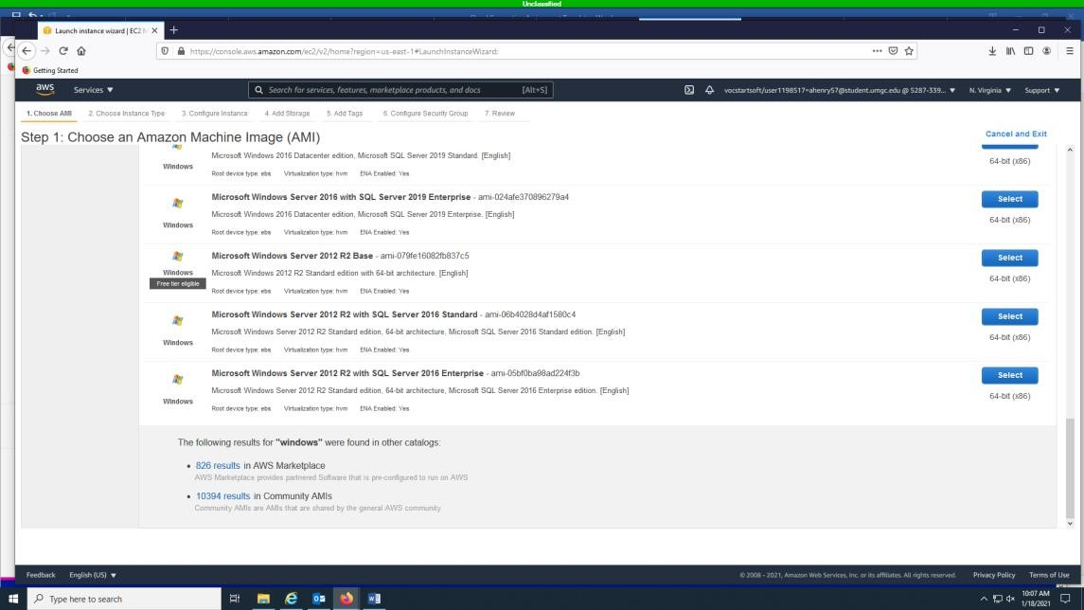

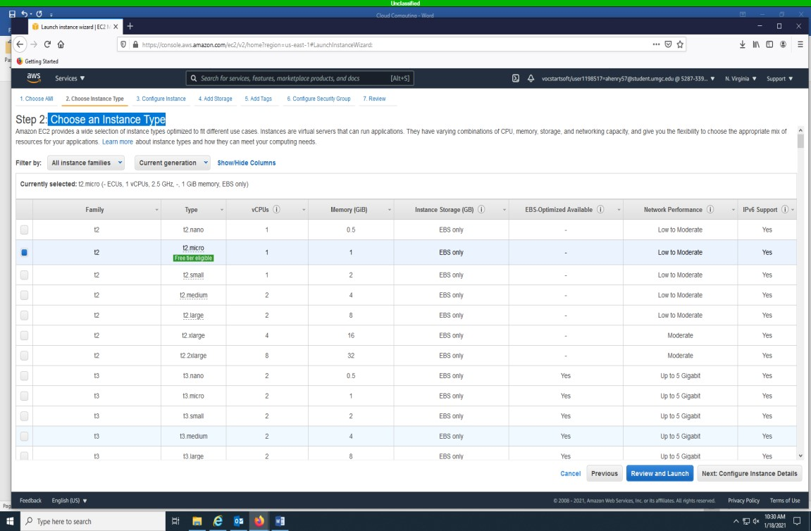

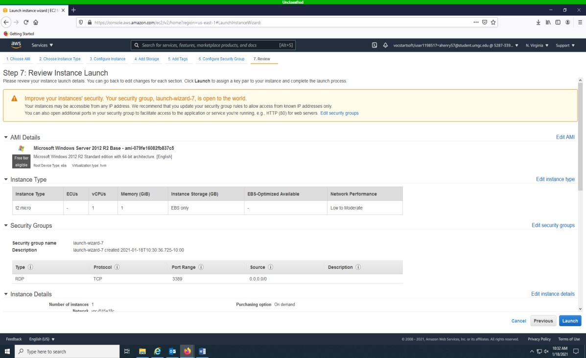

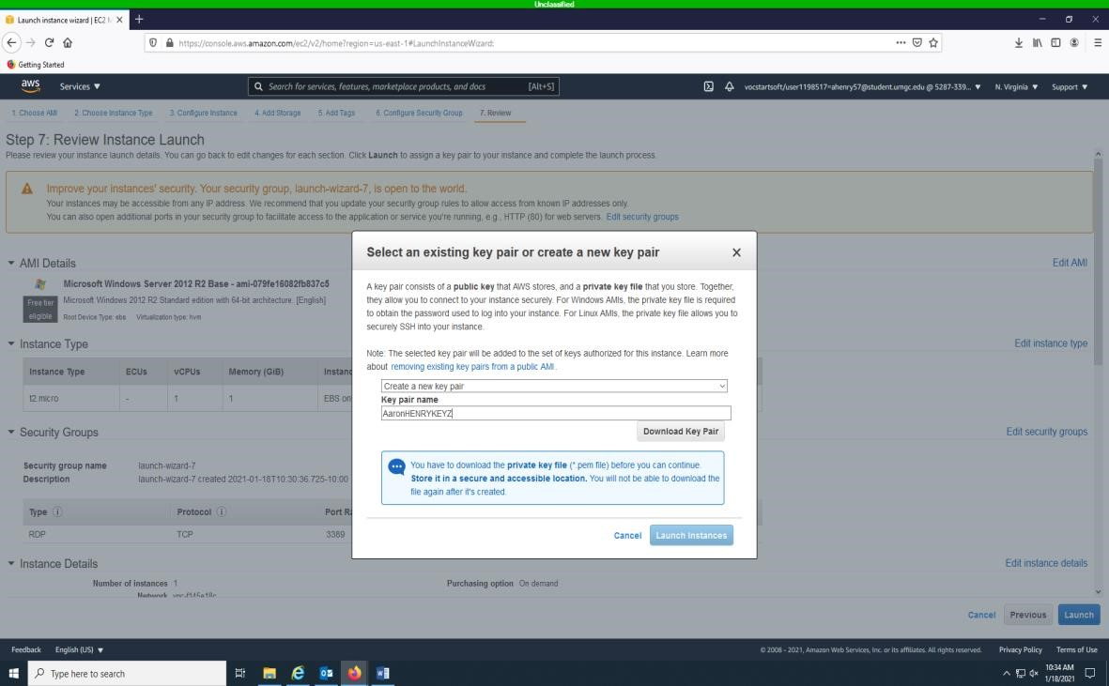

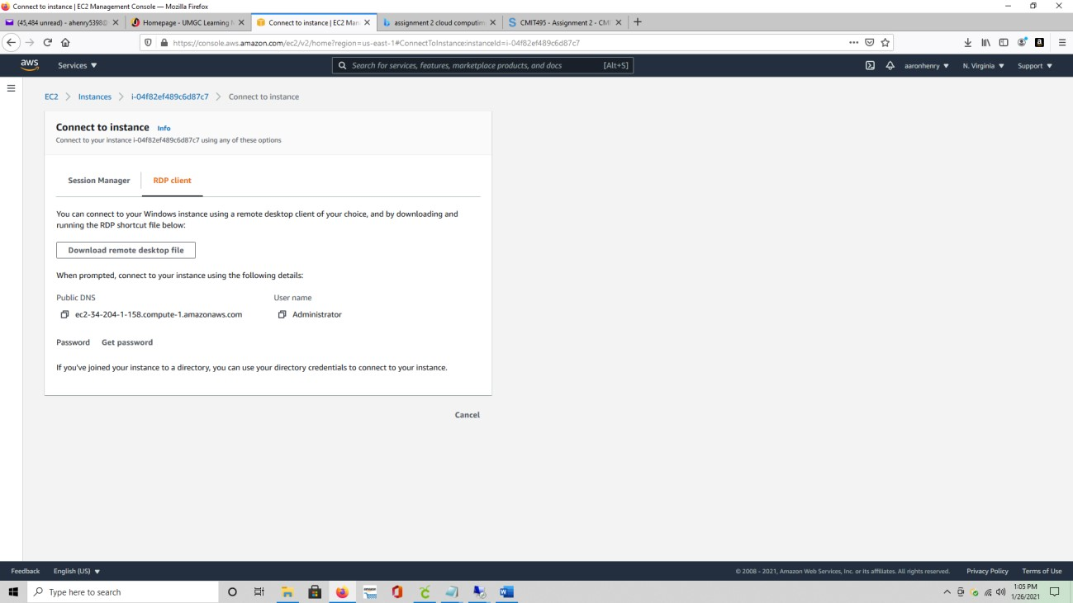

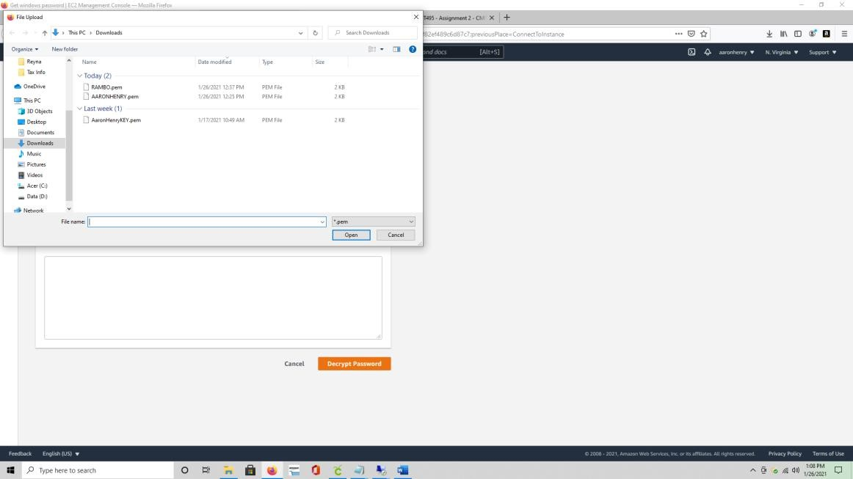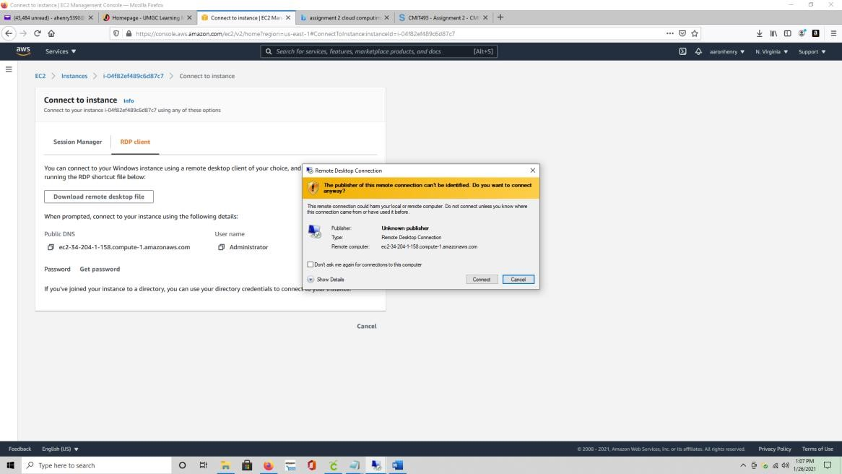

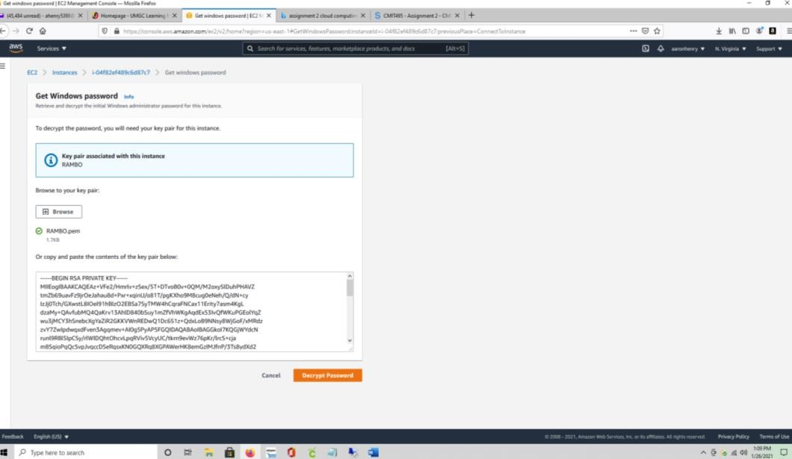

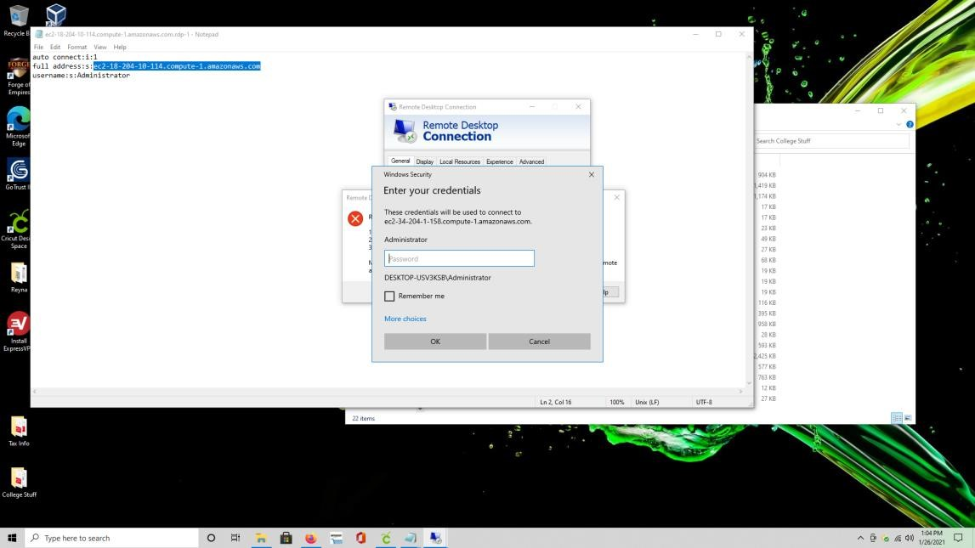

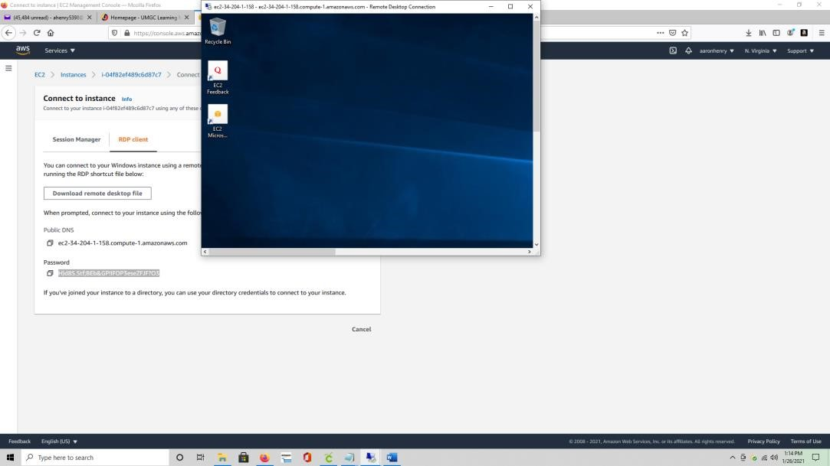

1. Create an Amazon Lightsail account

This tutorial is free tier eligible.

[Sign-up for AWS](https://portal.aws.amazon.com/billing/signup?client=lightsail&fid=1A3F6B376ECAC516-2C15C39C5ACECACB&redirect_url=https%3A%2F%2Flightsail.aws.amazon.com%2Fls%2Fsignup#/start)

Already have an account? [Sign-in](https://portal.aws.amazon.com/billing/signup?client=lightsail&fid=1A3F6B376ECAC516-2C15C39C5ACECACB&redirect_url=https%3A%2F%2Flightsail.aws.amazon.com%2Fls%2Fsignup#/start)

2. Create a Windows Server 2016 instance in Amazon Lightsail

a. Choose Create instance in the Instances tab of the [Lightsail home page](https://lightsail.aws.amazon.com/ls/).

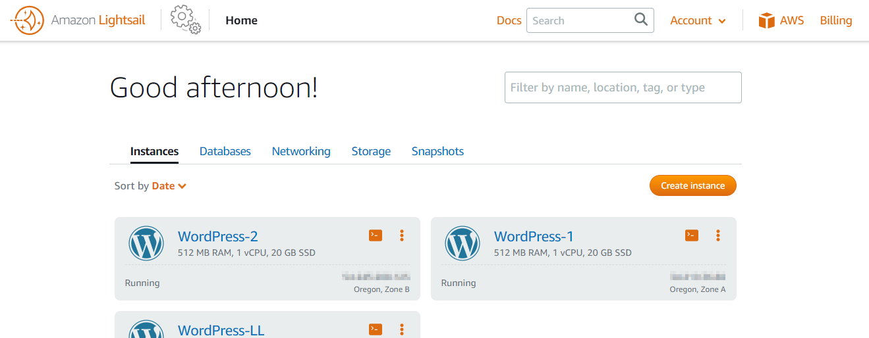

3. Configure the instance

a. An AWS Region and Availability Zone is selected for you. Choose Change Region and Availability Zone to create your instance in another location.

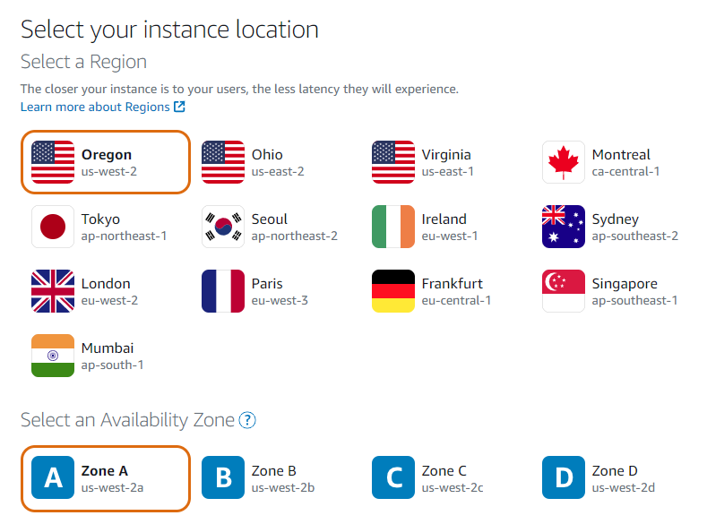

b. Choose the Microsoft Windows platform option, and choose OS only to view the operating system-only instance images available in Lightsail.

To learn more about Lightsail instance images, see [Choose an Amazon Lightsail instance image.](https://lightsail.aws.amazon.com/ls/docs/en_us/articles/compare-options-choose-lightsail-instance-image)

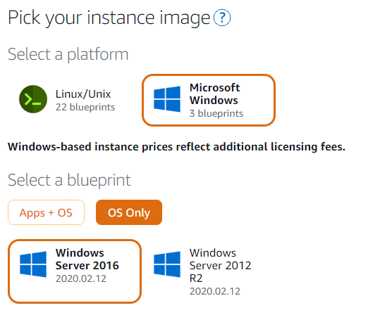

c. Choose the Windows Server 2016 image.

d. (Optional) Choose Add launch script to add a PowerShell script that will run on your instance when it launches.

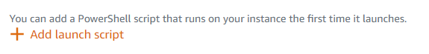

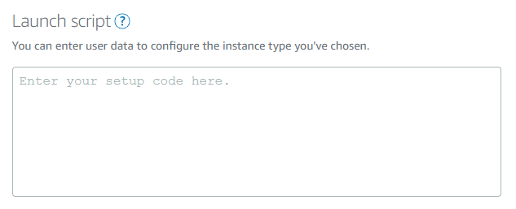

e. Choose your instance plan.

You can try the $8 USD Lightsail plan free for one month (up to 750 hours). We'll credit one free month to your account.

[Learn more on our Lightsail pricing page.](http://www.amazonlightsail.com/pricing/)

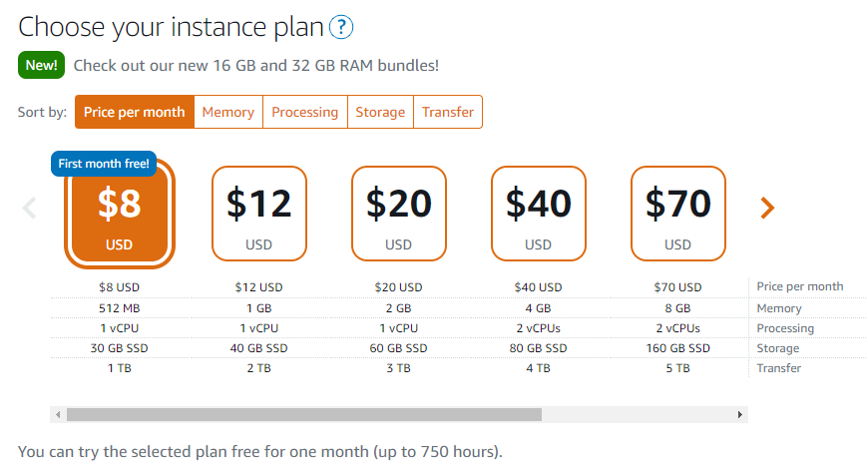

f. Enter a name for your instance.

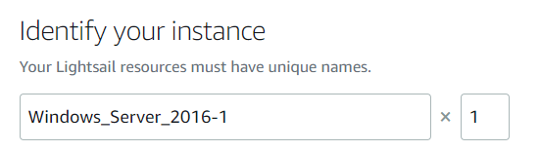

g. (Optional) Choose one of the following options to add tags to your instance:

* (Optional) Add key-only tags— Enter your new tag into the tag key text box, and press Enter. Choose Save when you’re done entering your tags to add them, or choose Cancel to not add them.
* (Optional) Create a key-value tag— Enter a key into the Key text box, and a value into the Value text box. Choose Save when you’re done entering your tags, or choose Cancel to not add them.

Key-value tags can only be added one at a time before saving. To add more than one key-value tag, repeat the previous steps.

For more information about key-only and key-value tags, see [Tags in Amazon Lightsail.](https://lightsail.aws.amazon.com/ls/docs/en_us/articles/amazon-lightsail-tags)

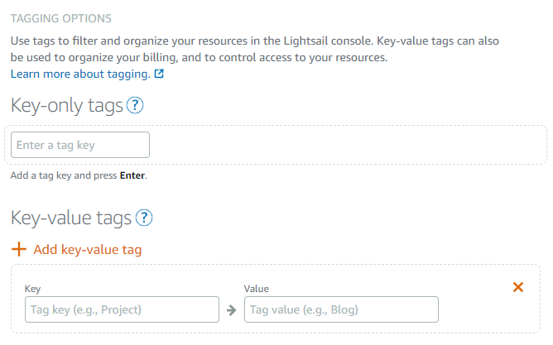

h. Chose Create instance.



Within minutes, your Windows Server 2016 instance is ready, and you can connect to it using the browser-based RDP client in the Lightsail console.

4. Connect to your instance using the browser-based RDP client in Lightsail

a. In the Instances tab of the [Lightsail home page](https://lightsail.aws.amazon.com/ls/), choose the RDP icon, or the ellipsis (⋮) icon next to the Windows Server 2016 instance you just created.

The browser-based RDP client window appears. You can use, and manage your instance without configuring a third-party RDP client.

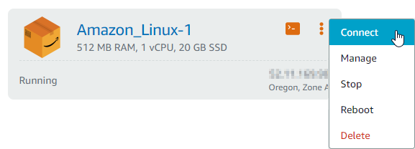

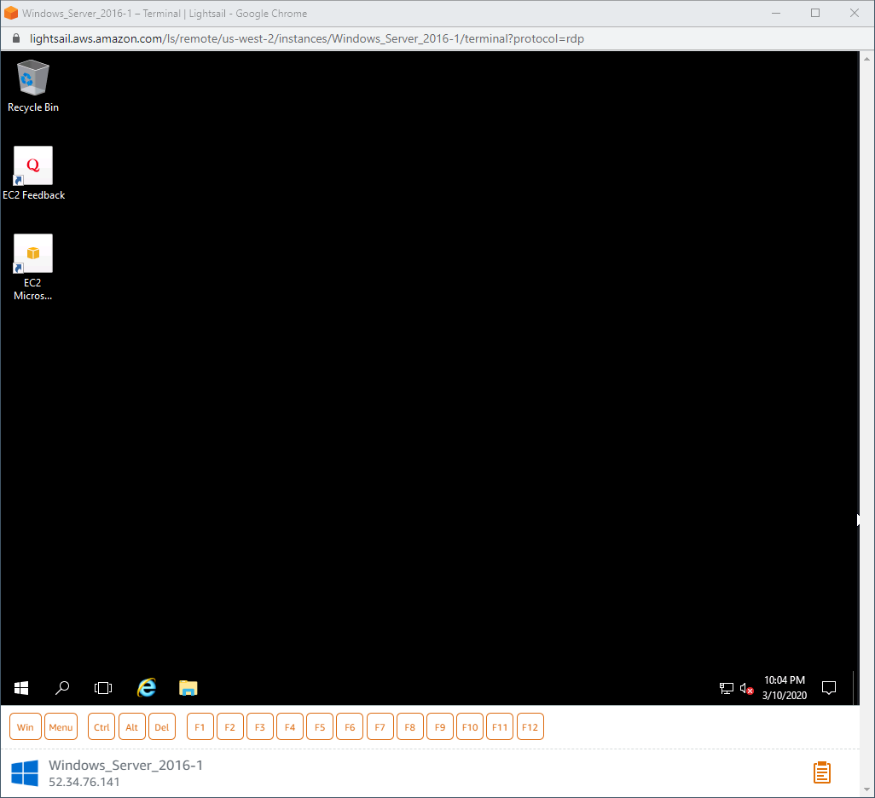

b. To get the administrator password for your Windows Server 2016 instance, choose the name of the Windows Server 2016 instance in the Instances tab of the Lightsail home page.  
Choose the Connect tab, scroll down to the Default login credentials section of the page, and choose Show default password.

Important: If you changed the administrator password after signing in to your Windows Server 2016 instance, then the administrator password displayed in the Lightsail console is no longer valid.

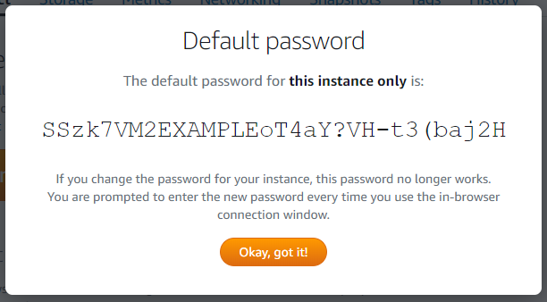

5. Next steps

Now that you can connect to your instance, what you do next depends on how you plan to use it. For example, you can:

* for your instance to keep the same IP address each time you stop and start your Lightsail instance.
* Create a snapshot of your instance to keep as a backup.
* Attach a disk to your instance to add more storage space

1. **Using AWS, *create a network file system* with Amazon Elastic File Systems (EFS). Use the *AWS Use Cases web page* for step-by-step instructions. Take a screenshot of the result and embed it below. Specifically, take a screenshot of *verifying your file system has been successfully mounted*, and the results of *creating a test file in your new file system by running a simple dd command to generate a 1GiB file in your new directory.* Finally, describe the value of a network file system.**

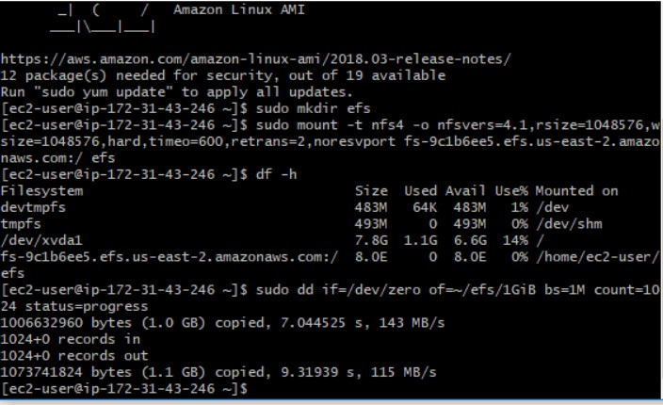

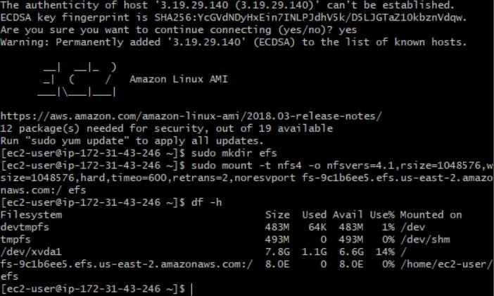

•

NFS is a low-cost solution for network file sharing that is easy to setup as it uses the existing IP infrastructure. NFS is that allows for central management, decreasing the need for added software and disk space on individual user systems. Enables local users to access remote data and files in the same ability it can be locally. NFS utilizes TCP and UDP for data access and delivery, which is dependent on the version in use.

1. **Using AWS, *store and retrieve a file*. Use the AWS Use Cases web page for step-bystep instructions. Take a screenshot of the result and embed it below. Specifically, take a screenshot *retrieving the object from the S3 bucket*.**

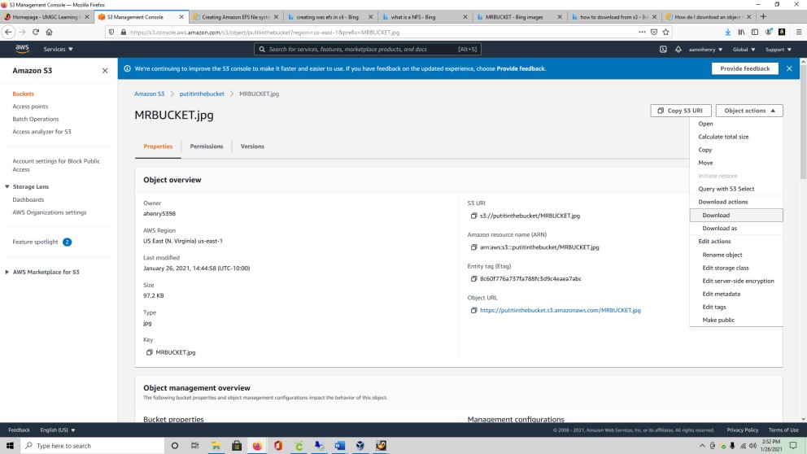

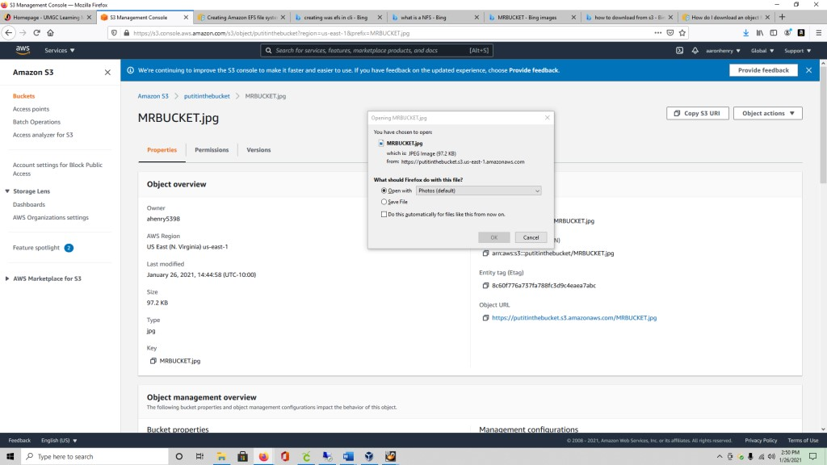

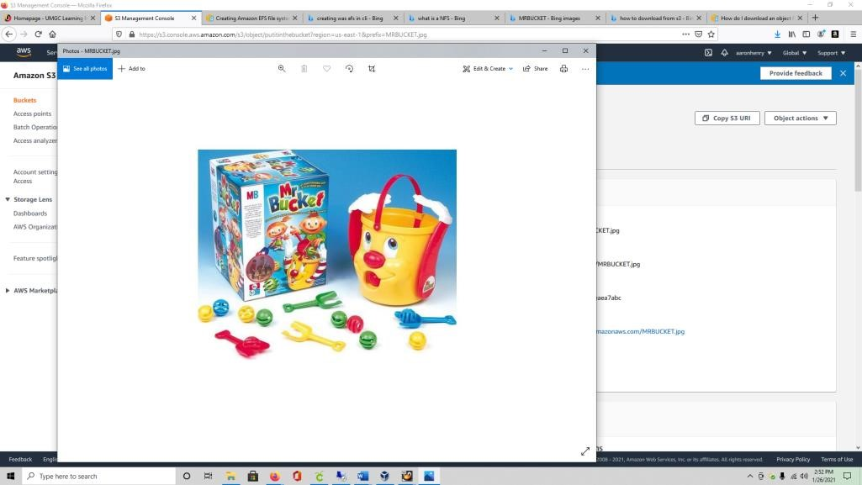

1. **The CTO will be reviewing this document. You have shown how easy it is to provision a Microsoft operating system using AWS. The CTO chose AWS because it offered a free account. She will now expect a recommendation from you on what cloud service to use for the organization PaaS (e.g. operating system) needs. There is no need for a private cloud, so the public option will work just fine. Describe the different between the Google Cloud Platform, Amazon AWS, and Microsoft Azure. Make a recommendation to the CTO as to which service provider you would recommend and why. Be explicit and detailed in your recommendation.**

**AWS** is growing platform that is continues to demonstrate Amazon’s capability. While they can and do offer free cost structure their pay to play structure can be a little confusing at times and hard to understand. AWS tends to focus on public cloud rather a t hybrid or private cloud. This causes interoperating of data over different clouds more difficult to migrate. As AWS is not just out the box like other programs one must be sure they know exactly what is required before utilizing its services, but if the priority is to go with public cloud option then AWS will offer its customers exactly what it needs.

**Azure** also offers an infrastructure that is just as responsive and exceptional as AWS. Azure is highly attractive to enterprise customers. Unlike AWS, Azure has an option that gives public cloud options, but their focus is both Public and Private. Azure platform works hard to interoperate with data centers.

**Google Cloud Platform** is relatively newer than the other two. Their enterprise focus is not centrally strong and therefore they have yet to attract the fanbase that AWS and AZURE process. One bright spot in the Google Cloud Platform is unmatched technical expertise. Currently the market leader in learning and AI, machine learning and data analytics.

As the current search is for a Platform as a Service (PaaS) the focus will be in the public cloud option. Our strongest recommendation is that your company go with Amazon AWS. While the free to cost base can be confusing, we have no doubt your company will figure out the requirements needed to be meet.

**6. The CTO appreciated the analysis performed between the cloud service providers**

**(Amazon, Google, and Microsoft). She has decided to proceed with an Amazon Virtual Private Cloud. Amazon Virtual Private Cloud (Amazon VPC) enables you to launch AWS resources into a virtual network that you've defined. This virtual network closely resembles a traditional network that you'd operate in your own data center, with the benefits of using the scalable infrastructure of AWS. To begin, the CEO would like you to provision two subnets. One subnet will be for the developers (Subnet A), which will be provisioned with 146.38.70.105/20. The second subnet will for the marketing department (Subnet B), which will be provisioned with 215.16.52.119/19.**

**What is the network address, broadcast address, and subnet mask for Subnet A and B? Perform the necessary calculations and explain your answer.**

To get the subnet mask of the IP addresses given turn into binary but turning on or utilizing the bits. For **146.38.70.105/20** is broken down into 4 segments, each consisting of 8 bits each. From left to right I used 1’s to make a total of 20 bits. I used the following formula to get the Subnet mask.

128 + 64 + 32 + 16 + 8 + 4 + 2 + 1 = 11111111 = 255

128 + 64 + 32 + 16 + 8 + 4 + 2 + 1 = 11111111 = 255

128 + 64 + 32 + 0 + 0+ 0 + 0 + 0 = 11111111 = 224

NO BITS USED= 00000000 = 0

Subnet Mask: **255.255.224.0**

Same formula used to get the subnet mask of **215.16.52.119/19.**

**SUBNET A: 146.38.70.105/20**

**Address:** **146.38.70.105** 10010010. 00100110. 01000110. 01101001 **subnet mask:** **255.255.240.0** = 20 11111111.11111111.1111 0000.00000000

**Broadcast:** **146.38.79.255**

**Network Address:** **146.38.64.0** = 10010010. 00100110. 01000000. 00000000

-To get the network address use the first 20 bits from the given IP address 10010010. 00100110. 01000000. 00000000 and the remaining bits turned them to zero with a result of **146.38.64.0.**

-To get the broadcast address turn last bits into 1’s to get 10010010. 00100110.

01001111. 11111111 = **146.38.79.255**

**SUBNET B: 215.16.52.119/19**

**Address:** 215.16.52.119 11010111. 00010000. 00110100. 01110111

**Subnet mask:** 255.255.224.0 = 19 11111111. 11111111. 1110 0000. 00000000

**Broadcast:** 215.16.63.255

**Network Address:** 215.16.32.0

* To get the network address use the first 19 bits from the given IP address.

11010111. 00010000. 00100000. 00000000 and the remaining bits turned them to zero with a result of 215.16.32.0

* To get the broadcast address turn last bits into 1’s to get 11010111. 00010000. 00111111. 1111111 = 215.16.63.255

**7. Confirm that you have stopped and terminated your Microsoft virtual machine, Linux instance, deleted your file system from the Amazon EFS console and deleted your Amazon S3 bucket. To confirm, simply type your name below.**

Aaron Henry