THEORY OF COMPUTING

**1.QUESTION 1**

The Dwarves of the Lonely Mountain have a lot of time on their hands, and are very worried about information about the size of their horde of gold getting around various parts of Middle-Earth, as they fear invasion by all and sundry if any hint of their true wealth were to be revealed. Accordingly King Durin XIII decrees that all records are to be written only in encrypted Khuzdul, in which there are 32 distinct characters. The encryption process is based on a Khuzdul keyword of n characters in length. Durin’s advisors inform him that an evil wizard with an army of orc-slaves at his disposal (or a few of the lesser intelligent hobbits :-)) could exhaustively search through all possible keywords at a rate of 100,000 keywords per day. Durin decrees that the royal Khuzdul keyword must be secure ”until the end of the age”.

Model Structure

**2.QUESTION 2**

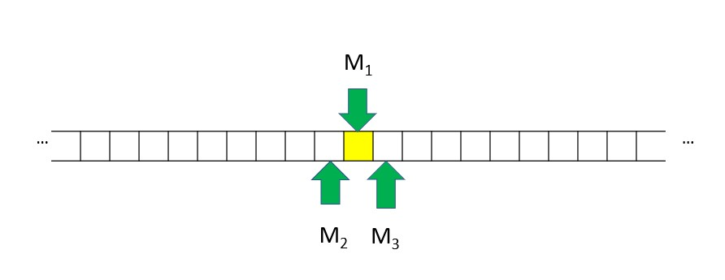

A party game for two to eight players, Platypus sees players working together to identify the right word card over the space of seven rounds. At the very beginning of the game, the players are split into two different roles - guides and explorers - who must help each other to identify the correct ‘platypus’ card. Eight words are placed in a row in front of the players, with the guides knowing which card the explorers need to guess in order to win the game.

The guides must then take turns to provide the explorers with a clue card from their hand, meaning that - similar to the word game Decrypto - the players will receive a gradual trickle of information. Clue cards are adjectives that should have some connection to the correct platypus card, whilst avoiding making potential connections with the wrong platypus cards - in a similar fashion to party game Codenames. The explorers will then need to eliminate a platypus card from the row that they think does not fit with the clues.

Model Scenario

Should the explorers remove the correct platypus card, everyone loses the co-op board game. However, if the last remaining card is the right platypus card, everyone wins and roles can be swapped around for the next playthrough.

Besides designing Platypus and Sushi Go!, Walker-Harding is known for creating historical city-building title Imhotep, tile-placement board game Bärenpark and card-drafting marbles game Gizmos.

Matagot is the studio responsible for publishing Platypus, with the company’s previous releases including co-op board game Captain Sonar and epic Greek mythology game Cyclades and its Egyptian spiritual successor, Kemet

**3.QUESTION 3**

1: Let *w* be A

A1: 0*n*2*n*1210*n*2*n*. A2: 2*n*1212*n*. A3: 0*n*1210*n*. A4: 1*n*1211*n*.

2: and so *xyiz* is B

B1: 2*n*0*n*+*j*1212*n*0*n* B2: 2*n*+*j*1212*n* B3: 0*n*+*j*1210*n* B4: 1*n*+*j*1211*n*

3: Then ∃*n* ≥ 1 such that C and D,

C1: for all *w* ∈ *L* and |*w*| ≥ *n* C2: for some *w* ∈ *L* and |*w*| ≥ *n* C3: for all *w* ∈ *L* and |*w*| ≤ *n* C4: for some *w* ∈ *L* and |*w*| ≤ *n*

D1: ∃*x,y,z* such that *w* = *xyz,*|*xy*| ≤ *n* D2: ∀*x,y,z* such that *w* = *xyz,*|*xy*| ≤ *n* D3: ∃*x,y,z* such that *w* = *xyz,*|*xy*| ≥ *n* D4: ∀*x,y,z* such that *w* = *xyz,*|*xy*| ≥ *n*

4: Finrod’s Tale: A proof that the language *L* =E is F .

E1: {*w*121|*w* ∈ {0*,*1*,*2}∗} E2: {121*w*|*w* ∈ {0*,*1*,*2}∗} E3: {*w*000*w*|*w* ∈

{0*,*1*,*2}∗} E4: {*w*121*w*|*w* ∈ {0*,*1*,*2}∗}

F1: regular F2: context-free F3: not regular F4: empty

5: As the Pumping Lemma requires *xyiz* ∈ *L*, this is a G

G1: problem G2: paradox G3: contradiction G4: tautology

6: and so we have shown that our assumption is false, i.e. that L is H.

H1: regular H2: context-free H3: not regular H4: empty 7: Assume *L* is I.

I1: regular I2: context-free I3: not regular I4: empty

8: Now consider J

J1: *i* = 0 J2: *i* = 1 J3: *i* = 2 J4: *i* = 3

9: so we have *w* ∈ *L*, K and |*xy*| ≤ *n*, and so we have L for some 1 ≤ *j* ≤ *n*.

K1: |*w*| ≤ *n* K2: |*w*| *< n* K3: |*w*| ≥ *n* K4: |*w*| *> n* L1: *y* = 0*j* L2: *y* = 1*j* L3: *y* = (02)*j* L4: *y* = (12)*j*

10: *y* 6= *λ* and M

M1: *xyiz* ∈6 *L* for all *i* ≥ 0 M2: *xyiz* 6∈ *L* for some *i* ≥ 0 M3: *xyiz* ∈ *L* for all *i* ≥ 0 M4: *xyiz* ∈ *L* for some *i* ≥ 0

**4.QUESTION 4**

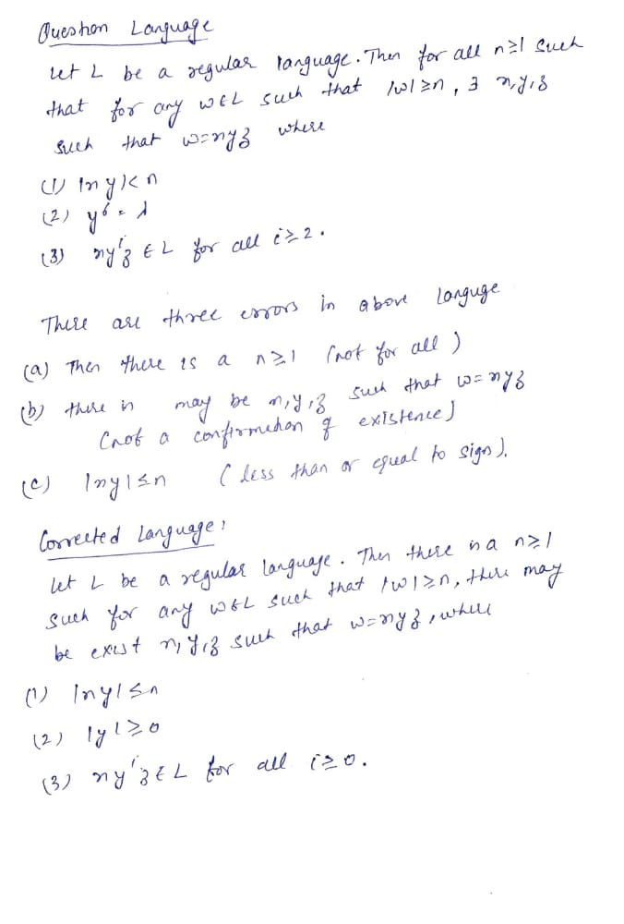

**5.QUESTION 5**

**6.QUESTION 6**