Report of ANN Configurations and corresponding Accuracy, Precision, Recall, F1-score on

Train and Test data

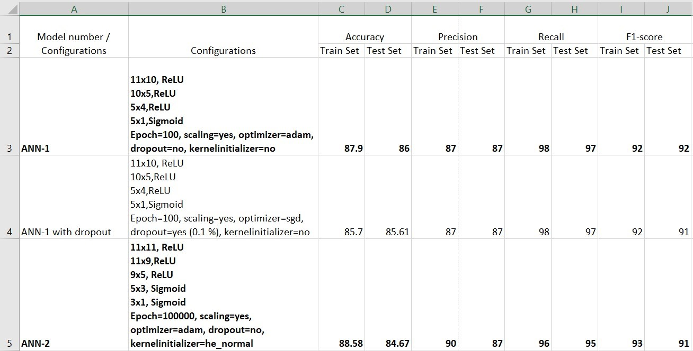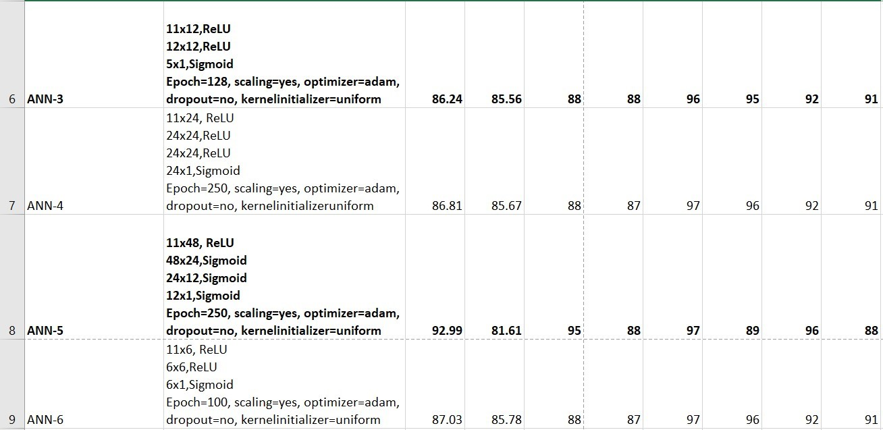

Report of ANN Configurations and corresponding Accuracy, Precision, Recall, F1-score on

Train and Test data

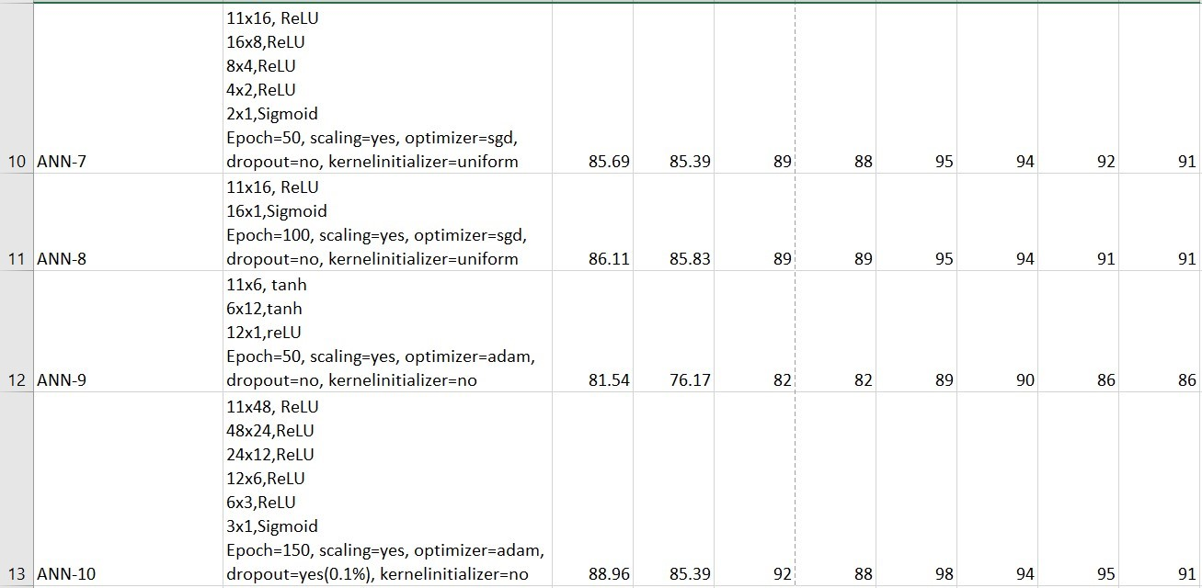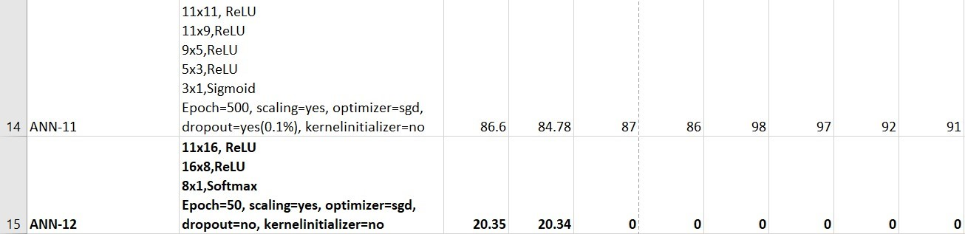

From the above report table, we can conclude that model ANN-1 shows better performance with accuracy 86% and hence I am using the same to predict judge.csv dataset.