BAIS:6050

Homework 5: Advanced SQL Queries - RUBRIC

Specifications

* This homework is worth 75 points.
* Submit a SQL script file (.sql) with all of queries:
  + Add a comment to the top of the script with your name
  + Use comments to denote each question number
  + Your file name should contain your last name and the assignment name (e.g., “lastname_homework5.sql”)

Download “CARPENTER.sql” from ICON, then upload into APEX and run. This script contains 88 SQL statements to create and populate a database tracking information about the films of John Carpenter, best known as the creator and director of the *Halloween* movie franchise. This data is sourced from IMDB ([https://www.imdb.com)](https://www.imdb.com) and Wikipedia (<https://en.wikipedia.org/wiki/John_Carpenter>). The normalized database contains 5 tables:

* FILM stores the unique ID, type (feature movie, video release, TV movie, or short film), title, and release year for all films where Carpenter had a principal role. In addition, it records the length (in minutes), average IMDB user rating (out of 10), total number of IMDB user votes, estimated budget (i.e., cost), estimated box office revenue, and production company for each film, though these fields may have missing values. (46 rows total)
* GENRE tracks the genre (e.g., Horror, Drama) of each film. Each movie is associated with 1-3 genres. (101 rows total)
* PERSON contains the unique ID, name, birth year, and death year for people that have worked on films with Carpenter (including John Carpenter himself). While all people have a first name, some people are missing the other name components, birth year, and/or death year. (266 rows total)
* CREW records the principal people involved in the cast and crew of each film and their job on the film (e.g., actor, director, producer). There are 1-13 principal cast and crew members for each movie. All people in the database are associated with one or more films, and the same person may have multiple jobs on the same film (e.g., Carpenter wrote, directed, and composed for *Halloween*). For actors, there is also a character name. (435 rows total)
* AWARD contains information about major award nominations for films in the database. Each row records a unique award ID, film ID, award name, award category, and a binary (0/1) variable tracking whether it won the award. A film may be nominated for 0 awards, but may also be nominated for multiple awards. (30 rows total)

You should review each table in the Object Browser and/or examine the SQL script to make sure that you understand the field definitions, constraints, primary key(s), foreign key(s), and relationships. A logical relational schema for the data is displayed below:

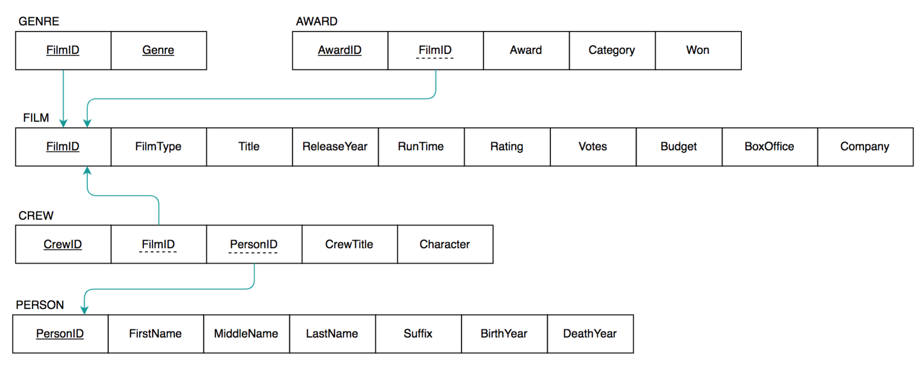

Then write SQL queries to answer the following questions. Submit all code as a SQL script (.sql). Add a comment at the top of the script with your name and comments to denote each question:

1. (13 points) Much like legendary director Alfred Hitchcock, John Carpenter appears in small cameo roles in several of his films. Write a compound query that returns the IDs for all film where Carpenter was both the director and an actor.
2. (20 points) John Carpenter has collaborated with many people over the course of his career. Write a join query that returns information about his collaborators, specifically their ID, full name (formatted as one field), birth year, death year, and total number of times they’ve worked with Carpenter. Only include people who’ve collaborated with Carpenter at least 4 times.
3. (15 points) John Carpenter has had a long career (spanning 1962 to the present), but has the profitability of his work changed over time? Write a CASE query that categorizes films by decade (e.g., films made between 1960 and 1969 = 1960s). For each film, return the title, run time, and profit, plus the decade when the film was released. Format profit as a currency value (e.g. $1,500,000). Exclude films with missing values for profit. Sort the films from most to least profitable.
4. (27 points) John Carpenter often performs multiple jobs on the same film (e.g., directing and composing the score for *Assault on Precinct 13*), but does this improve the quality of the final work? Write a subquery that returns title, year, IMDB rating, and total award nominations for films where Carpenter had multiple jobs. Include only standard movies in the results (i.e., no TV movies, straight-to-video releases, or short films). (Extra Credit: +2 points for adding a column that calculates the total number of awards won for each movie)