sudo dd if=/dev/sdb of=sdb_image.img bs=65536 conv=noerror,sync | split -d -b 30m | md5sum > sdb_image.md5

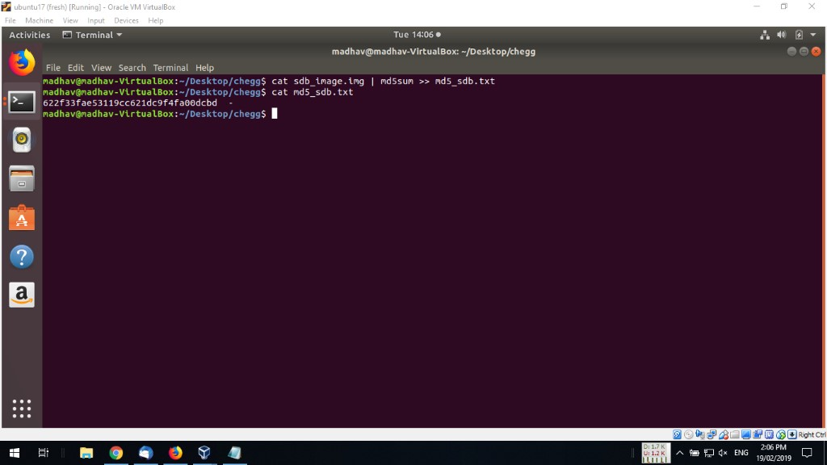



**md5sum Command in Linux with Examples**

The md5sum is designed to verify data integrity using [MD5](https://en.wikipedia.org/wiki/MD5) (Message Digest Algorithm 5).

MD5 is 128-bit cryptographic hash and if used properly it can be used to verify file authenticity and integrity.

Example :

Input : md5sum /home/mandeep/test/test.cpp

Output : c6779ec2960296ed9a04f08d67f64422 /home/mandeep/test/test.cpp

**Importance :**  
Suppose, anyone wants to install an operating system , so to verify if it’s correct CD, it’s always a good idea to verify .iso file using MD5 checksum, so that you don’t end up installing wrong software (some sort of virus which can corrupt your filesystem).

**Syntax :**

md5sum [OPTION]... [FILE]...

It will print or check MD5(128-bit) checksum.

It computes MD5 checksum for file “test.cpp”  
Output :

c6779ec2960296ed9a04f08d67f64422 /home/mandeep/test/test.cpp

**Options :**  
**-b :** read in binary mode  
**-c :** read MD5 from files and check them  
**–tag :** create a BSD-style checksum  
**-t :** read in text mode(it’s by default)

**The options which are useful when verifying checksum :**  
**–ignore-missing :** don’t report status for missing files  
**–quiet :** don’t print OK for each successfully verified file  
**–status :** don’t output anything, status code shows success  
**–strict :** exit non-zero for improperly formatted checksum files  
**-w :** warn about improperly formatted checksum files

**Command usage examples with options :**

Example 1: Store the MD5 checksum in file and then verify it.

# md5sum /home/mandeep/test/test.cpp > checkmd5.md5

It will store the MD5 checksum for test.cpp in file checkmd5.md5

# md5sum -c checkmd5.md5

It will verify the contents of file

Output :

/home/mandeep/test/test.cpp: OK

After changing the contents of file checkmd5.md5, the output will be :

/home/mandeep/test/test.cpp: FAILED

md5sum: WARNING: 1 computed checksum did NOT match

Example 2: create a BSD-style checksum with –tag option

# md5sum --tag /home/mandeep/test/test.cpp

Output :

MD5 (/home/mandeep/test/test.cpp) = c6779ec2960296ed9a04f08d67f64422

Example 3: –quiet option, can be used when verifying checksum, don’t print OK when verification is successful.

# md5sum -c --quiet checkmd5.md5

Don’t produce any output, means it’s successful.

But if checksum don’t match, it produces warning.

# md5sum -c --quiet checkmd5.md5

/home/mandeep/test/test.cpp: FAILED

md5sum: WARNING: 1 computed checksum did NOT match

Example 4: –warn option, it can be used for generating a warning for improperly formatted checksum files.

content of file checkmd5.md5:

c6779ec2960296ed9a04f08d67f64422 /home/mandeep/test/test.cpp

Now, execute command with –warn option

# md5sum -c --warn checkmd5.md5

/home/mandeep/test/test.cpp: OK

It don’t produce any warning.

Now, do some formatting in file checkmd5.md5

c6779ec2960296ed9a04f08d67f64422

/home/mandeep/test/test.cpp

Now, execute the command

# md5sum -c --warn checkmd5.md5

Output :

md5sum: checkmd5.md5: 1: improperly formatted MD5 checksum line

md5sum: checkmd5.md5: 2: improperly formatted MD5 checksum line

md5sum: checkmd5.md5: no properly formatted MD5 checksum lines found

and if –warn is replaced with –strict option, it will exit non-zero for improperly formatted checksum lines

# md5sum -c --strict checkmd5.md5

md5sum: checkmd5.md5: no properly formatted MD5 checksum lines

