The sedimentation and filtration segments of the water treatment plant were designed in consideration with the 10 States Standards. The aim of sedimentation is to remove particulates from the filtration process. Sedimentation is the method of removing suspended objects from water by gravity or isolation. The water flows into a comparatively calm and still basin during the sedimentation period. Turbidity describes the amount of particulate contamination in water, which includes organic and inorganic particles.

General design guidelines specify that sedimentation and filtration should be as close as possible, this proximity can be seen on the plans. Additionally, because the required flow rates can vary based on average, peak, and maximum flow conditions, multiple sedimentation units are required. The design document specified two parallel units of sedimentation, with a mean retention time of 4 hrs for each unit. The total volume of the two sedimentation basins is enough to handle the maximum predicted hourly flow, while providing redundancy to handle maintenance or downtime during average flow conditions. The 10 States Standards requires that overflow rates will be in the range of 500-800 gpd/ft2, so design of sedimentation basin will be on maximum day demand because on peak demand OFR will be lower than the standard or on avg demand OFR will be higher than the standard. The total volume of the two sedimentation basins is 30503.29 ft3. Total area will be calculated by dividing volume to depth that is assumed to be 5 m. after calculating area length and width of each basin will be calculated by using 4:1 approach that is given. The dimensions of each sedimentation basin will be 60 ft x 15 ft x 16 ft. weir length will be calculated by assuming weir loading rate that is 250 m3/m.day and by dividing flow with weir loading rate, weir length will be calculated.

Filtration occurs after the sedimentation process so the clear water is filtered out in the filtration tank. Filtration is basically the process of removing impurities from a water passes through a filter that removes particles from the water. The filters are composed of layers of sand and gravel, and in some cases, compressed anthracite. Filtration collects the suspended impurities in liquids, improving the potency of disinfection. Filtration rate is assumed and area of filtration unit is calculated. It is also design on maximum day demand. Length of each filter unit will be 12 ft and width will be 6.22 ft.

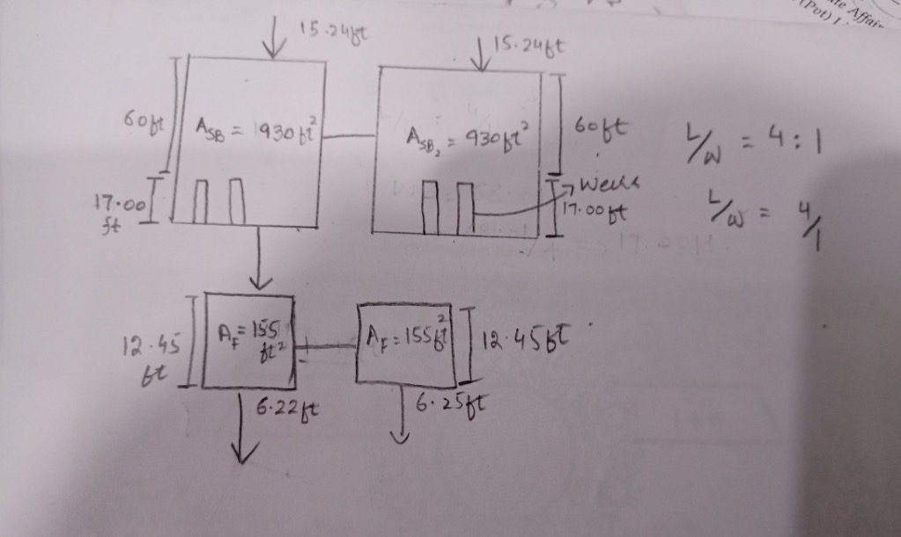

**Calculat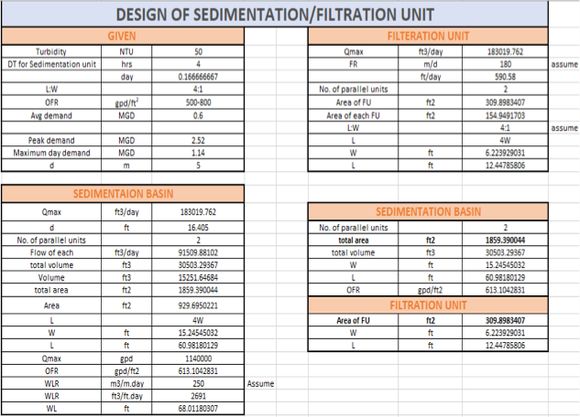ions :-**