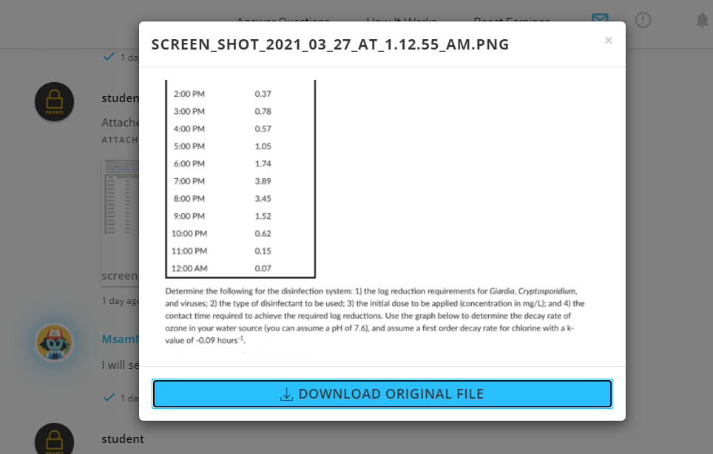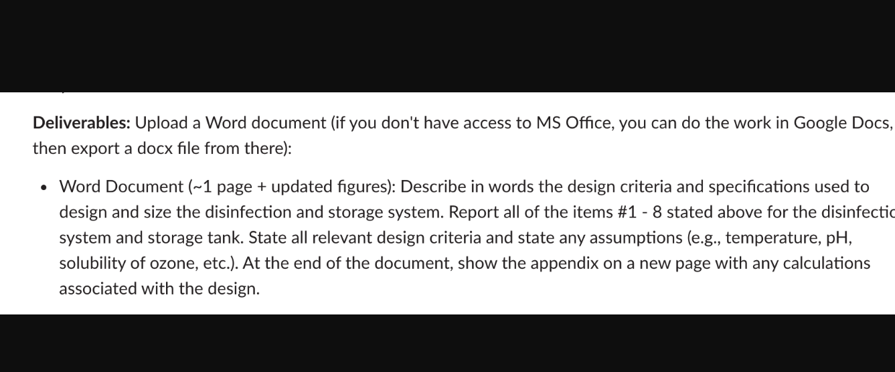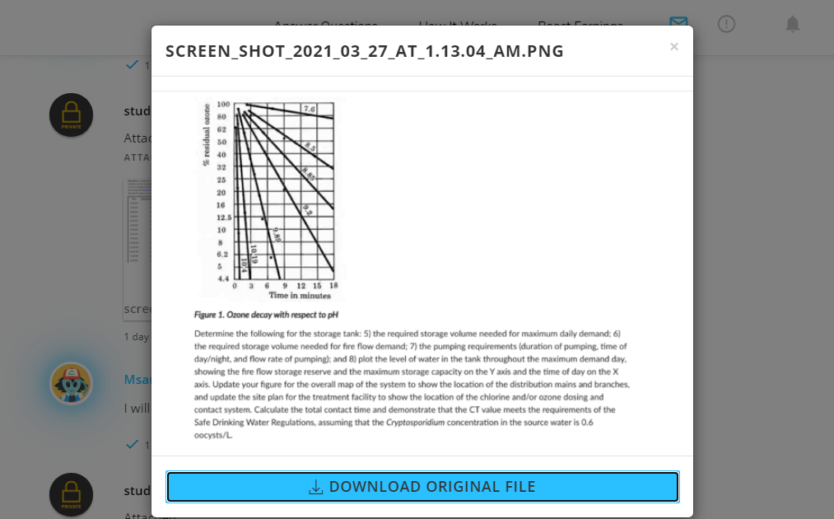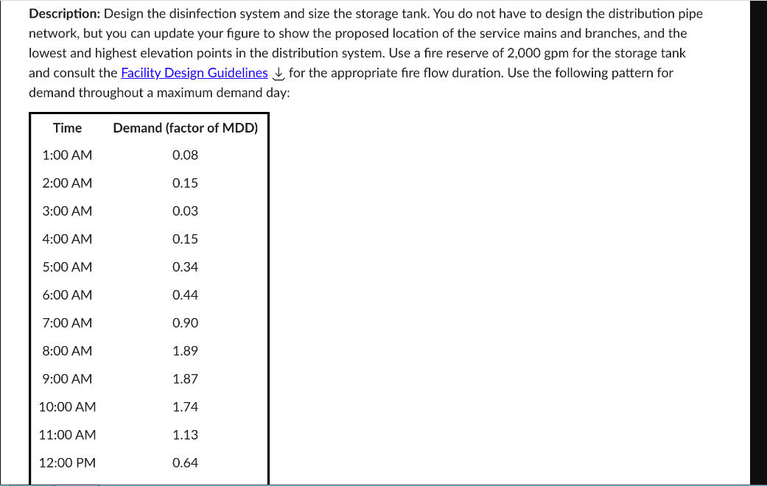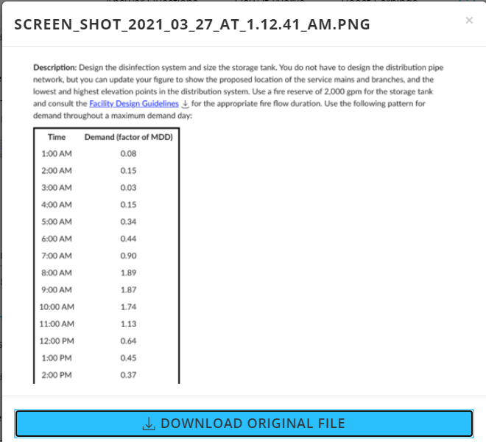

BACKGROUND

P2 - Coagulation, Mixing, and Flocculation

The coagulation and flocculation segments of the water treatment plant were designed in consideration with the 10 States Standards. This stage of treatment is performed to reduce the turbidity of the water before disinfection. Turbidity describes the amount of particulate contamination in water, which includes organic and inorganic particles. Coagulation uses chemicals to destabilize colloidal particles into flocs and agglomerate larger suspended particles. The velocity gradient (G-value) and detention time are experimentally determined through jar testing by the engineer based on the source water. The proximate location of the site was designated in the P1 deliverable, however, the exact area of the site was not provided and therefore could not be included in the plan.

The mixing equipment should provide a minimum velocity gradient of 750s-1 and should be able to handle a variety of flow rates. General design guidelines specify that coagulation and flocculation basins should be as close as possible, this proximity can be seen on the plans. Additionally, because the required flow rates can vary based on average, peak, and maximum flow conditions, multiple mixing basins are required. The design document specified three parallel trains of rapid mixing basins, with a mean retention time of 30 sec for each unit. The total volume of the three basins is enough to handle the maximum predicted hourly flow, while providing redundancy to handle maintenance or downtime during average flow conditions. The 10 States Standards requires that detention time for mixing basins be less than or equal to 30 seconds, therefore the lowest flow rate (average annual usage) was used to calculate the volume of the mixing basins. If the largest flow rate were used (peak hour demand) the detention time would be far greater than the maximum of 30 seconds. With both mixing trains down for maintenance the retention time would be 10 seconds, within the 10 States Standards. The desired coagulation is alum, specifically the liquid alum product manufactured by Geo Specialty Chemicals. We estimate that coagulation will produce approximately 54.9 kg of sludge per day, which will be collected during flocculation, dewatered, treated, and then disposed of to a landfill or sold as a fertilizer. The power requirements are estimated as 0.167 kw, a conservative cost estimate of $594.04 per year to run all the mixing tanks. The alkalinity will not be completely consumed during reaction; approximately half of the 82mg/L alkalinity will be consumed.

Flocculation occurs after the mixing of coagulant into the source water and allows the large flocs to settle out. Keeping flocs agglomerated is key to efficient reduction of turbidity and therefore turbidity and short-circuiting should be minimized in inlets, outlets, and piping. Velocity of flocs should stay between 0.5 and 1.5 feet per minute, and detention time for flocs should be at least 30 minutes. For this design we used the specified detention time of 40 minutes, and the calculated flow-through velocity was 0.69 ft/min at peak hourly demand and 0.66ft/min at average annual demand, which was in the middle of the standard range of 0.5-1.5 ft/min. Four flocculation trains were used in parallel to provide enough flow rate at the desired retention time to handle the maximum hourly load. This also provides redundancy similarly to the mixing basin design. Each train is divided into three cube chambers of dimensions 9.2ft. x 9.2ft. x 9.2ft. and each chamber volume is 779.8 ft3. The outlet piping will utilize 45-degree pipes to minimize turbulence and will quickly terminate into the sedimentation chamber. Each flocculation train will enter the sedimentation chamber separately, that way the number of connections and bends are minimized, and floc separation is reduced.

BACKGROUND 2

The sedimentation and filtration segments of the water treatment plant were designed in consideration with the 10 States Standards. The aim of sedimentation is to remove particulates from the filtration process. Sedimentation is the method of removing suspended objects from water by gravity or isolation. The water flows into a comparatively calm and still basin during the sedimentation period. Turbidity describes the amount of particulate contamination in water, which includes organic and inorganic particles.

General design guidelines specify that sedimentation and filtration should be as close as possible, this proximity can be seen on the plans. Additionally, because the required flow rates can vary based on average, peak, and maximum flow conditions, multiple sedimentation units are required. The design document specified two parallel units of sedimentation, with a mean retention time of 4 hrs for each unit. The total volume of the two sedimentation basins is enough to handle the maximum predicted hourly flow, while providing redundancy to handle maintenance or downtime during average flow conditions. The 10 States Standards requires that overflow rates will be in the range of 500-800 gpd/ft2, so design of sedimentation basin will be on maximum day demand because on peak demand OFR will be lower than the standard or on avg demand OFR will be higher than the standard. The total volume of the two sedimentation basins is 30503.29 ft3. Total area will be calculated by dividing volume to depth that is assumed to be 5 m. after calculating area length and width of each basin will be calculated by using 4:1 approach that is given. The dimensions of each sedimentation basin will be 60 ft x 15 ft x 16 ft. weir length will be calculated by assuming weir loading rate that is 250 m3/m.day and by dividing flow with weir loading rate, weir length will be calculated.

Filtration occurs after the sedimentation process so the clear water is filtered out in the filtration tank. Filtration is basically the process of removing impurities from a water passes through a filter that removes particles from the water. The filters are composed of layers of sand and gravel, and in some cases, compressed anthracite. Filtration collects the suspended impurities in liquids, improving the potency of disinfection. Filtration rate is assumed and area of filtration unit is calculated. It is also design on maximum day demand. Length of each filter unit will be 12 ft and width will be 6.22 ft.

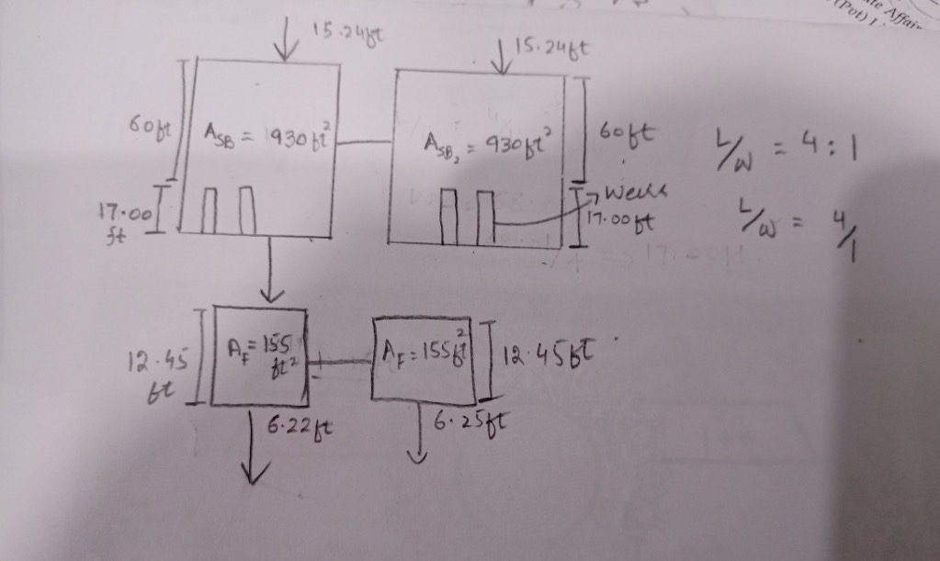

**Calculat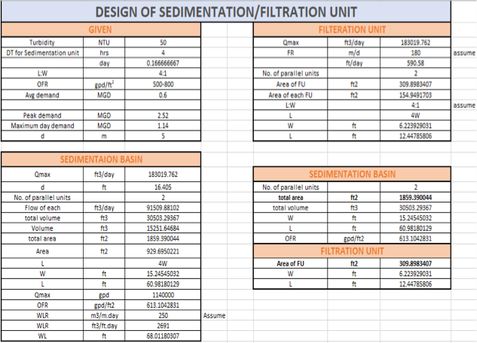ions :-**