FUZZY LOGIC CONTROLLER OF A GREENHOUSE

Abstract: These seedlings should provide a controlled environment for the production of plants in adequate sunlight, temperature and humidity. Better growing conditions are found in nursery stores especially by maintaining a higher indoor surface compared to the outdoor temperature. Greenhouse heating requirements therefore depend on the amount of heat loss in the building. The proposed scheme calculates consecutive online temperature data from the greenhouse and the thermal energy is regenerated according to the low-temperature energy balance using intelligent controls. The simulation results of greenhouse dynamics show the effectiveness of the proposed system without a direct model of plant statistics.

Keywords: Greenhouse, unintelligible logic control, temperature loss, temperature control, temperature, PSO.

1. INTRODUCTION

Greenhouse farming aims to protect the fields from adverse weather conditions and in recent years has become a factor in achieving controlled agricultural production. Climate control in nursery has been widely acquired over the years. The main reasons for this growing interest are related to the following agronomic and financial objectives: (a) to extend the period of growth and potential yield; (b) climate management to achieve the highest standards of quality; (c) developing low productivity programs, coupled with a lack of resources and low investment potential for farmers. The main purpose of the climate control problem is to maintain the temperature within the temperature range within the appropriate range. The difficulty lies in the complexity of the conditions that create the ideal environment, caused by the day / night cycle, the growing season, the local climate, and the nature of the culture. (Bakker J C et al., 1995).

2. HEAT

Multi-seedling storage areas should be heated with vegetable production all year round. A good temperature system is one of the most important steps in the successful production of plants. Any heating system that provides the same temperature control without removing harmful substances from plants is acceptable. Suitable energy sources include natural gas, LP gas, petroleum, wood and electricity. The cost and availability of these resources will vary somewhat from one place to another. Simple, investment and operating costs are considered alternatives. Savings in operations can allow a more expensive heating system with automatic controls. Greenhouse heat requirements depend on the amount of heat loss in the building. Heat loss from home heaters usually occurs in all three ways of heat transfer: conduction, mechanical alignment and radiation. Often many types of heat exchangers occur simultaneously.

2.1 Driving

Heat is carried out by an object or between objects by direct physical contact. The operating rate between the two items depends on the location, the length of the path, the temperature difference and the physical properties of the object (as a quantity). Condensed heat transfer is easily reduced by replacing the heat exchanger with an insulator or by placing an insulator in the heat flow path.

2.2 Conference

Convection heat transfer is the body's movement of warm gas or liquid in a cold environment. Heat loss by convection inside the greenhouse occurs with air inflow and inflow (fans and air leaks).

2.3 Radiation

Radiation heat transfer occurs between two bodies without direct contact or the need for an air-like environment. Like light, heat rays follow a straight line and are reflected, transmitted or pulled when they hit an object. Glowing energy must be applied to the heat. The degree of heat transfer of radiation varies with the location of the object, and the temperature and surface of the two bodies involved.

2405-8963 © 2016, IFAC (International Federation of Automatic Control) Hosted by Elsevier Ltd. All rights reserved. Peer review under the auspices of the International Federation of Automatic Control.

10.1016 / j.ifacol.2016.03.112

2.4 Factors Affecting Heat Loss

Temperature by air intake depends on age, condition and type of temperature. Old or nursery storage sheds often have cracks around the doors or holes to cover the entrance that can get a lot of cold air into them. Seedling houses covered with large sheets of molded material, large sheets of fiber glass or single or double layer of solid or flexible plastic have a small penetration (Figure 1). The sun's rays penetrate a house that absorbs heat and is absorbed by plants, soil, and heat. Warm things then re-release this energy out. The amount of heat loss dependent depends on the type of glazing, the ambient temperature and the number of cloud cover. (Seginer, et al.; 1992)

Figure 1. Loss of energy and gains in greenhouse

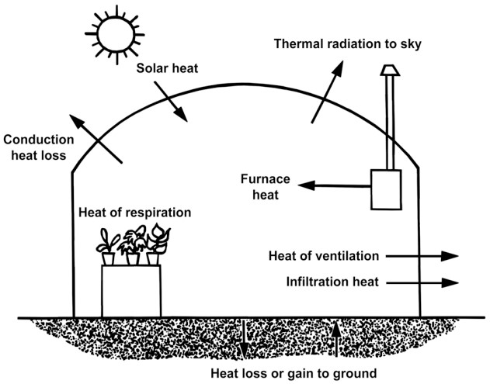

3. TALPERATURES ACTIVITY CALCULATION CALCULATION

Good external heat you can use in the calculation of the heater design

(Selecting heater size) can be obtained by subtracting 15 degrees F from the minimum daily temperature. Another requirement a heater must meet is to provide sufficient heat to prevent the plants from freezing during very low temperatures. (as stated at www.cps.gov.on.ca/english/plans/E6000/6701/M-6701L.pdf) For example consider table 1.

Table

|  |  |  |
| --- | --- | --- |
| **Location** | **Minimum Temperature**  **°F and (Year Occurring)** | **Average Daily Minimum January Temperatures**  **(°F)** |
| Atlanta | -8 (1985) | 33.6 |
| Athens | -4 (1985) | 33.2 |
| Augusta | -1 (1985) | 33.6 |
| Columbus | -2 (1985) | 36.4 |
| Macon | -6 (1985) | 35.8 |
| Rome | -9 (1985) | 30.5 |
| Savannah | 3 (1985) | 39.0 |
| Tifton | 0 (1985) | 38.0 |
| Valdosta | 9 (1981) | 38.6 |

In the Augusta area with an average January average temperature of 33.6 degrees F, the design temperature can be approximately 18.6 degrees F, so use 20 degrees F. This requires a 45-degree F rise above the temperature design; and, with glass, the value of R will be 0.91.

Temperature Loss Process, QC = Location x ΔT / R (1)

Ventilation Loss, QA = 0.02 x Volume x C x ΔT (2)

Perimeter Loss Heat, QP = P x L x (ΔT) (3) Total Heat Loss, QT = QC + QA + QP (4)

Where

Q = Heat loss, BTU / hr

A = Higher temperature, sq. Ft

R = Resistance to heat flow (information element) V = Greenhouse volume, cu. Ft

C = Air exchange rate per hour

P = Perimeter for equal heat loss, BTU / ft ° F hr L = Round perimeter The values ​​listed below in table 2.

Table 2: Estimates used for the estimated temperature

R (glass) 0.91

V 30,928 cu ft

C of new construction, glass or fiberglass 0.75 to 1

C classic

Construction glass, good storage 1 to 2

C classic

Construction glass, bad condition 2 to 4

The cycle of

P 0.8 BTU / ft ° F not allowed

The cycle of

combined P 0.4 BTU / ft ° F hr

4. HEAT CONTROL

Temperature is a major climate affecting plant growth, therefore, this variation has been traditionally controlled in nursery. Based on the power balance of the basic air temperature, the relationship can be provided by eq. 5. (Arvanitis, 1999).

𝑑𝑑𝑇𝑇𝐺𝐺 [𝑇𝑇𝑜𝑜𝑜𝑜𝑑𝑑 - 𝑇𝑇𝐺𝐺]) (5)

𝑄𝑄𝐻𝐻 = 𝐶𝐶𝑞𝑞 (𝑑𝑑𝑑𝑑) - (𝐾𝐾𝑜𝑜𝑜𝑜𝑑𝑑, 𝑎𝑎𝑎𝑎𝑎𝑎

When 𝑇𝑇𝐺𝐺 heat heat, 𝐶𝐶𝑞𝑞 hot heat energy, green, 𝑎𝑎𝑎𝑎𝑎𝑎 heat loss energy from hot air to outdoor air, the external heat and heat energy.

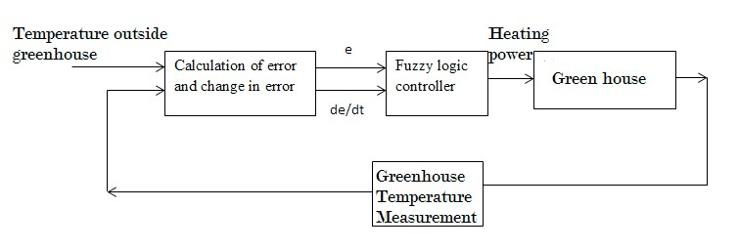

The temperature control scheme inside the greenhouse is shown in (Fig. 2).

Figure 2. Temperature and temperature system

External temperature and current internal temperature are the inputs from the sensor. Error and error change are calculated which are included in the logical control of the concept. The output is the thermal energy required to maintain a comfortable thermal conductivity.

5. FUZZY CONTROL

Fig. 3. Block diagram of a fuzzy controller

The block diagram of a fuzzy controller is shown in fig 3. It is

composed of four principal modules: The fuzzification

interface performs the transformation of crisp inputs into fuzzy

sets. The knowledge base supplies the fuzzification module,

the interface engine, and the defuzzification interface with

necessary information for their proper functioning. The

decision making unit or interface engine computes the

meaning of the set linguistic rules. The defuzzification

interface

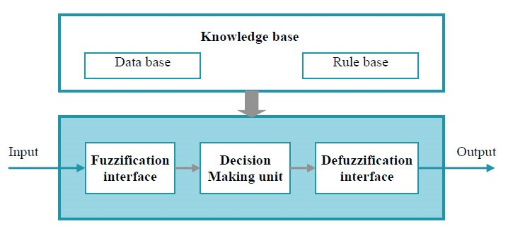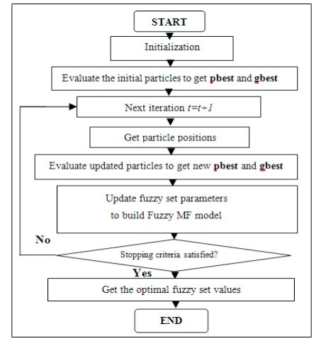

Over the past decade, the mysterious concept has gained interest in the scientific community and information-based programs are one of the most effective programs for mysterious sets and obscure logical methods. This is due to the flexibility and simplicity where knowledge can be expressed through ambiguous rules and academic developments in the field.

The advantage of unambiguous control is that it is possible to use the knowledge of human experts in a linguistic way if, then, the rules. Invisible control design begins with a selection of language variations, process status, inputs and output variables. The next step is to choose a set of grammatical rules and the type of abstract thought process. Once the rules are set, after consideration, an unspecified set and a good output value should be generated; a demolition strategy should be re-established. (Horiuchi J,

2002)

the contributions of each law on the basis of the law) of the output output.

(Chuen-Lee, C., 1990)

5.1 It is designed to be ambiguous to use the PSO

In order to increase the automaticity of the fraudulent control system, a “very close” control strategy was developed using the PSO process. A method that finds the right solution using the particle mass is the PSO algorithm. Each PSO pile is a solution in the solution space. The algorithm can be described as follows. (Eberhart, R. 1995) (Lafont 2002).

• Each particle has the following characteristics: Current position in the Xid search area, current velocity pid and better human position in the Pid search area.

• The most appropriate personal pidcor corresponds to the situation in the search field where the particle i presents the smallest error as determined by the intended function - taking into account the reduction function.

• The best global position marked by the position that shows the lowest error among all pgd.

During the iteration all the particles in the graves are regenerated using the following two calculations:

IVid (t + 1) = w. Vid (t) + c1. I-r1 (Pid - Xid (t)) c2. r2 (Pgd - Xid (t))

Xid (t + 1) = Xid (t) + Vid (t + 1) (6)

Where Vid (t + 1) and Vid (t) are the regenerated and current velocities, respectively, Xid (t + 1) and Xid (t) are the particles of the updated and current particles, respectively, and1 and 𝑐𝑐2 are two positive conditions and r1 and r2 are normal numbers of random units within range [0, l] and iw the weight of inertia.

How to use PSO to fix MF in FLC is shown in (Figure 4).

Figure 4. FLC Growth Flow Flow using PSO

|  |  |
| --- | --- |
| **PSO parameters** | **values** |
| Population Size | 25 |
| Personal Learning Coefficient | 1 |
| Global Learning Coefficient | 2 |
| Inertia Weight | 1 |
| Maximum Number of Iterations | 1000 |

In this process, each particle is designed to represent the MF parameters of the inputs and outputs of the FLC. The cost function used here is a square error that means roots. The parameters of the PSO are listed below in table 3.

Table 3. PSO parameters

Figure 7. Membership function of ce

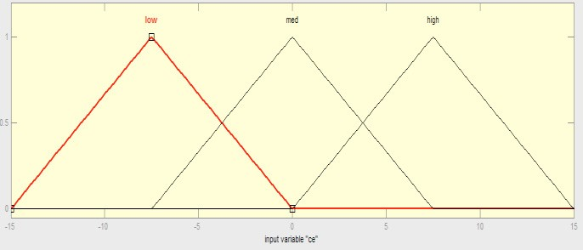

The labels used in the ‘out’ language range are ‘range1’, ‘range2’, ‘range3’, ‘range4’, ‘range5’, ‘range6’. Triangular and trapezoidal membership functions are used.

Optimized heating Power pattern applied to greenhouse

0

5

10

15

20

25

30

150

200

250

300

350

400

450

Heating pattern in KW

6. MEASUREMENT

Figure 5. Georgia Geothermal Graph (January 2015)

(www.accuweather.com/en/us/ga/georgia.weather) Low temperature pattern recorded in Georgia

January 2015 is shown in (Figure 9). Compared to against

6.1 Linguistic diversity, prices and functions of heat transfer membership. Error and error modification is a complex basis

### REFERENCES

Arvanitis, K.G.(1996). Adaptive LQ regulation by multirate- output controllers, Found. *Comput. Decis*., Sci. 21, 183-213.

Bakker J C; Bot G P A; Challa H; De Braak N J V (1995). Greenhouse Climate Control: An Integrated Approach. Wageningen, The Netherlands.

Chuen-Lee, C. (1990b). Fuzzy Logic in Control systems*:* Fuzzy logic controller, Part II. *IEEE Transactions on Systems Man and Cybernetics*, 20, 419–435.

Eberhart, R. and Kennedy, I (1995).A new optimizer using particle swarm theory. Symposium on Micro Machine and Human Science, 39-43.

Horiuchi J (2002). Fuzzy modelling and control of biological processes. *Journal of Bioscience and Bioengineering*, 94(6), 574–578.

Lafont. F and Balmat .J. -F. (2002). Optimized fuzzy control of a greenhouse.*Fuzzy Sets and Systems*, 28, 47-59.

Seginer, I., McClendon, R.W., (1992). *Methods for optimal control of the greenhouse environment*, Trans. ASAE 35, 1299-1307.