MOLECULE

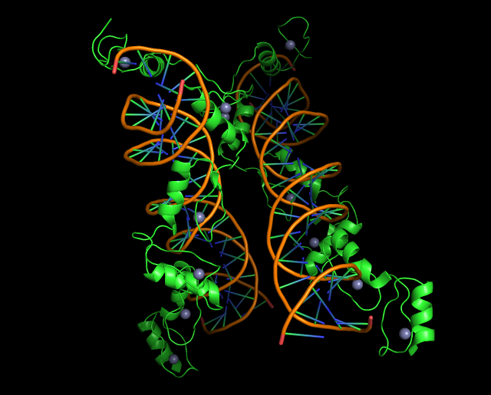

Fit model/data

[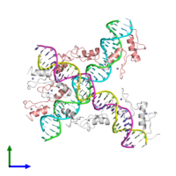](https://www.ebi.ac.uk/pdbe/entry/pdb/1tf6/portfolio/?view=entry_index#ad-image-0)

[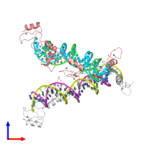](https://www.ebi.ac.uk/pdbe/entry/pdb/1tf6/portfolio/?view=entry_index#ad-image-1)

[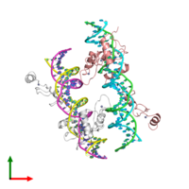](https://www.ebi.ac.uk/pdbe/entry/pdb/1tf6/portfolio/?view=entry_index#ad-image-2)

**Source organism:** [*Xenopus laevis*](https://www.ebi.ac.uk/pdbe/entry/search/index?organism_scientific_name:%22Xenopus+laevis%22)

Function and Biology[Details](https://www.ebi.ac.uk/pdbe/entry/pdb/1tf6/biology)

**Biochemical function:**

* not assigned

**Biological process:**

* not assigned

**Cellular component:**

* not assigned

**Sequence domains:**

* Zinc finger C2H2-type
* Zinc finger C2H2 superfamily

**Structure domain:**

* Classic zinc finger, C2H2

Structure analysis

**Assembly composition:**

hetero trimer

**Gene name:** [gtf3a](https://www.ebi.ac.uk/pdbe/entry/search/index?gene_name:gtf3a)  
**Sequence domains:** [Zinc finger, C2H2 type](https://www.ebi.ac.uk/pdbe/entry/search/index?searchParams=%7B%22q_pfam_description%22%3A%5B%7B%22value%22%3A%22Zinc%20finger%2C%20C2H2%20type%22%2C%22condition1%22%3A%22AND%22%2C%22condition2%22%3A%22Equal%20to%22%7D%5D%2C%22q_all_sequence_family%22%3A%5B%7B%22value%22%3A%22Zinc%20finger%2C%20C2H2%20type%22%2C%22condition1%22%3A%22OR%22%2C%22condition2%22%3A%22Contains%22%7D%5D%7D)   
**Structure domains:** [Classic Zinc Finger](https://www.ebi.ac.uk/pdbe/entry/search/index?searchParams=%7B%22q_all_structure_family%22%3A%5B%7B%22value%22%3A%22Classic%20Zinc%20Finger%22%7D%5D%7D)

 DNA (5'-D(*AP*CP*GP*GP*GP*CP*CP*TP*GP*GP*TP*TP*AP*GP*TP*AP*C P*CP*TP*GP*GP*AP* TP*GP*GP*GP*AP*GP*AP*CP*C)-3')

[Molecule details ›](https://www.ebi.ac.uk/pdbe/entry/pdb/1tf6/DNA/1)

**Chains:** B, E  
**Length:** 31 nucleotides  
**Theoretical weight:** 9.63 KDa  
**Source organism:** [*Xenopus laevis*](https://www.ebi.ac.uk/pdbe/entry/search/index?organism_scientific_name:%22Xenopus+laevis%22)  
**Expression system:** Not provided

 DNA (5'-D(*TP*GP*GP*TP*CP*TP*CP*CP*CP*AP*TP*CP*CP*AP*GP*GP*T P*AP*CP*TP*AP*AP* CP*CP*AP*GP*GP*CP*CP*CP*G)-3') Chains: C, F

Ligands and Environments

**1 bound ligand:**

12 x ZN

**No modified residues**

**DOI:** 10.2210/pdb1tf6/pdb

Model geometry

Fit model/data

[](https://www.ebi.ac.uk/pdbe/entry/pdb/1tf6/portfolio/?view=entry_index#ad-image-0)

[](https://www.ebi.ac.uk/pdbe/entry/pdb/1tf6/portfolio/?view=entry_index#ad-image-1)

[](https://www.ebi.ac.uk/pdbe/entry/pdb/1tf6/portfolio/?view=entry_index#ad-image-2)

Function and Biology[Details](https://www.ebi.ac.uk/pdbe/entry/pdb/1tf6/biology)

**Biochemical function:**

* not assigned

**Biological process:**

* not assigned

**Cellular component:**

* not assigned

**Sequence domains:**

* [Zinc finger C2H2-type](https://www.ebi.ac.uk/pdbe/entry/search/index?interpro_name:%22Zinc%20finger%20C2H2-type%22)
* [Zinc finger C2H2 superfamily](https://www.ebi.ac.uk/pdbe/entry/search/index?interpro_name:%22Zinc%20finger%20C2H2%20superfamily%22)

**Structure domain:**

* [Classic zinc finger, C2H2](https://www.ebi.ac.uk/pdbe/entry/search/index?scop_family:%22Classic%20zinc%20finger%2C%20C2H2%22)

Structure analysis

**Assembly composition:**

hetero trimer

**Entry contents:**

1 distinct polypeptide molecule  
2 distinct DNA molecules

**Macromolecules (3 distinct):**

 Transcription factor IIIA

Molecule details ›

**Chains:** A, D  
**Length:** 190 amino acids  
**Theoretical weight:** 22.13 KDa  
**Source organism:** *Xenopus laevis*  
**Expression system:** *Escherichia coli BL21(DE3)*  
**UniProt:**

**Gene name:** gtf3a  
**Sequence domains:** Zinc finger, C2H2 type   
**Structure domains:** Classic Zinc Finger

 DNA (5'-D(*AP*CP*GP*GP*GP*CP*CP*TP*GP*GP*TP*TP*AP*GP*TP*AP*C P*CP*TP*GP*GP*AP* TP*GP*GP*GP*AP*GP*AP*CP*C)-3')

Molecule details ›

**Chains:** B, E  
**Length:** 31 nucleotides  
**Theoretical weight:** 9.63 KDa  
**Source organism:** *Xenopus laevis*  
**Expression system:** Not provided

 DNA (5'-D(*TP*GP*GP*TP*CP*TP*CP*CP*CP*AP*TP*CP*CP*AP*GP*GP*T P*AP*CP*TP*AP*AP* CP*CP*AP*GP*GP*CP*CP*CP*G)-3') Chains: C, F

Ligands and Environments

**1 bound ligand:**

[12 x ZN](https://www.ebi.ac.uk/pdbe/entry/pdb/1tf6/bound/ZN)

**No modified residues**

Experiments and Validation

**X-ray source:** NSLS BEAMLINE X12B

**Spacegroup:***P*1

**Unit cell:**

a: 64.18Åb: 64.712Åc: 78.035Å

α: 90.07°β: 92.98°γ: 102.95°

**R-values:**

RRworkRfree

0.3080.3080.363

**Expression systems:**

* *Escherichia coli BL21(DE3)*
* Not provided