**Download and install PyMOL** onto your computer. Make sure you save the license from this page:

<https://protect-au.mimecast.com/s/0bDZCWLVXkUn8kmyc6YySw?domain=pymol.org>

USERNAME: jun2021

PASSWORD: betabarrel

Install PyMOL 2.0 and provide license file if required (you can also add by opening PyMOL and navigating to “Help” in the top menu bar and then choose “Install new license file” if necessary).

**Download your molecule from the PDB**:

* Go to <https://www.rcsb.org/> and type the PDB code (eg, 1AOI) in the search bar on the top right of the screen. Select “Go”

* This will lead you to a “Structure Summary” page for the PDB code. If you scroll down you will see that there are links to the paper describing the structure, and there’s also information on which chain corresponds to which molecule. Eg. Chains A and E correspond to Histone H3:

* On the top right corner, click on the arrowhead next to the “Download Files” button and select “PDB format”:

* Open PyMOL and load your molecule by selecting “File” 🡪 “Open” and then selecting your downloaded PDB file.

**Other option- loading PDB straight into PyMOL:**

* Alternatively, once you have PyMOL installed, you can load a molecule by navigating to “File” in the top menu bar, and then “Get PDB…” and type in your 4 letter PDB code. If you downloaded 1AOI, it would look like this:

**Making your molecule look nice in PyMOL:**

* Click on the “S” button at the bottom right corner (circled in red in the image above). The sequence of your PDB file should now show up in a panel above the molecule:

Move the slider (circled in yellow in the image above) right and you will see the sequences for all of the histone chains and DNA for the nucleosome. Red 0’s corresponds to water molecules.

* To highlight a particular feature/domain/molecule, click and drag on the residues you want to highlight using the sequence bar. The corresponding residues will be highlighted on the structure and a new item will appear on the right panel called “(sele)” which corresponds to the ***selected*** residues (circled in red below). Here I’ve selected all of the residues of Histone H3 Chain A (residues 38-135)

* To change the colour of this selected region, click on the “C” button next to the item “(sele)” and then choose a colour. I chose hot pink

Click on the “(sele)” button on the right panel to **deselect** it. The residues will no longer highlighted in the molecule panel, and you can now see that Chain A, corresponding to histone H3 is hot pink:

* To make a *new selection*, ie. Chain E which corresponds to the second Histone H3 chain, make sure that chain A is not selected as shown above (circled in green) and then select the Chain E sequence with your mouse using the sequence panel:

* Again, select “C” and then a different colour to change the colour of Chain E. I chose yellow. I then deselected chain E by clicking on “(sele)” again:

* To change the DNA into a different representation, make sure Chain E is not selected as shown above (circled in green). Then use your mouse to select the DNA, which corresponds to Chain I and J.

* To change the DNA (currently in cartoon representation) into ribbon representation, click on the “S” button next to the “(sele)” item, hover your mouse over the word “as”, and then a new drop down menu should appear:

* Click on “ribbon”, and then deselect by clicking “(sele)”.

**To delete chains** (eg. if there are 2 copies of your complex in your PDB file), make sure nothing is selected as shown above (circled in green) and then select the chains you’d like to remove on the sequence bar. I’ve selected chains C,D,G, and H, which corresponds to the 2 H2A and H2B chains:

To delete the selected chains, click on the “A” button next to “(sele)” and then choose remove atoms:

**To highlight a particular interaction**: Let’s say that the interaction between T30 of Histone H4 (Chain F) with water is very important and something that we’d want to highlight. You can center on the residue by right clicking on T30 (Chain F) on the sequence panel and then choosing “center”. Zoom in (right click on the background and move your mouse back and forth) and move the molecule around (left click on the background and move your mouse around) so that you have a good view of T30 and the water molecule.

Now select T30 of Chain F using the sequence bar. Click on the “S” button next to “(sele)” and then hover your mouse down to “side chain” and then select “sticks”.

Deselect T30 Chain F by clicking on “(sele)”. To introduce dotted lines between T30 (Chain F) and the nearby water molecule, on the top PyMOL menu bar, select “Wizard” and choose “Measurement”. New measurement options should show up on the right-hand side panel:

Click on the T30 oxygen atom first, and then click on the water (red *). A dotted line will appear between the two atoms as well as the distance between them. Click “Done” on the Right measurement option (in the red circle above). When you export as a COLLADA, the distance value will not show up in Sketchfab.

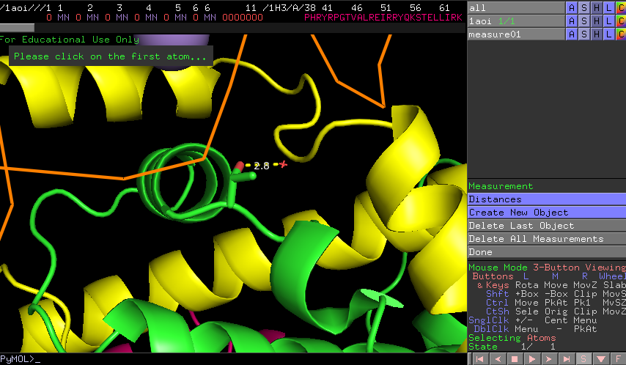

**To export for Sketchfab**: Once you are happy with your molecule and it’s ready for Sketchfab, you will have to export as a COLLADA. On the top PyMOL menu, Click on “File” 🡪 “Export image as” 🡪 “COLLADA” and save. Sketchfab will read the dae file saved.

**Other things:**

To change background colour: On the top PyMOL menu, Click “Display” 🡪 “Background” 🡪 “White”

For fancy helices: On the top PyMOL menu, Click “Setting” 🡪 “Cartoon” 🡪 “Fancy helices”

To change transparency of surface representation, Click “Setting” 🡪 “Transparency” 🡪 “Surface” 🡪 percentage