1.ADDRESS ASSIGNMENT

In Table 2, it is only necessary to indicate the first and last address of the PCs in each subnet using the lowest block of addresses.

|  |  |  |  |  |
| --- | --- | --- | --- | --- |
| Subnet | Network address | Mask in dotted decimal form (e.g. 255.255.0.0) | Number of hosts, including PCs and router interfaces | Number of unused addresses |
| A | 10.10.10.10/8 | 255.0.0.0 | 9 to 30 | 31, 32 |
| B | 172.168.1.1/16 | 255.255.0.0 | 17 to 30 | 31, 32 |
| C | 192.168.1.1/24 | 255.255.255.0 | 25 to 30 | 31, 32 |
| D | 192.168.1.1/28 | 255.255.255.240 | 0 | 31,32 |
| E | 192.168.1.1/28 | 255.255.255.255.0 | 0 | 31,32 |

Table 1. Subnet details.

|  |  |  |  |  |
| --- | --- | --- | --- | --- |
| Device | Interface | IP address | Mask in dotted decimal form (e.g. 255.255.0.0 for /16) | Default Gateway |
| R1 | Fa0/0 |  |  | N/A |
| Fa0/1 |  |  | N/A |
| S0/0 |  |  | N/A |
| R2 | Fa0/0 |  |  | N/A |
| Fa0/1 |  |  | N/A |
| S0/0 |  |  | N/A |
| 1st PC subnet A | NIC |  |  |  |
| Last PC subnet A | NIC |  |  |  |
| 1st PC subnet B | NIC |  |  |  |
| Last PC subnet B | NIC |  |  |  |
| 1st PC subnet C | NIC |  |  |  |
| Last PC subnet C | NIC |  |  |  |
| 1st PC subnet D | NIC |  |  |  |
| Last PC subnet D | NIC |  |  |  |
| DNS server | NIC |  |  |  |
| Eagle server | NIC |  |  |  |

ADDRESS STRUCTURE TEMPLATE

|  |  |  |  |
| --- | --- | --- | --- |
| 8 | 24 | 255.0.0.0 | /8 |
| A | 9 | 23 | 255.128.0.0 | /9 |
| A | 12 | 20 | 255.240.0.0 | /12 |
| A | 14 | 18 | 255.252.0.0 | /14 |
| B | 16 | 16 | 255.255.0.0 | /16 |
| B | 17 | 15 | 255.255.128.0 | /17 |
| B | 20 | 12 | 255.255.240.0 | /20 |
| B | 22 | 10 | 255.255.252.0 | /22 |
| C | 24 | 8 | 255.255.255.0 | /24 |
| C | 25 | 7 | 255.255.255.128 | /25 |
| C | 28 | 4 | 255.255.255.240 | /28 |
| C | 30 | 2 | 255.255.255.252 | /30 |

A SUBNET TABLE

* + 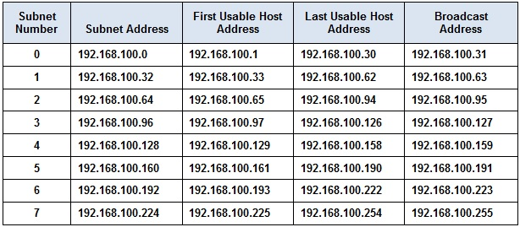

ADDRESSING TABLE

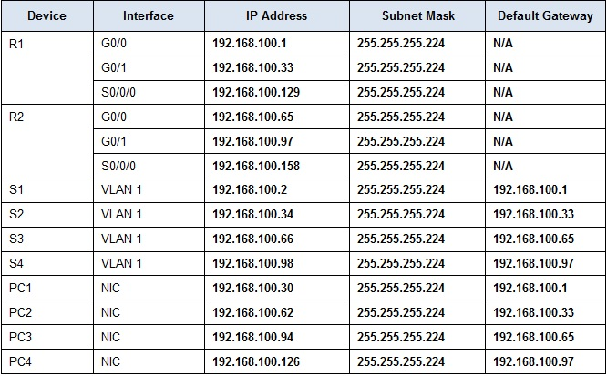

MAPPING

|  |
| --- |
| 1st PC subnet A -S1 |
| Last PC subnet A -S2 |
| 1st PC subnet B -S3 |
| Last PC subnet B -S4 |
| 1st PC subnet C -S4 |
| Last PC subnet C -PC1 |
| 1st PC subnet D -PC2 |
| Last PC subnet D -PC3 |
| DNS server -PC4 |
| Eagle server |

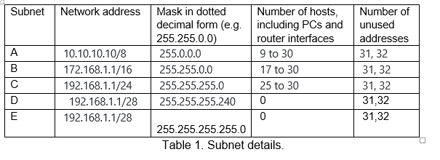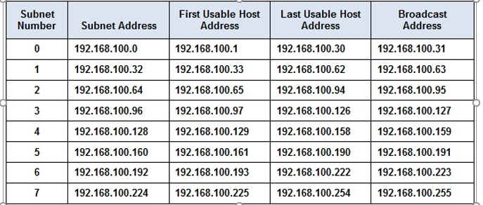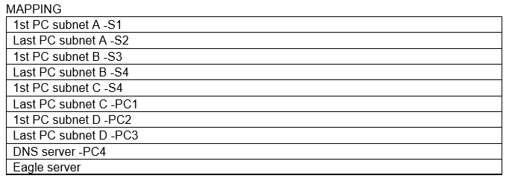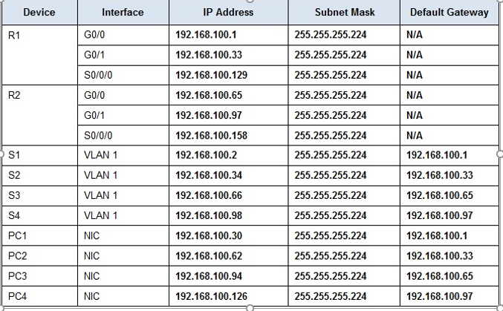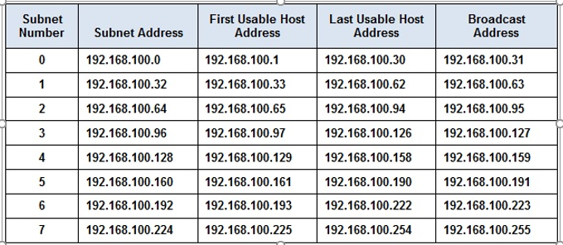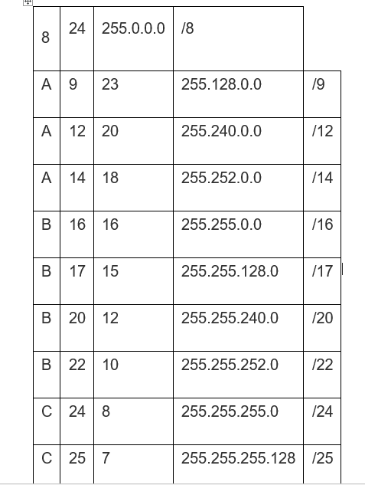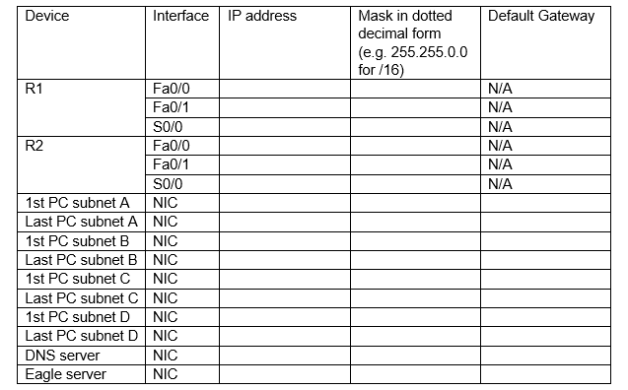

QUESTION 3

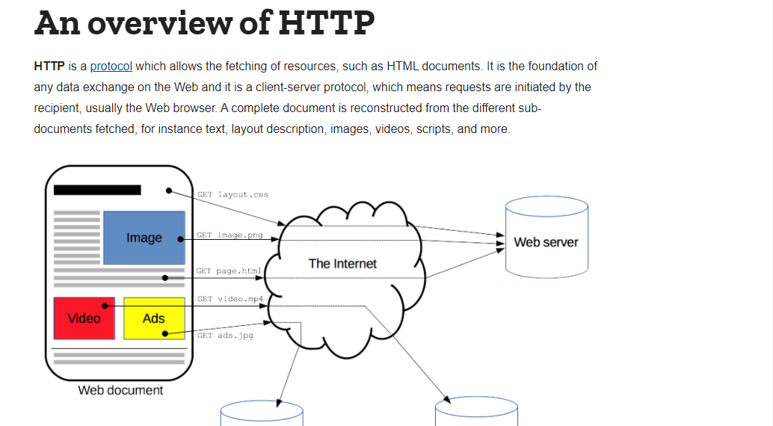

* The transport layer protocol (or protocols) usually used to transport the application protocol

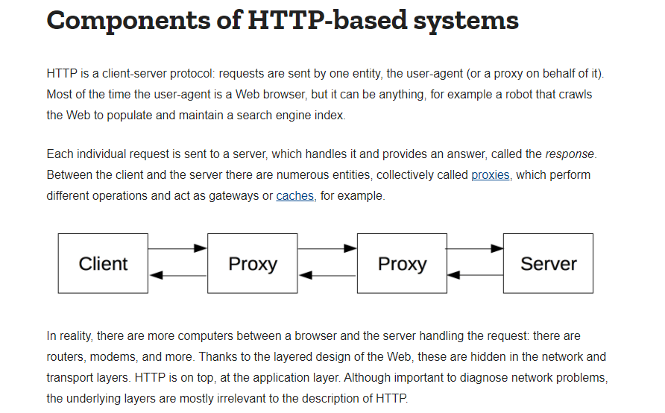

Logical Flow of the Processes in the Application

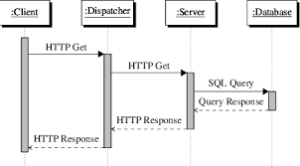

Form Strurcture

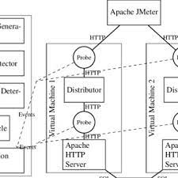

Reliability Analysis



