NETWORK MODEL

QUESTION 1

1.ADDRESS ASSIGNMENT

In Table 2, it is only necessary to indicate the first and last address of the PCs in each subnet using the lowest block of addresses.

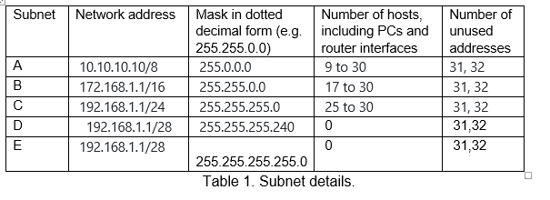

|  |  |  |  |  |
| --- | --- | --- | --- | --- |
| Device | Interface | IP address | Mask in dotted decimal form (e.g. 255.255.0.0 for /16) | Default Gateway |
| R1 | Fa0/0 |  |  | N/A |
| Fa0/1 |  |  | N/A |
| S0/0 |  |  | N/A |
| R2 | Fa0/0 |  |  | N/A |
| Fa0/1 |  |  | N/A |
| S0/0 |  |  | N/A |
| 1st PC subnet A | NIC |  |  |  |
| Last PC subnet A | NIC |  |  |  |
| 1st PC subnet B | NIC |  |  |  |
| Last PC subnet B | NIC |  |  |  |
| 1st PC subnet C | NIC |  |  |  |
| Last PC subnet C | NIC |  |  |  |
| 1st PC subnet D | NIC |  |  |  |
| Last PC subnet D | NIC |  |  |  |
| DNS server | NIC |  |  |  |
| Eagle server | NIC |  |  |  |

ADDRESS STRUCTURE TEMPLATE

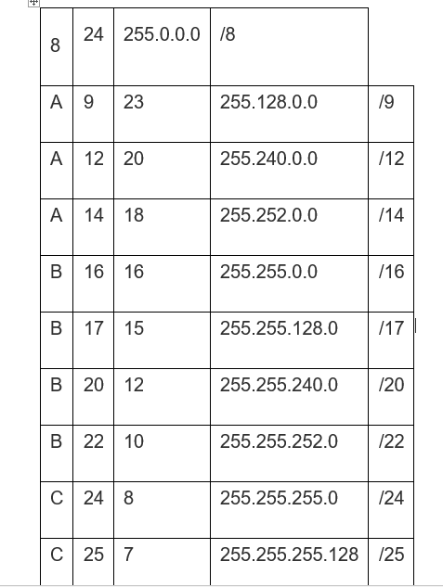

A SUBNET TABLE

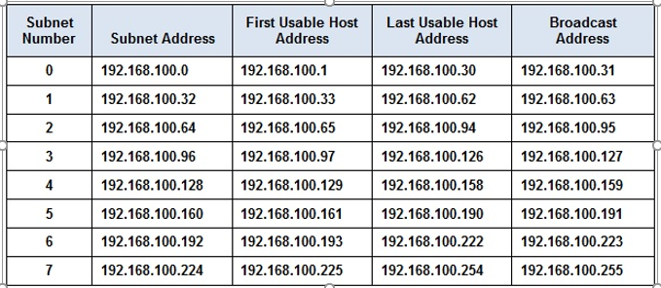

ADDRESSING TABLE

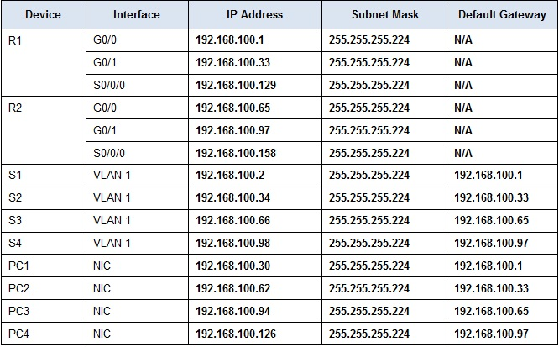

MAPPING

|  |
| --- |
| 1st PC subnet A -S1 |
| Last PC subnet A -S2 |
| 1st PC subnet B -S3 |
| Last PC subnet B -S4 |
| 1st PC subnet C -S4 |
| Last PC subnet C -PC1 |
| 1st PC subnet D -PC2 |
| Last PC subnet D -PC3 |
| DNS server -PC4 |
| Eagle server |

QUESTION 2

(a)Available subnets using the address range and mask that you have been allocated.

**5 Four for the LANs, and one for the link between the routers.**

(b) Efficiency

o used addresses to total number of usable addresses, and o unused addresses to total number of usable addresses

-How many bits must be borrowed to support the number of subnets in the topology table?  
***3***

How many subnets does this create?  
***8***

How many usable hosts does this create per subnet?  
***30***

(c)Address Space Structure

Structure of the Address Space

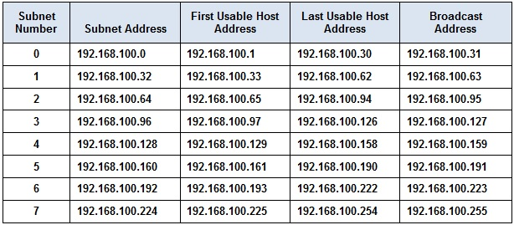

1. Trade-off

There are fewer hosts that can be used per subnet but overly the resources are used amicably without stressing on the available system resources.

1. Address on the trade-off

The address system is right for the system although it should cater more for the wireless devices.

QUESTION 3

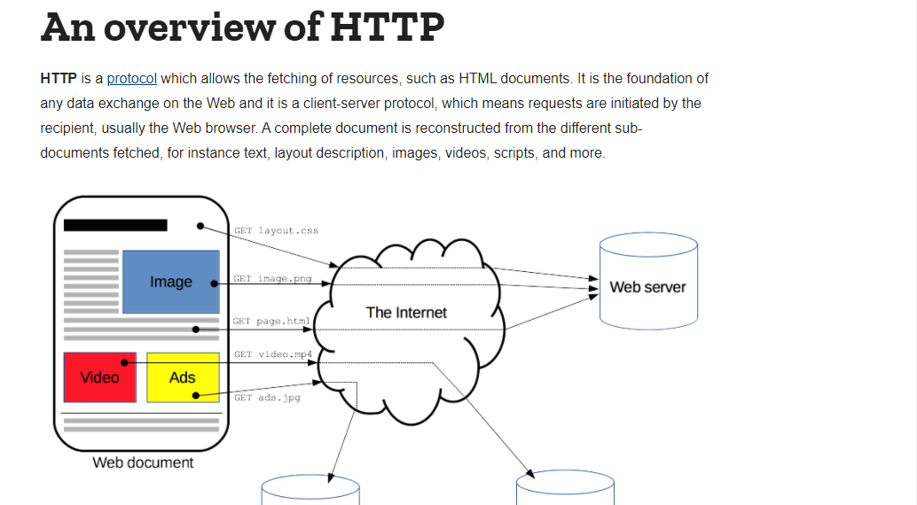

* The transport layer protocol (or protocols) usually used to transport the application protocol

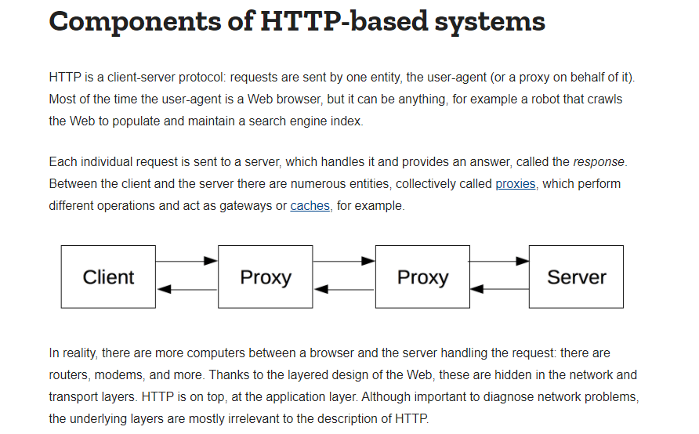

Logical Flow of the Processes in the Application

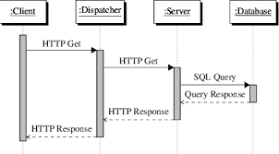

Form Structure

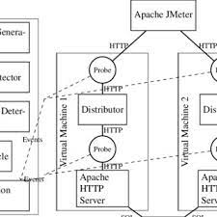

Reliability Analysis



