# Address assignment

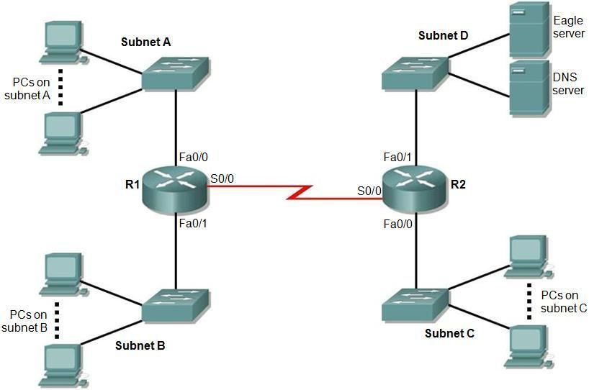

Figure 1. Topology diagram.

Figure 1 shows a network topology with five IP subnets. Notice that **Subnet E** covers the **WAN** between R1 and R2. By referring to your unique parameter web page you will find you have been allocated:

* The number of PCs on subnets A, B and C.
* An address range for you to use.
* A subnet mask length to use for ALL the five subnets.

Your task is to assign IP addresses to the devices in the network. You will fill in Table 1 and Table 2 with appropriate information bearing in mind the values on your unique parameter web page and the following facts:

* In addition to the PCs, each router interface needs a “host” IP address and it is part of the subnet.
* Only the DNS server and Eagle server are on Subnet D.
* Switches are not allocated IP addresses in this network.
* PCs and servers are to be allocated the lowest IP addresses in each subnet.
* Router interfaces are to be allocated the highest IP addresses in each subnet.
* The subnets are to be allocated in the order A, B, C, D and E, (i.e. A is the lowest address and E is the highest).

In Table 2, it is only necessary to indicate the first and last address of the PCs in each subnet using the lowest block of addresses.

|  |  |  |  |  |
| --- | --- | --- | --- | --- |
| Subnet | Network address | Mask in dotted decimal form (e.g. 255.255.0.0) | Number of hosts, including PCs and router interfaces | Number of unused addresses |
| A |  |  |  |  |
| B |  |  |  |  |
| C |  |  |  |  |
| D |  |  |  |  |
| E |  |  |  |  |

Table 1. Subnet details.

|  |  |  |  |  |
| --- | --- | --- | --- | --- |
| Device | Interface | IP address | Mask in dotted decimal form (e.g. 255.255.0.0 for /16) | Default Gateway |
| R1 | Fa0/0 |  |  | N/A |
| Fa0/1 |  |  | N/A |
| S0/0 |  |  | N/A |
| R2 | Fa0/0 |  |  | N/A |
| Fa0/1 |  |  | N/A |
| S0/0 |  |  | N/A |
| 1st PC subnet A | NIC |  |  |  |
| Last PC subnet A | NIC |  |  |  |
| 1st PC subnet B | NIC |  |  |  |
| Last PC subnet B | NIC |  |  |  |
| 1st PC subnet C | NIC |  |  |  |
| Last PC subnet C | NIC |  |  |  |
| 1st PC subnet D | NIC |  |  |  |
| Last PC subnet D | NIC |  |  |  |
| DNS server | NIC |  |  |  |
| Eagle server | NIC |  |  |  |

Table 2. Addressing table.

# Analysis of address space usage

You will submit an explanation encompassing:

* A statement on how many further subnets are available using the address range and mask that you have been allocated.
* A comment on how efficiently the address space you have been allocated has been used. Calculate the two ratios of:

o used addresses to total number of usable addresses, and o unused addresses to total number of usable addresses

* A brief description of how the address space you have been allocated could be utilised more efficiently to leave a maximum number of addresses free for future subnets. You should not state any actual addresses but rather provide a general description of the process used.
* A comment on the trade-off between efficient utilisation of the address space and the prospects of future expansion within a subnet
* A comment on how you would address this trade-off if you had complete freedom in allocating the address range.

# Application layer services

In your unique parameter web page you have been allocated two application layer servi

For each one, provide:

* The full title of the protocol if it is given in abbreviated form (e.g. HTTP is hypertext transfer protocol)
* A brief description of the purpose of the application
* The transport layer protocol (or protocols) usually used to transport the application protocol
* The normal (well known) transport layer port(s) that the protocol uses (some may use more than one)
* A brief description of how the protocol works, for example the key messages sent by the protocol. You are free to include visual illustrations such as (but not limited to) message sequence diagrams.
* A selection of references to either: a book, published article, or standards document that describes the protocol. Each reference should be included (i.e. cited) at a suitable point in your description of the protocol. A web reference (except to a

standards document) is unacceptable. For example, HTTP is defined in RFC 2626 [1], described in a journal paper by Janssen [2] and also described by Tanenbaum [3]. Note how a recognised reference standard, the IEEE, is used below in Section 4 as an example to a standards document, a scholarly article and finally a well-known textbook.

ces. In most cases the name is given as an abbreviation.

# References

1. R. Fielding et al., Hypertext Transfer Protocol -- HTTP/1.1, IETF RFC 2626,

June 1999. Available from: http://www.ietf.org/rfc/rfc2616.txt

1. W. C. Janssen, “A next generation architecture for HTTP,” IEEE Internet Computing, Volume 3, Issue 1, Jan.-Feb. 1999, pp 69-73.
2. A. S. Tanenbaum, *Computer Networks*, Pearson Education, 4th ed., 2007.