REPORT DOCUMENT

**INTRODUCTION**  
Adobe Photoshop is a powerful design tool used to manipulate photographs and create illustrative graphics. Photoshop can be used for tasks as simple as applying color corrections to a photograph or as complex as combining multiple images and special effects into an illustration. If you are a photographer or designer interested in creating high-end designs for print, web, and mobile, Photoshop is a tool you cannot live without. Photoshop CS6 introduces a range of performance improvements and tool updates, including new brush features with stylus support and improved photo editing filters and adjustments, just to name a few. Photoshop CS6 Extended now provides enhanced support for 3D text extrusion and video editing in the new Timeline panel. In this article, I guide you through some of the main features in the Photoshop workspace and introduce you to a basic workflow for creating an illustration. The expressive features in Photoshop can be used for many possible workflows. You'll build a poster illustration by combining photographs, an imported typographic element, and graphics created in Photoshop. You'll also learn how to create an editable master Photoshop file using composite elements as well as how to set up the final design for both print and web.

**1.COPY IN A PRINT AD**

Copy is written material, in contrast to photographs or other elements of layout, in contents such as magazines, advertising, and books. In advertising, web marketing, and similar fields, copy refers **to the output of copywriters**, who are employed to write material which encourages consumers to buy goods or services

**Print ads have value in a digital world.**

Not all advertisements exist on a screen, even today. Print ad campaigns are an effective way to build brand awareness, especially in a world where it’s harder than ever to differentiate your brand. Refresh your brand in the eyes of customers by bringing it into the physical world and ensure that your customers remember you as a trustworthy resource with magazine ads, posters, flyers, and billboards.

**Why print advertisements matter.**

In a world full of digital content, the concise and eye-catching nature of the copy and design in printed ads offer a level of clarity, intrigue, and memorability unmatched by digital advertising. Ad recall is 2.6 times higher when an ad is in print than when it’s viewed digitally. The clarity of the ad to the consumer is increased by nearly the same factor as well. In addition, consumers are nearly three times as likely to label a print ad interesting as opposed to a digital one.

**Before you design your print ads.**

Print ad campaigns are often the work of an ad agency, but they can be handled by your in-house creative team with the right tools and planning. First, decide how your print ads will fit into the larger picture of your marketing strategy, and come up with a plan for reaching your target audience. A creative director, whether on your team or at an outside agency, can help put forward concepts that make sense within your company’s larger visual identity and personality. A clear brand identity for your business and a brand kit will ensure internal teams or hired agencies follow your brand guidelines when designing print ads.

**Components of a print advertisement.**

The basic building blocks of a creative ad include a background image, illustrations or graphics, your business name and logo, any relevant contact information, body copy, a tagline, and a strong call to action. One app that’s a great choice for creating multiple layouts with different content or sizes is Adobe InDesign — part of the Adobe Creative Cloud. It allows you to adapt your designs to be used in various locations.

Examples of Copy in A Print Ad



**2.RADIO AD SCRIPT**

Radio ad script examples are one of the best ways to communicate ideas to a new client for they should use popular radio ad script examples as templates (or references) to make your client’s ad stand out. Knowing what works for other companies in your industry can help develop a killer radio ad script.

Often, the difference between a good and a bad radio ad script lies in your ability to take a chance. This doesn’t mean you should take a shot in the dark and hope for the best.

In most of the cases we produce 15, 30 and 60 sec radio spots. Some countries also operate on 10, 20 and 45 seconds so if in doubt do check with the station you are looking to advertise on. By miles most popular is a 30 sec ad. In a 30 second radio spot you have plenty of time to get your message across. This is the standard length for most spots on the radio. In this script we’ll mix music, give the location, what’s happening, when and a contact at the end.

**Production Options For a Sample Radio Ad**

*Music:* A relevant music track is essential! This is what gives the spot the feeling and emotion. Sad, happy, urgent, dreamy, relaxed, stressed – think what feeling you would like to leave the listener with and you have the answer on what music track to choose for production. If you get that part wrong you can effectively ruin the advertising campaign and have much less of a positive impact on a campaign success.

*Voice Over:* Male or female? Young or mature? Best to think of your target audience and try to make it appealing for them. Advertising to a young crowd? Get a young voice over. If your message needs authority usually mature male can be the best choice.

**3.ONE POST AD**

Create a new file at print resolution Design projects created in Photoshop use an editable master file called a PSD file. The PSD file separates elements with layers, saves color selections as masks, and preserves the ability to edit many of the effects applied to images and text. You can always return to the PSD file to make changes as needed. Photoshop is primarily used to render bitmap graphics. Unlike vector images created in Adobe Illustrator or Adobe Flash Professional, bitmap images are composed of a grid of colors. The colors appear as dots side by side in rows and columns. The number of dots per inch (dpi) defines the resolution of the image. The higher the resolution, the more detail and clarity the image contains. Tip: Photoshop CS6 introduces a new set of real vector drawing tools, enabling you to work with both photographs and vector shapes in an easy way. Photoshop projects are usually created in high resolution at 300dpi for print design or in low resolution at 72dpi for web and mobile design. High-resolution projects produce a larger file size but enable you to publish for both print and web. Tip: If you're working in 3D.

Example of Single Poster Designs

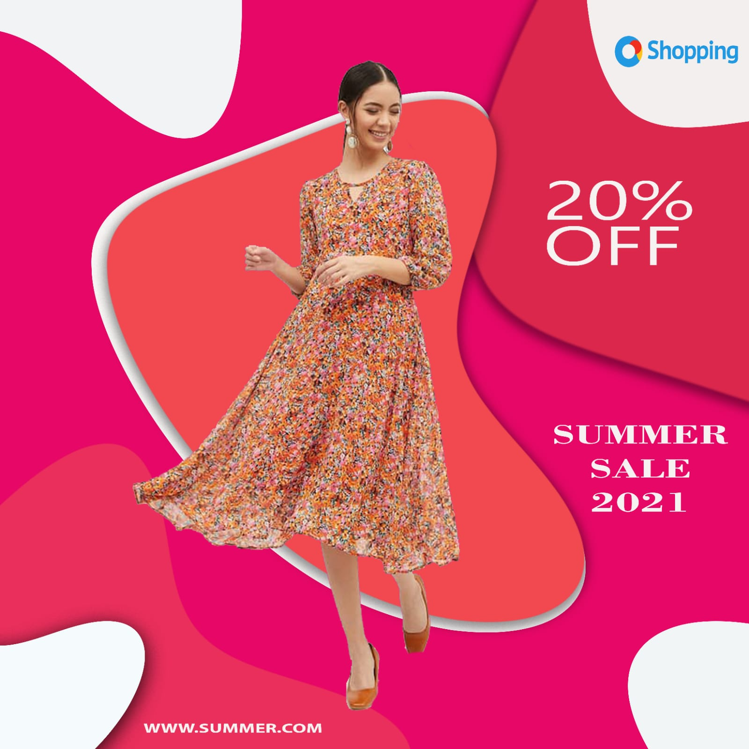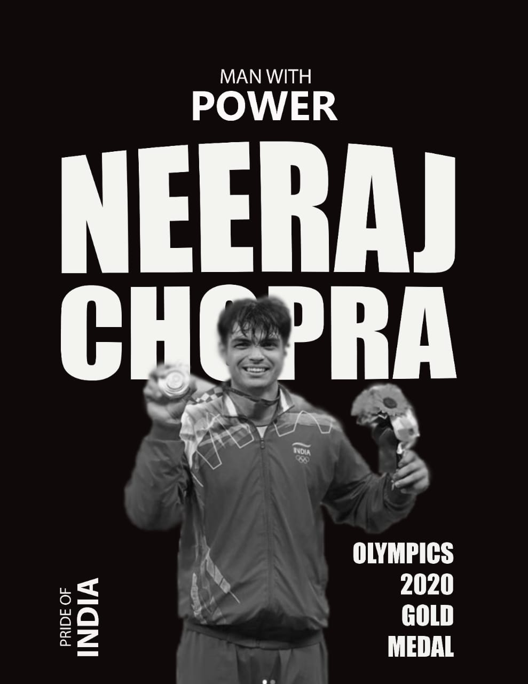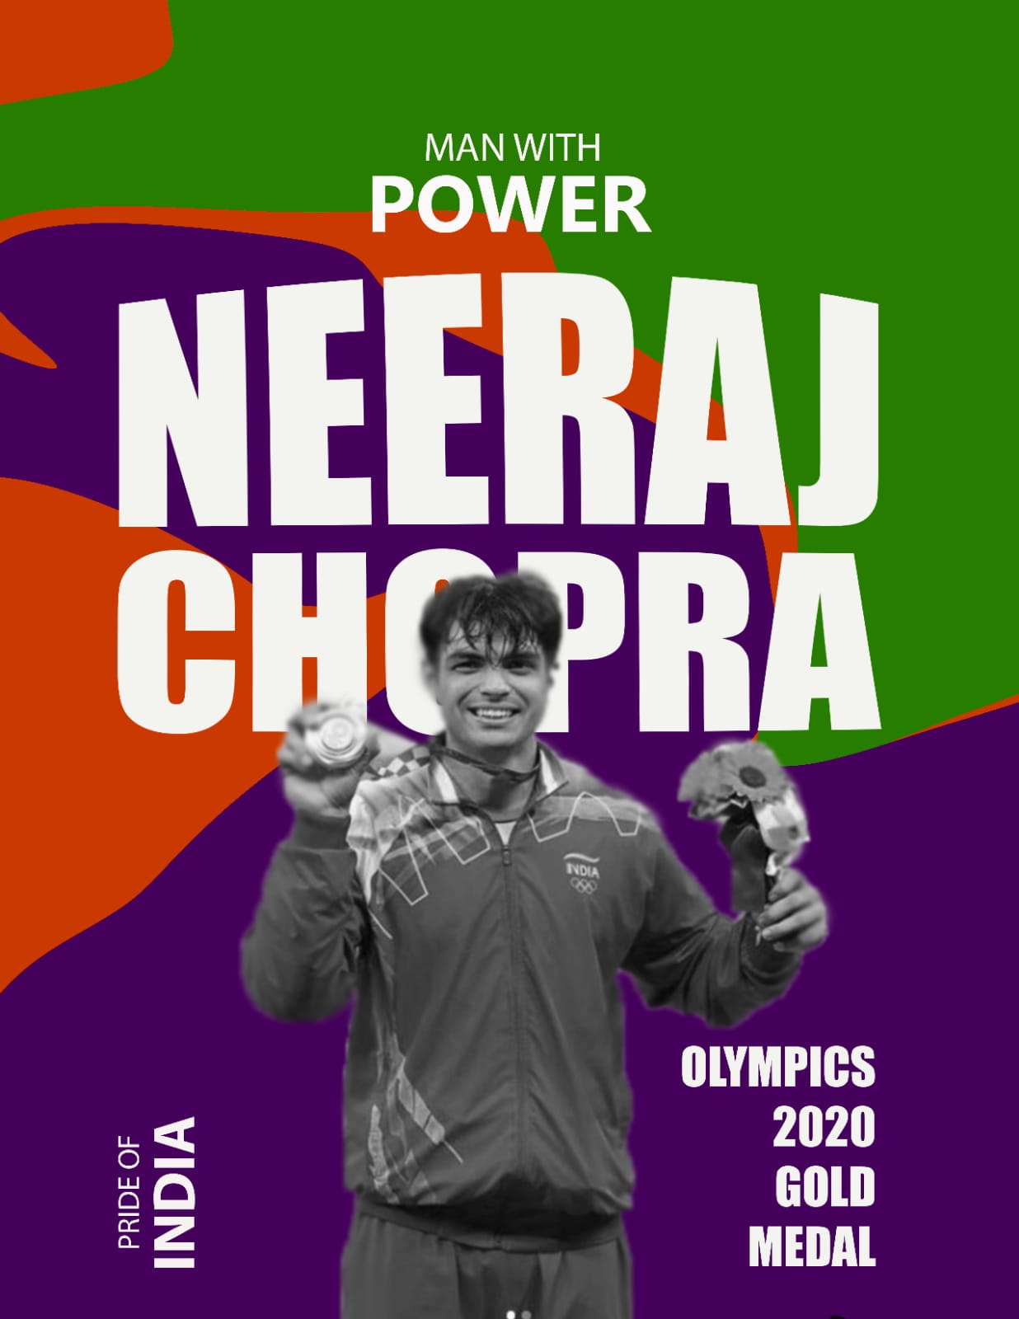

REFERENCES

1.Adobe Photoshop Wikipedia (https://en.wikipedia.org/wiki/Adobe_Photoshop)(1)

2.Photoshop interface https://www.photoshopessentials.com(2)

3.Text Tooland Menu Bar https://www.bapugraphics.com/learnphotoshopfilemenututorials.php(3)

4.Layershttps://wsnet2.colostate.edu/cwis6/ttcpdf/how_to/PSD/PSDLayers.pdf (4)

5.Blend Modehttps://helpx.adobe.com/in/photoshop/using/color-modes.html (5)

6.Level, Curves (https://helpx.adobe.com/in/photoshop/using/levels-adjustment.html)

7.Gaussian Blur and Field Blur (digital-photography-school.com)

8.Motion Blur (https://www.shutterstock.com/support/article/what-is-motion-blur)

9.Radial Blur (gamingstackchange.com)

10.Clipping Maskhttps://helpx.adobe.com/in/photoshop-elements/using/clipping-masks.html