REPORT

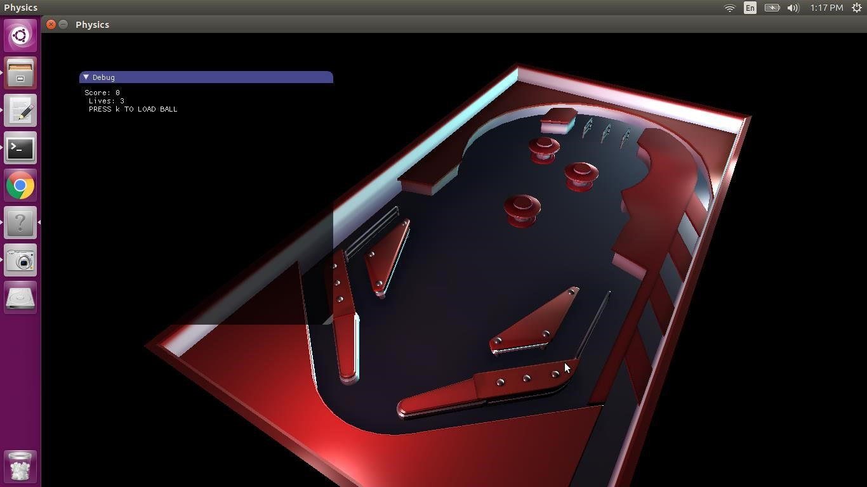

# Overview

Features include custom models and a GUI. This is a simple pinball game with two paddles, a plunger, and a whole bunch of bumpers. Separate models were made for static collision meshes so that concave collisions would behave correctly and predictably.

**Libraries needed**

GLEW, GLM, SDL, Assimp 3.3.1, Magick++, Bullet 2.87

**Build instructions**

Create a build folder called build and do cmake .. inside of it.

Build from within the PA9/build directory via the make file generated by cmake. Simply do make to build and make clean to remove the build files.

Run the program by doing ./Tutorial after building the program.

Ensure that you don't remove the build folder entirely, as the assets folder exists in both the PA9 and build directory due to root directory differences between the IDE and Ubuntu.

# Controls

* K to load a ball on the plunger
* B to launch the ball
* G to activate left paddle
* H to activate right paddle
* Y to switch to per vertex lighting
* T to switch to per fragment lighting
* Q W E to increase ambient RGB lighting
* A S D to decrease ambient RGB lighting
* Move mouse to move viewport (camera)

# Extra Credit

* Scoring is done through a GUI in addition to terminal - Multiple balls (you can load multiple balls onto the plunger) - Bumpers that bounce and light when hit.
* Spotlight that follows the ball
* Top 10 Scores List

# Tech Manual

* Issues o Too many lights will cause the game to crash. Currently, the limit is hard-coded to resolve this.
  + Per vertex lighting does not have proper ambient lighting due to an issue with getting it to work in the vertex shader
* What to do different o Adding more methods for adding points than hitting the bumpers.
  + Add sound effects for a better game feel
  + Find a way to get the top ten scores to display on GUI instead of terminal

# Code Outline

Camera.h – Container class for viewport

Light.h – Container class for light data (position, color, etc)

Ball.h – Ball physics object

Bumper.h – Class for cylindrical and triangle bumpers

Engine.h – Container class for game engine

Event.h – Container class for managing keyboard & physics events

Graphics.h – Container class for graphics rendering

Graphics_Headers.h – Container class for OPENGL, GLEW, and GLM

Gui.h – Container class for GUI functions

Imconfig.h – Used for IMGUI

Imgui.h – Used for IMGUI

Imgui_impl_sdl_gl3.h – Used for IMGUI

Imgui_internal.h – Used for IMGUI

Loader.h – Class for loading textures & models

Obj.h – Class for loading models

Object.h – Base class for graphics rendering Paddle.h – Object that hits the paddles physObject.h – Base class for objects using bullet api plunger.h – Object that launches the ball shader.h – Container class for shader compiling and binding stb_rect_pack.h – Used for IMGUI stb_textedit.h – Used for IMGUI stb_truetype.h – Used for IMGUI window.h – Container class for SDL window world.h – Object that represents pinball game