**R CODE FOR THE MODEL**

#Libraries Import

library(agridat)

library(ggplot2)

library(moments)

library(pscl)

library(MuMIn)

library(gam)

library(car)

#Load the Data

SleepData <- read.csv("E:/ONLINE WORKING/R_Maths/SleepData.txt", sep="")

View(SleepData)

#This will give us the structure of our data

print(SleepData)

#Anaysis of Loaded Data

summary(SleepData)

#Frequency Analysis of the Basis

frequency(SleepData)

#Structure of DATA

# Simple Histogram

hist(SleepData$Hours)

hist(SleepData$Treatment)

hist(SleepData$Individual)

# Kernel Density Plot

# returns the density data

d1 <- densityPlot(SleepData$Hours)

d3 <- densityPlot(SleepData$Individual)

# plots the results

plot(d1)

plot(d3)

#Distribution Fixes

# Add a Normal Curve

x <- SleepData$Hours

h<-hist(x, breaks=5, col="red", xlab="Hours",

main="Histogram with Normal Curve")

xfit<-seq(min(x),max(x),length=100)

yfit<-dnorm(xfit,mean=mean(x),sd=sd(x))

yfit <- yfit*diff(h$mids[1:2])*length(x)

lines(xfit, yfit, col="blue", lwd=2)

x <- SleepData$Individual

h<-hist(x, breaks=5, col="red", xlab="Individual",

main="Histogram with Normal Curve")

xfit<-seq(min(x),max(x),length=5)

yfit<-dnorm(xfit,mean=mean(x),sd=sd(x))

yfit <- yfit*diff(h$mids[1:2])*length(x)

lines(xfit, yfit, col="blue", lwd=2)

x <- SleepData$Treatment

h<-hist(x, breaks=5, col="red", xlab="Treatment",

main="Histogram with Normal Curve")

xfit<-seq(min(x),max(x),length=5)

yfit<-dnorm(xfit,mean=mean(x),sd=sd(x))

yfit <- yfit*diff(h$mids[1:2])*length(x)

lines(xfit, yfit, col="blue", lwd=2)

#Graphing of Treatment and Related Hours

ts.plot(SleepData, xlab="Hours", ylab="Treatment", main="SleepTotals")

#Part(a)

#MOdelling using Graphing Algorithms

ggplot(data=SleepData, aes(x="Hours", y="Treatment")) +

geom_point(aes(col="Individual")) +

geom_smooth(method = "lm", se = F, col="red")+

geom_smooth(method="gam", formula=y~s(x), se = F, col="blue") +

stat_smooth(method="lm", formula=yield~x+I(x^2),se = F, col="green")

#SCATTER PLOT OF VARIABLE

x <- SleepData$Hours

y <- SleepData$Individual

# Plot with main and axis titles

# Change point shape (pch = 19) and remove frame.

plot(x, y, main = "Main title",

xlab = "X axis title", ylab = "Y axis title",

pch = 19, frame = FALSE)

# Add regression line

plot(x, y, main = "ScatterPlot of Hours and Treatment",

xlab = "Hours", ylab = "Individuals",

pch = 19, frame = FALSE)

abline(lm(y ~ x, data = SleepData), col = "blue")

#Enhanced Analysis

scatterplot(Hours ~ Individual, data = SleepData)

#REML MODEL

library(sp)

data(SleepData)

fit.variogram.reml(log(zinc)~1, ~x+y, SleepData, model = vgm(1, "Sph", 900,1))

SUMMARY ANALYTICS  
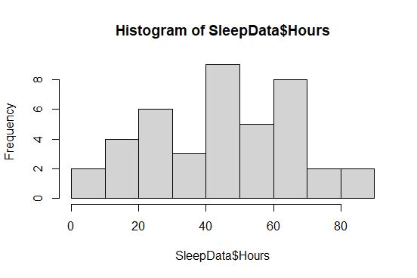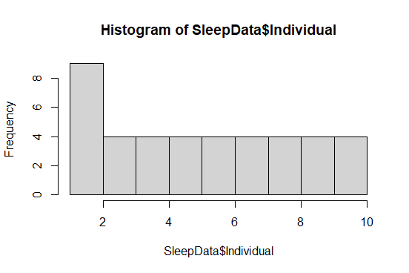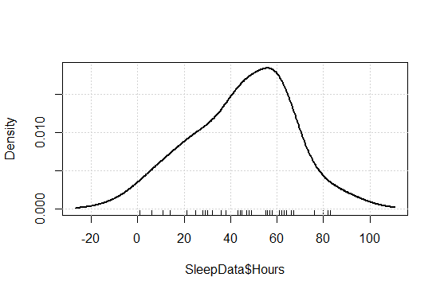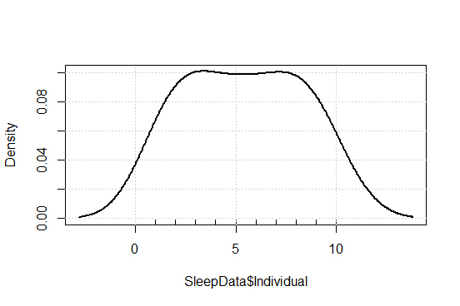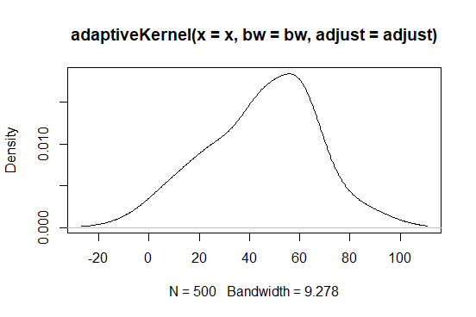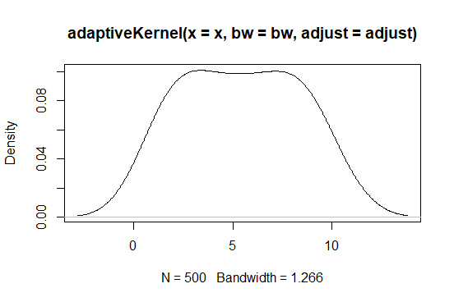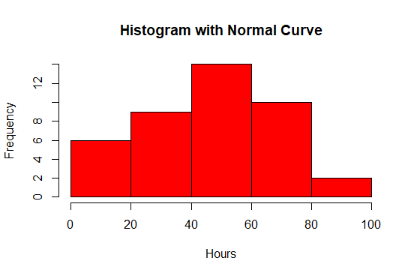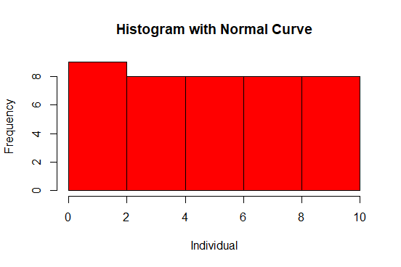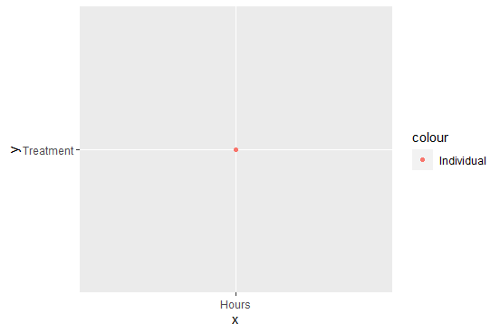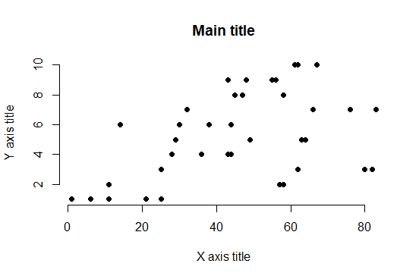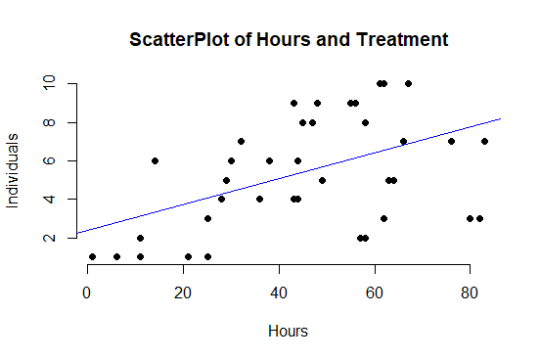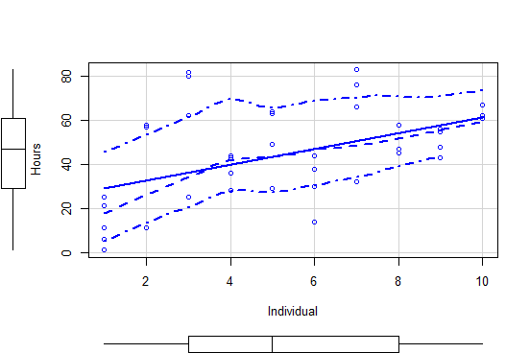

GENERAL SUMMARIES  
 1. Drug C and D are more effective on curing amnesiacs that drug A and B

2.There is a direct relationship between patient recovery and the treatment used

3. The mean effect of this drugs is clinically useful

4.The drug A and B have a lower recovery turnover.