Program Structure

DATA PROCESSING AND CLEANING

-The default data structure has errors that are to be resolved by deleting the excess bits

DATA choice;

INPUT y x1-x9;

CARDS;

1 17 0 0 0 1 1 1 2000 0

1 35 1 0 0 8 0 0 40000 1

1 28 0 1 0 5 0 0 35000 1

1 31 1 0 0 4 0 0 65000 1

0 65 1 0 3 42 0 1 2000 1

0 32 0 1 0 3 1 1 80000 1

1 23 0 0 0 2 0 0 10000 0

1 45 1 0 0 25 0 1 120000 1

1 38 1 0 2 19 0 0 90000 1

0 55 0 1 0 2 0 0 200000 0

1 20 0 0 0 2 0 0 22000 0

0 70 1 0 2 45 0 0 20000 0

1 40 1 0 1 13 0 0 75000 1

0 40 1 0 1 10 1 1 80000 1

0 37 0 1 0 3 1 1 120000 1

0 38 0 1 0 2 1 1 250000 1

1 30 1 0 9 7 0 0 60000 0

0 33 0 0 0 3 1 1 100000 1

1 22 0 0 0 4 0 0 30000 0

1 27 1 0 0 5 0 0 70000 1

0 36 0 1 1 7 1 1 150000 0

1 18 0 0 0 1 0 0 3000 0

0 35 1 0 3 8 1 1 190000 1

0 39 1 0 2 7 1 1 170000 1

0 38 1 0 1 8 1 1 150000 1

0 38 1 0 2 8 1 1 150000 1

1 19 0 0 0 1 0 0 10000 0

1 16 0 0 0 1 0 0 2000 0

0 44 1 0 1 16 0 1 90000 0

1 34 1 0 1 13 0 0 70000 0

;

Output of the Code

1 %studio_hide_wrapper;

77

78 DATA choice;

79 INPUT y x1-x9;

80 CARDS;

NOTE: The data set WORK.CHOICE has 30 observations and 10 variables.

NOTE: DATA statement used (Total process time):

real time 0.00 seconds

cpu time 0.00 seconds

Output of the Data Structure

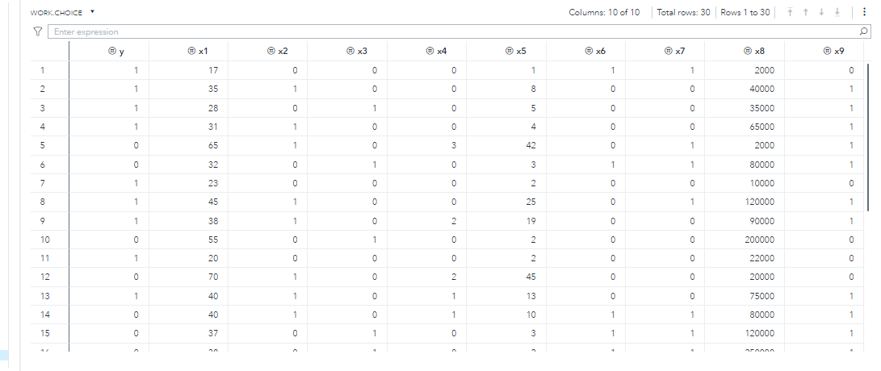

EXPLORATORY DATA ANALYSIS OF THE INDIVIDUAL VARIABLES

**The FREQ Procedure**

| **y** | **Frequency** | **Percent** | **Cumulative Frequency** | **Cumulative Percent** |
| --- | --- | --- | --- | --- |
| **0** | 14 | 46.67 | 14 | 46.67 |
| **1** | 16 | 53.33 | 30 | 100.00 |

X11

| **x1** | **Frequency** | **Percent** | **Cumulative Frequency** | **Cumulative Percent** |
| --- | --- | --- | --- | --- |
| **16** | 1 | 3.33 | 1 | 3.33 |
| **17** | 1 | 3.33 | 2 | 6.67 |
| **18** | 1 | 3.33 | 3 | 10.00 |
| **19** | 1 | 3.33 | 4 | 13.33 |
| **20** | 1 | 3.33 | 5 | 16.67 |
| **22** | 1 | 3.33 | 6 | 20.00 |
| **23** | 1 | 3.33 | 7 | 23.33 |
| **27** | 1 | 3.33 | 8 | 26.67 |
| **28** | 1 | 3.33 | 9 | 30.00 |
| **30** | 1 | 3.33 | 10 | 33.33 |
| **31** | 1 | 3.33 | 11 | 36.67 |
| **32** | 1 | 3.33 | 12 | 40.00 |
| **33** | 1 | 3.33 | 13 | 43.33 |
| **34** | 1 | 3.33 | 14 | 46.67 |
| **35** | 2 | 6.67 | 16 | 53.33 |
| **36** | 1 | 3.33 | 17 | 56.67 |
| **37** | 1 | 3.33 | 18 | 60.00 |
| **38** | 4 | 13.33 | 22 | 73.33 |
| **39** | 1 | 3.33 | 23 | 76.67 |
| **40** | 2 | 6.67 | 25 | 83.33 |
| **44** | 1 | 3.33 | 26 | 86.67 |
| **45** | 1 | 3.33 | 27 | 90.00 |
| **55** | 1 | 3.33 | 28 | 93.33 |
| **65** | 1 | 3.33 | 29 | 96.67 |
| **70** | 1 | 3.33 | 30 | 100.00 |

| **x2** | **Frequency** | **Percent** | **Cumulative Frequency** | **Cumulative Percent** |
| --- | --- | --- | --- | --- |
| **0** | 14 | 46.67 | 14 | 46.67 |
| **1** | 16 | 53.33 | 30 | 100.00 |

| **x3** | **Frequency** | **Percent** | **Cumulative Frequency** | **Cumulative Percent** |
| --- | --- | --- | --- | --- |
| **0** | 24 | 80.00 | 24 | 80.00 |
| **1** | 6 | 20.00 | 30 | 100.00 |

| **x4** | **Frequency** | **Percent** | **Cumulative Frequency** | **Cumulative Percent** |
| --- | --- | --- | --- | --- |
| **0** | 17 | 56.67 | 17 | 56.67 |
| **1** | 6 | 20.00 | 23 | 76.67 |
| **2** | 4 | 13.33 | 27 | 90.00 |
| **3** | 2 | 6.67 | 29 | 96.67 |
| **9** | 1 | 3.33 | 30 | 100.00 |

| **x5** | **Frequency** | **Percent** | **Cumulative Frequency** | **Cumulative Percent** |
| --- | --- | --- | --- | --- |
| **1** | 4 | 13.33 | 4 | 13.33 |
| **2** | 4 | 13.33 | 8 | 26.67 |
| **3** | 3 | 10.00 | 11 | 36.67 |
| **4** | 2 | 6.67 | 13 | 43.33 |
| **5** | 2 | 6.67 | 15 | 50.00 |
| **7** | 3 | 10.00 | 18 | 60.00 |
| **8** | 4 | 13.33 | 22 | 73.33 |
| **10** | 1 | 3.33 | 23 | 76.67 |
| **13** | 2 | 6.67 | 25 | 83.33 |
| **16** | 1 | 3.33 | 26 | 86.67 |
| **19** | 1 | 3.33 | 27 | 90.00 |
| **25** | 1 | 3.33 | 28 | 93.33 |
| **42** | 1 | 3.33 | 29 | 96.67 |
| **45** | 1 | 3.33 | 30 | 100.00 |

| **x6** | **Frequency** | **Percent** | **Cumulative Frequency** | **Cumulative Percent** |
| --- | --- | --- | --- | --- |
| **0** | 19 | 63.33 | 19 | 63.33 |
| **1** | 11 | 36.67 | 30 | 100.00 |

| **x7** | **Frequency** | **Percent** | **Cumulative Frequency** | **Cumulative Percent** |
| --- | --- | --- | --- | --- |
| **0** | 16 | 53.33 | 16 | 53.33 |
| **1** | 14 | 46.67 | 30 | 100.00 |

| **x8** | **Frequency** | **Percent** | **Cumulative Frequency** | **Cumulative Percent** |
| --- | --- | --- | --- | --- |
| **2000** | 3 | 10.00 | 3 | 10.00 |
| **3000** | 1 | 3.33 | 4 | 13.33 |
| **10000** | 2 | 6.67 | 6 | 20.00 |
| **20000** | 1 | 3.33 | 7 | 23.33 |
| **22000** | 1 | 3.33 | 8 | 26.67 |
| **30000** | 1 | 3.33 | 9 | 30.00 |
| **35000** | 1 | 3.33 | 10 | 33.33 |
| **40000** | 1 | 3.33 | 11 | 36.67 |
| **60000** | 1 | 3.33 | 12 | 40.00 |
| **65000** | 1 | 3.33 | 13 | 43.33 |
| **70000** | 2 | 6.67 | 15 | 50.00 |
| **75000** | 1 | 3.33 | 16 | 53.33 |
| **80000** | 2 | 6.67 | 18 | 60.00 |
| **90000** | 2 | 6.67 | 20 | 66.67 |
| **100000** | 1 | 3.33 | 21 | 70.00 |
| **120000** | 2 | 6.67 | 23 | 76.67 |
| **150000** | 3 | 10.00 | 26 | 86.67 |
| **170000** | 1 | 3.33 | 27 | 90.00 |
| **190000** | 1 | 3.33 | 28 | 93.33 |
| **200000** | 1 | 3.33 | 29 | 96.67 |
| **250000** | 1 | 3.33 | 30 | 100.00 |

| **x9** | **Frequency** | **Percent** | **Cumulative Frequency** | **Cumulative Percent** |
| --- | --- | --- | --- | --- |
| **0** | 13 | 43.33 | 13 | 43.33 |
| **1** | 17 | 56.67 | 30 | 100.00 |