Project Phase I: Implementation Specification

1. Methods Description

* Input { read( ), store( ) }

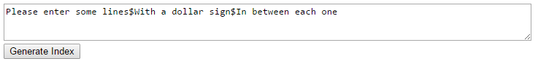

* Line Storage { setChar(int line, int word, int char, int value), char(int line, int word, int char), word(int line) }

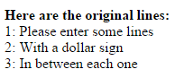

* Circular Shift { setUp( ), setChar(int shift_no, int word, int char, String value), char(int shift_no, int word, int char), word(int shift_no) }

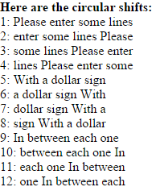

* Alphabetic Sort { setUp( ), alpha_sort(String[ ] list), line_ith( ) }

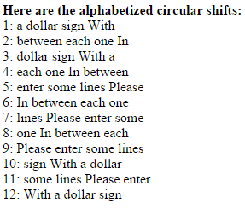

* Output {read( ), store( ), display( ) }
  + The output module’s implementation produces the above three module screenshots.

1. Prototype/ Screenshots

2.1 Implementation on Team Website (Version 1)

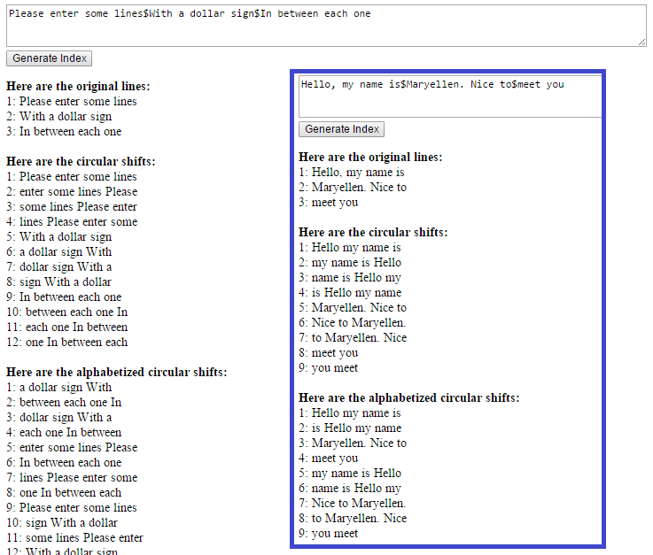

2.2 Prototype (Version 2)

