CS5220

Adv Application Programming in Java

Smart City Transportation

Prabhu Kiran Kotipalli

Sumanth Anepally

**Project Description:**

Transportation is critical part of a smart city and it is very important that people are kept informed at what is available for them so they could use a service at maximum efficacy. The route of a bus, what route does it take to reach a particular destination, the timings, updates on if a bus is running or is not currently running due to an issue, ability to book a private shuttle are all important for the people who rely on public transportation.

**Requirements:**

**Functional:**

**Signup**

* Admin
* Driver
* User

**Login**

* Admin, driver, user needs to login to access their portals.

**Admin**

* Will be able to respond to user requests
* Will be able to complete a request of shuttle booking.
* Will be able to add additional routes and additional buses.

**User**

* Display bus status
* Search for buses
* search for routes
* book a shuttle service
* track live bus updates
* track crowd in a bus

**Driver**

* Will be able to update status of the bus

**Non-Functional**

* User authentication checks are performed to verify the user.

**Design**

As part of the design we have class diagram and sequence diagram

**Class diagram**

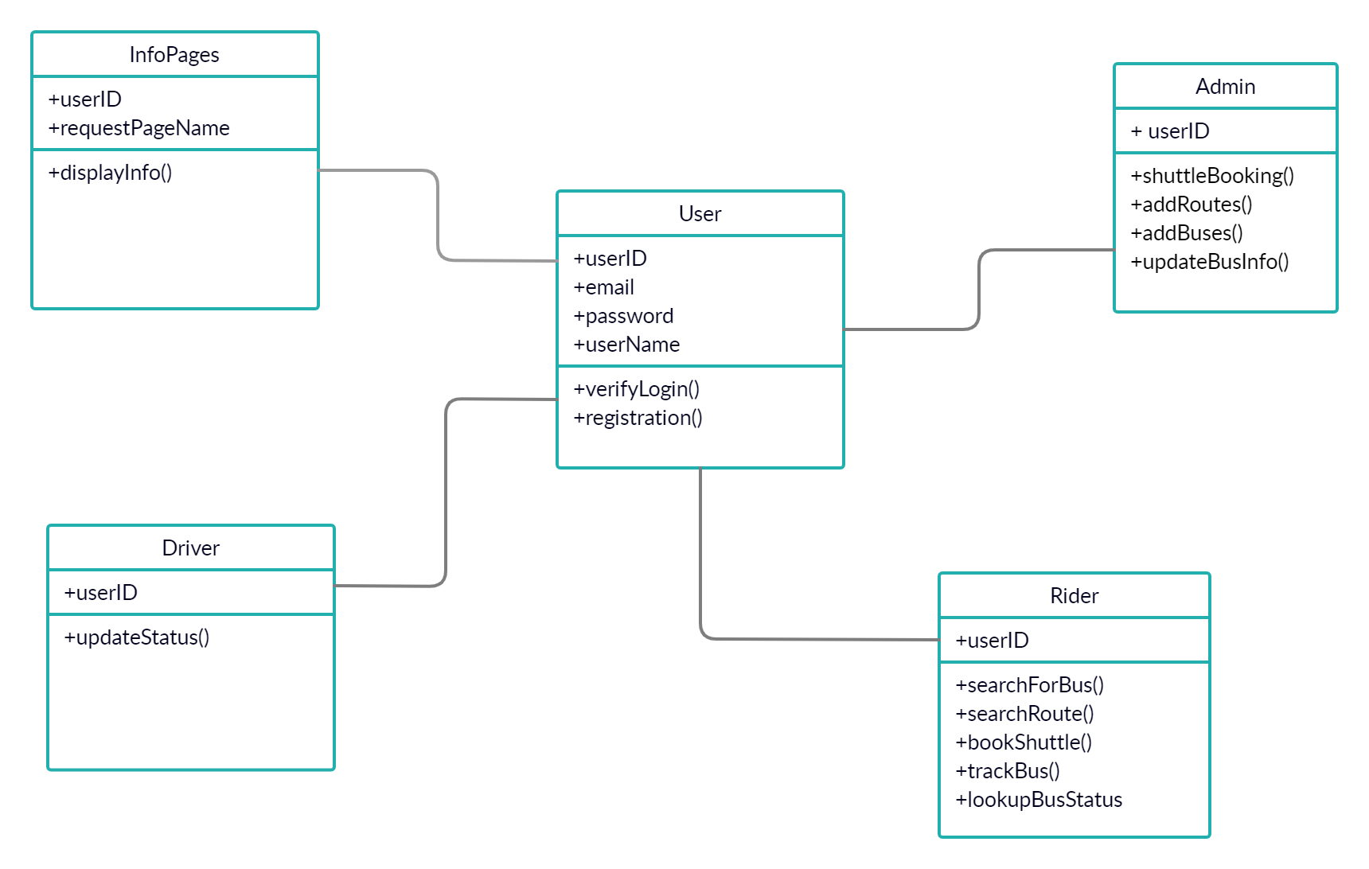

**Sequence diagram**

The interaction between various objects is illustrated in the sequence diagram.

Sequence diagram for User:

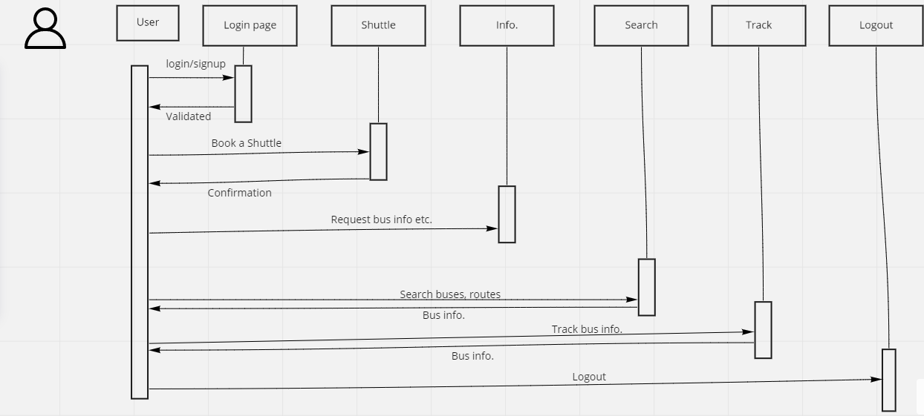

Sequence diagram for Admin:

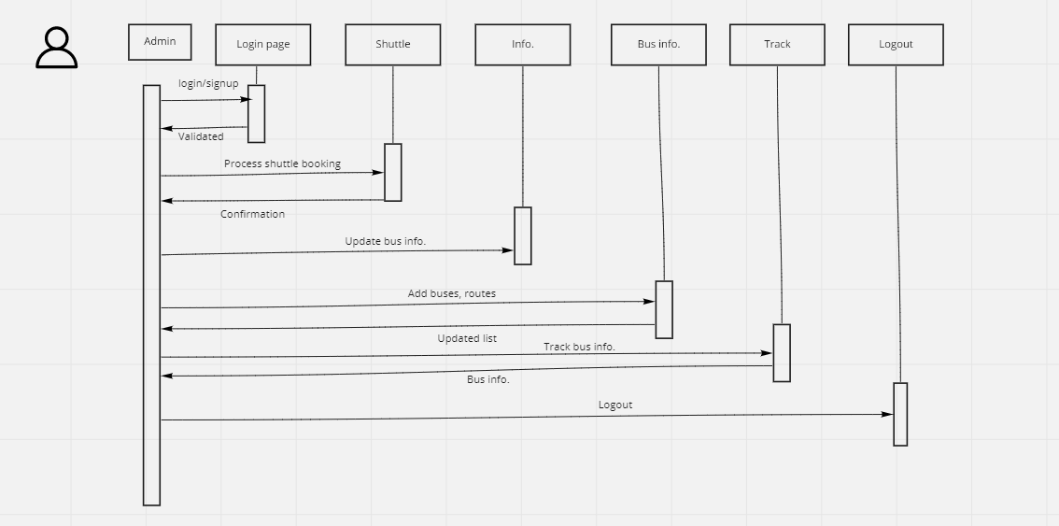

Sequence diagram for Driver:

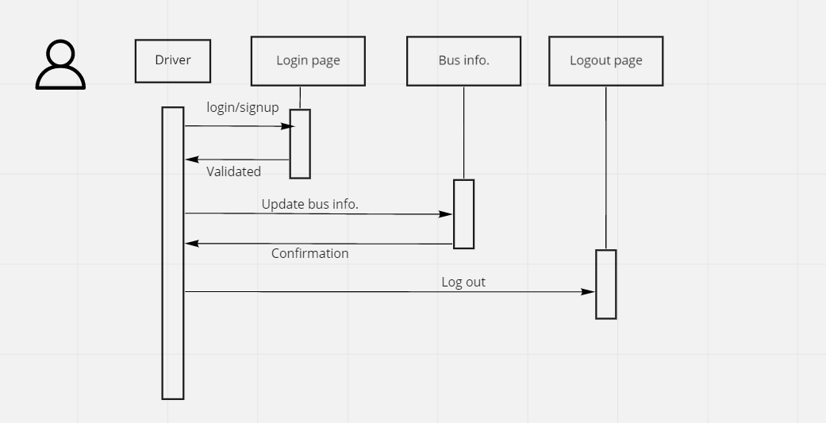

**Architectural design pattern:**

Smart city transportation is a web application based on JSP. For a page, the browser sends a HTTP request to the web server and the server understands the sent request is for a JSP page and pushes it to JSP engine. This is done by a JSP page which ends with .jsp instead of .html. The JSP page is then loaded by JSP engine from disk and is converted into servlet content. In this process the JSP elements are converted to Java code, which implements the dynamic behavior of the code.

When a user requests for information or requests to make a booking, the sever responds accordingly and processes the respective code.

**Algorithms**

Sorting techniques are used to sort buses or routes in various functionalities and are displayed according to the user requests.

**Data Structures**

Arrays are used to store the bus information, route information, user information collected from the users and are stored in the database. Hashing technique is used to retrieve the information from forms.

**References**

* <http://javatpoint.com/>
* <https://www.tutorialspoint.com>
* Online tools are used for class diagrams and sequence diagrams.