|  |
| --- |
| Tomasz Przybylski KC68744 |
| CMDF CX3005 Portfolio |
|  |

|  |
| --- |
| Tomasz Przybylski  [Pick the date] |

Fibonacci Program

The program allows the user to look at the sequence of Fibonacci numbers up to the 91st Fibonacci number, and allows for users to input an integer and check if it is part of the Fibonacci sequence, and also which nth term in the sequence it is.

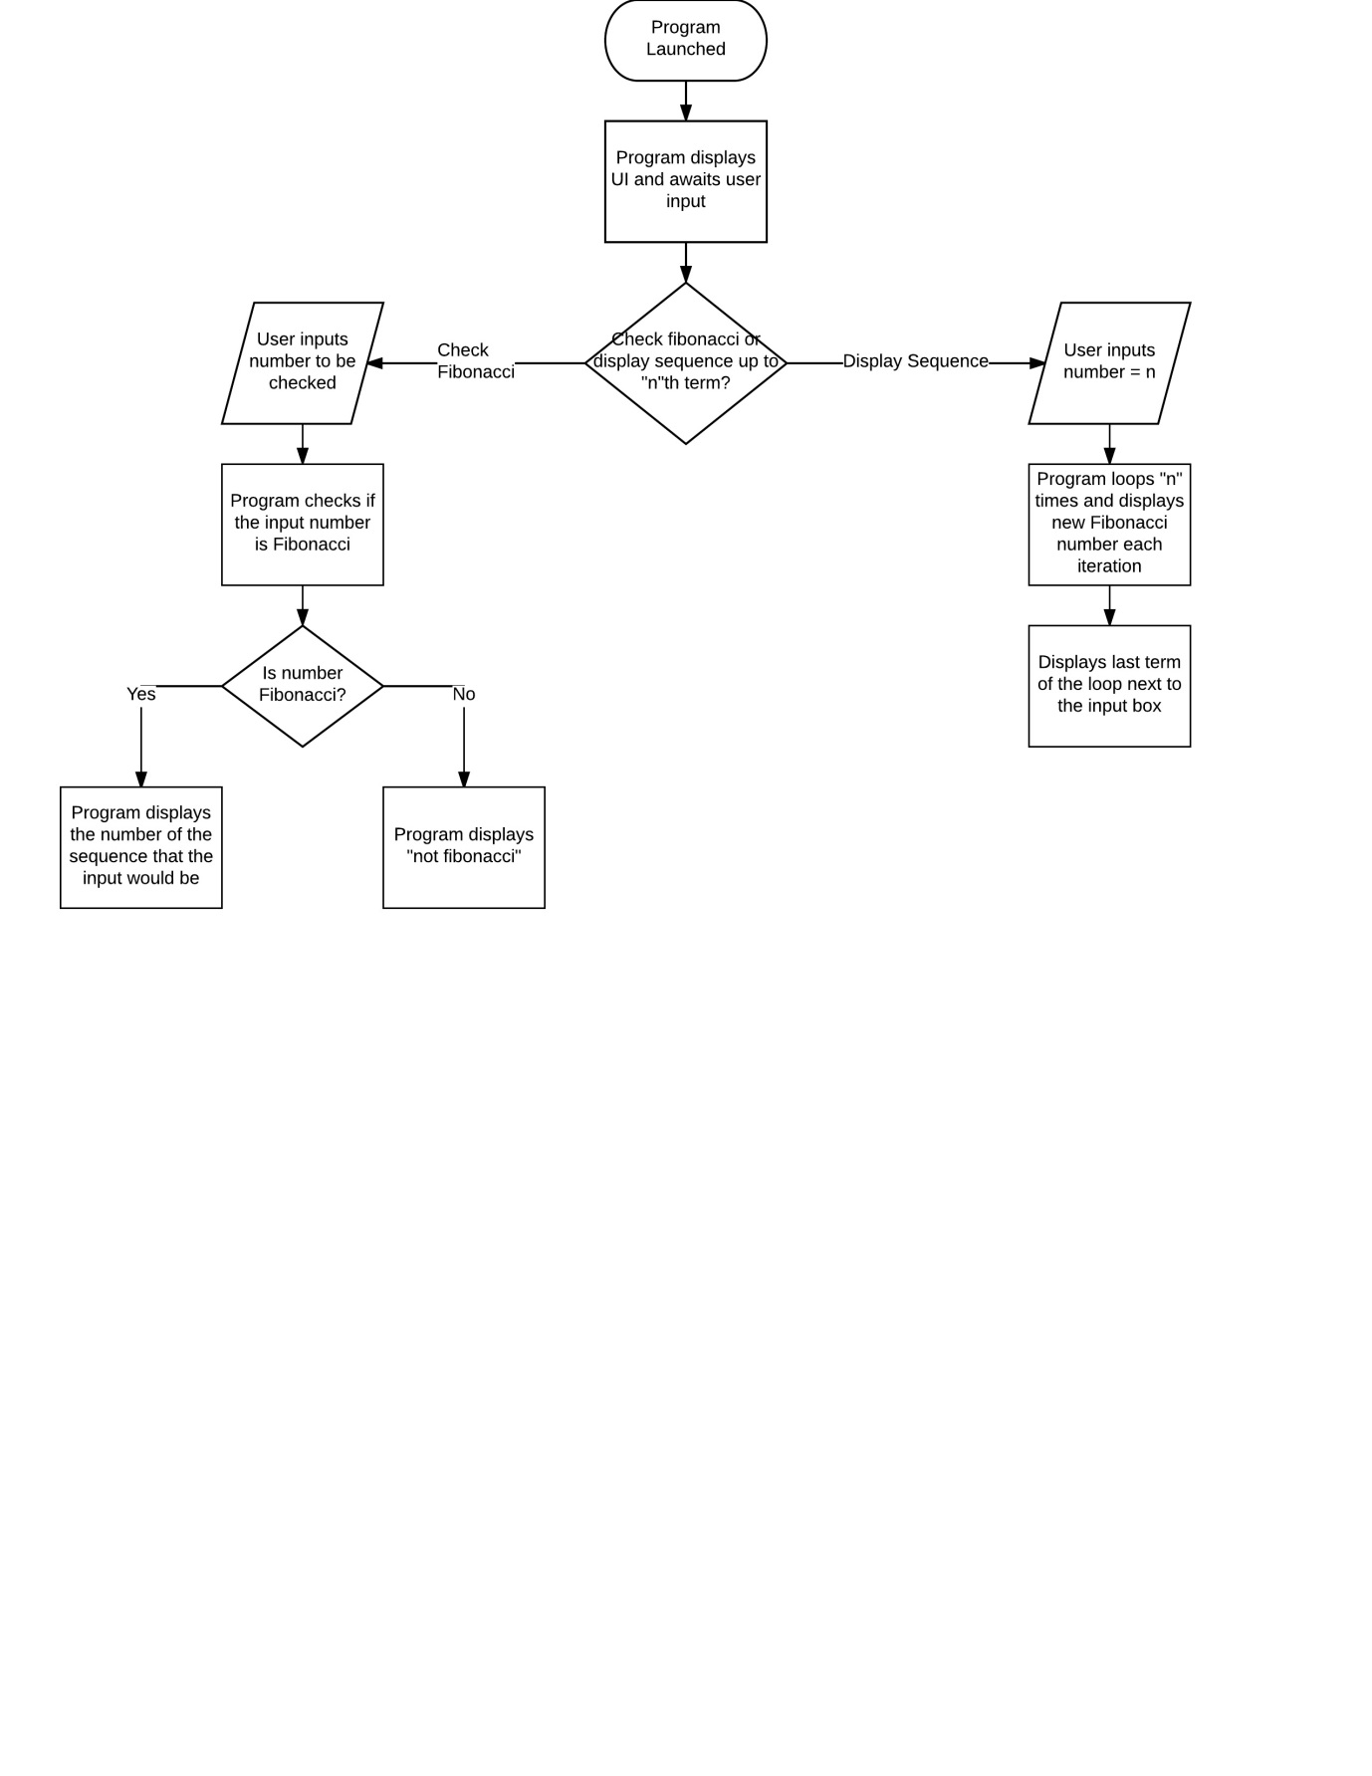

Public Class Form1

Private Sub btn_Submit_Click(sender As Object, e As EventArgs) Handles btn_Submit.Click

txt_DisplaySeq.Clear()

Dim Ln_a As Long = 0

Dim Ln_b As Long = 1

Dim Ln_fibo As Long = 0 'Fibonacci number

Dim Int_nth As Integer = 1 'N-th Fibonacci number

txt_DisplaySeq.Text = "*0th Number* " & txt_DisplaySeq.Text + Ln_a.ToString & ControlChars.NewLine 'Displays the first two digits of the Fibonacci sequence (0, 1)

txt_DisplaySeq.Text = txt_DisplaySeq.Text + Ln_b.ToString & ControlChars.NewLine

Try

Do

Ln_fibo = Ln_a + LN_b 'Adds the two values of a and b'

Ln_a = Ln_b 'A takes the value of B, while B takes the value of a+b'

Ln_b = Ln_fibo

txt_DisplaySeq.Text = txt_DisplaySeq.Text + Ln_fibo.ToString & ControlChars.NewLine 'Writes the fibonacci number to the text box and creates a new line'

Int_nth = Int_nth + 1

Loop Until Int_nth = txt_Enternth.Text

'Loops for nth number of times before stopping the loop

txt_DisplayFibo.Text = Ln_fibo.ToString 'writes final loop result to the text box

Catch ex As Exception

txt_DisplaySeq.Text = "Invalid Term - Check if out of range"

txt_DisplayFibo.Text = "Invalid Term"

End Try

End Sub

Private Sub btn_Check_Click(sender As Object, e As EventArgs) Handles btn_Check.Click

Dim Dbl_a As Double = 0

Dim Dbl_b As Double = 1

Dim Dbl_fibo As Double = 0

Dim Int_nth As Integer = 1

Dim Dbl_checkinput As Double

Dim Bln_fibonacci As Boolean

Try

Dbl_checkinput = txt_CheckInput.Text

Catch ex As Exception

End Try

If Dbl_checkinput < 1 Then

txt_CheckInput.Text = "Invalid Input"

End If

Do

Dbl_fibo = Dbl_a + Dbl_b

If Dbl_fibo = Dbl_checkinput Then 'checks if the input is a fibonacci number with each loop

Bln_fibonacci = True 'if the two numbers match then the loop will end early

txt_CheckOutput.Text = Int_nth + 1 'If the input is a fibonacci number, this will display which fibonacci number it is.

End If

Dbl_a = Dbl_b

Dbl_b = Dbl_fibo

Int_nth = Int_nth + 1

Loop Until Int_nth = 300 Or Bln_fibonacci = True

'Loops until the number being checked turns out to be a Fibonacci or until Loop gets to 300th iteration

If Bln_fibonacci = True Then

Else

txt_CheckOutput.Text = "Not Fibonacci"

End If

End Sub

End Class

|  |  |  |
| --- | --- | --- |
| Name of Variable | Type of Variable | Other Comments |
| Ln_a | Long | Used in the sequence displaying. |
| Dbl_a | Double | Used in the Fibonacci number checking |
| Ln_b | Long | Used in the sequence displaying. |
| Dbl_b | Double | Used in the Fibonacci number checking |
| Ln_Fibo | Long | Used in the sequence displaying. |
| Dbl_Fibo | Double | Used in the Fibonacci number checking |
| Int_nth | Integer | Used as a count to stop the loop, either at “n”th term or once it reaches 300 for the Fibonacci check |
| Dbl_Checkinput | Double | Holds the number to be checked |
| Bln_Fibonacci | Boolean | Will reflect if the number is Fibonacci or not |

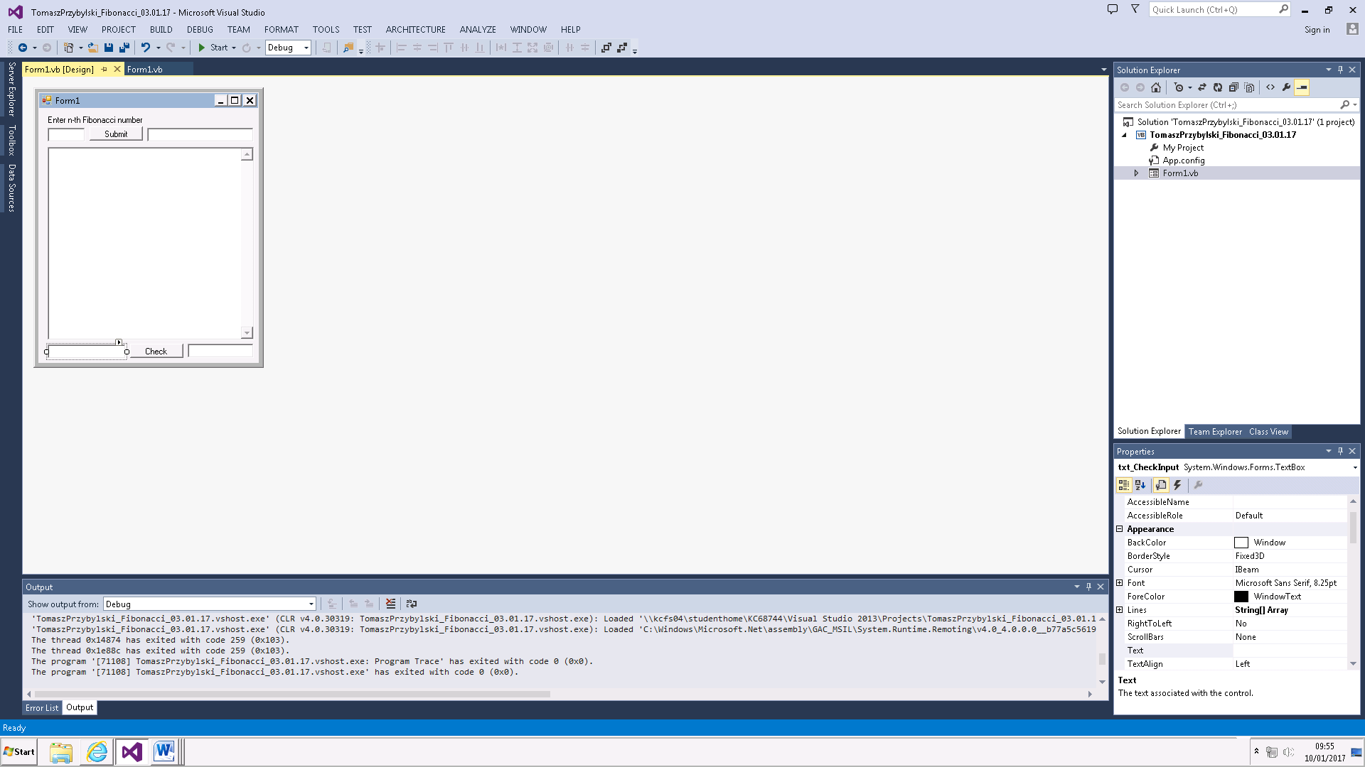

Input for checking if a number is a Fibonacci number

Displays “Not Fibonacci” if number is not a Fibonacci number, otherwise displays the term of the Fibonacci number.

For example: 13 would display 7, because it is the 7th Fibonacci term

Displays all the Fibonacci numbers up to the “N-th” term in sequence

The “N-th” Fibonacci number

Input Box for “N-th” term

## Comments:

* In my submit.click sub, the “a”, “b”, and “fibo” variables are declared as long, whereas in the check.click sub, they are declared as double. This is because a “long” type variable will have less range but more precision than a “double” type variable. This means that my program can only display 91 terms, but it can display them all fully. This is preferred because the checking part of the program can only check precise numbers. If I used double in my sequence generation, I could have achieved up to and beyond 1000 terms for the Fibonacci sequence, but they would begin to lose precision and be written in scientific notation.
* Although my sequence generator will display 91 terms, the Fibonacci checker can be used up to the 216th term. This is because of the previously mentioned “long” and “double” variable difference.

|  |  |  |  |  |  |
| --- | --- | --- | --- | --- | --- |
| Test | Description | Input | Expected Outcome | Actual Outcome | Other Comments |
| #1 | Input a positive integer into the “N-th term” textbox | 7 | Fibonacci Sequence displays until 7th term | As expected |  |
| #2 | Input a negative integer into the “N-th term” textbox | -13 | Invalid term displayed | As expected |  |
| #3 | Input a string into the “n-th term” textbox | ABCD | Invalid term displayed | As expected |  |
| #4.1  #4.2 | Input a very long number or string into the textbox | ABCDEFGHIJKLMNOPQRSTUVWXYZ  1234567891011121314151617181920 | Invalid term displayed | As expected |  |
| #5 | Input a string into the textbox for checking fibonacci | ABCD | Not Fibonacci displayed | As expected |  |
| #6 | Input a Fibonacci number into textbox for checking | 21 | 8 | As expected |  |
| #7 | Input a non-Fibonacci number into textbox for checking | 22 | Not Fibonacci | As expected |  |
| #8 | Input very long integer into textbox for checking | 999999999999999999999999999999999999 | Not Fibonacci | As expected |  |