|  |
| --- |
| Tomasz Przybylski KC68744 |
| CMDF CX3005 Portfolio |
| Fibonacci  Caesar Cypher  Grade Calculator  Password Checker & Generator |

|  |
| --- |
| Tomasz Przybylski  25/04/2017 |

Contents

Fibonacci Program 2

Summary: 2

Flowcharts: 2

General Flowchart: 2

Sub Specific: 3

Annotated Code: 4

Variable List: 5

Comments: 6

Test Plan: 7

Caesar Cypher 8

Summary: 8

Flowcharts: 8

General Flowchart: 8

Sub Specific: 9

Annotated Code: 10

Variable List: 13

Comments: 14

Test Plan: 15

Grade Calculator 16

Summary: 16

Flowcharts: 16

General: 16

Sub Specific: 17

# Fibonacci Program

## Summary:

The program allows the user to look at the sequence of Fibonacci numbers up to the 91st Fibonacci number, and allows for users to input an integer and check if it is part of the Fibonacci sequence, and also which nth term in the sequence it is.

## **Flowcharts:**

### **General Flowchart**:

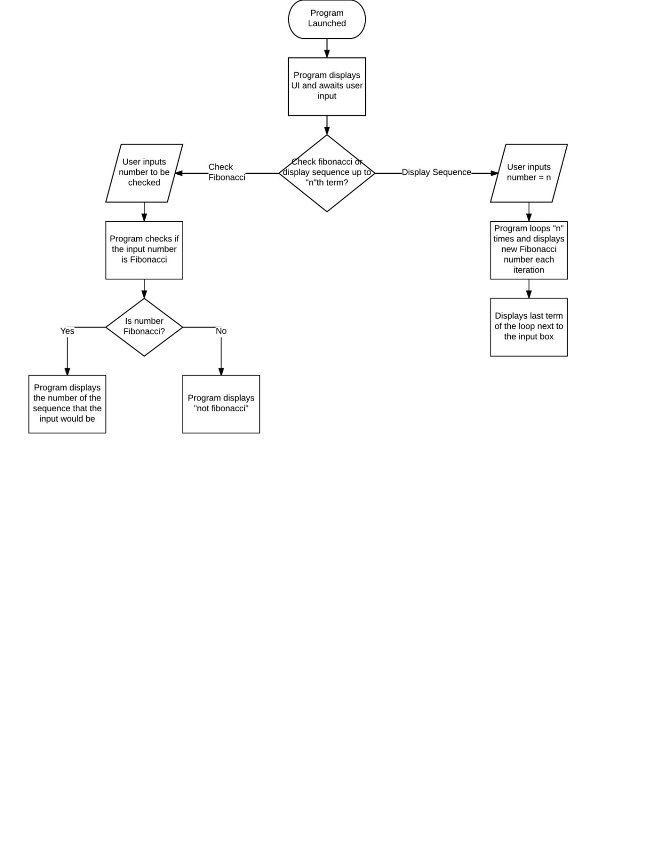

### Sub Specific:

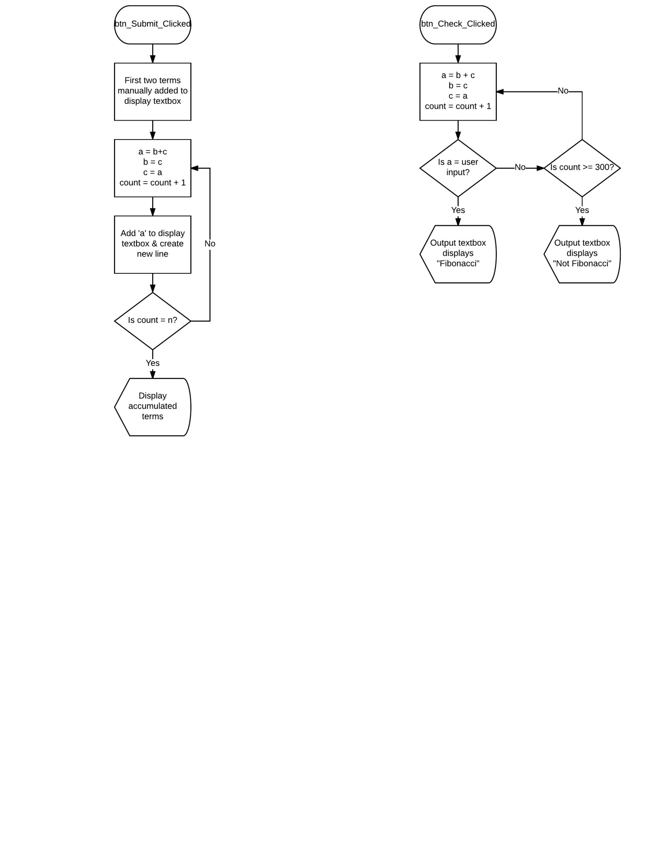

## Annotated Code:

Public Class Form1

Private Sub btn_Submit_Click(sender As Object, e As EventArgs) Handles btn_Submit.Click

txt_DisplaySeq.Clear()

Dim Ln_a As Long = 0

Dim Ln_b As Long = 1

Dim Ln_fibo As Long = 0 'Fibonacci number

Dim Int_nth As Integer = 1 'N-th Fibonacci number

txt_DisplaySeq.Text = "*0th Number* " & txt_DisplaySeq.Text + Ln_a.ToString & ControlChars.NewLine 'Displays the first two digits of the Fibonacci sequence (0, 1)

txt_DisplaySeq.Text = txt_DisplaySeq.Text + Ln_b.ToString & ControlChars.NewLine

Try

Do

Ln_fibo = Ln_a + LN_b 'Adds the two values of a and b'

Ln_a = Ln_b 'A takes the value of B, while B takes the value of a+b'

Ln_b = Ln_fibo

txt_DisplaySeq.Text = txt_DisplaySeq.Text + Ln_fibo.ToString & ControlChars.NewLine 'Writes the fibonacci number to the text box and creates a new line'

Int_nth = Int_nth + 1

Loop Until Int_nth = txt_Enternth.Text

'Loops for nth number of times before stopping the loop

txt_DisplayFibo.Text = Ln_fibo.ToString 'writes final loop result to the text box

Catch ex As Exception

txt_DisplaySeq.Text = "Invalid Term - Check if out of range"

txt_DisplayFibo.Text = "Invalid Term"

End Try

End Sub

Private Sub btn_Check_Click(sender As Object, e As EventArgs) Handles btn_Check.Click

Dim Dbl_a As Double = 0

Dim Dbl_b As Double = 1

Dim Dbl_fibo As Double = 0

Dim Int_nth As Integer = 1

Dim Dbl_checkinput As Double

Dim Bln_fibonacci As Boolean

Try

Dbl_checkinput = txt_CheckInput.Text

Catch ex As Exception

End Try

If Dbl_checkinput < 1 Then

txt_CheckInput.Text = "Invalid Input"

End If

Do

Dbl_fibo = Dbl_a + Dbl_b

If Dbl_fibo = Dbl_checkinput Then 'checks if the input is a fibonacci number with each loop

Bln_fibonacci = True 'if the two numbers match then the loop will end early

txt_CheckOutput.Text = Int_nth + 1 'If the input is a fibonacci number, this will display which fibonacci number it is.

End If

Dbl_a = Dbl_b

Dbl_b = Dbl_fibo

Int_nth = Int_nth + 1

Loop Until Int_nth = 300 Or Bln_fibonacci = True

'Loops until the number being checked turns out to be a Fibonacci or until Loop gets to 300th iteration

If Bln_fibonacci = True Then

Else

txt_CheckOutput.Text = "Not Fibonacci"

End If

End Sub

End Class

### Variable List:

|  |  |  |
| --- | --- | --- |
| Name of Variable | Type of Variable | Other Comments |
| Ln_a | Long | Used in the sequence displaying. |
| Dbl_a | Double | Used in the Fibonacci number checking |
| Ln_b | Long | Used in the sequence displaying. |
| Dbl_b | Double | Used in the Fibonacci number checking |
| Ln_Fibo | Long | Used in the sequence displaying. |
| Dbl_Fibo | Double | Used in the Fibonacci number checking |
| Int_nth | Integer | Used as a count to stop the loop, either at “n”th term or once it reaches 300 for the Fibonacci check |
| Dbl_Checkinput | Double | Holds the number to be checked |
| Bln_Fibonacci | Boolean | Will reflect if the number is Fibonacci or not |

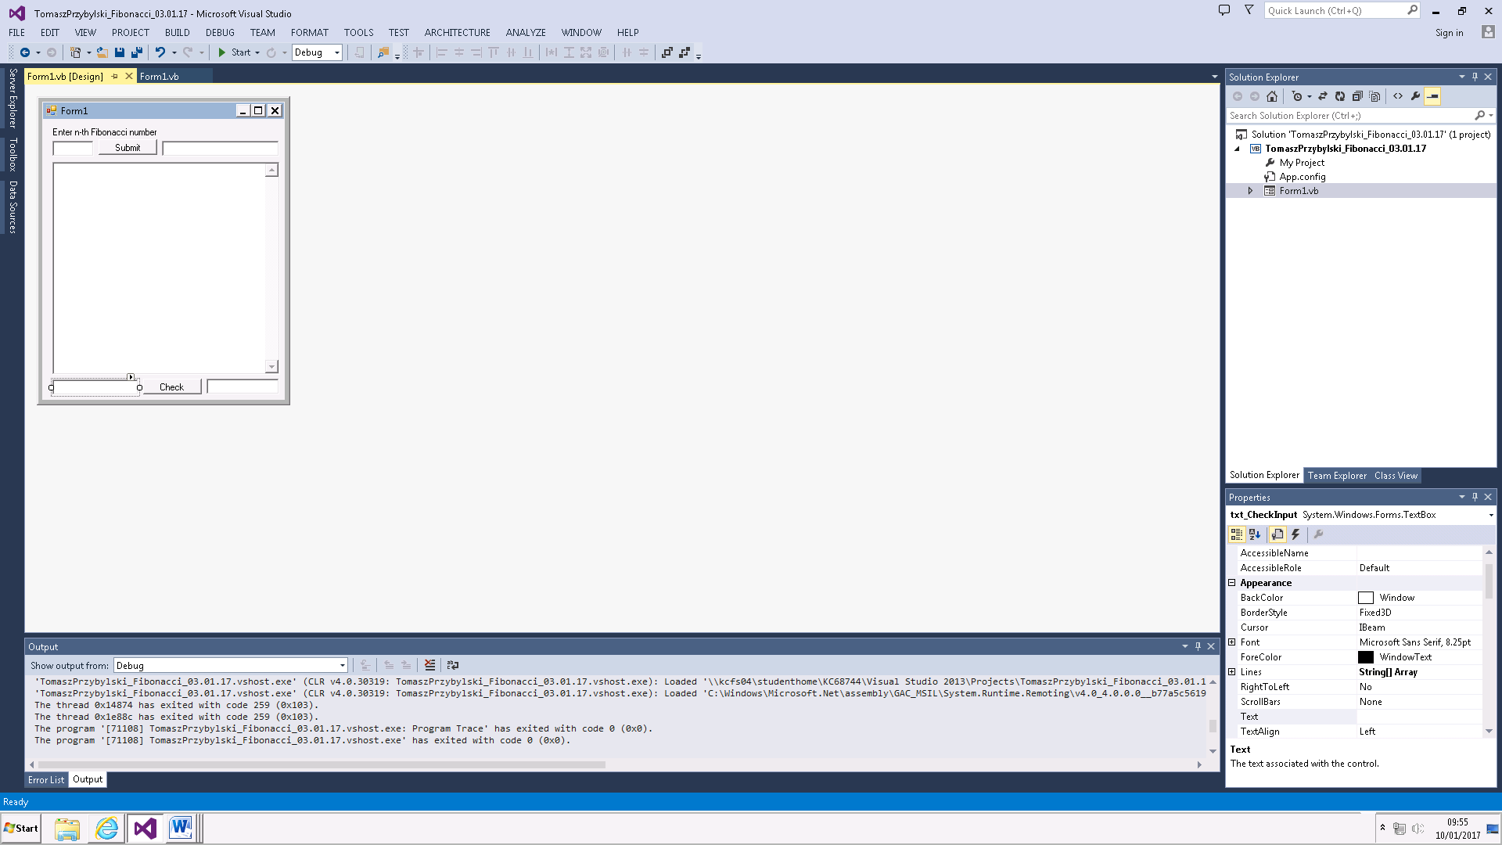

Input for checking if a number is a Fibonacci number

Displays “Not Fibonacci” if number is not a Fibonacci number, otherwise displays the term of the Fibonacci number.

For example: 13 would display 7, because it is the 7th Fibonacci term

Displays all the Fibonacci numbers up to the “N-th” term in sequence

The “N-th” Fibonacci number

Input Box for “N-th” term

## Comments:

* In my submit.click sub, the “Ln_a”, “Ln_b”, and “Ln_fibo” variables are declared as long, whereas in the check.click sub, they are declared as double. This is because a “long” type variable will have less range but more precision than a “double” type variable. This means that my program can only display 91 terms, but it can display them all fully. This is preferred because the checking part of the program can only check precise numbers. If I used double variable types in my sequence generation, I could have achieved up to and beyond 1000 terms for the Fibonacci sequence, but they would begin to lose precision and be written in scientific notation.
* Although my sequence generator will display 91 terms, the Fibonacci checker can be used up to the 216th term. This is because of the previously mentioned “long” and “double” variable difference.

## Test Plan:

|  |  |  |  |  |  |
| --- | --- | --- | --- | --- | --- |
| Test | Description | Input | Expected Outcome | Actual Outcome | Other Comments |
| #1 | Input a positive integer into the “N-th term” textbox | 7 | Fibonacci Sequence displays until 7th term | As expected |  |
| #2 | Input a negative integer into the “N-th term” textbox | -13 | Invalid term displayed | As expected |  |
| #3 | Input a string into the “n-th term” textbox | ABCD | Invalid term displayed | As expected |  |
| #4.1  #4.2 | Input a very long number or string into the textbox | ABCDEFGHIJKLMNOPQRSTUVWXYZ  1234567891011121314151617181920 | Invalid term displayed | As expected |  |
| #5 | Input a string into the textbox for checking fibonacci | ABCD | Not Fibonacci displayed | As expected |  |
| #6 | Input a Fibonacci number into textbox for checking | 21 | 8 | As expected |  |
| #7 | Input a non-Fibonacci number into textbox for checking | 22 | Not Fibonacci | As expected |  |
| #8 | Input very long integer into textbox for checking | 999999999999999999999999999999999999 | Not Fibonacci | As expected |  |
| #9 | No input for “N-th term” textbox |  | Invalid term displayed | As expected |  |
| #10 | No input for the Fibonacci checker |  | Invalid term displayed | As expected – also displays “Not Fibonacci” |  |

# Caesar Cypher

## Summary:

This program allows the user to input a series of strings, and then either have the sequence encrypted via a shift (up or down) of their choice, or to have a random shift of 1-10 applied. The program then displays the encrypted string and if a random shift was chosen, it will also display the shift amount, needed to decrypt the message.

## Flowcharts:

### General Flowchart:

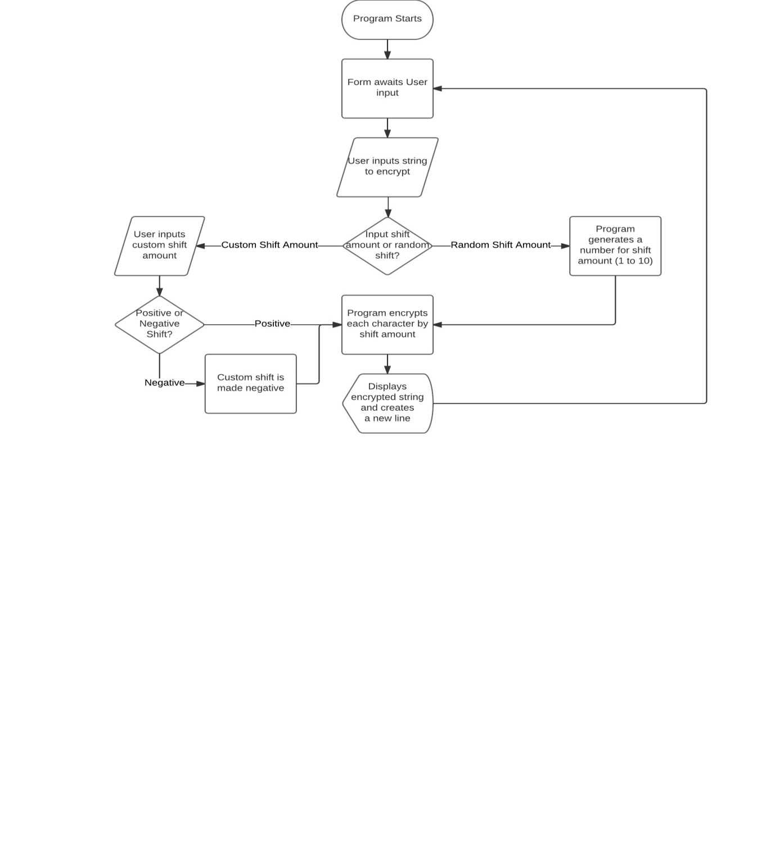

### Sub Specific:

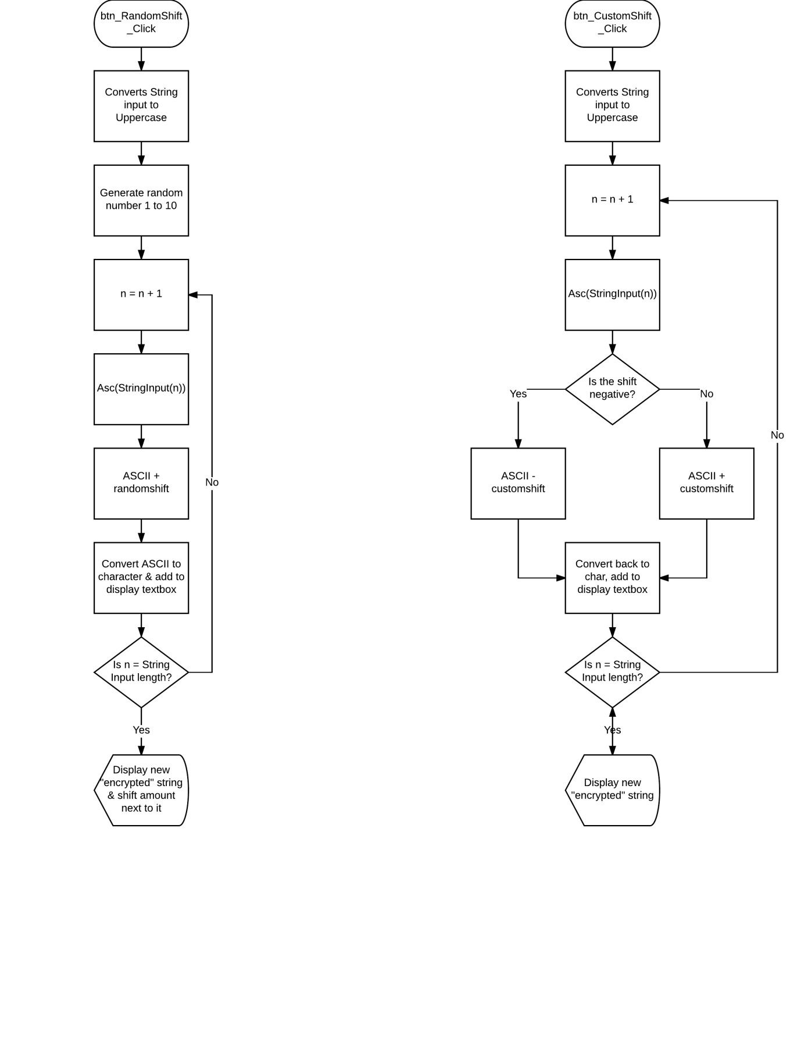

## Annotated Code:

Public Class frm_Main

Dim Str_cypherinput As String 'the string input is assigned here

Public Int_shiftamount As Integer 'the integer input for the shift

Public Str_cypheroutput As String 'the string after it has been shifted

Dim Int_Inputlength As Integer 'the length of the input string

Dim IntArr_ShiftArr(1) As Integer 'an array storing the ASCII of the shifted character

Dim StrArr_PostArr(1) As String 'an array storing the shifted character

Dim Int_ran As Integer 'takes the value of the randomly generated number

Dim Rdm_Rd As New Random 'used to generate a random number

Private Sub btn_RandomShift_Click(sender As Object, e As EventArgs) Handles btn_RandomShift.Click

Str_cypherinput = UCase(txt_InputWord.Text) 'converts string to uppercase

Int_Inputlength = txt_InputWord.TextLength - 1 'corrects the string length so that calculations are correct

Int_ran = Rdm_Rd.Next(1, 11) 'generates a random integer between inclusive 1 and exclusive 11 (1-10)

Int_shiftamount = Int_ran

ReDim IntArr_ShiftArr(Int_Inputlength) 're-declares the IntArr_ShiftArr to the size of the string length

ReDim StrArr_PostArr(Int_Inputlength) 're-declares the StrArr_PostArr to the size of the string length

If txt_InputWord.Text = "" Then

MsgBox("No String Input")

GoTo escape1

End If

For i = 0 To Int_Inputlength

If Str_cypherinput(i) <> " " Then

IntArr_ShiftArr(i) = Asc(Str_cypherinput(i)) + Int_shiftamount 'converts the current character into ASCII and adds the shift amount onto the ASCII value

If IntArr_ShiftArr(i) > 90 Then

IntArr_ShiftArr(i) = IntArr_ShiftArr(i) - 26 'if the ASCII value is above the uppercase Z value, that particular ASCII value is moved back down to uppercase A, creating a loop like a physical caesar cypher would create

End If

StrArr_PostArr(i) = Convert.ToChar(IntArr_ShiftArr(i))

ElseIf Str_cypherinput(i) = " " Then 'spaces are kept in the same place

StrArr_PostArr(i) = " "

End If

Next

For i = 0 To Int_Inputlength

Str_cypheroutput = Str_cypheroutput + StrArr_PostArr(i) 'this re-creates the string with the new encrypted characters

Next

txt_Display.Text = txt_Display.Text + Str_cypheroutput & " Shift Amount: " & Int_shiftamount.ToString & ControlChars.NewLine 'displays the encrypted (or decrypted) string in the textbox on the bottom, and creates a new line

Str_cypheroutput = ""

escape1:

End Sub

Private Sub btn_positive_Click(sender As Object, e As EventArgs) Handles btn_Positive.Click

'Majority of this code is the same as previous, with only some of the variables changed and lacking the integer generation

Str_cypherinput = UCase(txt_InputWord.Text)

Int_Inputlength = txt_InputWord.TextLength - 1

Try 'a try catch block, in case there is a problem with the shift input

Int_shiftamount = txt_CustomShift.Text

Catch ex As Exception

MessageBox.Show("Invalid Shift Input")

End Try

If Int_shiftamount >= 26 Or Int_shiftamount < 1 Then

MessageBox.Show("Please input a number between 1 and 25")

GoTo escape1

End If

ReDim IntArr_ShiftArr(Int_Inputlength)

ReDim StrArr_PostArr(Int_Inputlength)

For i = 0 To Int_Inputlength

If Str_cypherinput(i) <> " " Then

IntArr_ShiftArr(i) = Asc(Str_cypherinput(i)) + Int_shiftamount

If IntArr_ShiftArr(i) > 90 Then

IntArr_ShiftArr(i) = IntArr_ShiftArr(i) - 26 'this accounts for the "Positive" shift

End If

StrArr_PostArr(i) = Convert.ToChar(IntArr_ShiftArr(i))

ElseIf Str_cypherinput(i) = " " Then

StrArr_PostArr(i) = " "

End If

Next

For i = 0 To Int_Inputlength

Str_cypheroutput = Str_cypheroutput + StrArr_PostArr(i)

Next

txt_Display.Text = txt_Display.Text + Str_cypheroutput & ControlChars.NewLine

Str_cypheroutput = ""

escape1:

End Sub

Private Sub txt_customshift_KeyPress(ByVal sender As System.Object, ByVal e As System.Windows.Forms.KeyPressEventArgs) Handles txt_CustomShift.KeyPress

If Not Char.IsDigit(e.KeyChar) And Not Char.IsControl(e.KeyChar) Then

e.Handled = True 'disables the user from inputting any non-integer characters

End If

End Sub

Private Sub btn_Clear_Click(sender As Object, e As EventArgs) Handles btn_Clear.Click

txt_Display.Clear() 'clears the display

End Sub

Private Sub btn_Negative_Click(sender As Object, e As EventArgs) Handles btn_Negative.Click

Str_cypherinput = UCase(txt_InputWord.Text) 'identical to the positive shift sub, just moves the ASCII down instead of up

Int_Inputlength = txt_InputWord.TextLength - 1

Try

Int_shiftamount = txt_CustomShift.Text

Catch ex As Exception

MessageBox.Show("Invalid Shift Input")

End Try

If Int_shiftamount >= 26 Or Int_shiftamount < 1 Then

MessageBox.Show("Please input a number between 1 and 25")

GoTo escape1

End If

ReDim IntArr_ShiftArr(Int_Inputlength)

ReDim StrArr_PostArr(Int_Inputlength)

For i = 0 To Int_Inputlength

If Str_cypherinput(i) <> " " Then

IntArr_ShiftArr(i) = Asc(Str_cypherinput(i)) - Int_shiftamount

If IntArr_ShiftArr(i) < 65 Then

IntArr_ShiftArr(i) = IntArr_ShiftArr(i) + 26 'this accounts for the "Negative" shift

End If

StrArr_PostArr(i) = Convert.ToChar(IntArr_ShiftArr(i))

ElseIf Str_cypherinput(i) = " " Then

StrArr_PostArr(i) = " "

End If

Next

For i = 0 To Int_Inputlength

Str_cypheroutput = Str_cypheroutput + StrArr_PostArr(i)

Next

txt_Display.Text = txt_Display.Text + Str_cypheroutput & ControlChars.NewLine

Str_cypheroutput = ""

escape1:

End Sub

Private Sub txt_InputWord_KeyPress(ByVal sender As System.Object, ByVal e As System.Windows.Forms.KeyPressEventArgs) Handles txt_InputWord.KeyPress

If Not Char.IsLetter(e.KeyChar) And Not Char.IsControl(e.KeyChar) And Not Char.IsSeparator(e.KeyChar) Then

e.Handled = True 'disables input of numbers of symbols (apart from Spacebar) into the "Input text" textbox

End If

End Sub

End Class

### Variable List:

|  |  |  |
| --- | --- | --- |
| Variable Name | Variable Type | Other Comments |
| Str_cypherinput | String | Holds the string to be encrypted |
| Int_shiftamount | Integer | Holds the amount of places to shift the Caesar cypher |
| Str_cypheroutput | String | Holds the string after its been encrypted |
| Int_inputlength | Integer | Holds the length of the string (used in the array) |
| IntArr_ShiftArr | Integer (array) | Holds the ASCII of each letter after being shifted |
| StrArr_PostArr | String (array) | Holds each of the next encrypted letters |
| Int_ran | Integer | Holds the randomly generated integer from Rdm_Rd |
| Rdm_Rd | New Random | Randomly generates an integer between 1 and 10 inclusive |

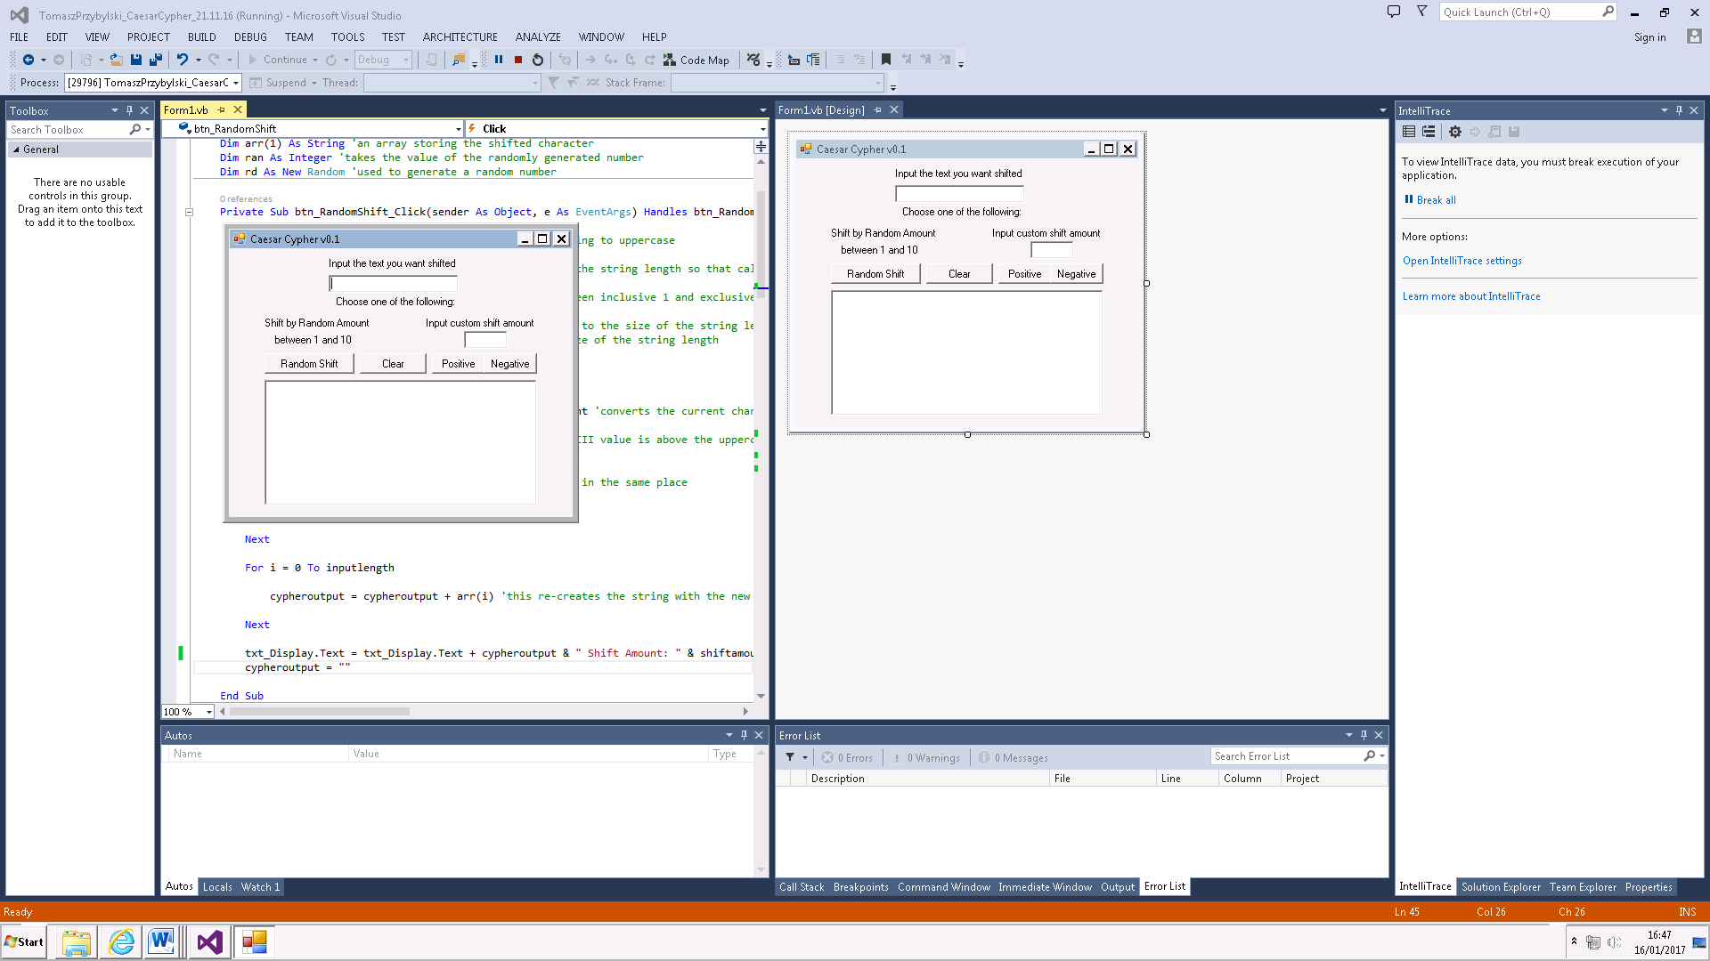

Output textbox. Will display the encrypted string

Shifts input text by a random amount between 1 and 10

Clears output textbox

Negative shift

Positive shift

Input for shift amount

Input for string

## Comments:

* I made two separate arrays for this program. Although the program could be created without using these and by re-creating the string during the loop, this method minimises the chances of errors or mix-ups during the code and makes it much friendlier to understand by looking at it.
* The clear button is only included for user-friendliness. It does not affect how the program executes
* Originally my program just shifted the input text either randomly or by a custom amount, but I decided to split that up to Positive and Negative shift so that the program could be also used to decrypt anything as long as the shift amount is known. This also doubles as a debug tool to check if the input text was being shifted correctly one way or another.
* I also decided to limit the shifts to letters like a real Caesar Cypher would, and in the same way that a Caesar Cypher loops with Z shifted by 1 equalling A, I made the code stay within the bounds of the ASCII letters (with the exception of a spacebar)
* I disabled any number or symbol input for the string.

## Test Plan:

|  |  |  |  |  |  |
| --- | --- | --- | --- | --- | --- |
| Test | Description | Input | Expected Outcome | Actual Outcome | Other Comments |
| #1 | Input 11 Character string into textbox & shift by +11 | Hello Hello | SPWWZ SPWWZ | As expected |  |
| #2 | Input 11 Character string into textbox & shift by -11 | Hello Hello | WTAAD WTAAD | As expected |  |
| #3 | Input 20 character string into textbox & shift by +- 13 | ABCDEFGHIJKLMNOPQRST | NOPQRSTUVWXYZABCDEFG | As expected |  |
| #4 | Input numbers & symbols into textbox | 1234+-{} | Inputs not allowed to be keyed in | As expected |  |
| #5 | Shift amount set to -3 | -3 | Invalid amount message displayed | As expected |  |
| #6 | Shift amount set to 40 | 40 | Invalid amount message displayed | As expected |  |
| #7 | Random Shift used with string in textbox | Help | Shifted by a random amount | As expected |  |
| #8 | No input for string & shift attempted |  | Invalid input message | As expected |  |
| #9 | Input for string present, no shift input | ABC | Invalid shift input & error message displayed | As expected |  |
| #10 | No input for string & random shift attempted |  | No string message displayed | As expected |  |

# Grade Calculator

## Summary:

The Grade calculator enables the user to input a student’s details (name, DOB, ID number) and the results of their Unit 1, 2 and 3 assessments, and generate a certificate if the results are a Pass or above overall.

## Flowcharts:

### General:

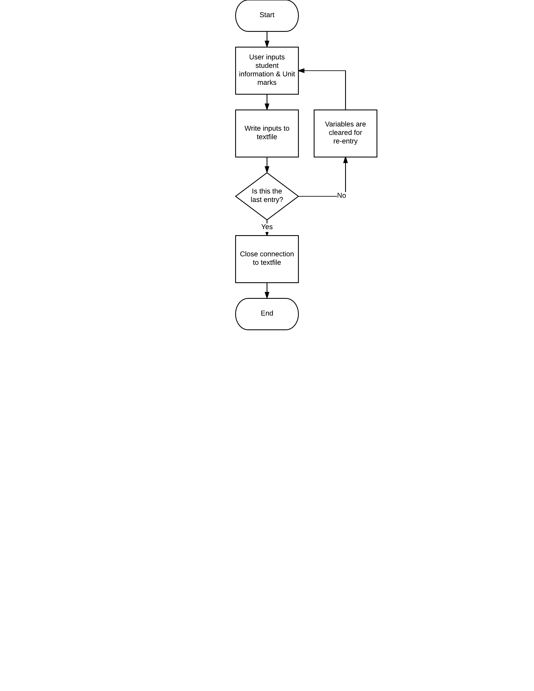

### Sub Specific:

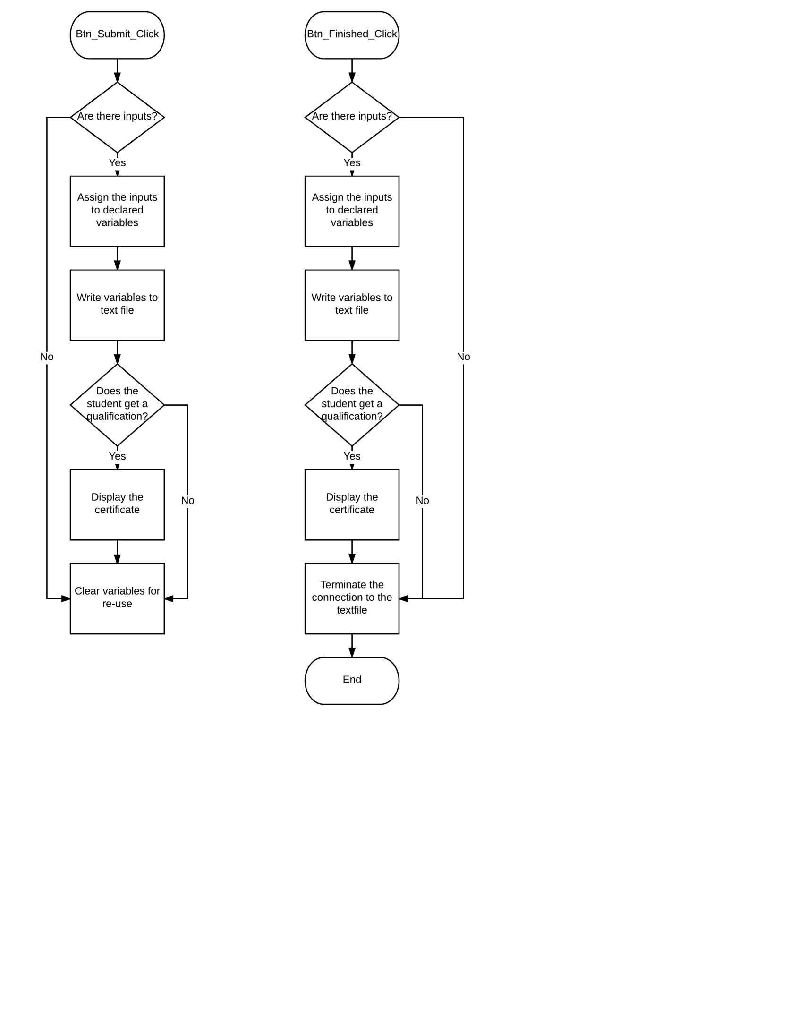

## Annotated Code:

### Display Form:

Imports System.IO

Public Class Frm_Scores

Dim Int_u1 As Integer 'Variables for storing the Unit marks.

Dim Int_u2 As Integer

Dim int_u3 As Integer

Structure studentinfo

Dim str_name As String

Dim str_DOB As String

Dim str_number As String

Dim int_U1Marks As Integer

Dim int_U2Marks As Integer

Dim int_U3Marks As Integer

Dim int_TMarks As Integer

End Structure

Public stinfo(1) As studentinfo

Private Sub btn_Submit_Click(sender As Object, e As EventArgs) Handles btn_Submit.Click 'This sub writes the information to file.

If txt_EnterName.Text = "" Or txt_EnterStudentNumber.Text = "" Then

MsgBox("Please input valid information. Try again")

GoTo 1

End If

Dim str_file_name As String = "N:\SavingTestFolder\SavingTestFile1.txt"

Dim str_txtfile = My.Computer.FileSystem.OpenTextFileWriter(str_file_name, True)

stinfo(1).str_name = txt_EnterName.Text

stinfo(1).str_DOB = txt_DOBDay.Text & "/" & txt_DOBMon.Text & "/" & txt_DOBYear.Text

stinfo(1).str_number = txt_EnterStudentNumber.Text

str_txtfile.WriteLine(stinfo(1).str_name) 'str_txtfile.writeline is used to write a line to the textfile specified in 'txtfile'

str_txtfile.WriteLine(stinfo(1).str_DOB)

str_txtfile.WriteLine(stinfo(1).str_number)

str_txtfile.WriteLine("Unit 1: " & stinfo(1).int_U1Marks * 10)

str_txtfile.WriteLine("Unit 2: " & stinfo(1).int_U2Marks * 10)

str_txtfile.WriteLine("Unit 3: " & stinfo(1).int_U3Marks * 10)

str_txtfile.WriteLine("Total: " & stinfo(1).int_TMarks * 10)

If stinfo(1).int_TMarks >= 23 Then

cert.Show()

str_txtfile.WriteLine("Certificate achieved")

ElseIf stinfo(1).int_TMarks < 23 Or stinfo(1).int_U1Marks < 7 Or stinfo(1).int_U2Marks < 7 Or stinfo(1).int_U3Marks < 7 Then

str_txtfile.WriteLine("Qualification Failed")

MsgBox("This student has not achieved the boundaries for certification")

End If

str_txtfile.WriteLine("--------------------------------------------------------------")

str_txtfile.Close()

1:

lbl_U2Grade.Text = "" 'This section of the code clears all the textboxes to make it easier to use again without restarting the program. Allows the user to input the next set of data immediately after the first.

lbl_U1Grade.Text = ""

lbl_U3Grade.Text = ""

txt_U2Marks.Clear()

txt_U1Marks.Clear()

txt_U3Marks.Clear()

txt_EnterName.Clear()

txt_DOBDay.Clear()

txt_EnterStudentNumber.Clear()

txt_DOBMon.Clear()

txt_DOBYear.Clear()

End Sub

Private Sub Frm_Scores_Load(sender As Object, e As EventArgs) Handles MyBase.Load

frm_StudentDetails.Hide()

End Sub

Private Sub txt_U1Marks_TextChanged(sender As Object, e As EventArgs) Handles txt_U1Marks.TextChanged

Try

stinfo(1).int_U1Marks = txt_U1Marks.Text

Int_u1 = txt_U1Marks.Text

Catch ex As Exception

End Try

If stinfo(1).int_U1Marks >= 9 And stinfo(1).int_U1Marks <= 10 Then 'If states to determine the mark for the specific unit

lbl_U1Grade.Text = "D"

ElseIf stinfo(1).int_U1Marks = 8 Then

lbl_U1Grade.Text = "M"

ElseIf stinfo(1).int_U1Marks = 7 Then

lbl_U1Grade.Text = "P"

ElseIf stinfo(1).int_U1Marks > 10 Or stinfo(1).int_U1Marks < 0 Then 'Validation to make sure extreme data cannot be inputted into the program and cause further errors

lbl_U1Grade.Text = "Invalid Marks"

Else

lbl_U1Grade.Text = "BP"

End If

stinfo(1).int_TMarks = Int_u1 + Int_u2 + int_u3

If Int_u1 < 7 Or Int_u2 < 7 Or int_u3 < 7 Then 'If statement to determine if all units were passed

stinfo(1).int_TMarks = 0

End If

If stinfo(1).int_TMarks > 25 Then

lbl_OverallGrade.Text = "D"

ElseIf stinfo(1).int_TMarks > 23 And stinfo(1).int_TMarks <= 25 Then

lbl_OverallGrade.Text = "M"

ElseIf stinfo(1).int_TMarks >= 21 And stinfo(1).int_TMarks <= 23 Then

lbl_OverallGrade.Text = "P"

ElseIf stinfo(1).int_TMarks > 27 Or stinfo(1).int_TMarks < 0 Then

lbl_OverallGrade.Text = "Invalid Marks"

Else

lbl_OverallGrade.Text = "BP"

End If

End Sub 'The next two subs contain identical code, just for checking Unit 2 marks and Unit 3 marks. As such, they will not be annotated as the annotations above also apply to them.

Private Sub txt_U2Marks_TextChanged(sender As Object, e As EventArgs) Handles txt_U2Marks.TextChanged

Try

stinfo(1).int_U2Marks = txt_U2Marks.Text

Int_u2 = txt_U2Marks.Text

Catch ex As Exception

End Try

If stinfo(1).int_U2Marks >= 9 And stinfo(1).int_U2Marks <= 10 Then

lbl_U2Grade.Text = "D"

ElseIf stinfo(1).int_U2Marks = 8 Then

lbl_U2Grade.Text = "M"

ElseIf stinfo(1).int_U2Marks = 7 Then

lbl_U2Grade.Text = "P"

ElseIf stinfo(1).int_U2Marks > 10 Or stinfo(1).int_U2Marks < 0 Then

lbl_U2Grade.Text = "Invalid Marks"

Else

lbl_U2Grade.Text = "BP"

End If

stinfo(1).int_TMarks = Int_u1 + Int_u2 + int_u3

If Int_u1 < 7 Or Int_u2 < 7 Or int_u3 < 7 Then

stinfo(1).int_TMarks = 0

End If

If stinfo(1).int_TMarks > 25 Then

lbl_OverallGrade.Text = "D"

ElseIf stinfo(1).int_TMarks > 23 And stinfo(1).int_TMarks <= 25 Then

lbl_OverallGrade.Text = "M"

ElseIf stinfo(1).int_TMarks >= 21 And stinfo(1).int_TMarks <= 23 Then

lbl_OverallGrade.Text = "P"

ElseIf stinfo(1).int_TMarks > 27 Or stinfo(1).int_TMarks < 0 Then

lbl_OverallGrade.Text = "Invalid Marks"

Else

lbl_OverallGrade.Text = "BP"

End If

End Sub

Private Sub txt_U3Marks_TextChanged(sender As Object, e As EventArgs) Handles txt_U3Marks.TextChanged

Try

stinfo(1).int_U3Marks = txt_U3Marks.Text

int_u3 = txt_U3Marks.Text

Catch ex As Exception

End Try

If stinfo(1).int_U3Marks >= 9 And stinfo(1).int_U3Marks <= 10 Then

lbl_U3Grade.Text = "D"

ElseIf stinfo(1).int_U3Marks = 8 Then

lbl_U3Grade.Text = "M"

ElseIf stinfo(1).int_U3Marks = 7 Then

lbl_U3Grade.Text = "P"

ElseIf stinfo(1).int_U3Marks > 10 Or stinfo(1).int_U3Marks < 0 Then

lbl_U3Grade.Text = "Invalid Marks"

Else

lbl_U3Grade.Text = "BP"

End If

stinfo(1).int_TMarks = Int_u1 + Int_u2 + int_u3

If Int_u1 < 7 Or Int_u2 < 7 Or int_u3 < 7 Then

stinfo(1).int_TMarks = 0

End If

If stinfo(1).int_TMarks > 25 Then

lbl_OverallGrade.Text = "D"

ElseIf stinfo(1).int_TMarks > 23 And stinfo(1).int_TMarks <= 25 Then

lbl_OverallGrade.Text = "M"

ElseIf stinfo(1).int_TMarks >= 21 And stinfo(1).int_TMarks <= 23 Then

lbl_OverallGrade.Text = "P"

ElseIf stinfo(1).int_TMarks > 27 Or stinfo(1).int_TMarks < 0 Then

lbl_OverallGrade.Text = "Invalid Marks"

Else

lbl_OverallGrade.Text = "BP"

End If

End Sub

Private Sub btn_Finished_Click(sender As Object, e As EventArgs) Handles btn_Finished.Click

'This sub does the same as the btn_Submit_Click sub, only this is used when dealing with the last set of data.

Dim str_file_name As String = "N:\SavingTestFolder\SavingTestFile1.txt"

Dim str_txtfile = My.Computer.FileSystem.OpenTextFileWriter(str_file_name, True)

'Clicking "Finished" on the form with no input will result in the closing of the textfile connection and the termination of the program

If txt_EnterName.Text = "" And txt_EnterStudentNumber.Text = "" Then

str_txtfile.Close()

End

End If

'Clicking "Finished" on the form with input will result in one last write to textfile, followed by the closing of the connection and termination of program.

stinfo(1).str_name = txt_EnterName.Text

stinfo(1).str_DOB = txt_DOBDay.Text & "/" & txt_DOBMon.Text & "/" & txt_DOBYear.Text

stinfo(1).str_number = txt_EnterStudentNumber.Text

str_txtfile.WriteLine(stinfo(1).str_name) 'Writes data to file, same as in the btn_Submit_click sub.

str_txtfile.WriteLine(stinfo(1).str_DOB)

str_txtfile.WriteLine(stinfo(1).str_number)

str_txtfile.WriteLine("Unit 1: " & stinfo(1).int_U1Marks * 10)

str_txtfile.WriteLine("Unit 2: " & stinfo(1).int_U2Marks * 10)

str_txtfile.WriteLine("Unit 3: " & stinfo(1).int_U3Marks * 10)

str_txtfile.WriteLine("Total:" & stinfo(1).int_TMarks * 10)

If stinfo(1).int_TMarks >= 23 Then

cert.Show()

str_txtfile.WriteLine("Certificate achieved")

Else

str_txtfile.WriteLine("Qualification Failed")

MsgBox("This student has not achieved the boundaries for certification")

End If

str_txtfile.WriteLine("--------------------------------------------------------------")

str_txtfile.Close() 'Closes the connection to the textfile and terminates the program

End

End Sub

End Class

### Certificate Form:

Public Class cert

Private Sub cert_Load(sender As Object, e As EventArgs) Handles MyBase.Load

'Displays Student Information entered earlier in a certificate format if the conditions were met earlier.

lbl_DisplayDOB.Text = Frm_Scores.txt_DOBDay.Text & "/" & Frm_Scores.txt_DOBMon.Text & "/" & Frm_Scores.txt_DOBYear.Text

lbl_DisplayIDNumber.Text = Frm_Scores.txt_EnterStudentNumber.Text

lbl_DisplayName.Text = Frm_Scores.txt_EnterName.Text

lbl_Unit1.Text = Frm_Scores.txt_U1Marks.Text & " * 10 Credits = " & Frm_Scores.stinfo(1).int_U1Marks * 10 & " | Grade : " & Frm_Scores.lbl_U1Grade.Text

lbl_Unit2.Text = Frm_Scores.txt_U2Marks.Text & " * 10 Credits = " & Frm_Scores.stinfo(1).int_U2Marks * 10 & " | Grade : " & Frm_Scores.lbl_U2Grade.Text

lbl_Unit3.Text = Frm_Scores.txt_U3Marks.Text & " * 10 Credits = " & Frm_Scores.stinfo(1).int_U3Marks * 10 & " | Grade : " & Frm_Scores.lbl_U3Grade.Text

lbl_DisplayOverall.Text = Frm_Scores.lbl_OverallGrade.Text

End Sub

End Class

### Variable List:

|  |  |  |
| --- | --- | --- |
| **Variable Name** | **Variable Type** | **Other Comments** |
| Int_u1 | Integer | Holds the Unit 1 score, used in calculating grades |
| Int_u2 | Integer | Holds the Unit 2 score, used in calculating grades |
| Int_u3 | Integer | Holds the Unit 3 score, used in calculating grades |
| Stinfo | Studentinfo (Structure) | Creates a data structure to hold a number of variables together. |
| Str_name | String | Part of the studentinfo structure |
| Str_DOB | String | Part of the studentinfo structure |
| Str_number | String | Part of the studentinfo |
| Int_U1Marks | Integer | Holds the Unit 1 scores for displaying. |
| Int_U2Marks | Integer | Holds the Unit 2 scores for displaying |
| Int_U3Marks | Integer | Holds the Unit 3 scores for displaying |
| Int_TMarks | Integer | Holds the total scores for displaying |
| Str_file_name | String | Holds the file path for the text file |
| Str_txtfile | My.Computer.FileSystem.OpenTextFileWriter | Enables writing to text file |

## Comments:

* The program currently runs an extra “Form1.vb” that isn’t being used. This is because I changed a big chunk of code so that it was more user friendly and fit the project description better, and the Form was left over. It currently does nothing, and so shouldn’t affect the ability of the program.
* The program works by letting the user input information about the student and creating the certificate (if applicable) and then clearing to be used again if the user desires to create another entry. If not, the program will just write the data and then exit. This means that data doesn’t need to be stored for a long period of time, and multiple entries don’t need to be stored and written at once. Instead, the entries are written after they are submitted by the user, so only one set of data has to be held by the program at any one time.

## Test Plan:

|  |  |  |  |  |  |
| --- | --- | --- | --- | --- | --- |
| Test | Description | Input | Expected Outcome | Actual Outcome | Other Comments |
| #1 | Pressing “Finished” with no input |  | Program closes | As expected |  |
| #2 | Pressing “New” with no input |  | “ Invalid Inputs” message displayed, nothing written to file | As expected |  |
| #3 | Invalid mark input | 90 | Displays invalid marks & BP for final grade | Displays invalid marks but does not register as BP | The way to fix this is to force the corresponding marks to format to 0 if they are invalid (>10 or <0) |
| #4 | Invalid mark input | -3 | Displays invalid marks & BP for final grade | As expected |  |
| #5 | Invalid mark input | SSS | Displays invalid marks & BP for final grade | Displays BP for unit and final grade | Can easily be fixed with an extra if statement to distinguish string entries from integers |
| #6 | Missing Student Name or Student Number |  | Displays “Invalid Inputs” message and asks to correct | As expected |  |
| #7 |  |  |  |  |  |
| #8 |  |  |  |  |  |
| #9 |  |  |  |  |  |
| #10 |  |  |  |  |  |

# Password Generator & Checker

## Summary:

The Password program will perform a number of tasks. First of all, it serves as validation. Any username and password entered by the user will be checked against a word document to see if the two can be matched. Both entries, the username and the password have to be correct for the program to return a message saying that the details were found. Secondly, the program allows the user to create a new data entry. Anything (within the parameters i.e. 8 characters, 3 or more of the following: one upper case, one lower case, one special, one integer) contained in the username and password fields will be written to the file, ready to be validated against.