Contents

Building a PC for less than £600 2

Introduction: 2

Adobe Photoshop CS6: - £18 2

Motherboard: Option 1: H110M PRO-VD - £45 PICKED 3

Motherboard: Option 2: Asus Z170-A -£120 4

CPU – Option 1: i3-6100 - £100 PICKED 5

CPU – Option 2: i5-6400 – £160 6

Memory: Storage (HDD + SDD) - £41.30 + £68.20 7

Memory: RAM (2x4GB Kingston HyperX Black) – £58 7

Windows 7 Professional - £14.99 7

PSU: EVGA 430W W1 - £38 7

Case: Fractal Design R5 - £70 + £36 7

GPU: GTX 1050 Ti 4GB - £110 7

Other Components: 7

Comments: 8

Regarding the Motherboard: 8

Regarding the CPU: 8

Regarding Memory: 8

Regarding the GPU: 8

Last Comments: 8

Overall Cost: £599.46 8

Research: Optical Data Transmission 9

Brief History 9

Currently 9

Future 9

# Building a PC for less than £600

## Introduction:

The purpose of the PC will be to be able to run Adobe Photoshop Lightroom CC/Lightroom 6. This is not a particularly difficult or intensive task, but it does rely very heavily on the processing aspect of the PC. For now, I will be assuming that the PC will be performing only this task, although I will revisit this later when talking about upgrading the PC. I will also assume that any input peripherals or display peripherals are not included in the £600 budget and will be bought separately in their own budgets.

## Adobe Photoshop CS6: - £18

[1]These are the minimum system requirements I found for Adobe Photoshop Lightroom:

* Intel® or AMD processor with 64-bit support*
* Microsoft Windows 7 with Service Pack 1 (64-bit), Windows 8.1 (64-bit) or Windows 10 (64-bit)
* 2 GB of RAM (8 GB recommended)
* 1024 x 768 display
* 1 GB of Video RAM (VRAM). 2 GB of dedicated VRAM is suggested for large, high-resolution monitors, such as 4K- and 5K-resolution monitors.
* 2 GB of available hard-disk space
* DVD-ROM drive required if purchasing Adobe® Photoshop® Lightroom® retail boxed version
* OpenGL 3.3 and DirectX 10-capable video adapter for GPU-related functionality
* Internet connection and registration are necessary for required software activation, validation of subscriptions, and access to online services.

## Motherboard: Option 1: H110M PRO-VD - £45 PICKED

[2]I chose this motherboard for a variety of reasons. I have opted for an intel-oriented PC build, this motherboard is ideal for the price. This motherboard is compatible with any LGA1151 socket Skylake or Kaby Lake CPU. It will not support chips past the 6th generation, but by the time the i7s become obsolete, the entire PC will need to be replaced anyway, so it is not much of a problem in that regard. The motherboard supports 2x DDR4-2133 Memory in Dual Channel architecture. The Intel H110 chipset that is in the motherboard has a limitation of DDR4 2133MHz and so quicker and better RAM will not run any quicker than the limit of the intel chipset. This may become an issue later but it should not be a factor for much of its lifespan. The board supports 1xPCie 3.0 (16 slot) and 2xPCIe 2.0 (1 slot). Other than that, the motherboard has 4 SATA ports, 4 USB 3.0 and 6 USB 2.0 ports. Also present are a DVI-D port and VGA port. Both ports support 1920x1200@60Hz, which is the most common display resolution and will suffice for this PC.

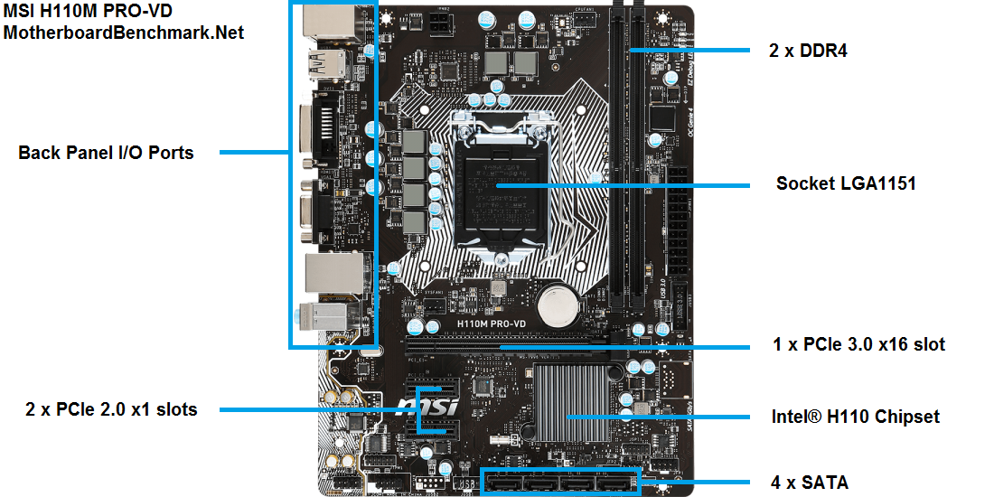

The board is better than can be expected for the price, with some going as low as £45 online. As mentioned before, this board is not as futureproof as one may hope, but it will allow for some manoeuvrability when it comes to swapping out components. The main limitations of the board are the Intel H110 chipset and the RAM limit, as well as the fact that the board does not handle Overclocking at all.

## Motherboard: Option 2: Asus Z170-A -£120

[3]This motherboard is also compatible with any LGA1151 socket CPUs (as is standard). The Chipset in this motherboard is the Z170, which is better than the H110m in almost every aspect (as shows the table below).

The Z170-A has more PCIe ports, more USB ports, and it handles higher resolutions such as 4K much better than the H110 but more importantly, supports RAM above DDR4-2133. This is the one outstanding limitation of the H110 and the only thing limiting the future-proof-ness of the PC. The Z170-A is a much better choice, although almost 3 times the price. [4]

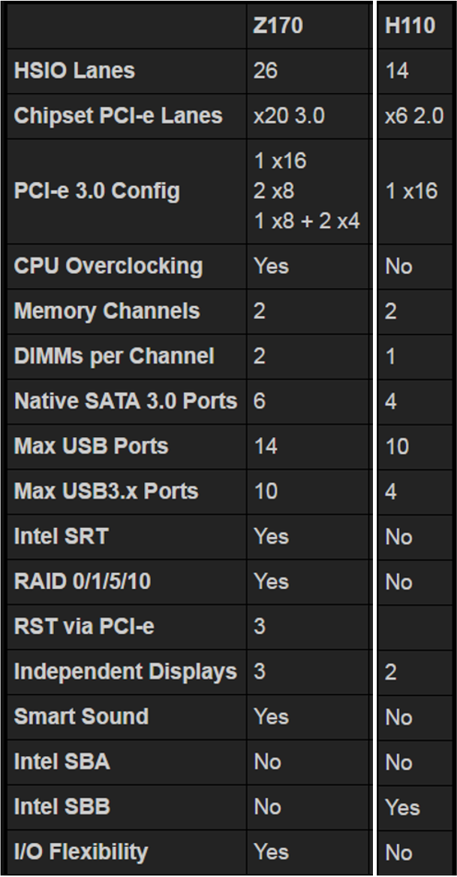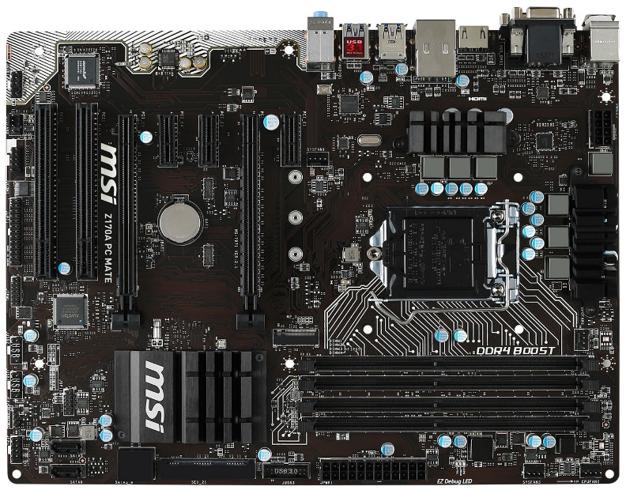

Both of these motherboards are fully compatible with the parts I chose and both run on the UEFI BIOS which is one of the best UEFI tools available currently.

## CPU – Option 1: i3-6100 - £100 PICKED

The [5]i3-6100 3.7GHz is a 6th generation Dual Core Intel Core Processor. It has a bus speed of 8 GT/s, a 3MB L3 cache and can be overclocked to a maximum of 4.27Ghz. This is fully compatible with the motherboard I chose above, although the bus speed will be reduced to 5GT/s DMI2. This is not something that should be worried about as the PC will not be relying too much on high bus speeds. It has a high speed for a dual core processor, and is one of the best intel processors when it comes to power per processor for cost

*Benchmarking is done by the PassMark Software [6]*

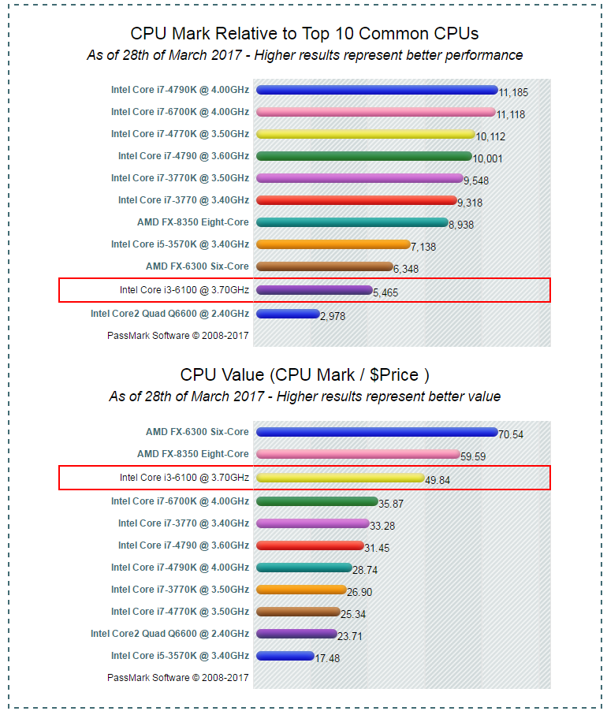

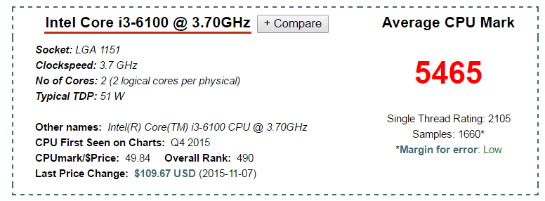

## CPU – Option 2: i5-6400 – £160

The [7]i5-6400 2.7GHz is also the 6th generation Intel Core Processor, although that is where most of the similarities end. Although the i5 has a frequency of 2.7GHz, it has double the cores of the i3 meaning that for processes such as video and image editing, it would be a much better choice, as more processes could be performed simultaneously, resulting in a much higher actual speed. [8]

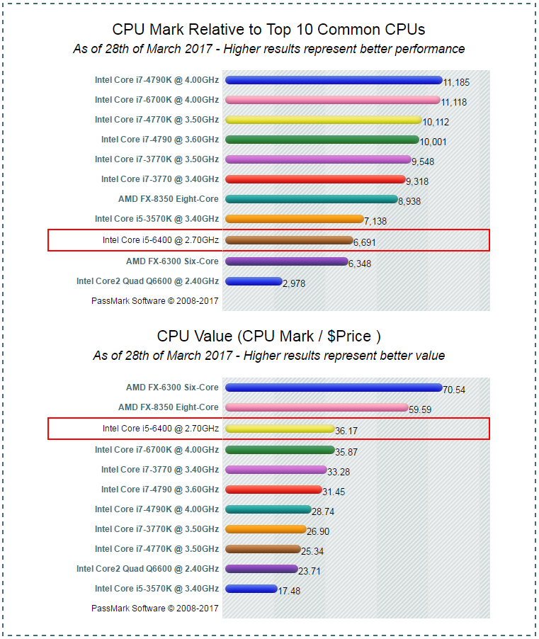

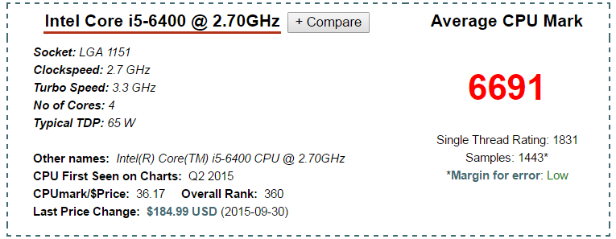

Comparing the two benchmarks, the i3 has a better ‘Single Thread Rating’, and is much better value for money and so for building on a budget it may be a better idea, but the i5 is a much better processor overall.

## Memory: Storage (HDD + SDD) - £41.30 + £68.20

Photo editing will be very memory intensive, which is why it would probably be better to invest in a large HDD than a small SSD. An SSD would be ideal due to the speed of data transfer, but if the user will have no external/other memory media, it would be best to prioritise a larger but slower memory drive. However, buying a SanDisk SSD for the OS and for Adobe Photoshop and then using a 1TB storage for the images is probably the best one can hope for with this budget.

The 1TB Seagate Internal HDD has a 64MB cache and an interface of 6Gb/s. It contains two read/write heads and a single disc. Assuming an average photo takes up 1MB, this HDD will be able to hold around 1 million images. This should be plenty.

For the SSD, I found the SanDisk Ultra II 120GB SATA internal SSD. It has speeds of 550MB/s read and 500MB/s write, which is ideal for quick image editing. It should also be large enough to hold the Windows 7 OS and the Linux OS, as well as the Adobe Photoshop software and maybe even images.

## Memory: RAM (2x4GB Kingston HyperX Black) – £58

The RAM is two 4GB Kingston HyperX Black sticks, each being DDR4-2133, the fastest that the board can handle. These should be enough for photo editing, but the opportunity is available to upgrade to 2x8GB of the same model of RAM, or alternatively switch to Crucial who make up to 16GB sticks of RAM, meaning that the maximum possible is 32GB. Although the speed is limited to DDR4-2133, it is still up to 34000MB/s (clock rate * number of bytes), and as such should suffice.

## Windows 7 Professional - £14.99

Windows 7 is cheaper and in my opinion still better than Windows 10, and is supposed to be much easier to get working alongside Linux. For £14.99 I have found a single use Windows 7 Professional version to be downloaded onto a USB or other flash storage and installed that way.

## PSU: EVGA 430W W1 - £38

430 watts should be more than enough to power the PC with some 10% spare, and EVGA are known for reliable hardware components so the PSU should last for the entire life of the computer.

## Case: Fractal Design R5 - £70 + £36

The case is very pretty, but more importantly is quite large and looks ideal for sleek cable management. This will aid in the cooling of the whole PC, and this is crucial as the budget does not really allow for much in terms of extra cooling, and so the whole computer will be relying on air cooling and very good airflow. The case comes with two GP14 140mm fans, but in my opinion another two should be added on (2x £18). The case is also noise cancelling, which is a big plus.

## GPU: GTX 1050 Ti 4GB - £110

Although the CPUs have decent integrated graphics, because the aim of the PC is to edit images, the GPU is about the same importance as the CPU or RAM. The GTX 1050 Ti 4GB is the newest generation budget graphics card. It has a memory clock speed of 7Gbps and the 4GB of VRAM should be more than enough for any image editing. It may even be enough for rendering 3D animations. This GPU is the 2nd best value for money card currently on the market.

## Other Components:

As I mentioned at the start, I did not include the input or display peripherals as I assumed that the budget is only for the PC. This meant that I could put more money into things like the GPU and the Storage. The only thing left is network connectivity. A wired Ethernet connection is the best choice, as the PC will be stationary and will not need Wi-Fi access, and because Ethernet cables are incredibly cheap now. The connection will not have to be strong either, as the only reason for the connection is for downloading Adobe Photoshop, for registration and for accessing “online services”. All cables needed to connect the components will come with the components or the case itself, and as such there is no need to purchase extra.

## Comments:

### Regarding the Motherboard:

Although the Z170A is much better compared to the H110M, and worth the price, the budget of the build was the deciding factor. For this PC, the H110M will perform well, and for £45 it is a huge bargain. It is fully compatible with every component listed here, and will be compatible with any minor upgrades, such as increasing the processor to the i5 listed above or increasing Storage space. However, it is important to bear in mind that this will be where the most bottlenecking will happen, and if the computer is to be upgraded further past small modifications, it will be necessary to replace the motherboard before anything else.

### Regarding the CPU:

Another important component, unfortunately again due to budgeting, I had to choose the cheaper option of the i3-6100. Having said that, the i3 is still very good and as mentioned before it is one of the most cost efficient Intel processors available. It has a very high clock speed for a Dual Core processor which makes it a very good budget choice. The i5 is no doubt better, but much less cost efficient, as for an extra £60 it has maybe 20-25% (based on the CPU Mark from the PassMark benchmark) more processing power than the i3. The i5 is a more powerful choice, but the i3 is much more cost efficient, which is the main point of this build, so I chose the i3 for the CPU.

### Regarding Memory:

As I have already stated before, in my opinion the small SSD & medium HDD are the best option when it comes to storage. I could have gotten a slightly larger SSD with the extra money from the HDD, but it would limit the capacity to which the PC could perform its task. Having both storage mediums means that any required programs and OS can be installed on the SSD to increase response time, while all the actual storage of images & other files can be managed by the 1TB HDD.

For RAM, I chose the 2x4GB Kingston HyperX sticks because they were quite good value for money. I believe that for image editing 8-16GB should suffice, and this RAM fulfils that requirement. Obviously more RAM would be ideal, and it is possible to fit up to 32GB (2x16GB) on the motherboard, but as mentioned earlier, only speeds of 2133MHz will be achievable, and as such the RAM will probably stay at 8GB until the motherboard is replaced.

### Regarding the GPU:

The GTX 1050 TI 4GB is an incredibly cost efficient card when it comes to NVIDIA cards and in general. Both CPUs mentioned above have integrated graphics, and I believe if it was necessary they would perform the task required, but having found such a decent card for only £110 meant that I was willing to make some cuts to the CPU and motherboard budget for this card.

### Last Comments:

In the end, I am happy with what I managed to find within the budget of £600 if only just, and I think that this PC could probably go on for about 3-4 years without needing any upgrades (however 4K is starting to become the norm now so that may not be entirely true) and I believe that these components are enough to fulfil the objective; building a £600 PC for image editing.

## Overall Cost: £599.46

# Research: Optical Data Transmission

## Brief History

First developed and produced in the 1970s, Optical Data Transmission is a method of transmitting data from one terminal to another by using light pulses. These light pulses or signals are emitted and relayed through a medium in a way that is picked up and recognised by the receiving terminal and interpreted into data. Currently, the most common form of Optical Data Transmission is via Fiber-Optic Cables, and when first put into commercial use in the late 1970s operated at up to 45Mb/s. By the late 1980s, the second generation of fiber-optic communcations were operating at speeds of up to 1.7Gb/s. As we approached the late 90s and early 2000s, due to advancements in light emission, the quality of the cables and the quality of optical repeaters, speeds of 10Tb/s and more were being reached, and as the internet grew in size, so did the usage and reliance on Optical Data Transmission.

## Currently

The current technology of Fiber-Optic Data Transmission relies on 4 different components. First an optical transmitter is necessary to convert digital information into optical signals. These transmitters are usually LEDs or Laser Diodes. However, LEDs are very inefficient and are usually only used in small LANs. Most transmissions rely on VCSEL (Vertical Cavity Surface Emitting Laser) which is much faster and powerful than LEDs, although much more expensive. The light emitted by the VCSEL is then manipulated by an applied electrical current and sent along the Fiber-Optic Cables. For most commercial uses, these cables will be multi-mode optical fibers, which allow for cheap transmitters and receivers to connect, such as those you might find outside your home. This kind of cable can cause some distortion, lowering the speeds of transmission. Single-mode optical fibers do not experience this but they are much more expensive to run and so are usually not used commercially. Along the way, amplifiers may be used to strengthen the passing signal, ensuring that distortions are eliminated and the signal can reach its destination intact. Finally, a photodetector build into the receiver will convert the light signals to electrical signals via the photoelectric effect.

## Future

The future of Optical Data Transmission holds many possibilities. For now, the focus is on finding ways to improve the current technology, for example by making better quality cables & by increasing the power of the transmitters. However, other forms of Optical Data Transmission are being researched alongside this (free-space transmission), such as the possibility of emitting data through certain forms of light in the corner of a room, and letting all the devices in that room pick up the information they need, or using light beams to send information to satellites or spacecraft and vice versa, or by using optical transmission for board-to-board or chip-to-chip connections.

ebsite name, (Year published). Page title. [online] Available at: URL [Accessed Day Mo. Year].

[1] Adobe, (2016). *Adobe Photoshop CS6 System Requirements*. [online] Available at: <https://helpx.adobe.com/creative-suite/kb/cs6-system-requirements.html> [Accessed 28/03/17]

[2] MSI, (2017). *MSI H110M PRO-VD.* [online] Available at: <https://www.msi.com/Motherboard/H110M-PRO-VD.html#hero-specification> [Accessed 28/03/17]

[3] Asus, (2017). *ASUS Z170-A*. [online] Available at: <https://www.asus.com/uk/Motherboards/Z170-A/> [Accessed 28/03/17]

[4]GamerNexus, (2017). *Intel Z170 vs. H170 vs. H110 Skylake Chipset Comparison*. [online] Available at: <http://www.gamersnexus.net/guides/2099-intel-chipset-comparison-z170-h170-h110> [Accessed 28/03/17]

[5]Intel, (2017). *Intel Core i3 6100 Processor*. [online] Available at: <http://ark.intel.com/products/90729/Intel-Core-i3-6100-Processor-3M-Cache-3_70-GHz> [Accessed 28/03/17]

[6]PassMark, (2017). *Intel i3 6100 @ 3.70GHz.* [online] Available at: <https://www.cpubenchmark.net/cpu.php?cpu=Intel+Core+i3-6100+%40+3.70GHz> [Accessed 28/03/17]

[7]Intel, (2017). *Intel Core i5 6400 Processor.* [online] Available at: <https://ark.intel.com/products/88185/Intel-Core-i5-6400-Processor-6M-Cache-up-to-3_30-GHz> [Accessed 28/03/17]

[8]PassMark, (2017). *Intel i5 6400 @ 2.70Ghz.* [online] Available at: <https://www.cpubenchmark.net/cpu.php?cpu=Intel+Core+i5-6400+%40+2.70GHz> [Accessed 28/03/17]