SDLC- Waterfall, Big Bang & RAD models

Waterfall Model:
The Waterfall Model is the basic model of the SDLC, originating from 1970 and designed by Winston W. Royce. This model is based upon the idea that the customer or user that the program is aimed at should not be involved with the developing process and should only be involved at the very beginning and very end of the SDLC. This meant that the Waterfall Model was ideal to be used during the 70s, 80s and even early to mid-90s, as the technology was rather static and uniform, and developing of new technologies took much longer and caused rather dramatic leaps, unlike today where both software and hardware are constantly changing and being updated with new features. During this time, it was also much less likely that project requirements or objectives would be constantly changing, as the projects would have been rather rudimentary or at least straightforward, with mostly very specialised programmes each doing one job or having one purpose, unlike in rather recent years where the focus has been to group many of these purposes together and undertake projects which result in one programme that will control everything useful. This also meant that most projects were rather quick in producing, which is also very important as the Waterfall Model relies on ample resources and very high developing expertise.
* This model can easily be changed to the Iterative Model, which means that a lot of the disadvantages relating to the linear nature of the model can be discarded. This is because the Iterative Model allows for reflection on each stage of the project and amending any problems or faults found at any stage.

Advantages of the Waterfall Model:
- Simple & easy to understand
- Easy to manage due to unchanging nature of the model
- Project is undertaken linearly, and each stage of the project is completed before the next one is undertaken
- Works best for small/quick projects where requirements are very well understood
- Easy to arrange and distribute tasks as all stages are separate and defined
- Process of development is very well documented
Disadvantages of the Waterfall Model:
- No working software is produced until almost the very end of the SDLC
- High amount of risk & uncertainty during the developing process
- Not suitable for complex and/or object-oriented projects
- Not suitable where the requirements of the project are at a moderate or higher risk of changing
- Not suitable for long & ongoing projects due to the strain on resources
- Difficult to measure progress of each stage
- Change of requirements or objectives or change of technology can cause a premature and incomplete end to the project
- Implementation is done all together near the end of the project SDLC, meaning challenges can be identified very late
Examples of Waterfall Model projects:
- Most retail systems (such as the EPoS – Electric Point of Sale) – These types of software do not require much complexity and face very little risks to changing requirements but still require input from the customer and planning beforehand, which is why the waterfall model is probably the most suitable to describe these systems.
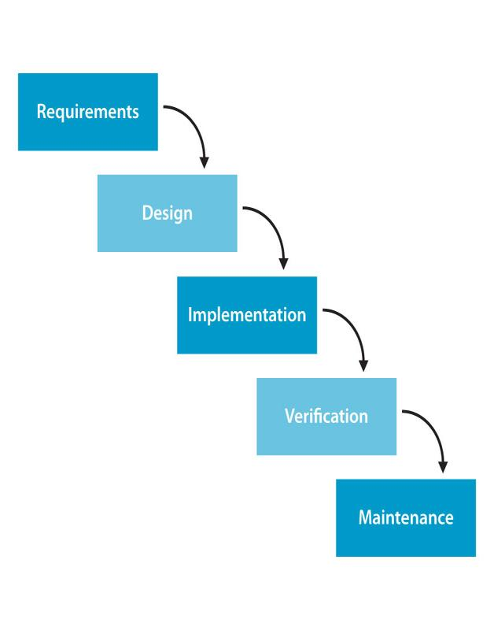

Big Bang Model:
This model is much less common. It is based around gathering all resources needed together and going straight into implementation with little to no planning and with limited knowledge of the requirements, and focuses on discovering and implementing the requirements during the implementation phase of the project. This project is ideal for a very small and inexperienced group of developers.
Advantages of the Big Bang Model:
- Very simple model to understand and follow
- Little to no planning necessary beforehand
- Enables the project to be managed very easily
- Very few resources are needed with this model
- Gives flexibility to developers if requirements are changed
- Good learning aid for inexperienced developers.
Disadvantages of the Big Bang Model:
- High risk & uncertainty
- Not a good model for complex and/or object-orientated projects
- Not suitable for long & ongoing projects due to lack of prior planning
- Can become very expensive if the project requirements are misunderstood or looked over
Examples of Big Bang projects:
- Academic projects (undertaken by students) – The Big Bang model is not very commonly seen because it has no real use. The model is very good at being used by new developers to understand how software systems should not be created and its only use could be academic assignments. The model cannot be used in actual projects because it cannot accommodate any sort of complexity the project might have and only small academic assignments may be attempted without any previous planning or recognising requirements and objectives.
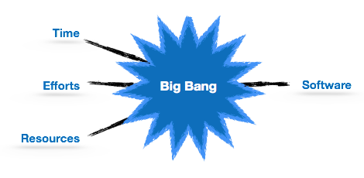

RAD (Rapid Application Development) Model:
This is probably one of the more complex models to understand and is the most common model in use today. This model focuses on prototyping and iterative development, sacrificing extensive planning for rapid delivery. Customer requirements are gathered thoroughly and requirements are split up into modules, each of which is undertaken parallel to one another and prototyped frequently to be delivered to the user for feedback.
RAD consists of the following phases:
Business Modelling: The business model for the product is assessed and designed to be most efficient in terms of flow and distribution of information.
Data Modelling: Information gathered previously is reviewed and analysed to form sets of data objects, vital for the business. Attributes of all the data objects are identified and defined and data & entity relations are established as relevant.
Process Modelling: Data object sets defined previously are converted to establish the business information flow needed to achieve specific requirements/objectives. The model for changes to data objects sets are defined here.
Application Generation: Implementation is started and coding is done using Automated Code Generation tools to convert Process and Data Models into working prototypes.
Testing and Turnover: Overall testing time is reduced as the prototypes are independently tested each iteration. However, data flow and interfaces between all components need to be tested extensively once prototypes are complete.
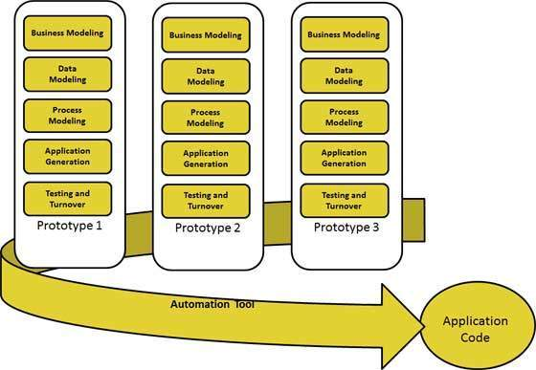

Advantages of the RAD Model:
- Changing requirements can be accommodated
- Progress can be measured
- Iteration time can be short with use of powerful RAD tools
- Reduced development time
- Increases reusability of components
- Quick initial reviews occur
- Encourages feedback and interaction from user/customer
Disadvantages of the RAD Model:
- Dependency on technically strong team members for identifying requirements
- Only modularised systems can be built with RAD
- Requires highly skilled and able developers
- Cost of modelling & automated code generation can be expensive.
- Higher management complexity
- Requires in-depth user interaction throughout project
The above points mean that the RAD model:
- Should only be used when a system can be modularised and delivered in increments
- Needs high availability of skilled designers available
- Should only be used if the budget permits use of automated code generation tools
- Should be used where requirements change during the course of the project
- Should include customer participation as much as possible and therefore prototypes should be presented frequently
RAD is one of the main SDLC models used today for products, not only software but also many other things like mobile devices. This is because most products today rely on a very rapidly changing set of requirements and this model is very good at handling those kinds of challenges. Due to the incremental nature of the model, the components can be reused for next generation products and updated where there is a need for an update. This is one of the main reasons companies such as ‘Apple’ have been able to roll out so many different products in such a small time. The iPhone SE is an excellent example of this, by using current-gen hardware such as the A9 chip from the iPhone 6S and putting it into a slightly altered case from a much older generation of iPhones, they were able to create a “brand new” product even though most of the components included in it are also included in other generations of the iPhone.

** A pre-made guide to making a “Financial Management Service” in 120 days with RAD (as taken from the US Department of Treasury Fiscal Service Bureau) **http://fms.treas.gov/rad/start-up/RAD-Project-Plan.pdf

